Supporting information
Synthesis, structure and molecular docking of new 4,5-dihydrothiazole derivatives based on 3,5-dimethylpyrazole and cytisine and salsoline alkaloids

Marat K. Ibrayev*^{1,2}, Oralgazy A. Nurkenov^{1,3}, Zhanar B. Rakhimberlinova¹, Altynaray T. Takibayeva¹, Irina V. Palamarchuk⁴ , Dastan M. Turdybekov¹, Assel A. Kelmyalene¹, Ivan V. Kulakov⁴

¹ Abylkas Saginov Karaganda Technical University, Ave. Nursultan Nazarbayev, 56, Karaganda, Kazakhstan
² Karaganda Buketov University, st. University 28, Karaganda, Kazakhstan
³ Institute of Organic Synthesis and Coal Chemistry of Republic of Kazakhstan, Alikhanova, 1, Karaganda 100008, Karaganda, Kazakhstan
⁴ Institute of Chemistry, Tyumen State University, 15a Perekopskaya St., Tyumen 625003, Russia; i.v.kulakov@utmn.ru
* Correspondence: mkibr@mail.ru; Tel.: +7 700 3106646

Table of contents
Experimental 1
General Information 1
Experimental Procedures 2
Spectroscopic and physical data 2
Copies of NMR Spectra of Products 6
Copies of MS Spectra of Products 13
X-Ray Structural Study of Product 16

X-Ray Structural Study of Product
Experimental
General Information
FTIR spectra were obtained with an Agilent Cary 630 spectrophotometer in a thin sample layer on a crystal attachment. ¹H and ¹³C NMR spectra were recorded on a Bruker DRX400 (400 and 100 MHz, respectively) and Bruker AVANCE 500 (500 and 125 MHz, respectively) instruments using DMSO-d₆ the internal standard was TMS or residual solvent signals (2.49 and 39.9 ppm ¹Н and for ¹³C nuclei in DMSO-d₆).
Chromato-mass spectrometric studies were carried out on a Trace GC Ultra chromatograph with a DSQ II mass-selective detector in the electron ionization mode (70 eV) on a Thermo TR-5 MS quartz capillary column, 15 m long, 0.25 mm inner diameter, with a film thickness of the stationary phase of 0.25 μm. Splitless input mode was used. Carrier gas discharge 20 ml/min. The velocity of the carrier gas (helium) is 1 ml/min. Evaporator temperature 200°C, transition chamber temperature 200°C, ion source temperature 200°C. The temperature of the column thermostat was changed according to the program: from 15 (5 min delay) to 220°C at a rate of 20°C per minute, to 290° at a rate of 15° per minute. The total analysis time was 30 min. The volume of the injected sample is 1 μl. Chromatograms were recorded in TIC mode. The range of mass scanning is 30 - 450 amu.
Melting points were determined using a Stuart SMP10 hot bench. Monitoring of the reaction course and the purity of the products was carried out by TLC on Sorbfil plates and visualized using iodine vapor or UV light.
Experimental Procedures
N-allyl-4-bromo-3,5-dimethyl-1H-pyrazole-1-carbothioamide 5. A solution of 1.75 g (0.01 mol) of 4-bromo-3,5-dimethylpyrazole in 10 ml of 2-propanol was added dropwise to a solution of 1 g (0.01 mol) of allylisothiocyanate in 10 ml of 2-propanol at a temperature of 50°C. The solution was stirred for about 6 hours. After the solvent distillation and recrystallization of the residue from hexane, there was obtained 1.95 g (71%) of a white crystalline substance with m.p. 50-52 °С.
5-(bromomethyl)-2-(3,5-dimethyl-1H-pyrazol-1-yl)-4,5-dihydrothiazole 8 (General method). A solution of 0.96 g (10 mmol) of 3,5-dimethylpyrazole 1 in 7 ml of benzene was added within 30 minutes to a solution of 2.60 g (10 mmol) of 2,3-dibromopropylisothiocyanate 7 and 1.01 g (20 mmol) of triethylamine in 10 ml of abs. benzene with vigorous stirring and a temperature of 20 °C. The solution was heated for about 3 hours at a temperature of 40 °C. The precipitate of triethylamine hydrobromide was filtered off, washed with benzene. The benzene solution was evaporated to yield 2.63 g (96%) of a white crystalline substance with m.p. 101.5-102.5 °C (hexane-benzene).
2-(4-bromo-3,5-dimethyl-1H-pyrazol-1-yl)-5-(bromomethyl)-4,5-dihydrothiazole 9 was obtained by analogy with 8 from 2.60 g (10 mmol) of 2,3-dibromopropylisothiocyanate 7, 1.01 g (20 mmol) of triethylamine and 1.75 g (10 mmol) of 4-bromo-3,5-dimethylpyrazole 2. The yield was 2.29 g (65%); white crystals, m.p. was 106-107 °C (2-PrOH/ hexane, 2:1).
3-(5-(bromomethyl)-4,5-dihydrothiazol-2-yl)-1,2,3,4,5,6-hexahydro-8H-1,5-methanopyrido[1,2-a][1,5]diazocin-8-one 11 was obtained by analogy with 8 from 2.60 g (10 mmol) of 2,3-dibromopropylisothiocyanate 7, 2.02 g (20 mmol) of triethylamine and 1.90 g (10 mmol) of cytisine a. The yield was 2.72 g (74%); white crystals, m.p. was 166-168°С (2-PrOH/hexane 1:1).
22-(5-(bromomethyl)-4,5-dihydrothiazol-2-yl)-7-methoxy-1-methyl-1,2,3,4-tetrahydroisoquinolin-6-ol 12 was obtained by analogy with 8 from 2.60 g (10 mmol) of 2,3-dibromopropylisothiocyanate 7, 2.02 g (20 mmol) of triethylamine and 1.93 g (10 mmol) of salsoline b. The yield was 3.08 g (83%); white crystals, m.p. was 149-150°С (2-PrOH/hexane 1:1).
5-(bromomethyl)-N-((1,3,5-trimethyl-1H-pyrazol-4-yl)methyl)-4,5-dihydrothiazol-2-amine 13 was obtained by analogy with 8 from 2.60 g (10 mmol) of 2,3-dibromopropylisothiocyanate 7, 2.02 g (20 mmol) of triethylamine and 1.39 g (10 mmol) of (1,3,5-trimethyl-1H-pyrazol-4-yl)methylamine 10. The yield was 2.28 g (72%); white crystals, m.p. was 95-97 °С (PhH/hexane 1:1).

Spectroscopic and physical data
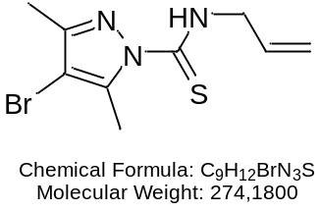 | N-allyl-4-bromo-3,5-dimethyl-1H-pyrazole-1-carbothioamide 3.  Yield: 1.94 g (71%); White crystals, mp. 50-52 °С (2-PrOH).  ¹H NMR (500 МГц, DMSO-d₆, δ, ppm, J/ Hz): 2.08 (s, 3Н, CН₃); 2.15 (s, 3Н, СН₃), 4.22 - 4.37 (m, 2Н, NH-СН₂-CH=), 5.17 (ddd, 1Н, J = 16.72, 10.3, 1.5, =С-Н_{а}), 5.29 (br. dd, 1H, J = 17.01, 10.2, =С-Н_{b}), 5.85-5.97 (ddt, 1H, J = 17.62, 10.25, 5.10, -СН=СН_{а}Н_{b}), 12.58 (br. s, 1H, NH-СН₂). ¹³C NMR (101 MHz, DMSO-d₆) δ ppm 12.1, 12.7, 46.4, 98.0, 115.2, 135.1, 142.3, 148.2, 160.5.  MS (EI) m/z (I_{rel}, %): 275 [M]⁺ (10), [M]⁺ 273 (10), 242 (69), 240 (71), 176 (100), 175 (78), 174 (99), 95 (39), 42 (46), 41 (62), 39 (89).  Anal. calcd for C₉H₁₂BrN₃S: C, 39.78; H, 4.66; N, 15.81; found: C, 39.43; H, 4.41; N, 15.33.
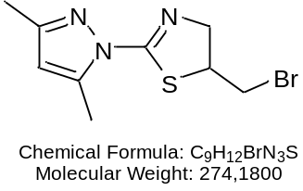 | 5-(bromomethyl)-2-(3,5-dimethyl-1H-pyrazol-1-yl)-4,5-dihydrothiazole 8. Yield: 2.63 g (96%); White crystals, mp 101-102 °С (2-PrOH/ hexane, 2:1).  ¹H NMR (500 МГц, DMSO-d₆, δ, ppm, J/ Hz): 2.15 (s, 3Н, Н₃); 2.47 (s, 3Н, СН₃), 3.65 (dd, 1 H, BrCH_{2a}, J = 9.7, 9.7 Hz), 3.72 (dd, 1 H, BrCH_{2b}, J = 9.9, 9.8 Hz), 4.25 - 4.30 (m, 3Н, =N-СН₂, S-СН), 6.15 (s, 1H, H-4 pyrazole).  ¹³C NMR (125 MHz, DMSO-d6) δ ppm 13.1, 13.5, 37.0, 50.1, 65.2, 110.0, 142.1, 150.3, 156.1.  Anal. calcd for C₉H₁₂BrN₃S: C, 39.81; H, 4.76; N, 15.52; found: C, 39.43; H, 4.41; N, 15.33.
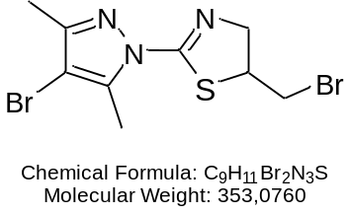 | 2-(4-bromo-3,5-dimethyl-1H-pyrazol-1-yl)-5-(bromomethyl)-4,5-dihydrothiazole 9. Yield: 2.29 g (65%); White crystals, mp 106-107 °C (2-PrOH/ hexane, 2:1).  ¹H NMR (400 МГц, DMSO-d₆, δ, ppm, J/ Hz): 2.16 (s, 3Н, Н₃); 2.49 (s, 3Н, СН₃), 3.64- 3.72 (m, 2 H, BrCH₂), 4.28 - 4.33 (m, 3Н, =N-СН₂, S-СН).  ¹³C NMR (101 MHz, DMSO-d₆) δ ppm 12.1, 12.8, 37.0, 50.5, 65.2, 99.6, 139.9, 148.9, 156.  MS (EI) m/z (I_{rel}, %): 355 [M]⁺ (5), [M]⁺ 353 (10), 351 [M]⁺ (5), 276 (5), 275 (12), 274 (95), 272 (100), 187 (15), 175 (78), 173 (90).  Anal. calcd for C₉H₁₁Br₂N₃S: C, 30.62; H, 3.14; N, 11.90; found: C, 30.94; H, 3.43; N, 12.27.
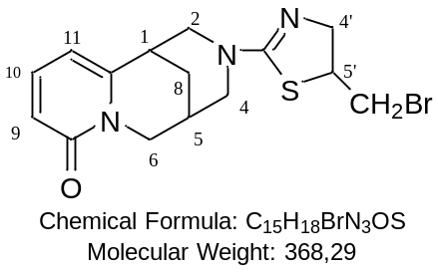 | 3-(5-(bromomethyl)-4,5-dihydrothiazol-2-yl)-1,2,3,4,5,6-hexahydro-8H-1,5-methanopyrido[1,2-a][1,5]diazocin-8-one 11. Yield: 2,72 g (74%); White crystals, mp 166-168°С (2-PrOH/hexane 1:1).  ¹H NMR (400 MHz, DMSO-d₆, δ, ppm, J/ Hz): 1.97 (br. s, 2Н, Н-8), 2.56 (br. s, 1Н, Н-5), 3.16 (br. s, 1Н, Н-1), 3.24 (br. d, 2Н, H-4_{a}), 3.4 (d, 1 H, J=5.0 Hz, H-2_{a}), 3.42 (dd, 2H, BrCH₂, J=9.8, 6.2 Hz), 3.45 (m, 1H, H-4_{e}) 3.70-3.80 (m, 2Н, =N-СН₂), 3.82-3.86 (m, 1H, H-2_{e}), 3.98 (d, 1Н, Н-6_{а}, J =15.1 Hz), 4.02 (d, 1Н, Н-6_{е}, J= 9.6 Hz), 4.08-4.14 (m, 1Н, S-СН), 6.23 (d, 1H, Н-11, J_{11,10} 6.9 Hz), 6.27 (d, 1H, Н-9, ³J_{9,10} = 8.7 Hz), 7.38 (dd, 1H, Н-10, ³J_{10,5} = 6.9 Гц, J_{10,9} = 8.7 Hz).  ¹³C NMR (101 MHz, DMSO-d₆) δ ppm 25.0, 26.9, 33.9, 36.3, 48.6, 52.5, 54.1, 55.6 62.9, 104.9, 115.8, 138.9, 149.9, 160.9, 162.1.  MS (EI) m/z (I_{rel}, %): 288 (18), 287 (100), 160 (23), 146 (38), 141 (70), 113 (14), 100 (12).  Anal. calcd for C₁₅H₁₈BrN₃OS: C, 48.92; H, 4.93; N, 11.41; found: C, 49.18; H, 5.17; N, 11.27.
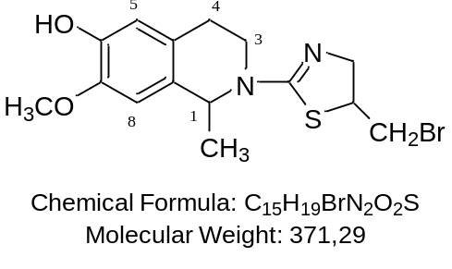 | (2-(5-(bromomethyl)-4,5-dihydrothiazol-2-yl)-7-methoxy-1-methyl-1,2,3,4-tetrahydroisoquinolin-6-ol 12. Yield: 3.08 g (83%); White crystals, mp 149-150°С (2-PrOH/hexane 1:1).  ¹H NMR (400 MHz, DMSO-d₆, δ ppm): 1.37 (d, 3Н, NСН-СН₃, J = 6.4); 2.54 (dt, 1Н, Н-4_{ax}, J=16.0, 3.2 Hz), 2.71 (ddd, 1 H, J=16.0, 10.8, 5.7 Hz, Н-4_{eq}), 3.34-3.42 (m, 2Н, Н-3), 3.53 (t, 1 H, BrCH_{2a}, J=9.2 Hz), 3.61 (dd, 1 H, BrCH_{2b}, J = 10.1, 9.5 Hz), 3.72 (s, 3Н, ОСН₃), 3.85 - 3.96 (m, 2Н, =N-СН₂), 4.16-4.22 (m, 1Н, S-СН), 4.90 (q, 1 H, NСН-СН₃, J=6.3 Hz,), 6.50 (s, 1Н, Н-8), 6.70 (s, 1Н, Н-5), 8.77 (br. s, 1H, О-H).  ¹³C NMR (101 MHz, DMSO-d₆) δ ppm 21.6, 27.3, 36.5, 42.0, 52.3, 54.2, 55.8, 62.9, 110.5, 115.1, 125.4, 128.5, 145.0, 146.2, 159.5.  MS (EI) m/z (I_{rel}, %): 372 [M]⁺ (10), [M]⁺ 273 (10), 242 (69), 240 (71), 176 (100), 175 (78), 174 (99), 95 (39), 42 (46), 41 (62), 39 (89).  Anal. calcd for C₁₅H₁₉BrN₂O₂S: C, 48.52; H, 5.16; N, 7.54; found: C, 48.71; H, 5.31; N, 7.73.
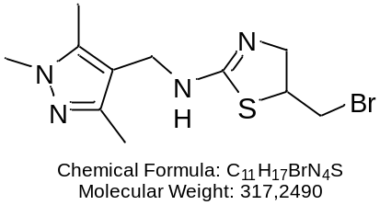 | 5-(bromomethyl)-N-((1,3,5-trimethyl-1H-pyrazol-4-yl)methyl)-4,5-dihydrothiazol-2-amine 13. Yield: 2.28 g (72%) White crystals, mp 95-97 °С (PhH/hexane 1:1).  ¹H NMR (500 МHz, DMSO-d₆, δ, ppm, J/ Hz): 2.06 (s, 3Н, CН₃); 2.16 (s, 3Н, СН₃), 3.60 (s, 3Н, СН₃), 3.56-3.62 (m, 1 H, BrCH_{2a}), 3.66 (dd, 1 H, BrCH_{2b}, J = 9.9, 9.8 Hz), 3.87 - 3.93 (m, 2Н, =N-СН₂), 4.08, 4.12 (2 d, 2 H, HN-СН_{2ab}, ²J_{ab} = ²J_{ba} = 14.3 Hz), 4.16-4.21 (m, 1Н, S-СН), 7.37 (s, 1H, N-H).  MS (EI) m/z (I_{rel}, %): 318 [M]⁺ (2), [M]⁺ 316 (2), 351 [M]⁺ (5), 138 (25), 123 (100), 122 (28), 56 (66), 55 (22), 41 (28), 39 (29).  Anal. calcd for C₁₁H₁₇BrN₄S: C, 41.65; H, 5.40; N, 17.66; found: C, 41.17; H, 5.74; N, 17.91.

Copies of NMR Spectra of Products
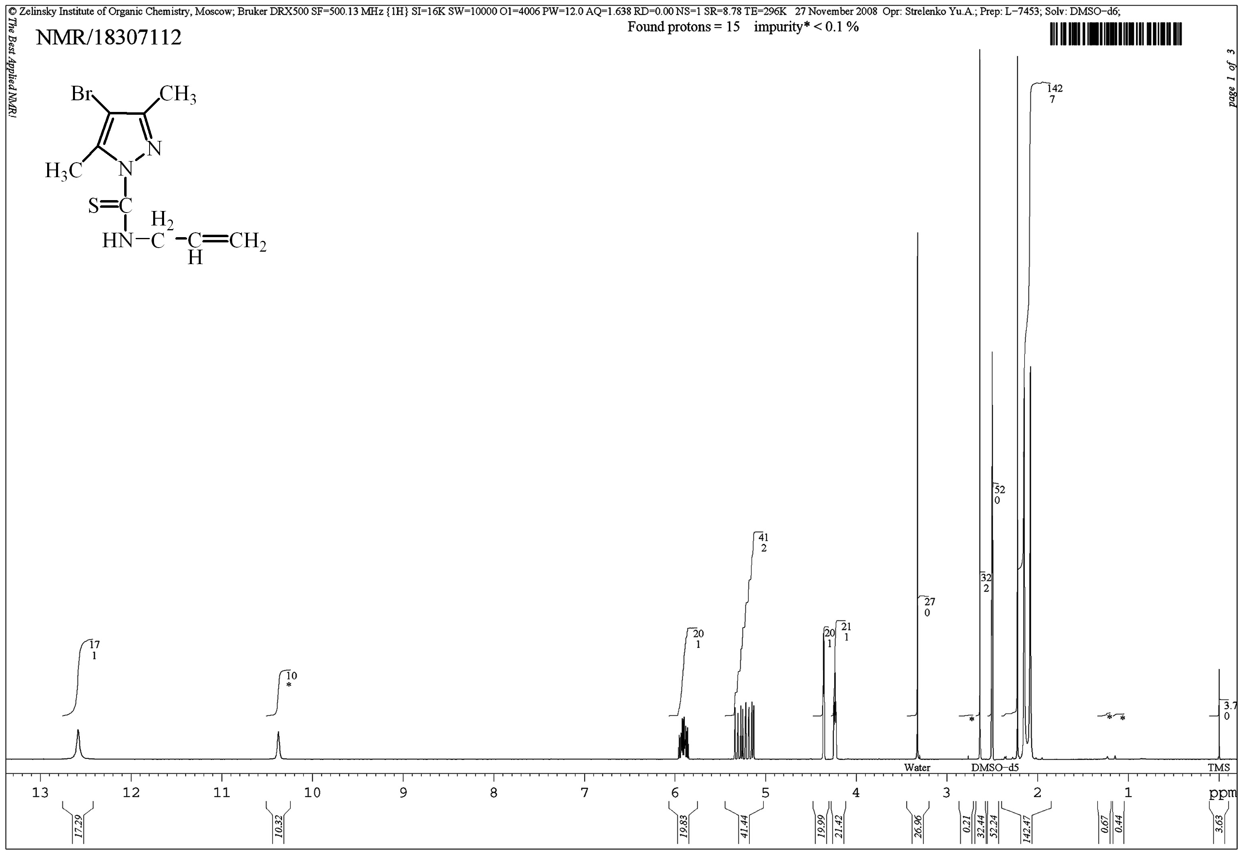
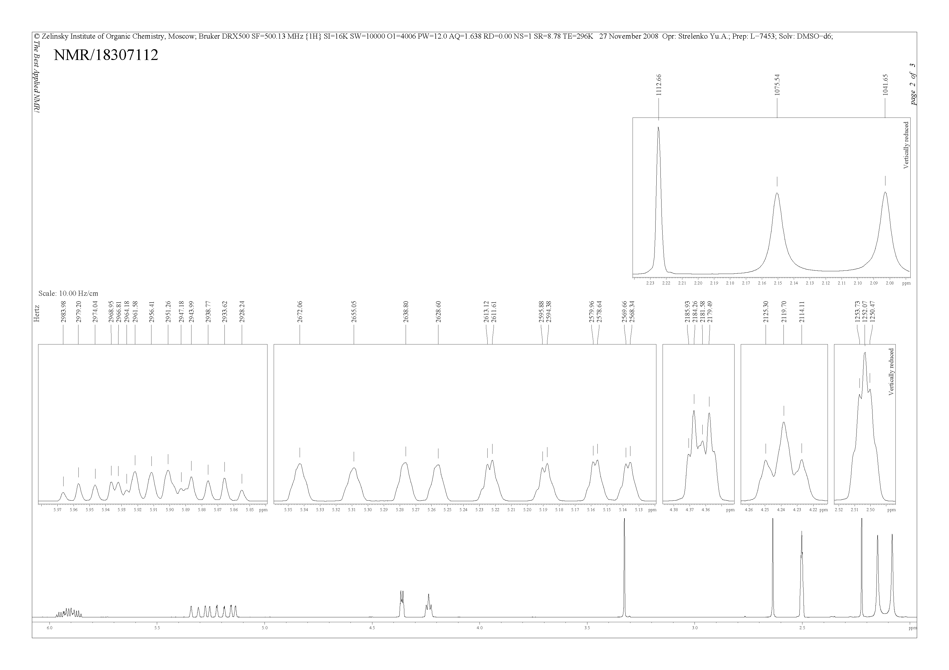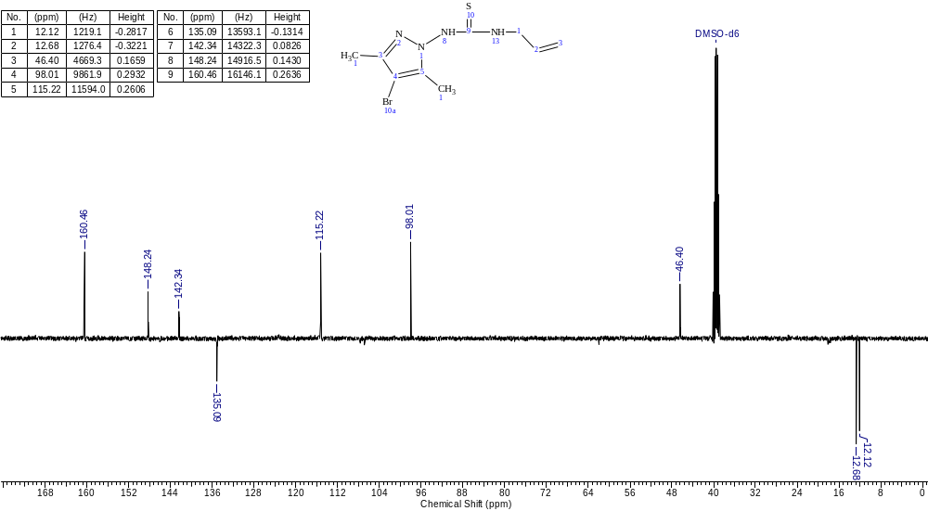
Fig. S1. ¹H (500 MHz, DMSO-d6) and ¹³C (100 MHz, DMSO-d6) NMR Spectra of 3

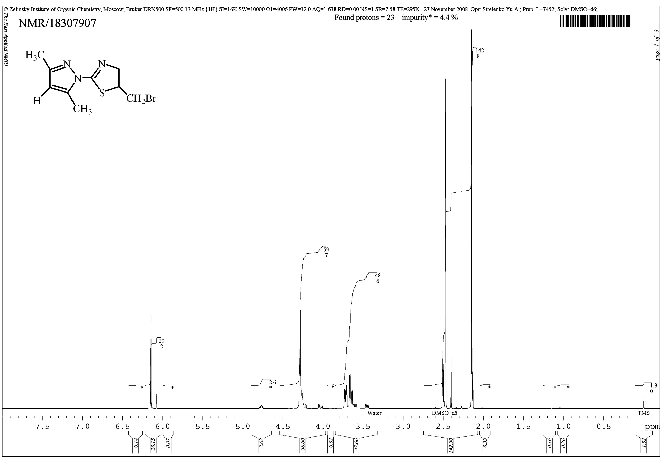
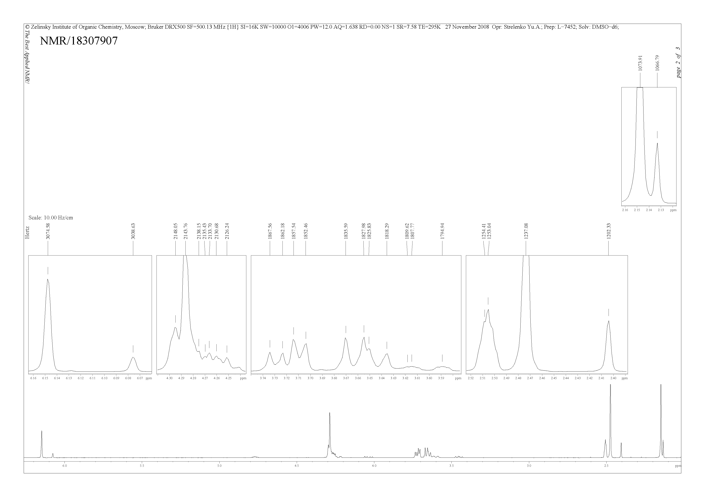
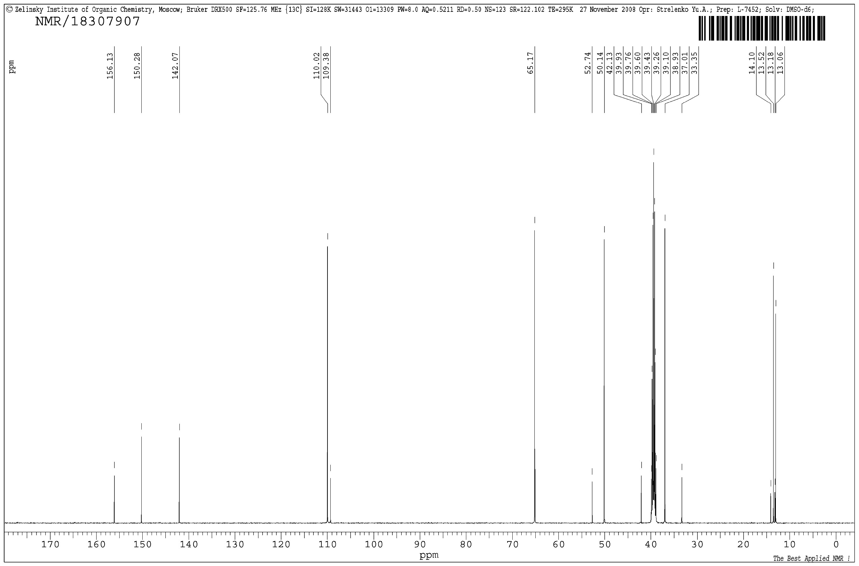
Fig. S2. ¹H (500 MHz, DMSO-d6) and ¹³C (125 MHz, DMSO-d6) NMR Spectra of 8
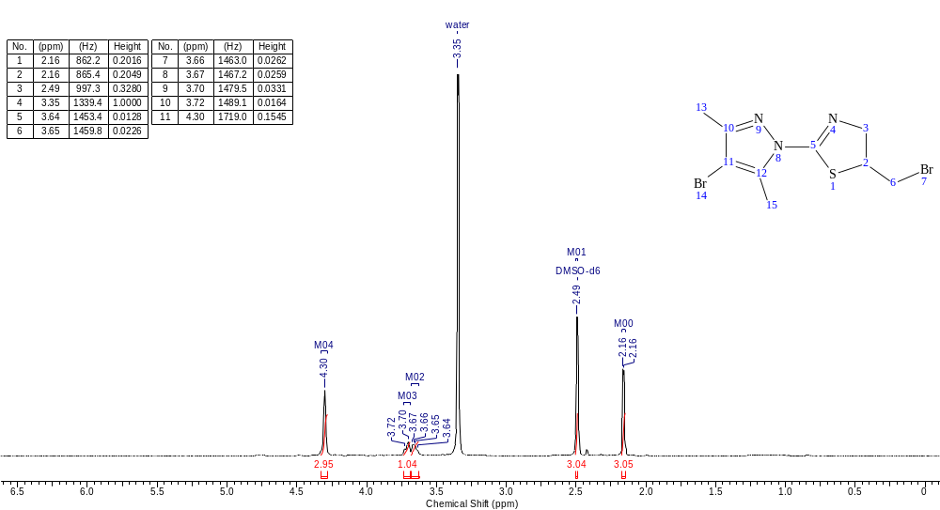

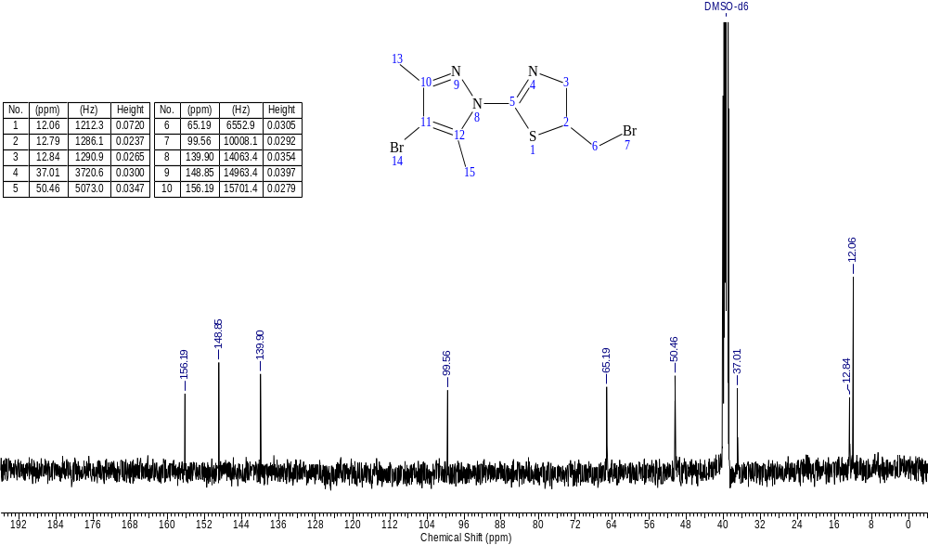
Fig. S3. ¹H (400 MHz, DMSO-d6) and ¹³C (100 MHz, DMSO-d6) NMR Spectra of 9

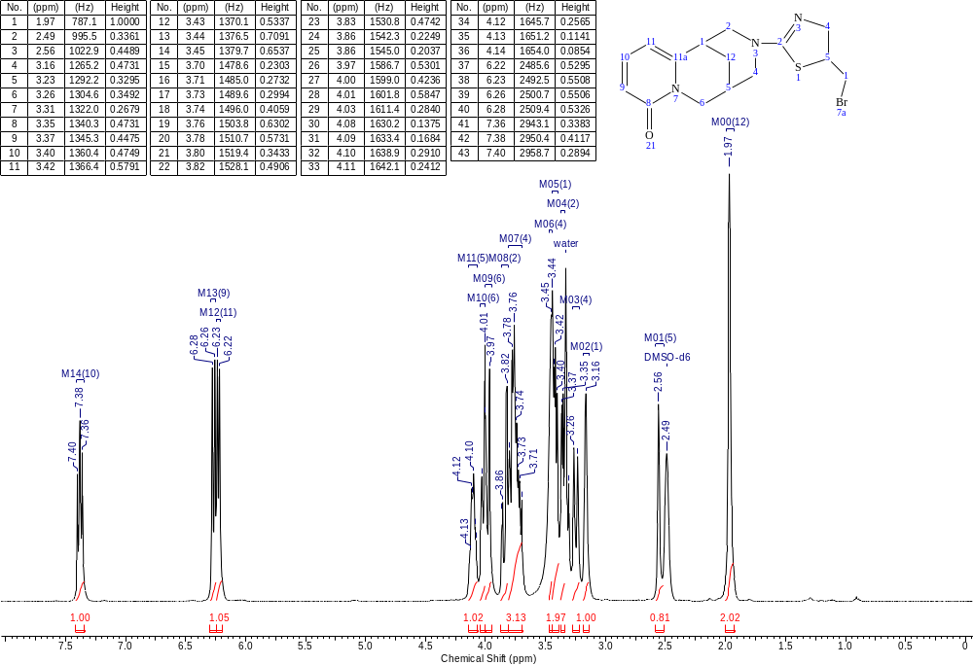

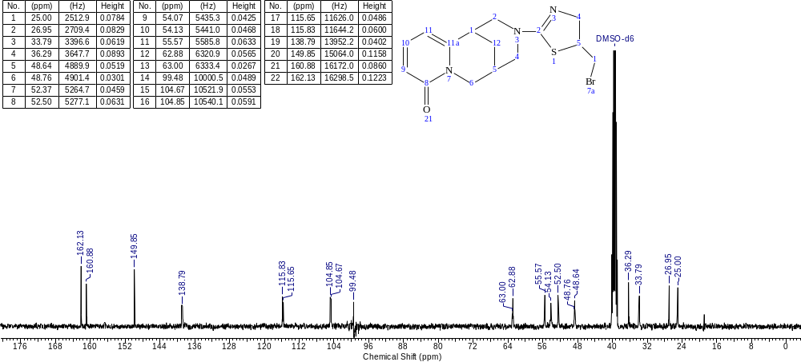
Fig. S4. ¹H (400 MHz, DMSO-d6) and ¹³C (100 MHz, DMSO-d6) NMR Spectra of 11

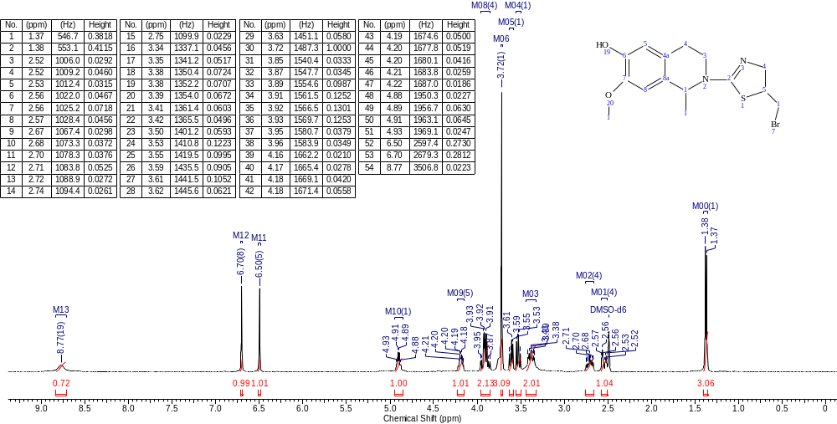

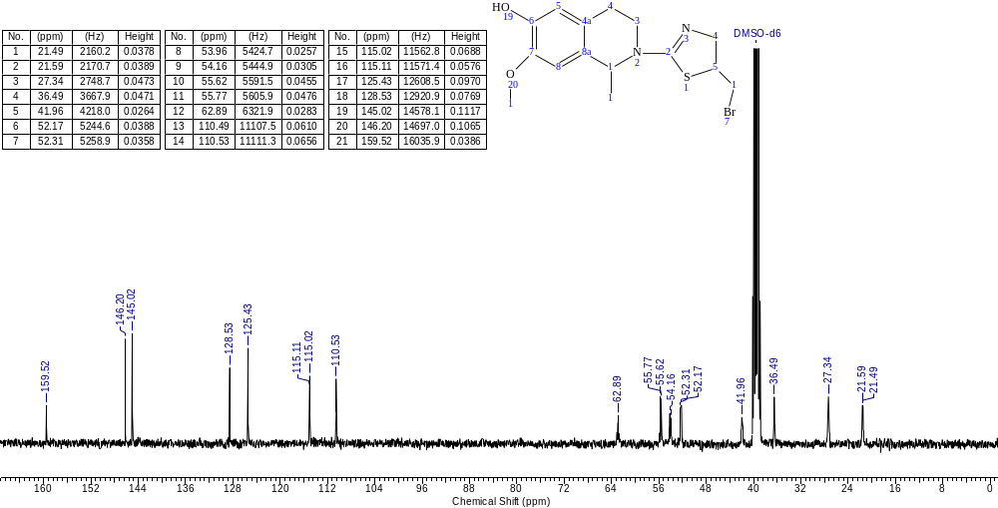
Fig. S5. ¹H (400 MHz, DMSO-d₆) and ¹³C (101 MHz, DMSO-d₆) NMR Spectra of 12

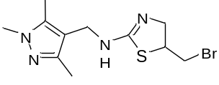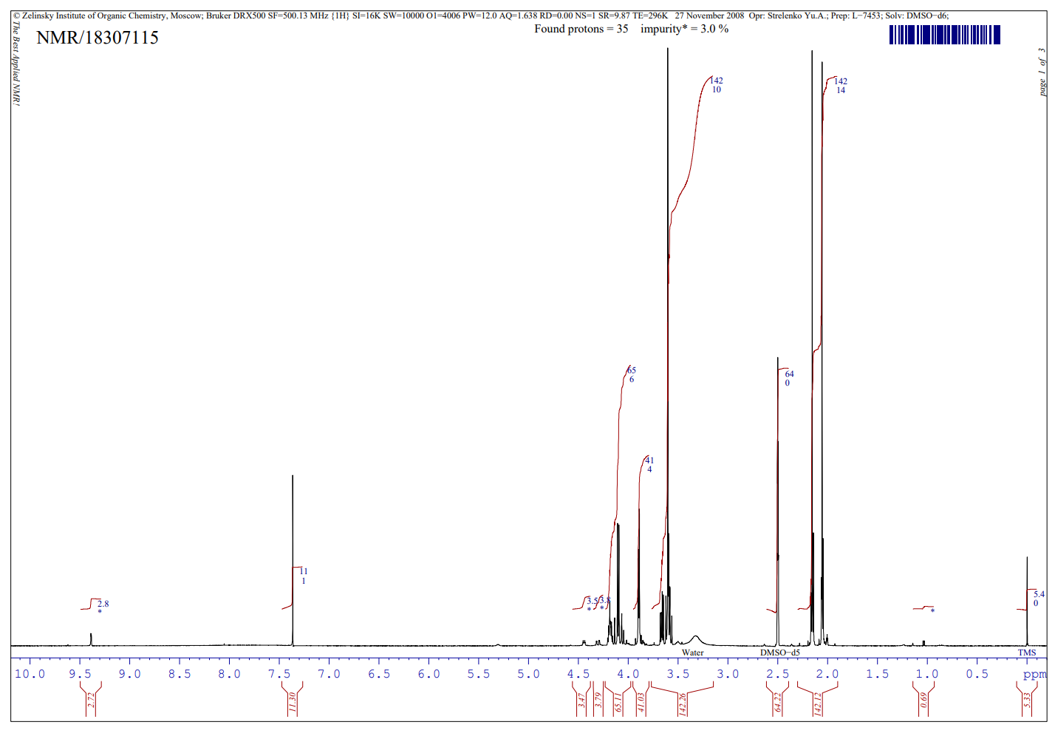
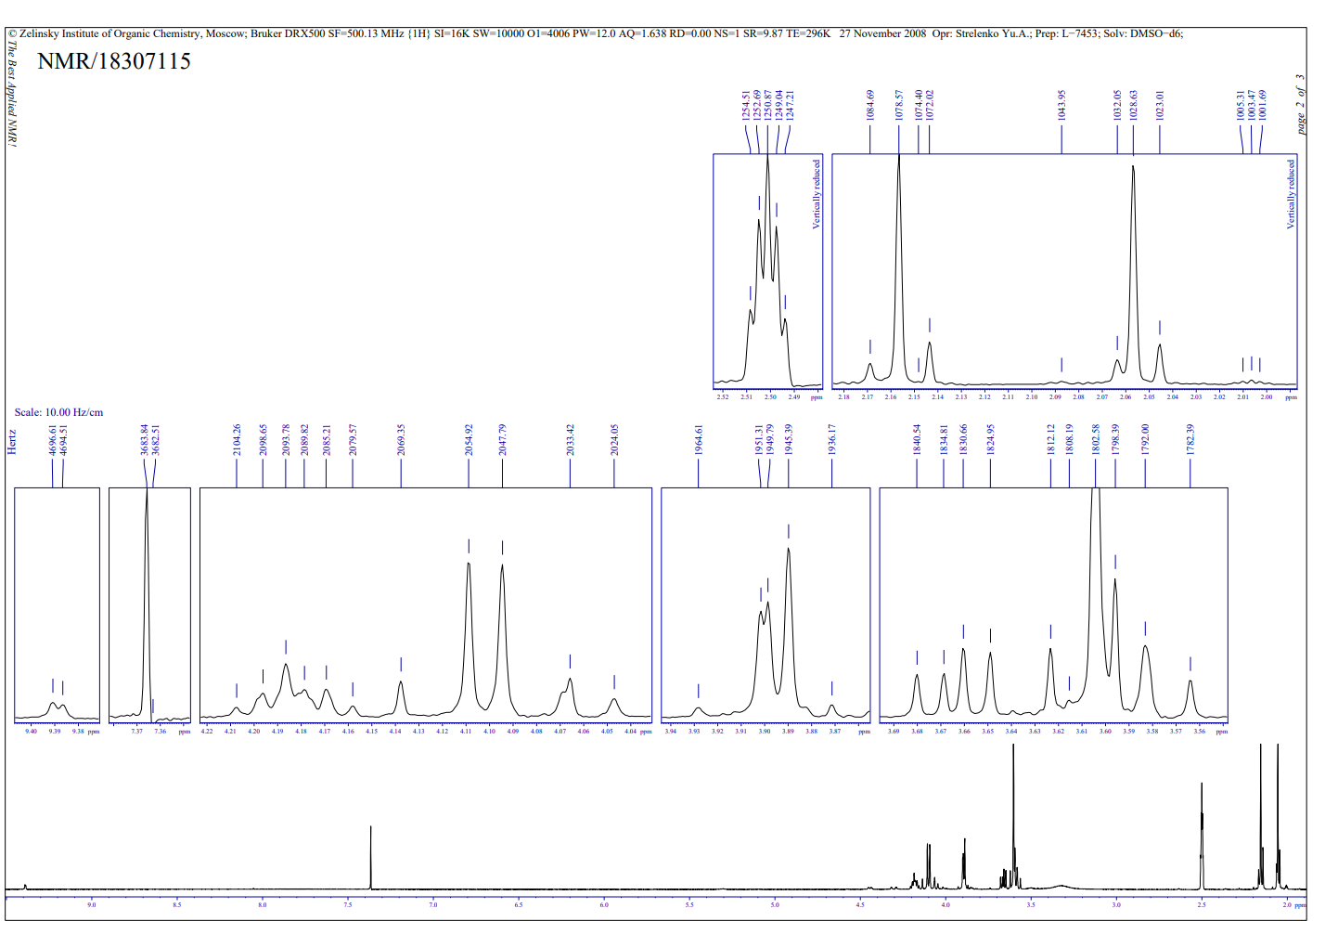
Fig. S6. ¹H (500 MHz, DMSO-d₆) NMR Spectra of 13
Copies of MS Spectra of Products
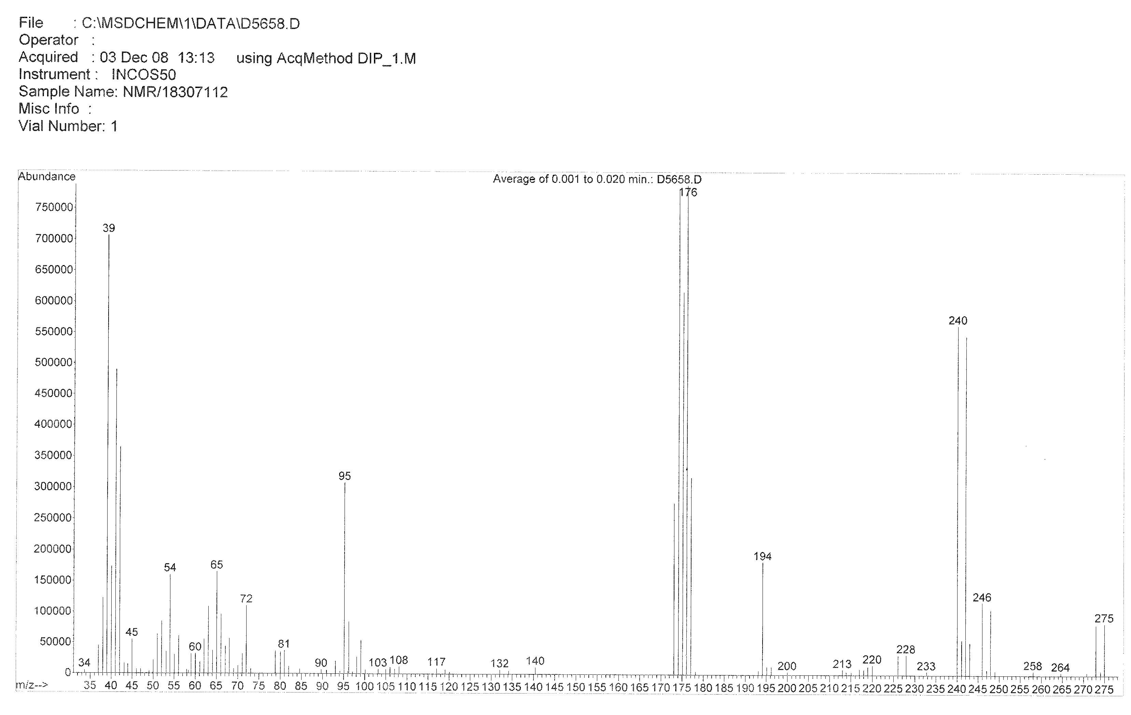
Fig. S7. Mass spectrum of 3

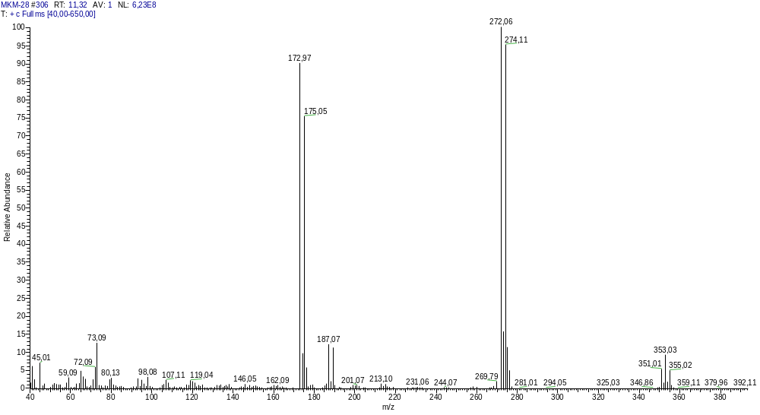
Fig. S8. Mass spectrum of 9

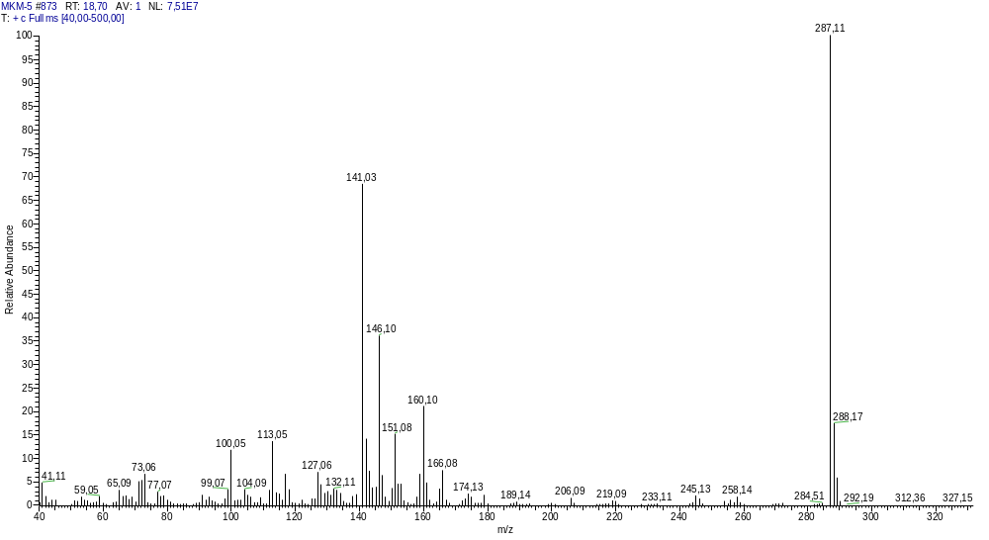
Fig. S9. Mass spectrum of 11

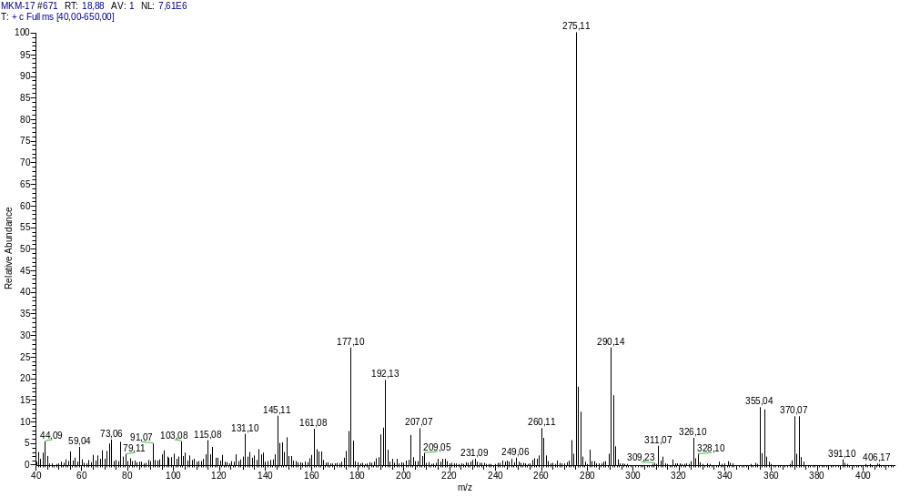
Fig. S10. Mass spectrum of 12

Mass spectrum NMR/18307115: formula C11H17BrN4S, mol. mass 317.25
Max intensity: 999 for mass 123
Discrimination level for relative intensity: 5.0%,
whithin the interval of (molecular mass+50): 0.5% (marked with -->)
One symbol '*' on graphic = 5% of maximum relative intensity

Mass Intens. Rel.Int(%) | Mass *** Graphic *** Rel.Int(%)
39 292 29.23 | 39 ***** 29.23
40 85 8.51 | 40 * 8.51
41 279 27.93 | 41 ***** 27.93
42 234 23.42 | 42 **** 23.42
43 51 5.11 | 43 * 5.11
45 165 16.52 | 45 *** 16.52
53 93 9.31 | 53 * 9.31
54 72 7.21 | 54 * 7.21
55 216 21.62 | 55 **** 21.62
56 656 65.67 | 56 ************* 65.67
58 50 5.01 | 58 * 5.01
59 118 11.81 | 59 ** 11.81
66 101 10.11 | 66 ** 10.11
73 64 6.41 | 73 * 6.41
81 70 7.01 | 81 * 7.01
122 284 28.43 | 122 ***** 28.43
123 999 100.00 | 123 ******************** 100.00
124 92 9.21 | 124 * 9.21
138 246 24.62 | 138 ***** 24.62
155 82 8.21 | 155 * 8.21
237 82 8.21 | 237 * 8.21
316 19 1.90 --> 316 1.90
317 1 0.10 mol.mass: 317 0.10
318 19 1.90 --> 318 1.90
Fig. S11. Mass spectrum of 13

X-Ray Structural Study of Product
Cell parameters and intensities of 1480 independent reflections were measured on a Bruker APEX-II CCD diffractometer, MoKα-radiation, graphite monochromator, θ/2θ-scan, 2θ≤60^{о}. There were rhombic crystals, a=5.5149(5), b=18.4636(7), c=20.7277(11) Å, V= 2110.6(2)Å3, d_{calc}= 1.600g/cm³, Z=8 (C₉H₁₃N₃SBr), space group Рbca. The structure was elucidated by the direct method and refined by full-matrix least squares in the anisotropic approximation for non-hydrogen atoms. The H atoms were calculated geometrically and planted according to the “rider” type. The calculations used 958 reflections with I>2σ(I). Final divergence factors were R=0.082 and WR2= 0.227. The structure was solved and refined using the programs “SHELXS-97” and “SHELXL-97”. The structure geometrical parameters were deposited with the CSDC (CCDC 723563).

Table 1. Bond lengths (d, Å) in molecule 8
Bond | d | Bond | d
S₁C₇ | 1.744(3) | O₂C₁₀ | 1.218(4)
S₁C₈ | 1.764(5) | O₃C₁₃ | 1.442(5)
C₁C₂ | 1.374(4) | N₃C₇ | 1.267(4)
C₁C₅ | 1.376(5) | N₄C₁₀ | 1.359(5)
C₁C₆ | 1.503(4) | N₄C₇ | 1.391(4)
N₁C₃ | 1.299(5) | C₄C₅ | 1.376(4)
N₁C₄ | 1.330(4) | C₈C₉ | 1.426(7)
O₁C₆ | 1.222(4) | C₉C₁₁ | 1.497(7)
N₂C₆ | 1.340(4) | C₉C₁₀ | 1.515(6)
N₂N₃ | 1.414(3) | C₁₂C₁₃ | 1.429(8)
C₂C₃ | 1.379(5) | C₁₃C₁₄ | 1.465(7)

Table 2. Bond angles (, deg) in molecule 8
Angle | degrees | Angle | degrees
C₇S₁C₈ | 100.82(18) | N₂C₆C₁ | 115.8(3)
C₂C₁C₅ | 116.6(3) | N₃C₇N₄ | 116.3(3)
C₂C₁C₆ | 118.2(3) | N₃C₇S₁ | 123.3(2)
C₅C₁C₆ | 125.3(3) | N₄C₇S₁ | 120.4(2)
C₃N₁C₄ | 117.0(3) | C₉C₈S₁ | 118.5(4)
C₆N₂N₃ | 120.0(3) | C₈C₉C₁₁ | 120.4(5)
C₁C₂C₃ | 119.7(3) | C₈C₉C₁₀ | 112.3(5)
C₇N₃N₂ | 112.7(3) | C₁₁C₉C₁₀ | 112.8(4)
N₁C₃C₂ | 123.7(3) | O₂C₁₀N₄ | 118.8(3)
C₁₀N₄C₇ | 128.3(3) | O₂C₁₀C₉ | 123.1(4)
N₁C₄C₅ | 123.3(3) | N₄C₁₀C₉ | 118.1(3)
C₁C₅C₄ | 119.5(3) | C₁₂C₁₃O₃ | 112.2(4)
O₁C₆N₂ | 123.1(3) | C₁₂C₁₃C₁₄ | 118.5(6)
O₁C₆C₁ | 121.0(3) | O₃C₁₃C₁₄ | 109.0(4)

Table 3. Torsion angles (, deg) in molecule 8
Angle | degrees | Angle | degrees
C5C1C2C3 | -4.7(6) | N2N3C7N4 | -177.4(3)
C6C1C2C3 | 174.2(4) | N2N3C7S1 | -0.1(4)
C6N2N3C7 | -90.0(4) | C10N4C7N3 | -166.1(3)
C4N1C3C2 | 2.3(7) | C10N4C7S1 | 16.5(5)
C1C2C3N1 | 1.7(8) | C8S1C7N3 | -177.9(4)
C3N1C4C5 | -3.4(7) | C8S1C7N4 | -0.7(4)
C2C1C5C4 | 3.7(6) | C7S1C8C9 | -35.0(6)
C6C1C5C4 | -175.1(4) | S1C8C9C11 | -167.4(5)
N1C4C5C1 | 0.3(7) | S1C8C9C10 | 56.1(8)
N3N2C6O1 | 5.2(5) | C7N4C10O2 | -179.8(4)
N3N2C6C1 | -178.2(3) | C7N4C10C9 | 2.5(6)
C2C1C6O1 | 13.8(5) | C8C9C10O2 | 143.0(5)
C5C1C6O1 | -167.5(4) | C11C9C10O2 | 3.1(8)
C2C1C6N2 | -162.8(4) | C8C9C10N4 | -39.4(8)
C5C1C6N2 | 15.9(5) | C11C9C10N4 | -179.3(5)

Table 4. Complexes between synthesized derivatives 8, 9, 11-13 and active sites of proteins (PDB: 2EXB, 3HUN)

2EXB |  | 3HUN
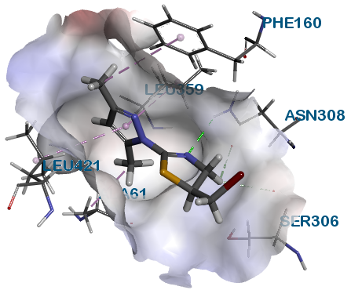  8 | 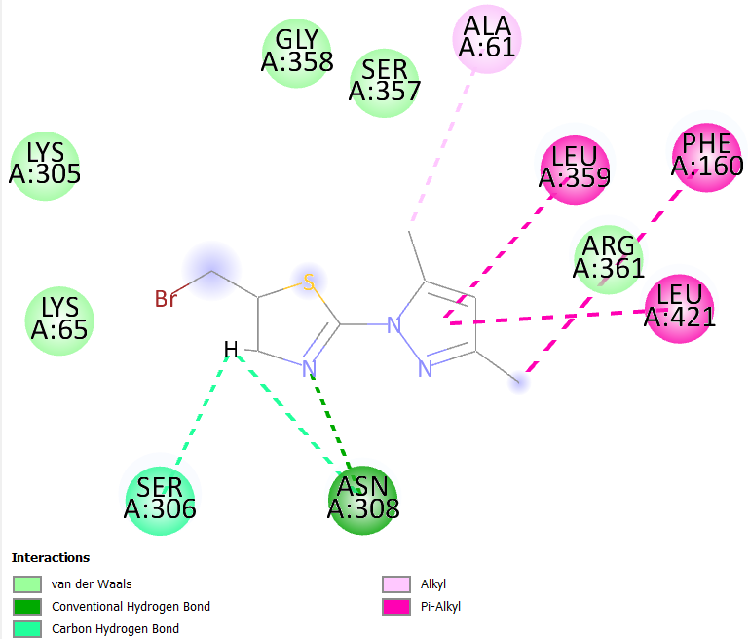  8 | 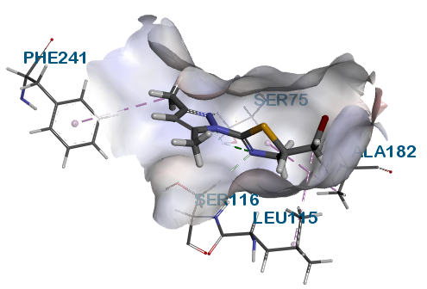  8 | 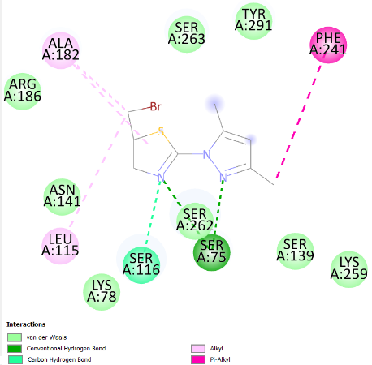  8
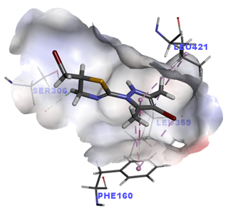  9 | 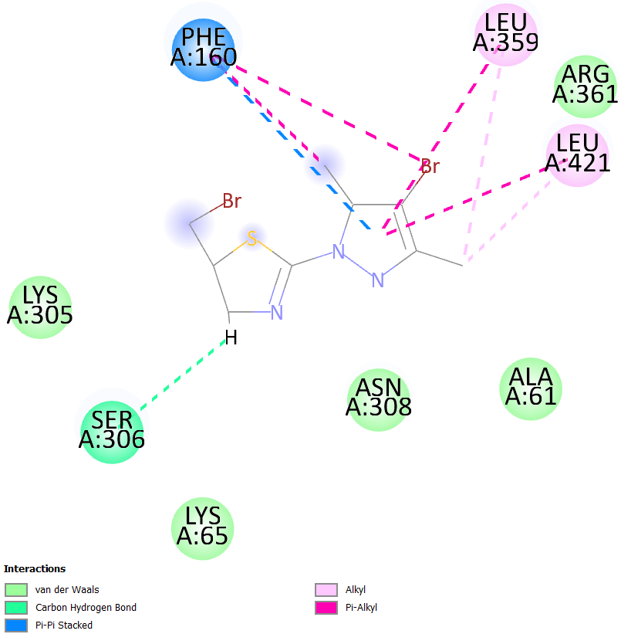  9 | 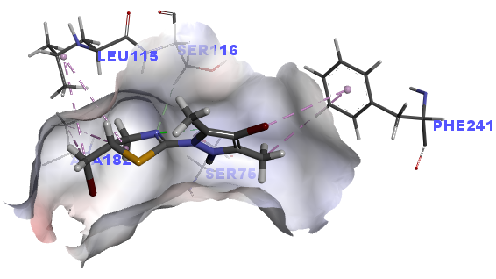  9 | 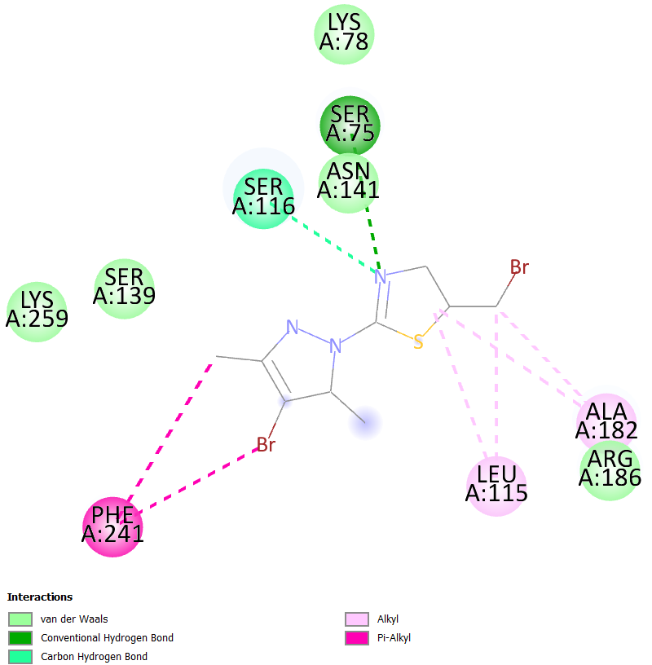  9
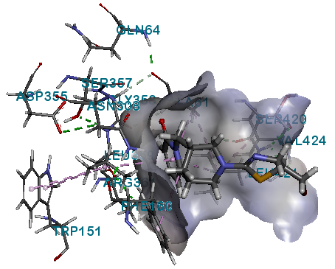  11 | 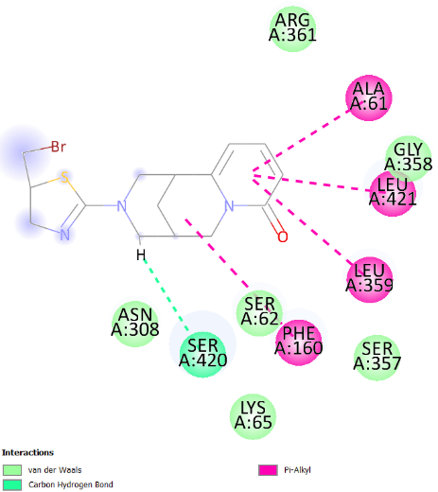  11 | 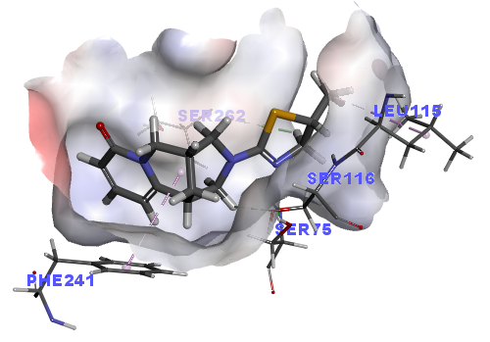  11 | 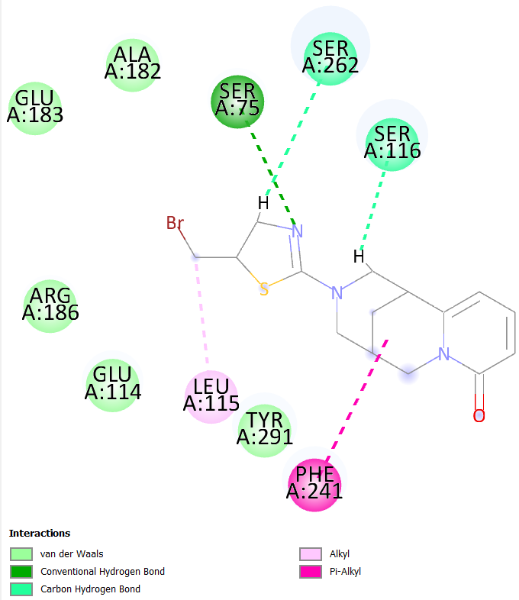  11
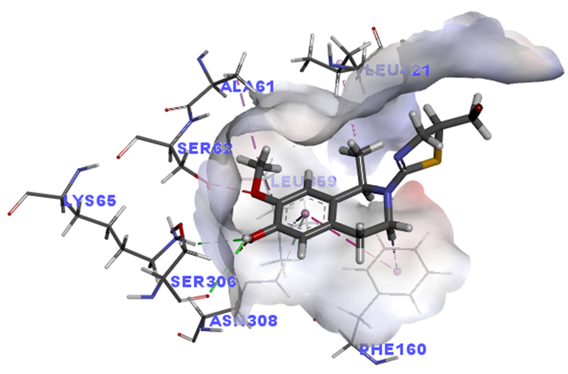  12 | 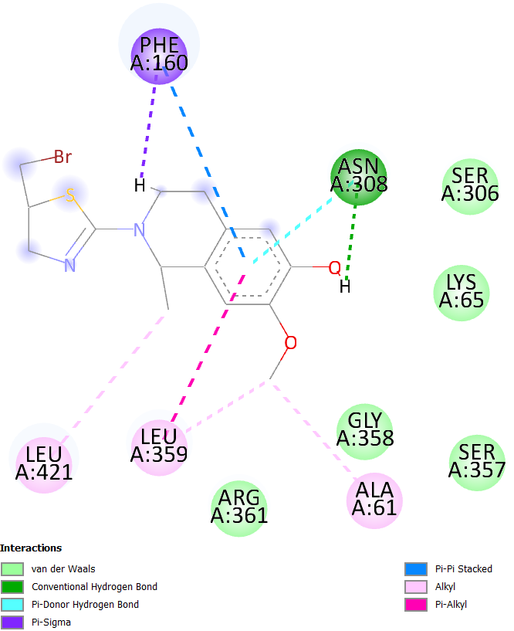  12 | 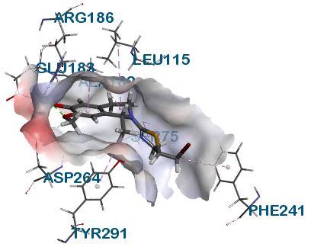  12 | 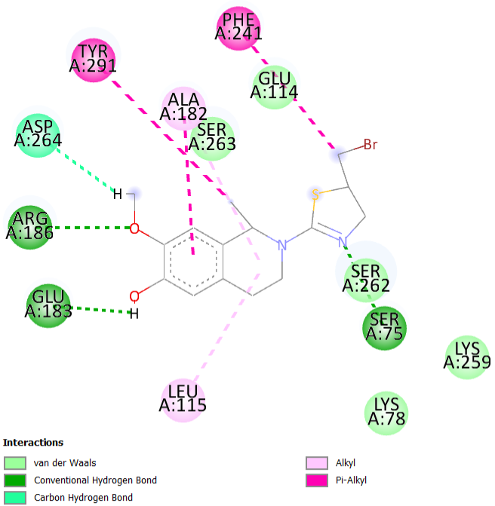  12
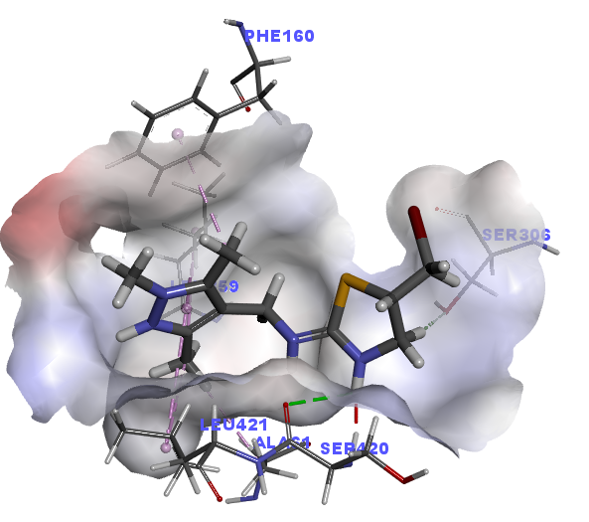  13 | 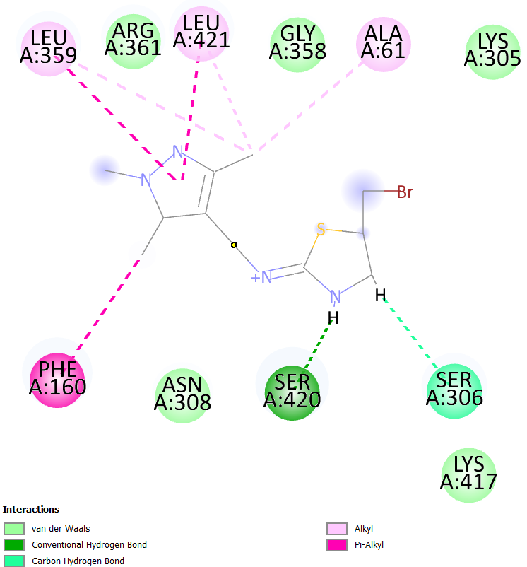  13 | 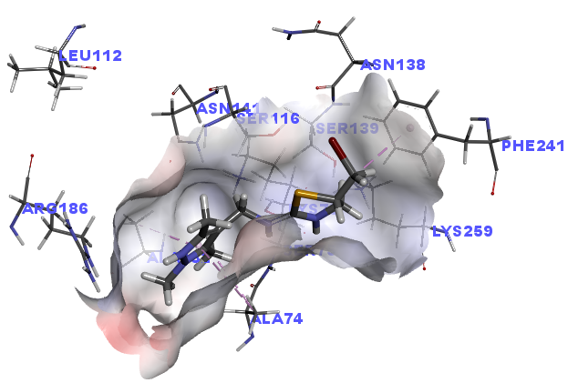  13 | 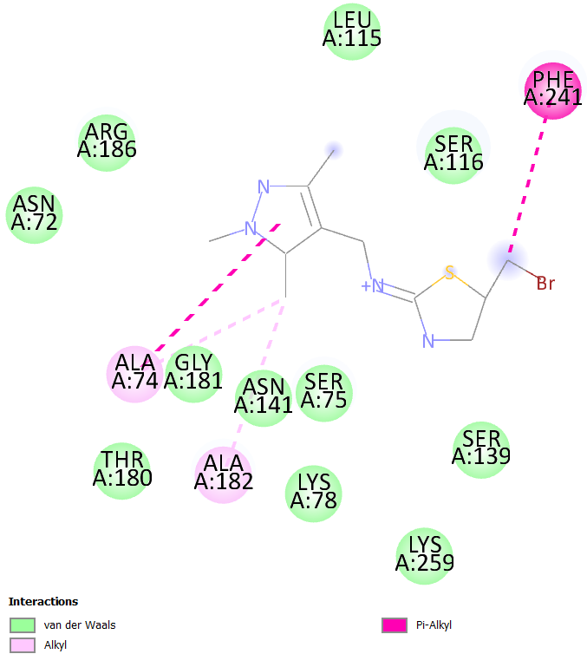  13

