Supplementary Materials

Appendix A: List of Word Stimuli
Table A.1 Example Word stimuli in the training program
No. | /i/ | /ɪ/
1 | deem | dim
2 | gene | gin
3 | sheen | shin
4 | peat | pit
5 | teen | tin
6 | feels | fills
7 | week | wick
8 | eats | its
9 | seeks | six
10 | seen | sin
11 | cheap | chip
12 | beat | bit
13 | beaker | Bicker
14 | candied | Candid
15 | fleet | flit

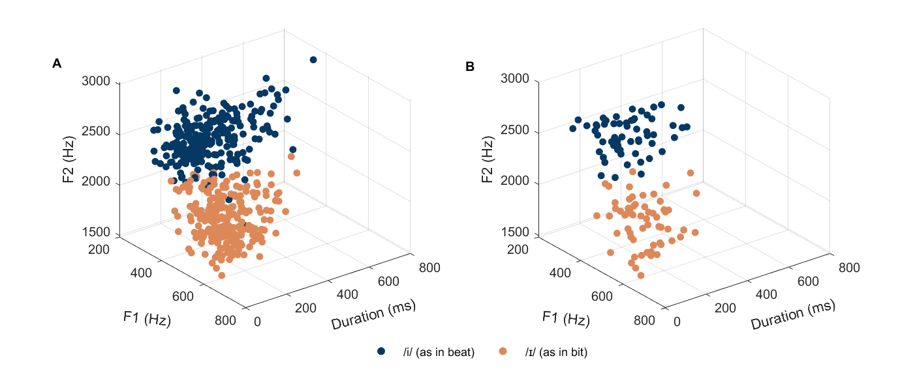
Fig. A.1 Acoustic distribution of the training stimuli along the F1, F2 and vowel duration dimensions in the two training conditions. Panel A represents the target vowels of the tokens used in the multiple-talker (MT) condition. Panel B represents the target vowels of the tokens used in the single-talker (ST) condition.

Table A.2 Acoustic characteristics of the target vowels produced by talkers in the multiple-talker (MT) and single-talker (ST) conditions
Vowel category | Acoustic feature | MT  Mean (SD) | ST  Mean (SD) | p value | MT  Variability | ST  Variability | p value
/i/ | F0 (Hz) | 180 (52) | 201 (29) | .15 | 0.018 | 0.0058 | < .01
 | F1 (Hz) | 358 (59) | 373 (53) | .08 | 0.0050 | 0.0038 | .29
 | F2 (Hz) | 2458 (217) | 2508 (183) | .10 | 0.0015 | 0.0011 | .25
 | Duration (ms) | 278 (125) | 254 (110) | .19 | 0.037 | 0.036 | .51
/ɪ/ | F0 (Hz) | 190 (54) | 211 (21) | .12 | 0.018 | 0.0021 | < .001
 | F1 (Hz) | 519 (73) | 529 (82) | .40 | 0.0038 | 0.0047 | .72
 | F2 (Hz) | 1931 (209) | 1903 (194) | .34 | 0.0022 | 0.0021 | .49
 | Duration (ms) | 188 (90) | 175 (84) | .28 | 0.040 | 0.041 | .57

Table A.3 Example word stimuli in the quizzes after training sessions
No. | /i/ | /ɪ/
1 | teal | till
2 | reap | rip
3 | heed | hid
4 | keen | kin
5 | least | list

Table A.4 Example word stimuli in the perception test
No. | Phonetic contexts | /i/ | /ɪ/
1 | Untrained words | sheep | ship
2 |  | beach | bitch
3 |  | deep | dip
4 |  | seep | sip
5 |  | deed | did
6 |  | leek | lick
7 | Trained words | peat | pit
8 |  | deem | dim
9 |  | teen | tin
10 |  | feels | fills

Appendix B: Summary output of the linear mixed-effects models regarding training effects
Table B.1 Summary output of the LMM on the word identification accuracy
Fixed effects | Estimate |  | SE | df | t value | p value
(Intercept) |  | 0.61 | 0.05 | 72.08 | 12.90 | <.001
GroupMT |  | <0.01 | 0.05 | 83.88 | 0.04 | .97
GroupST |  | -0.01 | 0.05 | 83.88 | -0.19 | .85
Testpost1 |  | -0.01 | 0.04 | 110.50 | -0.19 | .85
Testpost2 |  | 0.01 | 0.05 | 96.30 | 0.15 | .89
Typeuntrained |  | <0.01 | 0.05 | 34.39 | 0.02 | .99
GroupMT:Testpost1 |  | 0.14 | 0.06 | 110.50 | 2.35 | .02
GroupST:Testpost1 |  | 0.16 | 0.06 | 110.50 | 2.74 | .01
GroupMT:Testpost2 |  | 0.06 | 0.06 | 96.30 | 0.99 | .32
GroupST:Testpost2 |  | 0.12 | 0.06 | 96.30 | 1.86 | .07
GroupMT:Typeuntrained |  | -0.02 | 0.04 | 3393.00 | -0.49 | .63
GroupST:Typeuntrained |  | 0.01 | 0.04 | 3393.00 | 0.27 | .79
Testpost1:Typeuntrained |  | 0.02 | 0.04 | 3393.00 | 0.46 | .65
Testpost2:Typeuntrained |  | 0.03 | 0.04 | 3393.00 | 0.70 | .48
GroupMT:Testpost1:Typeuntrained |  | 0.04 | 0.05 | 3393.00 | 0.75 | .45
GroupST:Testpost1:Typeuntrained |  | 0.01 | 0.05 | 3393.00 | 0.28 | .78
GroupMT:Testpost2:Typeuntrained |  | <0.01 | 0.05 | 3393.00 | 0.04 | .97
GroupST:Testpost2:Typeuntrained |  | 0.01 | 0.05 | 3393.00 | 0.28 | .78
Random effects |  | Term | Variance | SD | Correlation
Subject |  | (Intercept) | 0.02 | 0.14
 |  | testpost1 | 0.02 | 0.13 | -0.68
 |  | testpost2 | 0.03 | 0.16 | -0.75 | 0.95
Word |  | (Intercept) | 0.01 | 0.08
Note. Final models: ACC ~ Group * Test * Type + (1 + Test | Subject) + (1 | Word)
Reference level: Group: CTRL; Test: pre-test; Type: trained.
Linear mixed model fit by REML.
t-tests use Satterthwaite’s method.

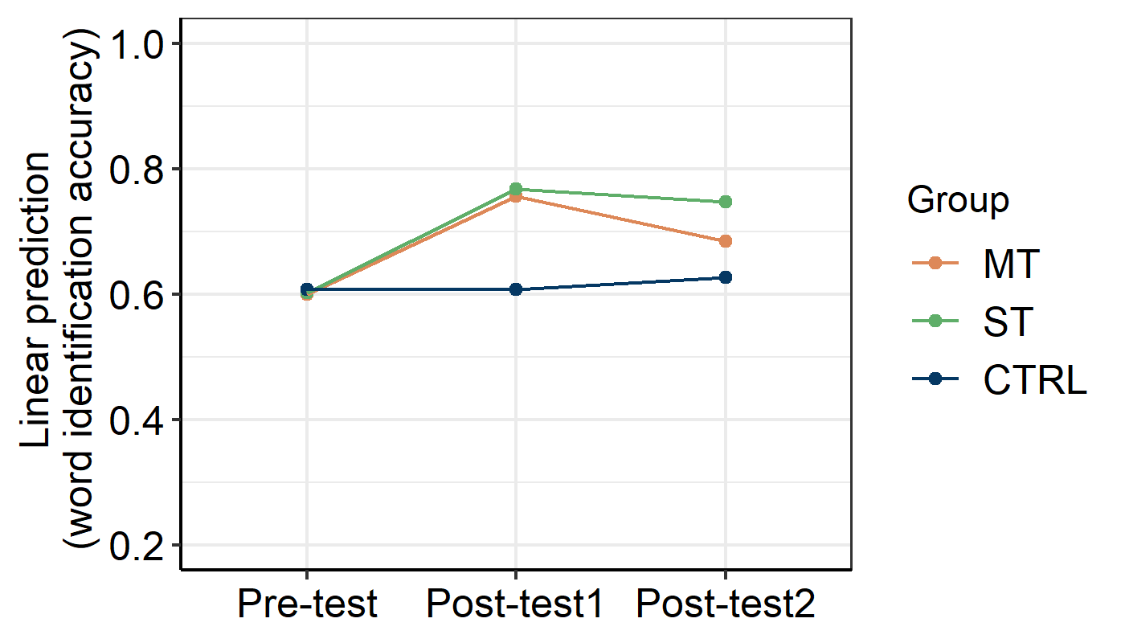
Fig. B.1 Visualization of the two-way interaction between Group (MT, ST, CTRL) and Test (Pre-test, Post-test1, Post-test2) on the percent correct accuracy of word identification.

Table B.2 Summary output of the LMM on the word identification response time (logRT)
Fixed effects | Estimate |  | SE | df | t value | p value
(Intercept) |  | 7.58 | 0.06 | 73.68 | 126.33 | < .001
GroupMT |  | 0.11 | 0.08 | 65.30 | 1.36 | .18
GroupST |  | 0.24 | 0.08 | 65.30 | 2.88 | .01
Testpost1 |  | -0.06 | 0.05 | 79.58 | -1.11 | .27
Testpost2 |  | -0.06 | 0.07 | 68.74 | -0.87 | .39
Typeuntrained |  | 0.04 | 0.03 | 77.71 | 1.14 | .26
GroupMT:Testpost1 |  | 0.10 | 0.08 | 79.58 | 1.28 | .20
GroupST:Testpost1 |  | 0.10 | 0.08 | 79.58 | 1.32 | .19
GroupMT:Testpost2 |  | 0.04 | 0.10 | 68.74 | 0.39 | .70
GroupST:Testpost2 |  | 0.08 | 0.10 | 68.74 | 0.84 | .40
GroupMT:Typeuntrained |  | -0.06 | 0.03 | 3393.00 | -1.66 | .10
GroupST:Typeuntrained |  | -0.06 | 0.03 | 3393.00 | -1.72 | .09
Testpost1:Typeuntrained |  | <0.01 | 0.03 | 3393.00 | -0.06 | .95
Testpost2:Typeuntrained |  | -0.04 | 0.03 | 3393.00 | -1.17 | .24
GroupMT:Testpost1:Typeuntrained |  | -0.03 | 0.05 | 3393.00 | -0.57 | .57
GroupST:Testpost1:Typeuntrained |  | -0.01 | 0.05 | 3393.00 | -0.21 | .84
GroupMT:Testpost2:Typeuntrained |  | -0.01 | 0.05 | 3393.00 | -0.15 | .88
GroupST:Testpost2:Typeuntrained |  | 0.01 | 0.05 | 3393.00 | 0.13 | .90
Random effects |  | Term | Variance | SD | Correlation
Subject |  | (Intercept) | 0.06 | 0.24
 |  | testpost1 | 0.04 | 0.21 | -0.23
 |  | testpost2 | 0.08 | 0.29 | -0.28 | 0.62
Word |  | (Intercept) | 0.002 | 0.05
Note. Final models: logRT ~ Group * Test * Type + (1 + Test | Subject) + (1 | Word)
Reference level: Group: CTRL; Test: pre-test; Type: trained.
Linear mixed model fit by REML.
t-tests use Satterthwaite’s method.

Table B.3 Summary output of the LMM on the perceptual RWA coefficient of F1
Fixed effects | Estimate | SE | df | t value | p value
(Intercept) | 0.14 | 0.04 | 109.80 | 3.78 | < .001
GroupMT | 0.02 | 0.05 | 109.80 | 0.32 | .75
GroupST | <0.01 | 0.05 | 109.80 | 0.01 | .99
Testpost1 | <0.01 | 0.04 | 114.00 | -0.04 | .97
Testpost2 | 0.01 | 0.04 | 114.00 | 0.25 | .81
GroupMT:Testpost1 | 0.20 | 0.05 | 114.00 | 4.12 | < .001
GroupST:Testpost1 | 0.21 | 0.05 | 114.00 | 4.19 | < .001
GroupMT:Testpost2 | 0.17 | 0.05 | 114.00 | 3.33 | .001
GroupST:Testpost2 | 0.18 | 0.05 | 114.00 | 3.70 | < .001
Random effect | Term | Variance | SD
Subject | (Intercept) | 0.01 | 0.12
Note. Final models: F1 ~ Group * Test + (1 | Subject)
Reference level: Group: CTRL; Test: pre-test.
Linear mixed model fit by REML.
t-tests use Satterthwaite’s method.

Table B.4 Summary output of the LMM on the perceptual RWA coefficient of F2
Fixed effects | Estimate | SE | df | t value | p value
(Intercept) | 0.15 | 0.04 | 103.22 | 4.01 | < .001
GroupMT | 0.01 | 0.05 | 103.22 | 0.13 | .90
GroupST | <0.01 | 0.05 | 103.22 | -0.04 | .97
Testpost1 | <0.01 | 0.04 | 114.00 | -0.03 | .98
Testpost2 | <0.01 | 0.04 | 114.00 | 0.09 | .93
GroupMT:Testpost1 | 0.20 | 0.05 | 114.00 | 4.12 | < .001
GroupST:Testpost1 | 0.19 | 0.05 | 114.00 | 3.75 | < .001
GroupMT:Testpost2 | 0.18 | 0.05 | 114.00 | 3.72 | < .001
GroupST:Testpost2 | 0.17 | 0.05 | 114.00 | 3.51 | < .001
Random effect | Term | Variance | SD
Subject | (Intercept) | 0.017 | 0.13
Note. Final models: F2 ~ Group * Test + (1 | Subject)
Reference level: Group: CTRL; Test: pre-test.
Linear mixed model fit by REML.
t-tests use Satterthwaite’s method.

Table B.5 Summary output of the LMM on the perceptual RWA coefficient of duration
Fixed effects | Estimate | SE | df | t value | p value
(Intercept) | 0.50 | 0.07 | 97.40 | 6.97 | < .001
GroupMT | 0.01 | 0.10 | 97.40 | 0.08 | .94
GroupST | 0.01 | 0.10 | 97.40 | 0.09 | .93
Testpost1 | 0.01 | 0.06 | 114.00 | 0.15 | .88
Testpost2 | 0.01 | 0.06 | 114.00 | 0.13 | .89
GroupMT:Testpost1 | -0.35 | 0.09 | 114.00 | -3.95 | < .001
GroupST:Testpost1 | -0.31 | 0.09 | 114.00 | -3.49 | < .001
GroupMT:Testpost2 | -0.40 | 0.09 | 114.00 | -4.54 | < .001
GroupST:Testpost2 | -0.29 | 0.09 | 114.00 | -3.30 | .001
Random effect | Term | Variance | SD
Subject | (Intercept) | 0.063 | 0.25
Note. Final models: duration ~ Group * Test + (1 | Subject)
Reference level: Group: CTRL; Test: pre-test.
Linear mixed model fit by REML.
t-tests use Satterthwaite’s method.

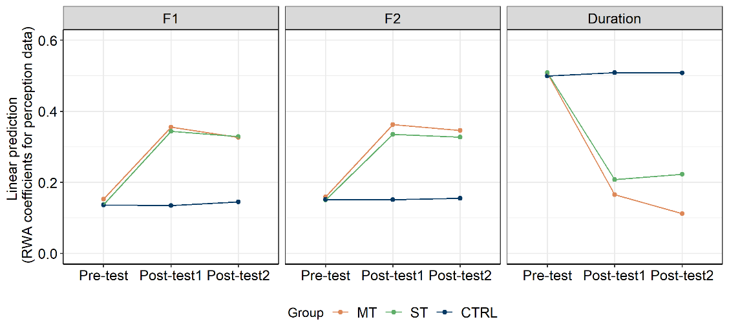
Fig. B.2 Visualization of the two-way interaction between Group (MT, ST, CTRL) and Test (pre-test, post-test1, post-test2) on the respective RWA coefficients of F1, F2, and duration measured in perception. Post-test1 represents the post-test; post-test2 represents the delayed post-test.

Table B.6 Summary output of the LMM on the production RWA coefficient of F1
Fixed effects | Estimate | SE | df | t value | p value
(Intercept) | 0.14 | 0.03 | 116.59 | 4.02 | < .001
GroupMT | -0.04 | 0.05 | 116.59 | -0.80 | .43
GroupST | -0.003 | 0.05 | 116.59 | -0.06 | .96
Testpost1 | -0.01 | 0.03 | 114.00 | -0.34 | .74
Testpost2 | 0.02 | 0.03 | 114.00 | 0.53 | .60
GroupMT:Testpost1 | 0.15 | 0.05 | 114.00 | 3.10 | .002
GroupST:Testpost1 | 0.12 | 0.05 | 114.00 | 2.41 | .02
GroupMT:Testpost2 | 0.13 | 0.05 | 114.00 | 2.72 | .01
GroupST:Testpost2 | 0.09 | 0.05 | 114.00 | 1.75 | .08
Random effect | Term | Variance | SD
Subject | (Intercept) | 0.01 | 0.11
Note. Final models: F1 ~ Group * Test + (1 | Subject)
Reference level: Group: CTRL; Test: pre-test.
Linear mixed model fit by REML.
t-tests use Satterthwaite’s method.

Table B.7 Summary output of the LMM on the production RWA coefficient of F2
Fixed effects | Estimate | SE | df | t value | p value
(Intercept) | 0.11 | 0.03 | 95.69 | 3.57 | < .001
GroupMT | -0.01 | 0.04 | 95.69 | -0.26 | .80
GroupST | -0.01 | 0.04 | 95.69 | -0.28 | .78
Testpost1 | -0.001 | 0.03 | 114.00 | -0.03 | .97
Testpost2 | -0.0001 | 0.03 | 114.00 | 0.00 | 1.00
GroupMT:Testpost1 | 0.09 | 0.04 | 114.00 | 2.51 | .01
GroupST:Testpost1 | 0.09 | 0.04 | 114.00 | 2.31 | .02
GroupMT:Testpost2 | 0.10 | 0.04 | 114.00 | 2.69 | .01
GroupST:Testpost2 | 0.11 | 0.04 | 114.00 | 3.02 | .003
Random effect | Term | Variance | SD
Subject | (Intercept) | 0.01 | 0.11
Note. Final models: F2 ~ Group * Test + (1 | Subject)
Reference level: Group: CTRL; Test: pre-test.
Linear mixed model fit by REML.
t-tests use Satterthwaite’s method.

Table B.8 Summary output of the LMM on the production RWA coefficient of duration
Fixed effects | Estimate | SE | df | t value | p value
(Intercept) | 0.49 | 0.04 | 116.18 | 11.14 | < .001
GroupMT | -0.06 | 0.06 | 116.18 | -0.92 | .36
GroupST | 0.08 | 0.06 | 116.18 | 1.31 | .19
Testpost1 | 0.01 | 0.05 | 114.00 | 0.26 | .80
Testpost2 | <0.01 | 0.05 | 114.00 | 0.08 | .94
GroupMT:Testpost1 | -0.15 | 0.06 | 114.00 | -2.38 | .02
GroupST:Testpost1 | -0.21 | 0.06 | 114.00 | -3.33 | .001
GroupMT:Testpost2 | -0.25 | 0.06 | 114.00 | -3.93 | < .001
GroupST:Testpost2 | -0.21 | 0.06 | 114.00 | -3.37 | .001
Random effect | Term | Variance | SD
Subject | (Intercept) | 0.02 | 0.14
Note. Final models: duration ~ Group * Test + (1 | Subject)
Reference level: Group: CTRL; Test: pre-test.
Linear mixed model fit by REML.
t-tests use Satterthwaite’s method.

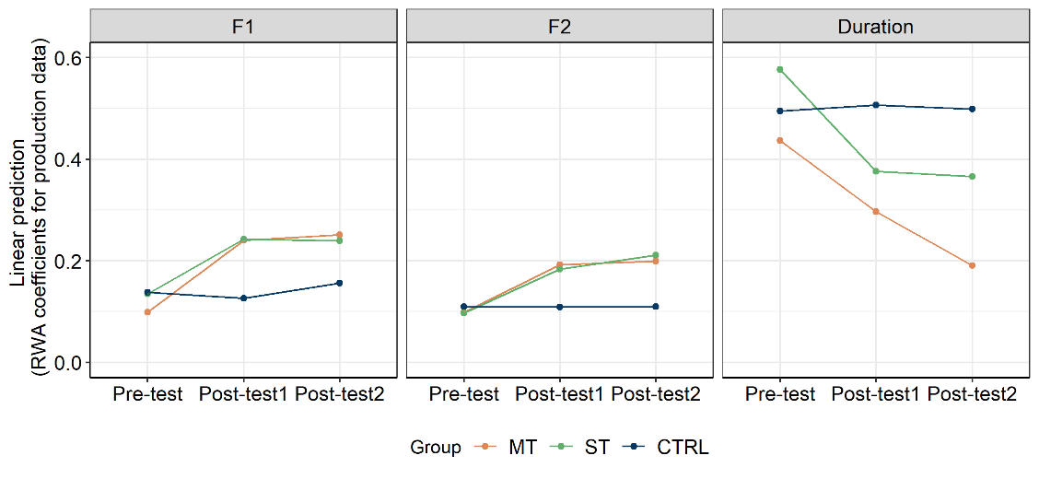
Fig. B.3 Visualization of the two-way interaction between Group (MT, ST, CTRL) and Test (Pre-test, Post-test1, Post-test2) on the respective RWA coefficients of F1, F2, and vowel duration measured in production.

Appendix C: Summary output of the linear mixed-effects models with cognitive factors being included as fixed effects
Table C.1 Summary output of the LMM on the word identification accuracy with cognitive variables
Fixed effects | Estimate | SE | df | t value | p value
(Intercept) | 0.61 | 0.04 | 58.45 | 16.01 | < .001
GroupST | -0.02 | 0.04 | 110.30 | -0.51 | .61
Testpost1 | 0.12 | 0.03 | 2312.00 | 4.17 | < .001
Testpost2 | 0.07 | 0.03 | 2312.00 | 2.36 | .02
Typeuntrained | -0.02 | 0.04 | 37.79 | -0.40 | .69
Flanker_c | 0.01 | 0.02 | 110.30 | 0.82 | .41
WM_acc_c | -0.42 | 0.31 | 110.30 | -1.34 | .18
GroupST:Testpost1 | 0.04 | 0.04 | 2312.00 | 0.90 | .37
GroupST:Testpost2 | 0.06 | 0.04 | 2312.00 | 1.51 | .13
GroupST:Typeuntrained | 0.03 | 0.04 | 2312.00 | 0.78 | .44
Testpost1:Typeuntrained | 0.06 | 0.04 | 2312.00 | 1.52 | .13
Testpost2:Typeuntrained | 0.03 | 0.04 | 2312.00 | 0.71 | .48
GroupST:Flanker_c | 0.03 | 0.02 | 110.30 | 1.14 | .26
GroupST:WM_acc_c | 0.56 | 0.39 | 110.30 | 1.42 | .16
Testpost1:Flanker_c | -0.01 | 0.02 | 2312.00 | -0.96 | .34
Testpost2:Flanker_c | 0.03 | 0.02 | 2312.00 | 1.91 | .06
Testpost1:WM_acc_c | 1.06 | 0.32 | 2312.00 | 3.38 | < .001
Testpost2:WM_acc_c | 0.53 | 0.32 | 2312.00 | 1.70 | .09
Typeuntrained:Flanker_c | 0.01 | 0.01 | 2312.00 | 0.37 | .71
Typeuntrained:WM_acc_c | -0.10 | 0.29 | 2312.00 | -0.36 | .72
GroupST:Testpost1:Typeuntrained | -0.02 | 0.05 | 2312.00 | -0.44 | .66
GroupST:Testpost2:Typeuntrained | 0.01 | 0.05 | 2312.00 | 0.27 | .79
GroupST:Testpost1:Flanker_c | -0.01 | 0.02 | 2312.00 | -0.57 | .57
GroupST:Testpost2:Flanker_c | -0.06 | 0.02 | 2312.00 | -2.24 | .02
GroupST:Testpost1:WM_acc_c | -0.82 | 0.40 | 2312.00 | -2.05 | .04
GroupST:Testpost2:WM_acc_c | -0.27 | 0.40 | 2312.00 | -0.67 | .51
GroupST:Typeuntrained:Flanker_c | 0.01 | 0.02 | 2312.00 | 0.42 | .68
GroupST:Typeuntrained:WM_acc_c | 0.12 | 0.37 | 2312.00 | 0.34 | .74
Testpost1:Typeuntrained:Flanker_c | 0.00 | 0.02 | 2312.00 | 0.02 | .99
Testpost2:Typeuntrained:Flanker_c | -0.02 | 0.02 | 2312.00 | -0.81 | .42
Testpost1:Typeuntrained:WM_acc_c | -0.03 | 0.41 | 2312.00 | -0.06 | .95
Testpost2:Typeuntrained:WM_acc_c | 0.17 | 0.41 | 2312.00 | 0.42 | .68
GroupST:Testpost1:Typeuntrained:Flanker_c | -0.02 | 0.03 | 2312.00 | -0.77 | .44
GroupST:Testpost2:Typeuntrained:Flanker_c | -0.02 | 0.03 | 2312.00 | -0.48 | .63
GroupST:Testpost1:Typeuntrained:WM_acc_c | 0.18 | 0.52 | 2312.00 | 0.35 | .73
GroupST:Testpost2:Typeuntrained:WM_acc_c | -0.21 | 0.52 | 2312.00 | -0.41 | .68
Random effects | Term | Variance | SD
Subject | (Intercept) | 0.008 | 0.09
Word | (Intercept) | 0.005 | 0.07
Note. Final model: Accuracy ~ Group * Test * Type * (Flanker_c + WM_acc_c) + (1 | Subject) + (1 | Word)
Reference level: Group: MT; Test: pre-test; Type: untrained.
Linear mixed model fit by REML.
t-tests use Satterthwaite’s method.

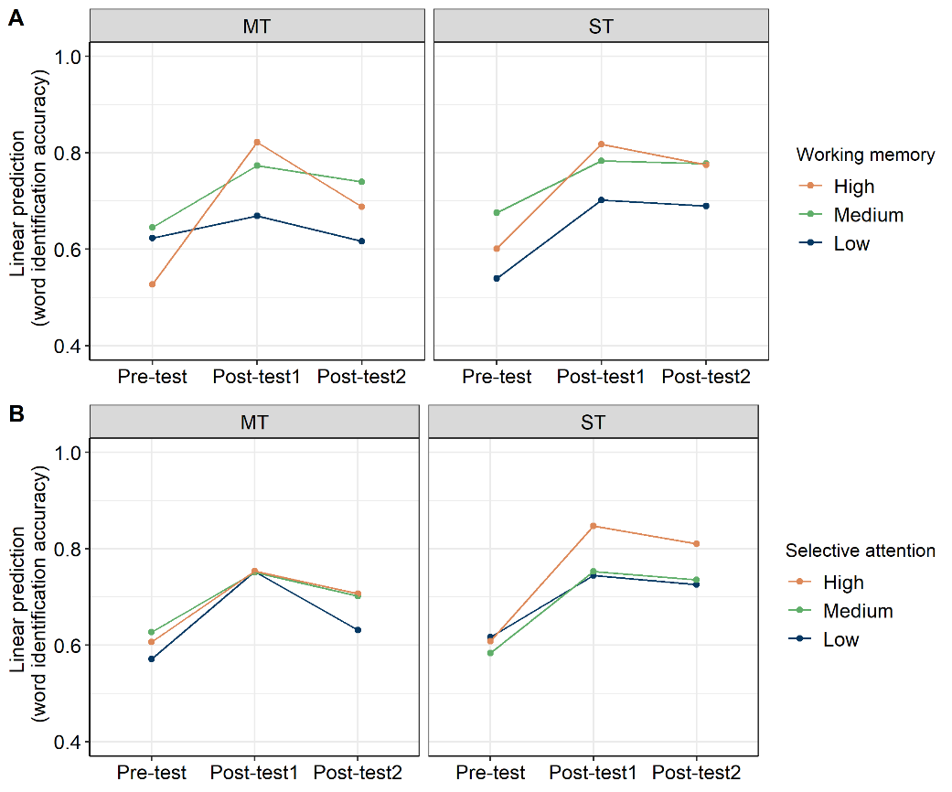
Fig. C.1 Panel A shows visualization of the three-way interaction between Group (MT, ST, CTRL), Test (Pre-test, Post-test1, Post-test2) and Working memory capacity (high, medium, low) on the word identification accuracy for two training groups (MT versus ST). Panel B shows visualization of the three-way interaction between Group (MT, ST, CTRL), Test (pre-test, post-test1, post-test2) and Selective attention ability (high, medium, low) on the word identification accuracy for two training group (MT versus ST).

Table C.2 Summary output of the LMM on the perceptual RWA coefficient of F1 with cognitive variables
Fixed effects | Estimate | SE | df | t value | p value
(Intercept) | 0.16 | 0.04 | 78.34 | 4.14 | < .001
GroupST | -0.02 | 0.05 | 78.34 | -0.42 | .68
Testpost1 | 0.20 | 0.04 | 68.00 | 4.69 | < .001
Testpost2 | 0.17 | 0.04 | 68.00 | 4.03 | < .001
Flanker_c | 0.03 | 0.02 | 78.34 | 1.37 | .17
WM_acc_c | -0.35 | 0.42 | 78.34 | -0.84 | .41
GroupST:Testpost1 | 0.01 | 0.06 | 68.00 | 0.14 | .89
GroupST:Testpost2 | 0.02 | 0.06 | 68.00 | 0.37 | .71
GroupST:Glanker_c | -0.01 | 0.03 | 78.34 | -0.33 | .74
GroupST:WM_acc_c | 0.28 | 0.54 | 78.34 | 0.52 | .60
Testpost1:Flanker_c | 0.00 | 0.02 | 68.00 | -0.09 | .93
Testpost2:Flanker_c | -0.02 | 0.02 | 68.00 | -1.00 | .32
Testpost1:WM_acc_c | 0.86 | 0.47 | 68.00 | 1.84 | .07
Testpost2: WM _acc_c | 0.35 | 0.47 | 68.00 | 0.75 | .46
GroupST:Testpost1:Flanker_c | 0.02 | 0.04 | 68.00 | 0.49 | .63
GroupST:Testpost2:Flanker_c | 0.04 | 0.04 | 68.00 | 1.19 | .24
GroupST:Testpost1:WM_acc_c | -0.71 | 0.59 | 68.00 | -1.19 | .24
GroupST:Testpost2:WM_acc_c | -0.05 | 0.59 | 68.00 | -0.08 | .94
Random effects | Term | Variance | SD
Subject | (Intercept) | 0.01 | 0.11
Note. Final model: F1 ~ Group * Test * (Flanker_c + WM_acc_c) + (1 | Subject)
Reference level: Group: MT; Test: pre-test.
Linear mixed model fit by REML.
t-tests use Satterthwaite’s method.

Table C.3 Summary output of the LMM on the perceptual RWA coefficient of F2 with cognitive variables
Fixed effects | Estimate | SE | df | t value | p value
(Intercept) | 0.16 | 0.04 | 75.26 | 4.24 | < .001
GroupST | -0.02 | 0.05 | 75.26 | -0.30 | .77
Testpost1 | 0.20 | 0.04 | 68.00 | 4.79 | < .001
Testpost2 | 0.18 | 0.04 | 68.00 | 4.39 | < .001
Flanker_c | 0.03 | 0.02 | 75.26 | 1.42 | .16
WM_acc_c | -0.38 | 0.43 | 75.26 | -0.88 | .38
GroupST:Testpost1 | -0.01 | 0.06 | 68.00 | -0.25 | .80
GroupST:Testpost2 | <0.01 | 0.06 | 68.00 | -0.08 | .94
GroupST:Glanker_c | -0.01 | 0.03 | 75.26 | -0.34 | .74
GroupST:WM_acc_c | 0.30 | 0.54 | 75.26 | 0.54 | .59
Testpost1:Flanker_c | <0.01 | 0.02 | 68.00 | 0.01 | .99
Testpost2:Flanker_c | -0.02 | 0.02 | 68.00 | -1.08 | .28
Testpost1:WM_acc_c | 0.75 | 0.46 | 68.00 | 1.64 | .11
Testpost2: WM _acc_c | 0.39 | 0.46 | 68.00 | 0.86 | .40
GroupST:Testpost1:Flanker_c | 0.02 | 0.04 | 68.00 | 0.44 | .66
GroupST:Testpost2:Flanker_c | 0.04 | 0.04 | 68.00 | 1.21 | .23
GroupST:Testpost1:WM_acc_c | -0.57 | 0.59 | 68.00 | -0.98 | .33
GroupST:Testpost2:WM_acc_c | 0.05 | 0.59 | 68.00 | 0.08 | .94
Random effects | Term | Variance | SD
Subject | (Intercept) | 0.01 | 0.11
Note. Final model: F2 ~ Group * Test * (Flanker_c + WM_acc_c) + (1 | Subject)
Reference level: Group: MT; Test: pre-test.
Linear mixed model fit by REML.
t-tests use Satterthwaite’s method.

Table C.4 Summary output of the LMM on the perceptual RWA coefficient of duration with cognitive variables
Fixed effects | Estimate | SE | df | t value | p value
(Intercept) | 0.50 | 0.07 | 66.16 | 7.04 | < .001
GroupST | 0.02 | 0.10 | 66.16 | 0.16 | .88
Testpost1 | -0.34 | 0.07 | 68.00 | -4.81 | < .001
Testpost2 | -0.39 | 0.07 | 68.00 | -5.58 | < .001
Flanker_c | -0.03 | 0.04 | 66.16 | -0.71 | .48
WM_acc_c | 0.32 | 0.79 | 66.16 | 0.41 | .68
GroupST:Testpost1 | 0.03 | 0.10 | 68.00 | 0.31 | .76
GroupST:Testpost2 | 0.10 | 0.10 | 68.00 | 1.03 | .31
GroupST:Glanker_c | -0.01 | 0.06 | 66.16 | -0.10 | .92
GroupST:WM_acc_c | 0.81 | 1.00 | 66.16 | 0.81 | .42
Testpost1:Flanker_c | -0.01 | 0.04 | 68.00 | -0.24 | .81
Testpost2:Flanker_c | 0.03 | 0.04 | 68.00 | 0.79 | .43
Testpost1:WM_acc_c | -1.12 | 0.77 | 68.00 | -1.44 | .15
Testpost2: WM _acc_c | -0.41 | 0.77 | 68.00 | -0.53 | .60
GroupST:Testpost1:Flanker_c | -0.01 | 0.06 | 68.00 | -0.23 | .82
GroupST:Testpost2:Flanker_c | -0.07 | 0.06 | 68.00 | -1.23 | .23
GroupST:Testpost1:WM_acc_c | 0.03 | 0.98 | 68.00 | 0.03 | .97
GroupST:Testpost2:WM_acc_c | -0.89 | 0.98 | 68.00 | -0.90 | .37
Random effects | Term | Variance | SD
Subject | (Intercept) | 0.01 | 0.11
Note. Final model: duration ~ Group * Test * (Flanker_c + WM_acc_c) + (1 | Subject)
Reference level: Group: MT; Test: pre-test.
Linear mixed model fit by REML.
t-tests use Satterthwaite’s method.

Table C.5 Summary output of the LMM on the production RWA coefficient of F1 with cognitive variables
Fixed effects | Estimate | SE | df | t value | p value
(Intercept) | 0.10 | 0.04 | 67.15 | 2.55 | < .001
GroupST | 0.04 | 0.05 | 67.15 | 0.72 | .47
Testpost1 | 0.14 | 0.04 | 68.00 | 3.84 | < .001
Testpost2 | 0.16 | 0.04 | 68.00 | 4.20 | < .001
Flanker_c | -0.02 | 0.02 | 67.15 | -0.76 | .45
WM_acc_c | 0.39 | 0.41 | 67.15 | 0.95 | .35
GroupST:Testpost1 | -0.03 | 0.05 | 68.00 | -0.64 | .52
GroupST:Testpost2 | -0.05 | 0.05 | 68.00 | -0.99 | .33
GroupST:Glanker_c | 0.03 | 0.03 | 67.15 | 1.06 | .30
GroupST:WM_acc_c | -0.35 | 0.53 | 67.15 | -0.67 | .51
Testpost1:Flanker_c | 0.01 | 0.02 | 68.00 | 0.71 | .48
Testpost2:Flanker_c | 0.02 | 0.02 | 68.00 | 1.23 | .22
Testpost1:WM_acc_c | 0.10 | 0.41 | 68.00 | 0.24 | .81
Testpost2: WM _acc_c | -0.08 | 0.41 | 68.00 | -0.21 | .84
GroupST:Testpost1:Flanker_c | -0.04 | 0.03 | 68.00 | -1.20 | .23
GroupST:Testpost2:Flanker_c | -0.03 | 0.03 | 68.00 | -0.84 | .40
GroupST:Testpost1:WM_acc_c | -0.29 | 0.52 | 68.00 | -0.55 | .58
GroupST:Testpost2:WM_acc_c | -0.14 | 0.52 | 68.00 | -0.27 | .79
Random effects | Term | Variance | SD
Subject | (Intercept) | 0.01 | 0.12
Note. Final model: F1 ~ Group * Test * (Flanker_c + WM_acc_c) + (1 | Subject)
Reference level: Group: MT; Test: pre-test.
Linear mixed model fit by REML.
t-tests use Satterthwaite’s method.

Table C.6 Summary output of the LMM on the production RWA coefficient of F2 with cognitive variables
Fixed effects | Estimate | SE | df | t value | p value
(Intercept) | 0.10 | 0.03 | 62.60 | 3.08 | < .001
GroupST | <0.01 | 0.05 | 62.60 | -0.01 | 1.00
Testpost1 | 0.09 | 0.03 | 68.00 | 3.03 | .003
Testpost2 | 0.10 | 0.03 | 68.00 | 3.39 | .001
Flanker_c | 0.01 | 0.02 | 62.60 | 0.40 | .69
WM_acc_c | -0.02 | 0.36 | 62.60 | -0.07 | .95
GroupST:Testpost1 | <0.01 | 0.04 | 68.00 | -0.05 | .96
GroupST:Testpost2 | 0.01 | 0.04 | 68.00 | 0.34 | .74
GroupST:Glanker_c | <0.01 | 0.03 | 62.60 | -0.05 | .96
GroupST:WM_acc_c | 0.41 | 0.45 | 62.60 | 0.90 | .37
Testpost1:Flanker_c | 0.01 | 0.02 | 68.00 | 0.65 | .52
Testpost2:Flanker_c | 0.01 | 0.02 | 68.00 | 0.84 | .41
Testpost1:WM_acc_c | 0.42 | 0.33 | 68.00 | 1.27 | .21
Testpost2: WM _acc_c | -0.09 | 0.33 | 68.00 | -0.26 | .79
GroupST:Testpost1:Flanker_c | -0.03 | 0.03 | 68.00 | -1.06 | .29
GroupST:Testpost2:Flanker_c | -0.04 | 0.03 | 68.00 | -1.56 | .12
GroupST:Testpost1:WM_acc_c | -0.05 | 0.43 | 68.00 | -0.12 | .91
GroupST:Testpost2:WM_acc_c | 0.30 | 0.43 | 68.00 | 0.69 | .49
Random effects | Term | Variance | SD
Subject | (Intercept) | 0.01 | 0.11
Note. Final model: F2 ~ Group * Test * (Flanker_c + WM_acc_c) + (1 | Subject)
Reference level: Group: MT; Test: pre-test.
Linear mixed model fit by REML.
t-tests use Satterthwaite’s method.

Table C.7 Summary output of the LMM on the production RWA coefficient of duration with cognitive variables
Fixed effects | Estimate | SE | df | t value | p value
(Intercept) | 0.43 | 0.05 | 66.38 | 9.36 | < .001
GroupST | 0.15 | 0.07 | 66.38 | 2.25 | .03
Testpost1 | -0.13 | 0.05 | 68.00 | -2.97 | .004
Testpost2 | -0.24 | 0.05 | 68.00 | -5.35 | < .001
Flanker_c | -0.03 | 0.02 | 66.38 | -1.01 | .32
WM_acc_c | 0.41 | 0.51 | 66.38 | 0.81 | .42
GroupST:Testpost1 | -0.07 | 0.06 | 68.00 | -1.14 | .26
GroupST:Testpost2 | 0.03 | 0.06 | 68.00 | 0.42 | .67
GroupST:Glanker_c | -0.02 | 0.04 | 66.38 | -0.55 | .59
GroupST:WM_acc_c | -0.85 | 0.65 | 66.38 | -1.31 | .20
Testpost1:Flanker_c | 0.02 | 0.02 | 68.00 | 0.88 | .38
Testpost2:Flanker_c | 0.04 | 0.02 | 68.00 | 1.56 | .12
Testpost1:WM_acc_c | -0.58 | 0.50 | 68.00 | -1.16 | .25
Testpost2: WM _acc_c | -0.08 | 0.50 | 68.00 | -0.15 | .88
GroupST:Testpost1:Flanker_c | 0.04 | 0.04 | 68.00 | 1.07 | .29
GroupST:Testpost2:Flanker_c | <0.01 | 0.04 | 68.00 | -0.03 | .98
GroupST:Testpost1:WM_acc_c | 0.48 | 0.64 | 68.00 | 0.75 | .46
GroupST:Testpost2:WM_acc_c | -0.10 | 0.64 | 68.00 | -0.16 | .87
Random effects | Term | Variance | SD
Subject | (Intercept) | 0.02 | 0.15
Note. Final model: duration ~ Group * Test * (Flanker_c + WM_acc_c) + (1 | Subject)
Reference level: Group: MT; Test: pre-test.
Linear mixed model fit by REML.
t-tests use Satterthwaite’s method.

