Supplementary information

Graphene-TLL-Cu₂ONPs hybrid as Highly Efficient Catalyst for degradation of organic pollutans
Noelia Losada-Garciaª, Jannier Carranzaª and Jose M. Palomo* ª
ª Instituto de Catalisis y Petroleoquimica (ICP), CSIC, Marie Curie 2, 28049, Madrid, Spain. E-mail: josempalomo@icp.csic.es

Synthesis of TLL-Cu₂O hybrid
0.9 mL of commercial (18 mg of protein) Thermomyces lanuginosus lipase (TLL) solution was added to 60 mL 0.1M of buffer sodium phosphate pH 7 in a 250 mL glass bottle containing a small magnetic bar stirrer. Then, 600 mg of Cu₂SO₄ x 5H₂O (10 mg/ml) was added to the protein solution and it was maintained for 16 hours. After the first 30 min incubation, the solution turned cloudy (turquoise). After 16 h, 6 mL of NaBH₄ (300 mg) aqueous solution (1.2 M) was added to the cloudy solution (in two times of 3 mL) obtaining a final concentration of 0.12 M of sodium borohydride in the mixture. The solution turned rapidly black and, the mixture was reduced during 30 min. After the incubation, the mixture was centrifuged at 8000 rpm for 5 min, (10 mL per falcon type tube). The generated pellet was re-suspended in 15 mL of water. It was centrifuged again at 8000 r.p.m for 5 min and the supernatant removed. The process was repeated twice more. Finally, the supernatant was removed and the pellet of each falcon was re-suspended in 2 mL of water, collected all solutions in a round-bottom flask, frozen with liquid nitrogen and lyophilized for 16 hours. After that, 150 mg of the so called TLL-Cu₂O hybrid was obtained.

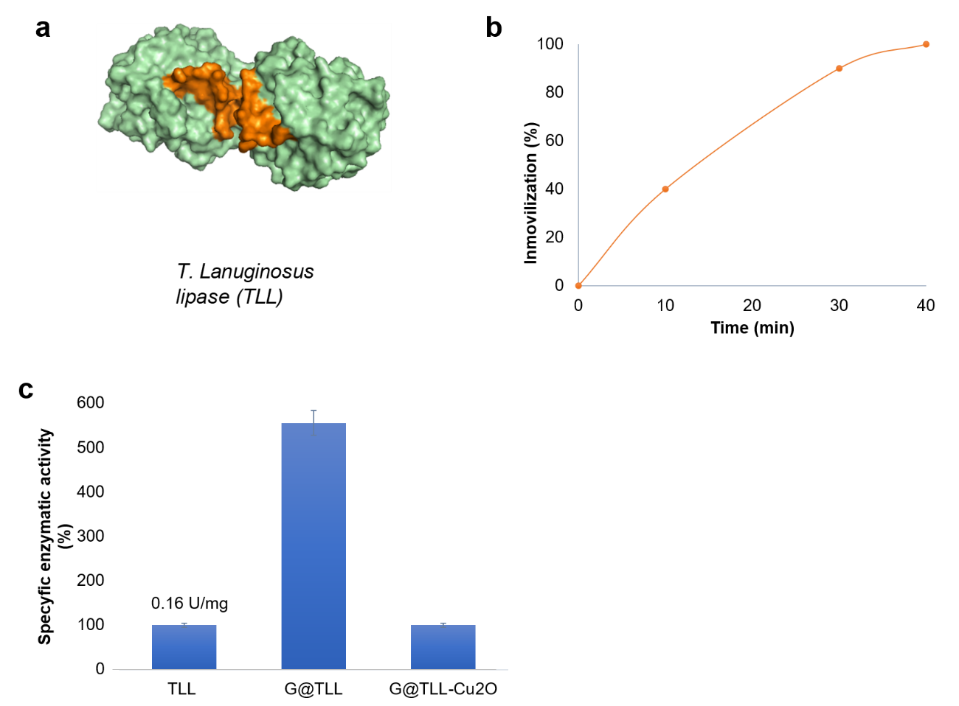
Figure S1. A) Three-dimensional Surface of dimer from TLL; B) Immobilization curve of G@TLL; C) Enzymatic activity.

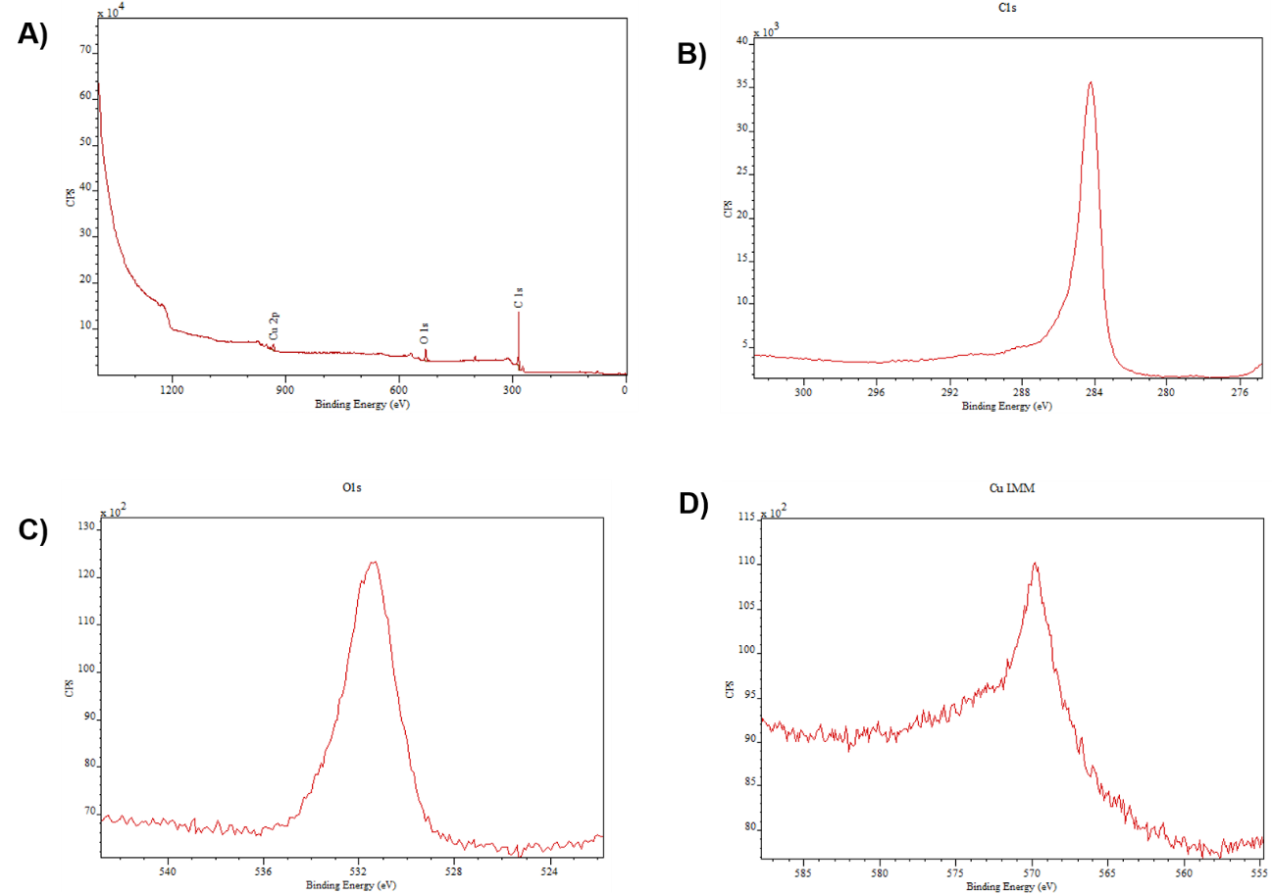

Figure S2. XPS analysis of G@TLL-Cu₂O hybrid. A) XPS full spectrum. B) XPS spectrum of C1s, C) XPS spectrum of O1s. D) Cu LMM auger spectrum.

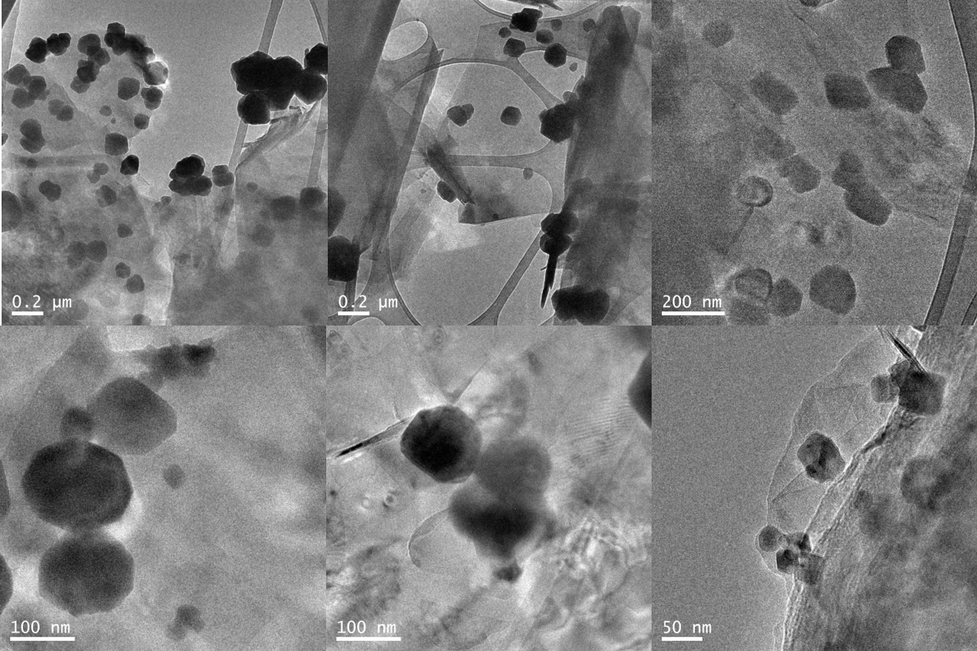
Figure S3. TEM images of G@TLL-Cu₂O hybrid.

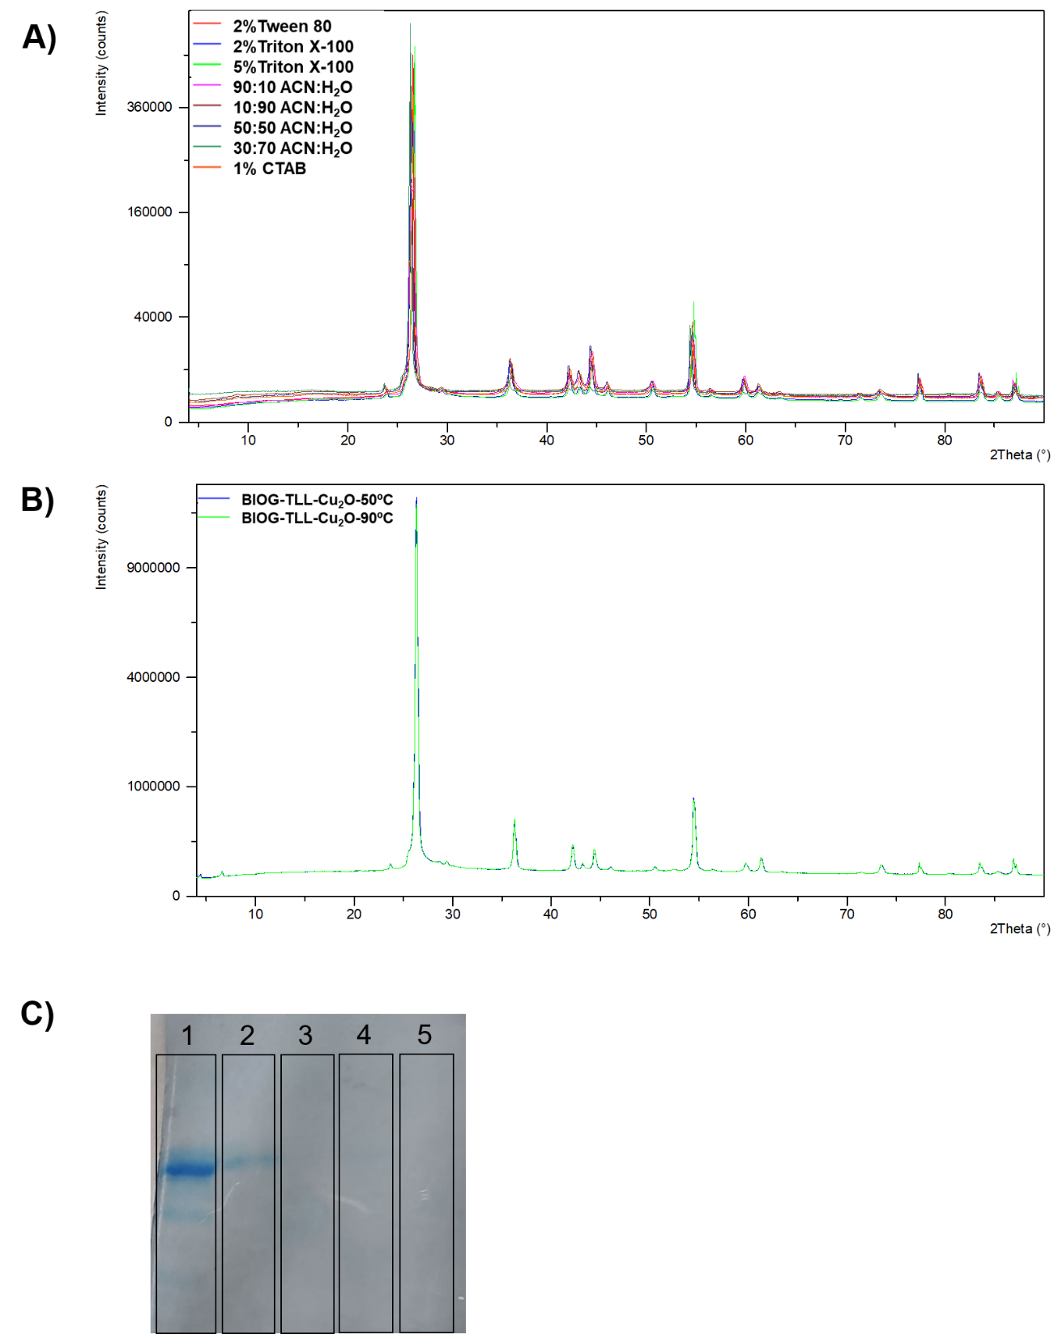
Figure S4. A) XRD spectra of the G@TLL-Cu₂O hybrid incubated in different solvents and detergents; B) XRD spectra for G@TLL-Cu₂O hybrid in SDS at 50 and 90 ºC; C) 1-TLL, 2- G@TLL, 3- G@TLL-Cu₂O pre-treated with SDS at 90ºC, 4- G@TLL-Cu₂O pre-treated with SDS at 50ºC, 5- G@TLL-Cu₂O.

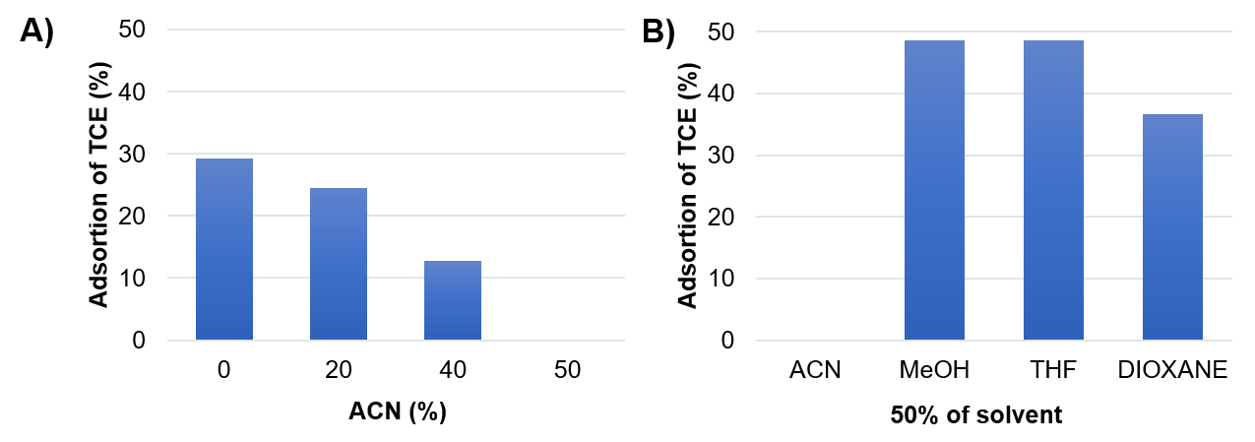
Figure S5. Study of adsorción of TCE to G@TLL in 1min. A) Differents concentrations of ACN; B) Differents solvents at 50:50 with water.

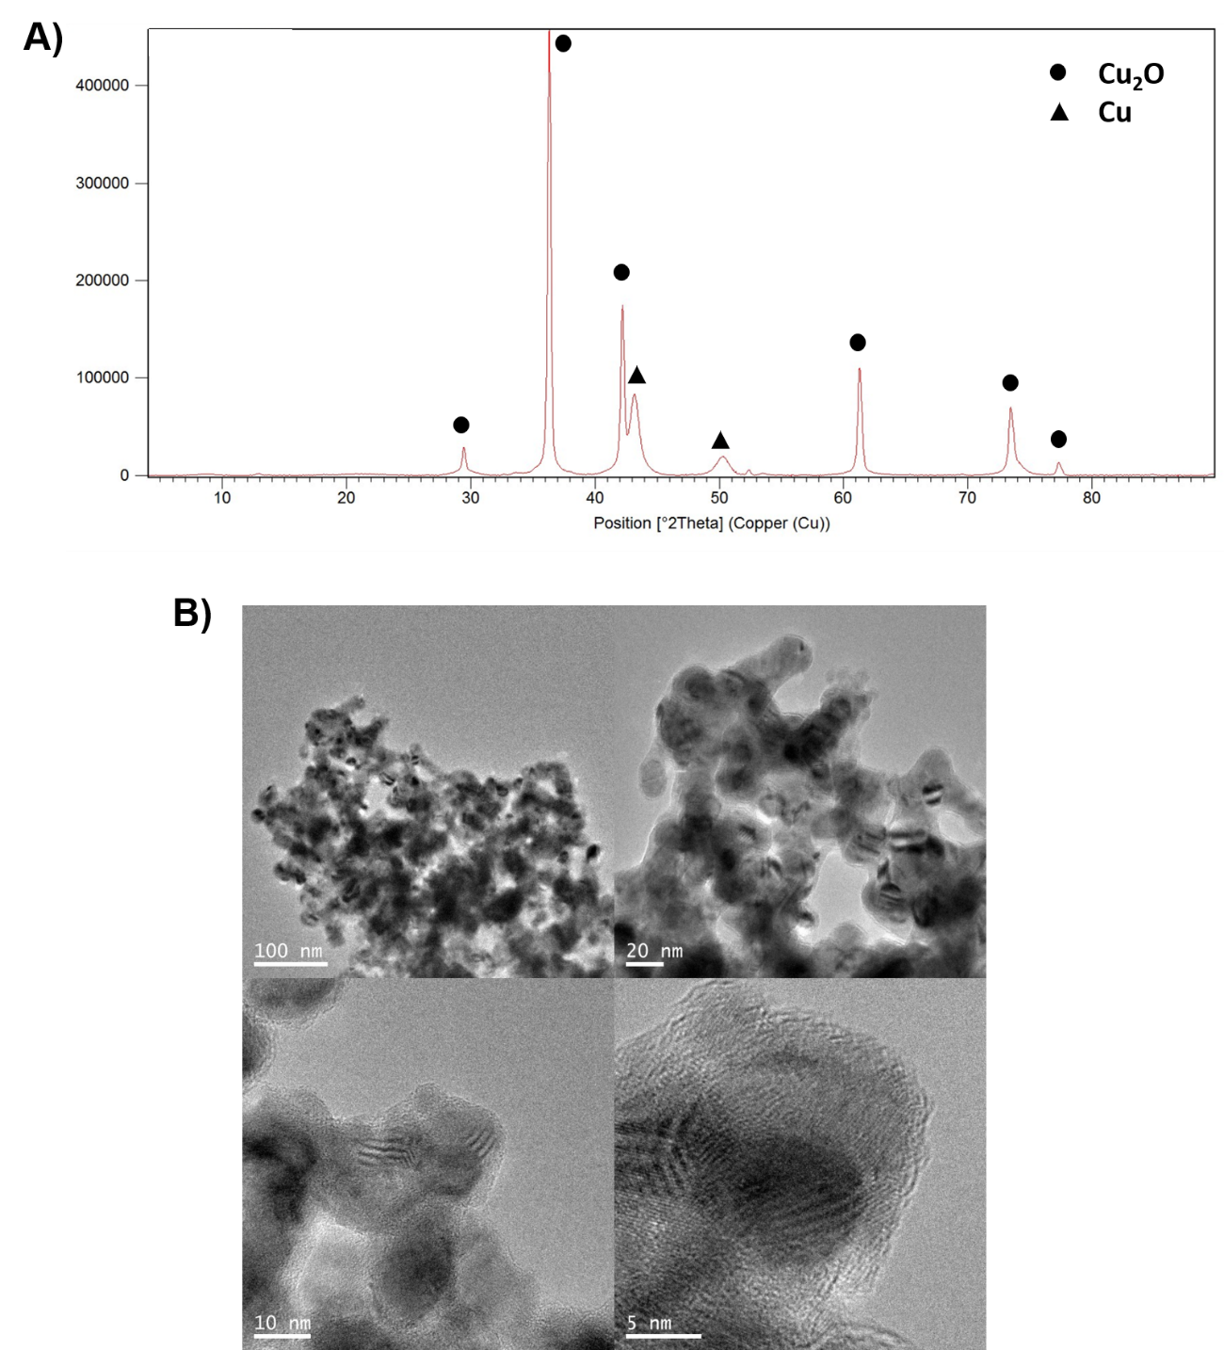
Figure S6. Characterization of TLL-Cu₂O hybrid: A) XRD spectrum; B) TEM and HR-TEM images.

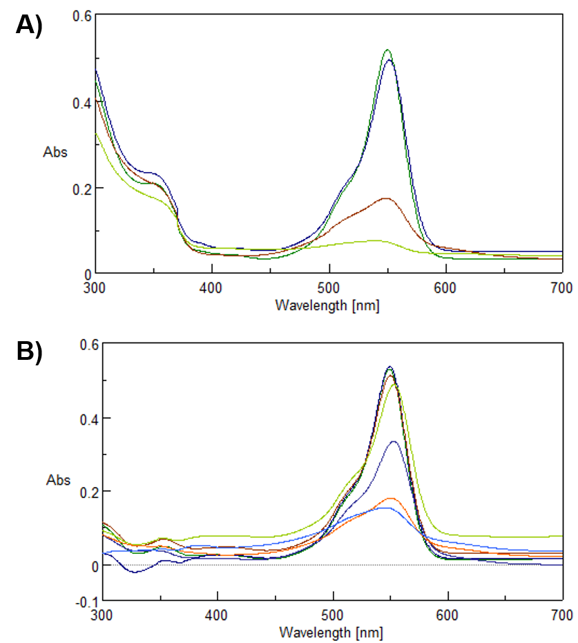
Figura S7. Effect of the amount of H₂O₂ with 5mg of G@TLL-Cu₂O hybrid and 0.1mM of RhB: A) 250mM; B) 200mM.
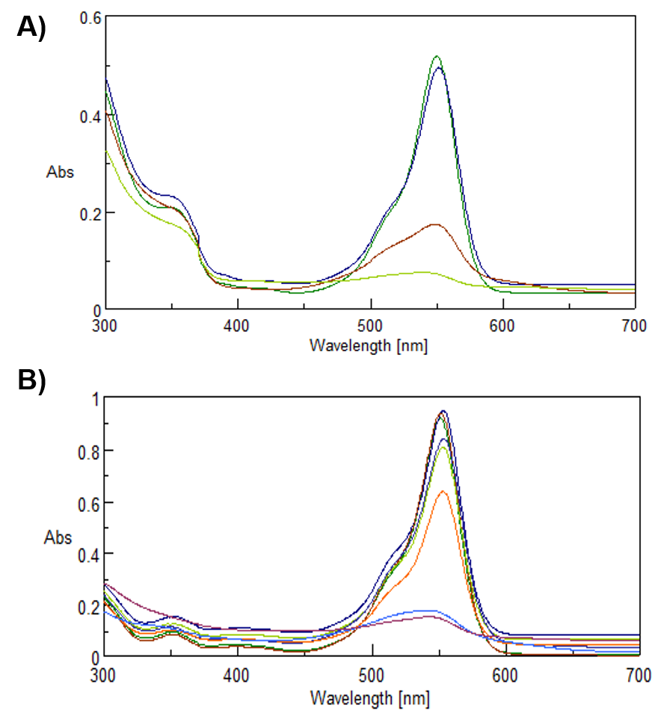
Figura S8. Effect of the amount of G@TLL-Cu₂O hybrid with 250mM of H₂O₂ and 0.1mM of RhB: A) 5mg; B) 10mg.

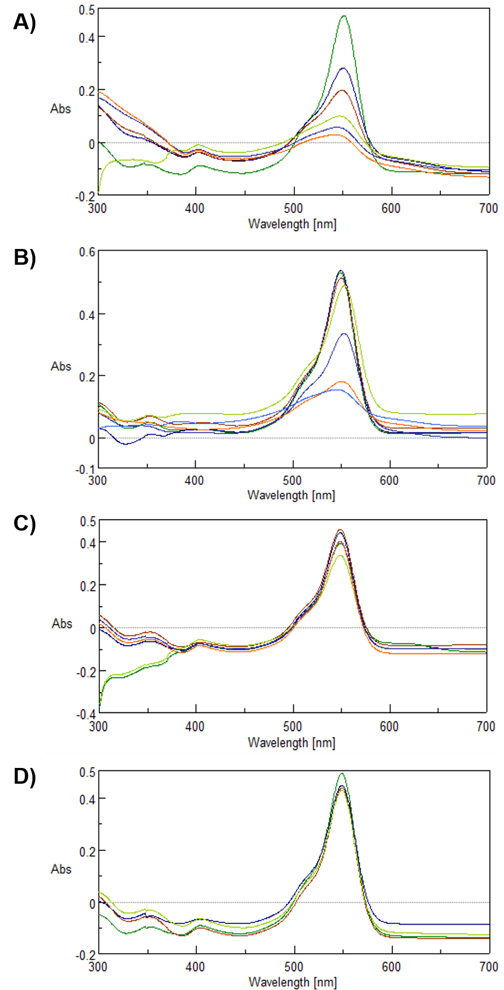
Figura S9. Effect of medium pH in the degradation of 0.1mM of RhB, conditions: 50:50 ACN:Buffer with 5mg of G@TLL-Cu₂O hybrid and 250mM of H₂O₂: A) Buffer sodium acetate pH4; B) Distilled water; C) Buffer sodium phosphate pH7; D) Buffer sodium bicarbonate pH8.5.

