Name | Forward | Reverse
CD8a | CCCTTTACTGCAACCACAGG | GTCTCCCGATTTGACCACAG
CD103 | ACCATTCTTTGCCTATCATCATTAAAG | CTCCATGCTGCTCTAGATCATC
CD14 | GACCTAAAGATAACCGGCACC | GCAATGCTCAGTACCTTGAGG
CD33 | GGTGTGACTACGGAGAGAACC | GGTAGGGTGGGTGTCATTCC
MPO | CCGGGATGGTGATCGGTTTT | CAGATGATCCGGGGCAATGA
CCL3 | GCAACCAGTTCTCTGCATCA | TGGCTGCTCGTCTCAAAGTA
CCL23 | CATCTCCTACACCCCACGAAG | GGGTTGGCACAGAAACGTC
β-Actin(human) | GATTACTGCTCTGGCTCCTAGC | GACTCATCGTACTCCTGCTTGC
Table S1. Nucleotide sequences of human primers for RT-qPCR

Table S2. Demographics and Clinical Characteristics of patients with acanthamoeba keratitis
Parameter | Patients 1 | Patients 2 | Patients 3
Subject (Age, gender) | 57y, FM | 55y, FM | 20y, M
Onset time (days) | 37 | 34 | 27
Risk Factor | Unknown | Agricultural injury,  Tap water exposure | Orthokeratology,  Tap water exposure
Preoperative/ Postoperative visual acuity | HM / 0.01 | CF / 0.01 | 0.01 / 0.3
Steroids used | Y | N | N
Ulcer size (mm) | 9 | 7 | 5
Scraping (+/-) | + | + | +
Culture (+/-) | + | + | +
IVCM (+/-) | + | + | +
Surgical Interventions | PK | PK | DALK

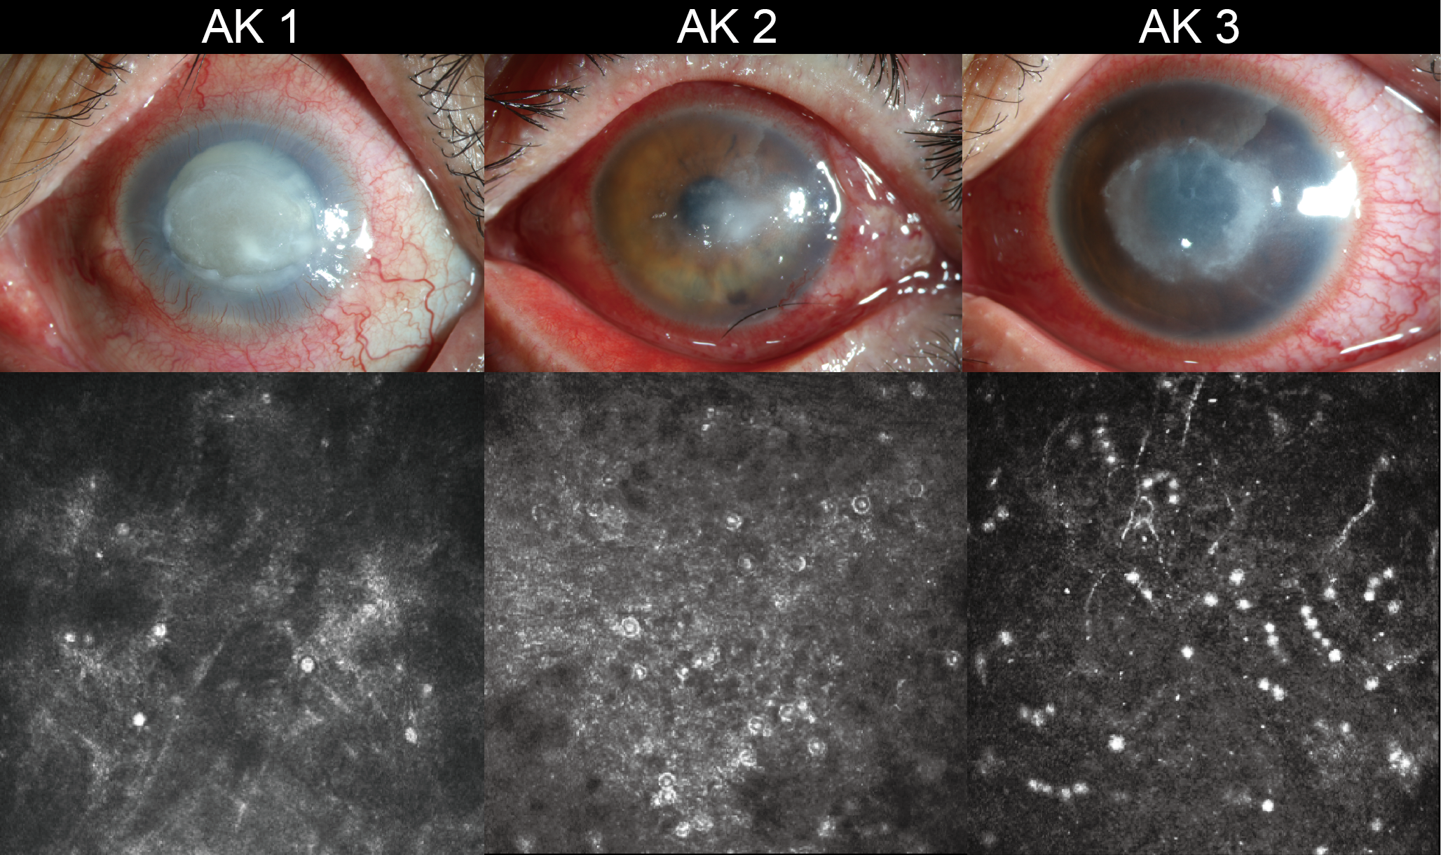
Figure S1: the slit-lamp and in vivo confocal microscopy images of three recruited patients with acanthamoeba keratitis

