Communication
Quick report of the ML=3.3 on 1 January 2023 Guidonia (Rome, Italy) earthquake: evidence of a seismic acceleration
Dedalo Marchetti¹, Kaiguang Zhu^{1,*}, Laura Marchetti², Yiqun Zhang^{1,} Wenqi Chen ¹, Yuqi Cheng ¹, Mengxuan Fan¹, Siyu Wang¹, Ting Wang ¹, Jiami Wen ¹, Donghua Zhang ¹, Hanshuo Zhang ¹.
Citation: Lastname, F.; Lastname, F.; Lastname, F. Title. Remote Sens. 2021, 13, x. https://doi.org/10.3390/xxxxx
Academic Editor: Firstname Lastname
Received: date
Accepted: date
Published: date
Publisher’s Note: MDPI stays neutral with regard to jurisdictional claims in published maps and institutional affiliations.
Copyright: © 2021 by the authors. Submitted for possible open access publication under the terms and conditions of the Creative Commons Attribution (CC BY) license (https://creativecommons.org/licenses/by/4.0/).
- College of Instrumentation and Electrical Engineering, Jilin University, Changchun 130061, China;
dedalomarchetti@jlu.edu.cn (D.M.); zhanghs6518@mails.jlu.edu.cn (H.Z.);
wqchen21@mails.jlu.edu.cn (W.C.); chengyuqi@jlu.edu.cn (Y.C.); tingwang20@mails.jlu.edu.cn (T.W.); wenjm20@mails.jlu.edu.cn (J.W.); zhangdh6518@mails.jlu.edu.cn (D.Z.); yiqun21@mails.jlu.edu.cn (Y.Z.)
- Noviconsult SAS, 15060, Basaluzzo (Alessandria), Italy; laura.marchetti@noviconsult.it (L.M.)
* Correspondence: zhukaiguang@jlu.edu.cn;

Supplementary Materials
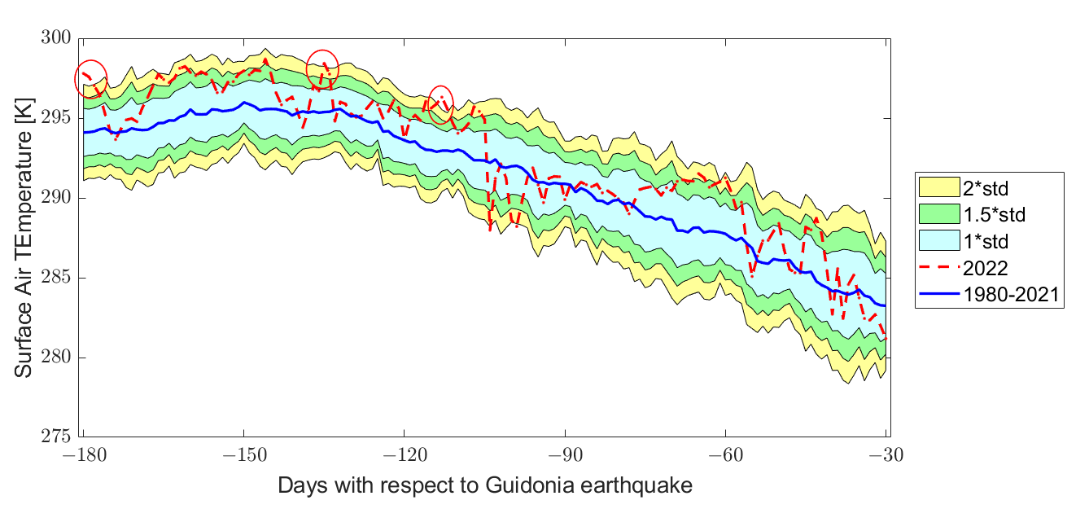
Figure S1. Surface air temperature time series from 3 July 2022 (six months before the ML=3.3 1 January 2023 Guidonia earthquake) until 30 November 2022.
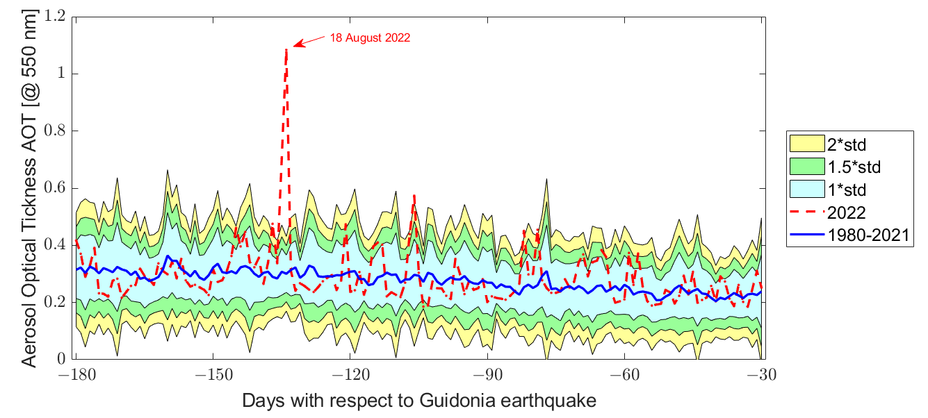
Figure S2. Aerosol time series from 3 July 2022 (six months before the ML=3.3 1 January 2023 Guidonia earthquake) until 30 November 2022.

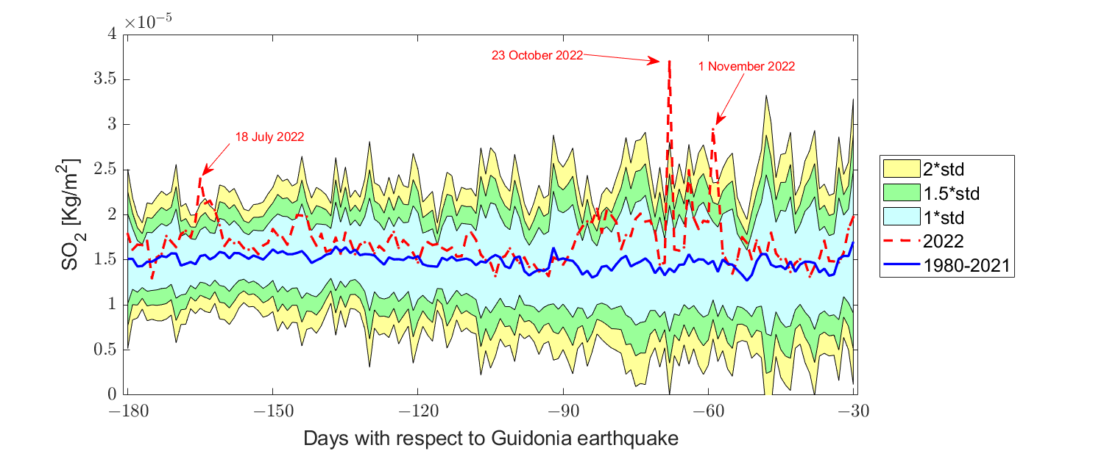
Figure S3. SO₂ time series from 3 July 2022 (six months before the ML=3.3 1 January 2023 Guidonia earthquake) until 30 November 2022. The years of 1989 and 1993 have been excluded automatically as particularly anomalous.
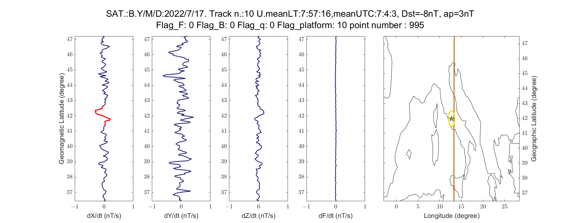
Figure S4. Swarm Bravo magnetic field analysis on 17 July 2022, track 10.
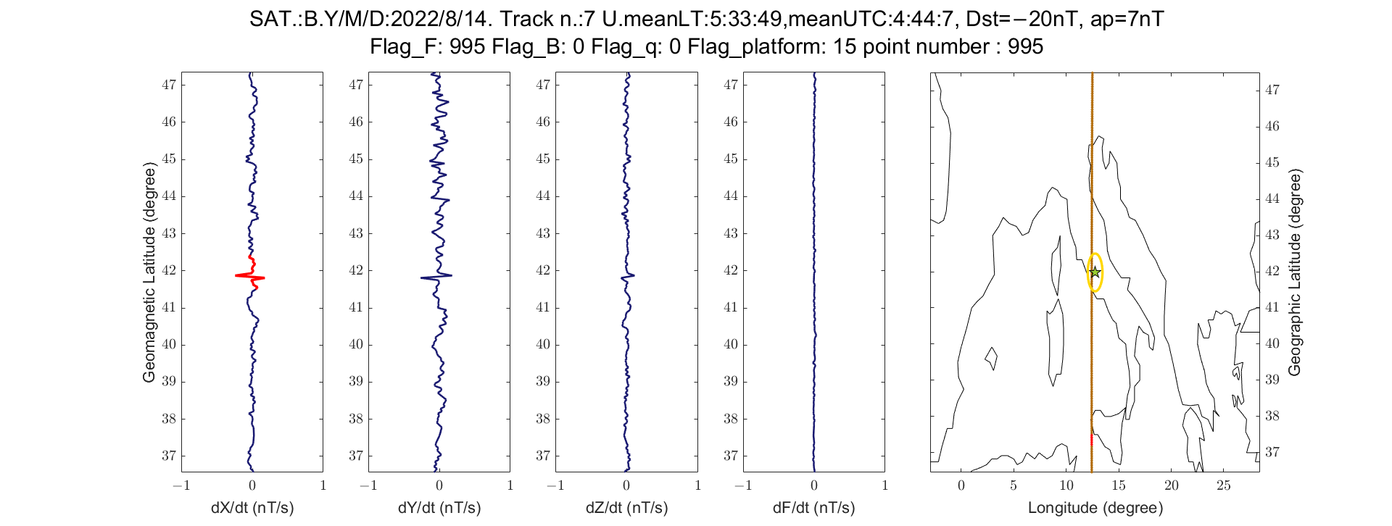
Figure S5. Swarm Bravo magnetic field analysis on 14 August 2022, track 7.

