Supplementary material
State of Public Health at the Local Level in Serbia:
Longitudinal Research
Citation: Cvetković, V.M.; Tanasić, J.; Živković-Šulović, M.; Ćurić, N.; Milojević, S. State of Public Health at the Local Level in Serbia: Longitudinal Research. Int. J.
Environ. Res. Public Health 2023, 20, x. https://doi.org/10.3390/xxxxx
Academic Editor(s):
Received: date
Revised: date
Accepted: date
Published: date
Copyright: © 2023 by the authors. Submitted for possible open access publication under the terms and conditions of the Creative Commons Attribution (CC BY) license (https://creativecommons.org/licenses/by/4.0/).
Vladimir M. Cvetković ^{1,2,3,}*, Jasmina Tanasić ⁴, Mirjana Živković-Šulović ⁵, Nedeljko Ćurić ⁴ and Stefan Milojević ⁶
¹ Faculty of Security Studies, University of Belgrade, Gospodara Vučića 50, 11040 Belgrade, Serbia
² Scientific-Professional Society for Disaster Risk Management, Dimitrija Tucovića 121, 11040 Belgrade, Serbia
³ International Institute for Disaster Research, Dmitrija Tucovića 121, 11040 Belgrade, Serbia
⁴ Standing Conference of Towns and Municipalities, Makedonska 22/VIII ,11103 Belgrade, Serbia;
jasmina.tanasic@skgo.org (J.T.); nedeljko.curic@skgo.org (N.Ć.)
⁵ Institute of Public Health of Serbia, Dr Milan Jovanović Batut, Dr Subotica 5, 11000 Belgrade, Serbia;
mirjanasulovic@gmail.com
⁶ Faculty of Finance, Banking and Audit,, Palmira Toljatija 3, 11070 Belgrade, Serbia;
aviation.adviser@gmail.com
* Correspondence: vmc@fb.bg.ac.rs

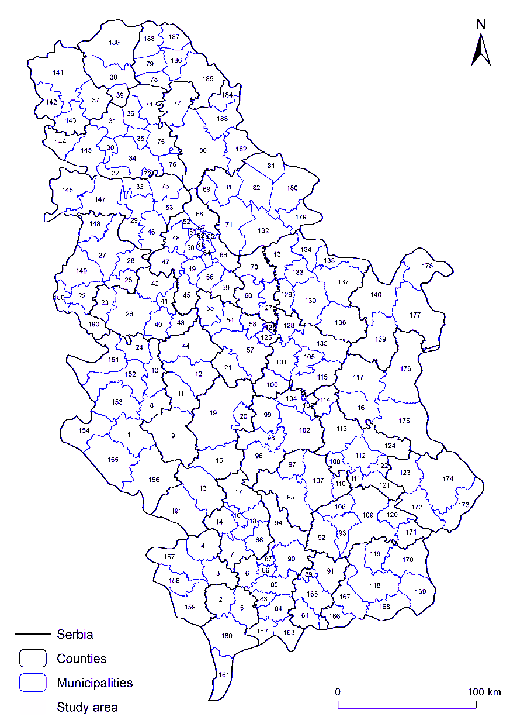
Figure S1. Study areas location (bold in text). Numbers refer to the ID of the municipality.
Table S1. The ID of the municipality and belonging county in Serbia.
ID |  | Municipality | County | ID | Municipality | County
1 |  | Nova Varoš | Zlatibor | 96 | Brus | Rasina
2 |  | Orahovac | Prizren | 97 | Blace | Toplica
3 |  | Klina | Peč | 98 | Aleksandrovac | Rasina
4 |  | Istok | Peč | 99 | Trstenik | Rasina
5 |  | Suva Reka | Prizren | 100 | Rekovac | Pomoravlje
6 |  | Glogovac | Kosovo | 101 | Jagodina | Pomoravlje
7 |  | Srbica | Kosovo-Mitrovica | 102 | Kruševac | Rasina
8 |  | Arilje | Zlatibor | 103 | Ćicevac | Rasina
9 |  | Ivanjica | Moravica | 104 | Varvarin | Rasina
10 |  | Požega | Zlatibor | 105 | Ćuprija | Pomoravlje
11 |  | Lučani | Moravica | 106 | Bojnik | Jablanica
12 |  | Čacak | Moravica | 107 | Prokuplje | Toplica
13 |  | Novi Pazar | Raška | 108 | Merošina | Nivaša
14 |  | Zubin Potok | Kosovo-Mitrovica | 109 | Leskovac | Jablanica
15 |  | Raška | Raška | 110 | Žitoradja | Toplica
16 |  | Zvečan | Kosovo-Mitrovica | 111 | Doljevac | Nivaša
17 |  | Leposavić | Kosovo-Mitrovica | 112 | Niš | Nivaša
18 |  | Kosovska Mitrovica | Kosovo-Mitrovica | 113 | Aleksinac | Nivaša
19 |  | Kraljevo | Raška | 114 | Ražanj | Nivaša
20 |  | Vrnjačka Banja | Raška | 115 | Paraćin | Pomoravlje
21 |  | Knić | Šumadija | 116 | Sokobanja | Zalečar
22 |  | Krupanj | Mačva | 117 | Boljevac | Zalečar
23 |  | Osecina | Kolumbara | 118 | Vranje | Pčinja
24 |  | Kosjerić | Zlatibor | 119 | Vladičin Han | Pčinja
25 |  | Koceljeva | Mačva | 120 | Vlasotince | Jablanica
26 |  | Valjevo | Kolumbara | 121 | Gadzin Han | Nivaša
27 |  | Šabac | Mačva | 122 | Niška Banja | Nivaša
28 |  | Vladimirci | Mačva | 123 | Bela Palanka | Pirot
29 |  | Ruma | Srem | 124 | Svrljig | Nivaša
30 |  | Bački Petrovac | South Bačka | 125 | Batočina | Šumadija
31 |  | Vrbas | South Bačka | 126 | Lapovo | Šumadija
32 |  | Beočin | South Bačka | 127 | Velika Plana | Podunavlje
33 |  | Irig | Srem | 128 | Svilajnac | Pomoravlje
34 |  | Novi Sad | South Bačka | 129 | Žabari | Braničevo
35 |  | Temerin | South Bačka | 130 | Petrovac | Braničevo
36 |  | Srbobran | South Bačka | 131 | Pozarevac | Braničevo
37 |  | Kula | West Bačka | 132 | Kovin | South Banat
38 |  | Bačka Topola | North Bačka | 133 | Malo Crnice | Braničevo
39 |  | Mali Iđoš | North Bačka | 134 | Veliko Gradiste | Braničevo
40 |  | Mionica | Kolumbara | 135 | Despotovac | Pomoravlje
41 |  | Lajkovac | Kolumbara | 136 | Zagubica | Braničevo
42 |  | Ub | Kolumbara | 137 | Kučevo | Braničevo
43 |  | Ljig | Kolumbara | 138 | Golubac | Braničevo
44 |  | Gornji Milanovac | Moravica | 139 | Bor | Bor
45 |  | Lazarevac | City of Belgrade | 140 | Majdanpek | Bor
46 |  | Pecinci | Srem | 141 | Sombor | West Bačka
47 |  | Obrenovac | City of Belgrade | 142 | Apatin | West Bačka
48 |  | Surčin | City of Belgrade | 143 | Odzaci | West Bačka
49 |  | Barajevo | City of Belgrade | 144 | Bač | South Bačka
50 |  | Čukarica | City of Belgrade | 145 | Bačka Palanka | South Bačka
51 |  | Novi Beograd | City of Belgrade | 146 | Šid | Srem
52 |  | Zemun | City of Belgrade | 147 | Sremska Mitrovica | Srem
53 |  | Stara Pazova | Srem | 148 | Bogatic | Mačva
54 |  | Topola | Šumadija | 149 | Loznica | Mačva
55 |  | Arandjelovac | Šumadija | 150 | Mali Zvornik | Mačva
56 |  | Sopot | City of Belgrade | 151 | Bajina Bašta | Zlatibor
57 |  | Kragujevac | Šumadija | 152 | Užice | Zlatibor
58 |  | Raca | Šumadija | 153 | Čajetina | Zlatibor
59 |  | Mladenovac | City of Belgrade | 154 | Priboj | Zlatibor
60 |  | Smederevska Palanka | Podunavlje | 155 | Prijepolje | Zlatibor
61 |  | Rakovica | City of Belgrade | 156 | Sjenica | Zlatibor
62 |  | Savski Venac | City of Belgrade | 157 | Peć | Peč
63 |  | Vračar | City of Belgrade | 158 | Dečani | Peč
64 |  | Voždovac | City of Belgrade | 159 | Djakovica | Peč
65 |  | Zvezdara | City of Belgrade | 160 | Prizren | Prizren
66 |  | Grocka | City of Belgrade | 161 | Gora | Prizren
67 |  | Stari Grad | City of Belgrade | 162 | Strpce | Kosovo
68 |  | Palilula | City of Belgrade | 163 | Kačanik | Kosovo
69 |  | Opovo | South Banat | 164 | Vitina | Kosovo-Pomoravlje
70 |  | Smederevo | Podunavlje | 165 | Gnjilane | Kosovo-Pomoravlje
71 |  | Pančevo | South Banat | 166 | Preševo | Pčinja
72 |  | Sremski Karlovci | South Bačka | 167 | Bujanovac | Pčinja
73 |  | Indjija | Srem | 168 | Trgovšte | Pčinja
74 |  | Bečej | South Bačka | 169 | Bosilegrad | Pčinja
75 |  | Abalj | South Bačka | 170 | Surdulica | Pčinja
76 |  | Titel | South Bačka | 171 | Crna Trava | Jablanica
77 |  | Novi Bečej | Central Banat | 172 | Babušnica | Pirot
78 |  | Ada | North Banat | 173 | Dimitorvgrad | Pirot
79 |  | Senta | North Banat | 174 | Pirot | Pirot
80 |  | Zrenjanin | Central Banat | 175 | Knjaževac | Zaječar
81 |  | Kovačica | South Banat | 176 | Zaječar | Zaječar
82 |  | Alibunar | South Banat | 177 | Negotin | Bor
83 |  | Stimlje | Kosovo | 178 | Kladovo | Bor
84 |  | Urosevac | Kosovo | 179 | Bela Crkva | South Banat
85 |  | Lipljan | Kosovo | 180 | Vršac | South Banat
86 |  | Kosovo Polje | Kosovo | 181 | Plandište | South Banat
87 |  | Obilić | Kosovo | 182 | Sečanj | Central Banat
88 |  | Vučitrn | Kosovo-Mitrovica | 183 | ÄitiÜte | Central Banat
89 |  | Novo Brdo | Kosovo-Pomoravlje | 184 | Nova Crnja | Central Banat
90 |  | Pristina | Kosovo | 185 | Kikinda | North Banat
91 |  | Kosovska Kamenica | Kosovo-Pomoravlje | 186 | Čoka | North Banat
92 |  | Medveđa | Jablanica | 187 | Novi Kneževac | North Banat
93 |  | Lebane | Jablanica | 188 | Kanjiža | North Banat
94 |  | Podujevo | Kosovo | 189 | Subotica | North Bačka
95 |  | Kuršumlija | Toplica | 190 | Ljubovija | Mačva
 |  |  |  | 191 | Tutin | Raška

