Feeding behavior of finishing pigs under diurnal cyclic variation in ambient temperature
Marllon José Karpeggiane de Oliveira ¹, Marcio Valk ², Antônio Diego Brandão Melo ¹, Danilo Alves Marçal ¹, Cleslei Alisson Silva ¹, Graziela Alves da Cunha Valini ¹, Pedro Righetti Arnaut ¹, Joseane Penteado Rosa Gonçalves ¹, Ines Andretta ⁴, Luciano Hauschild ^{1,}*
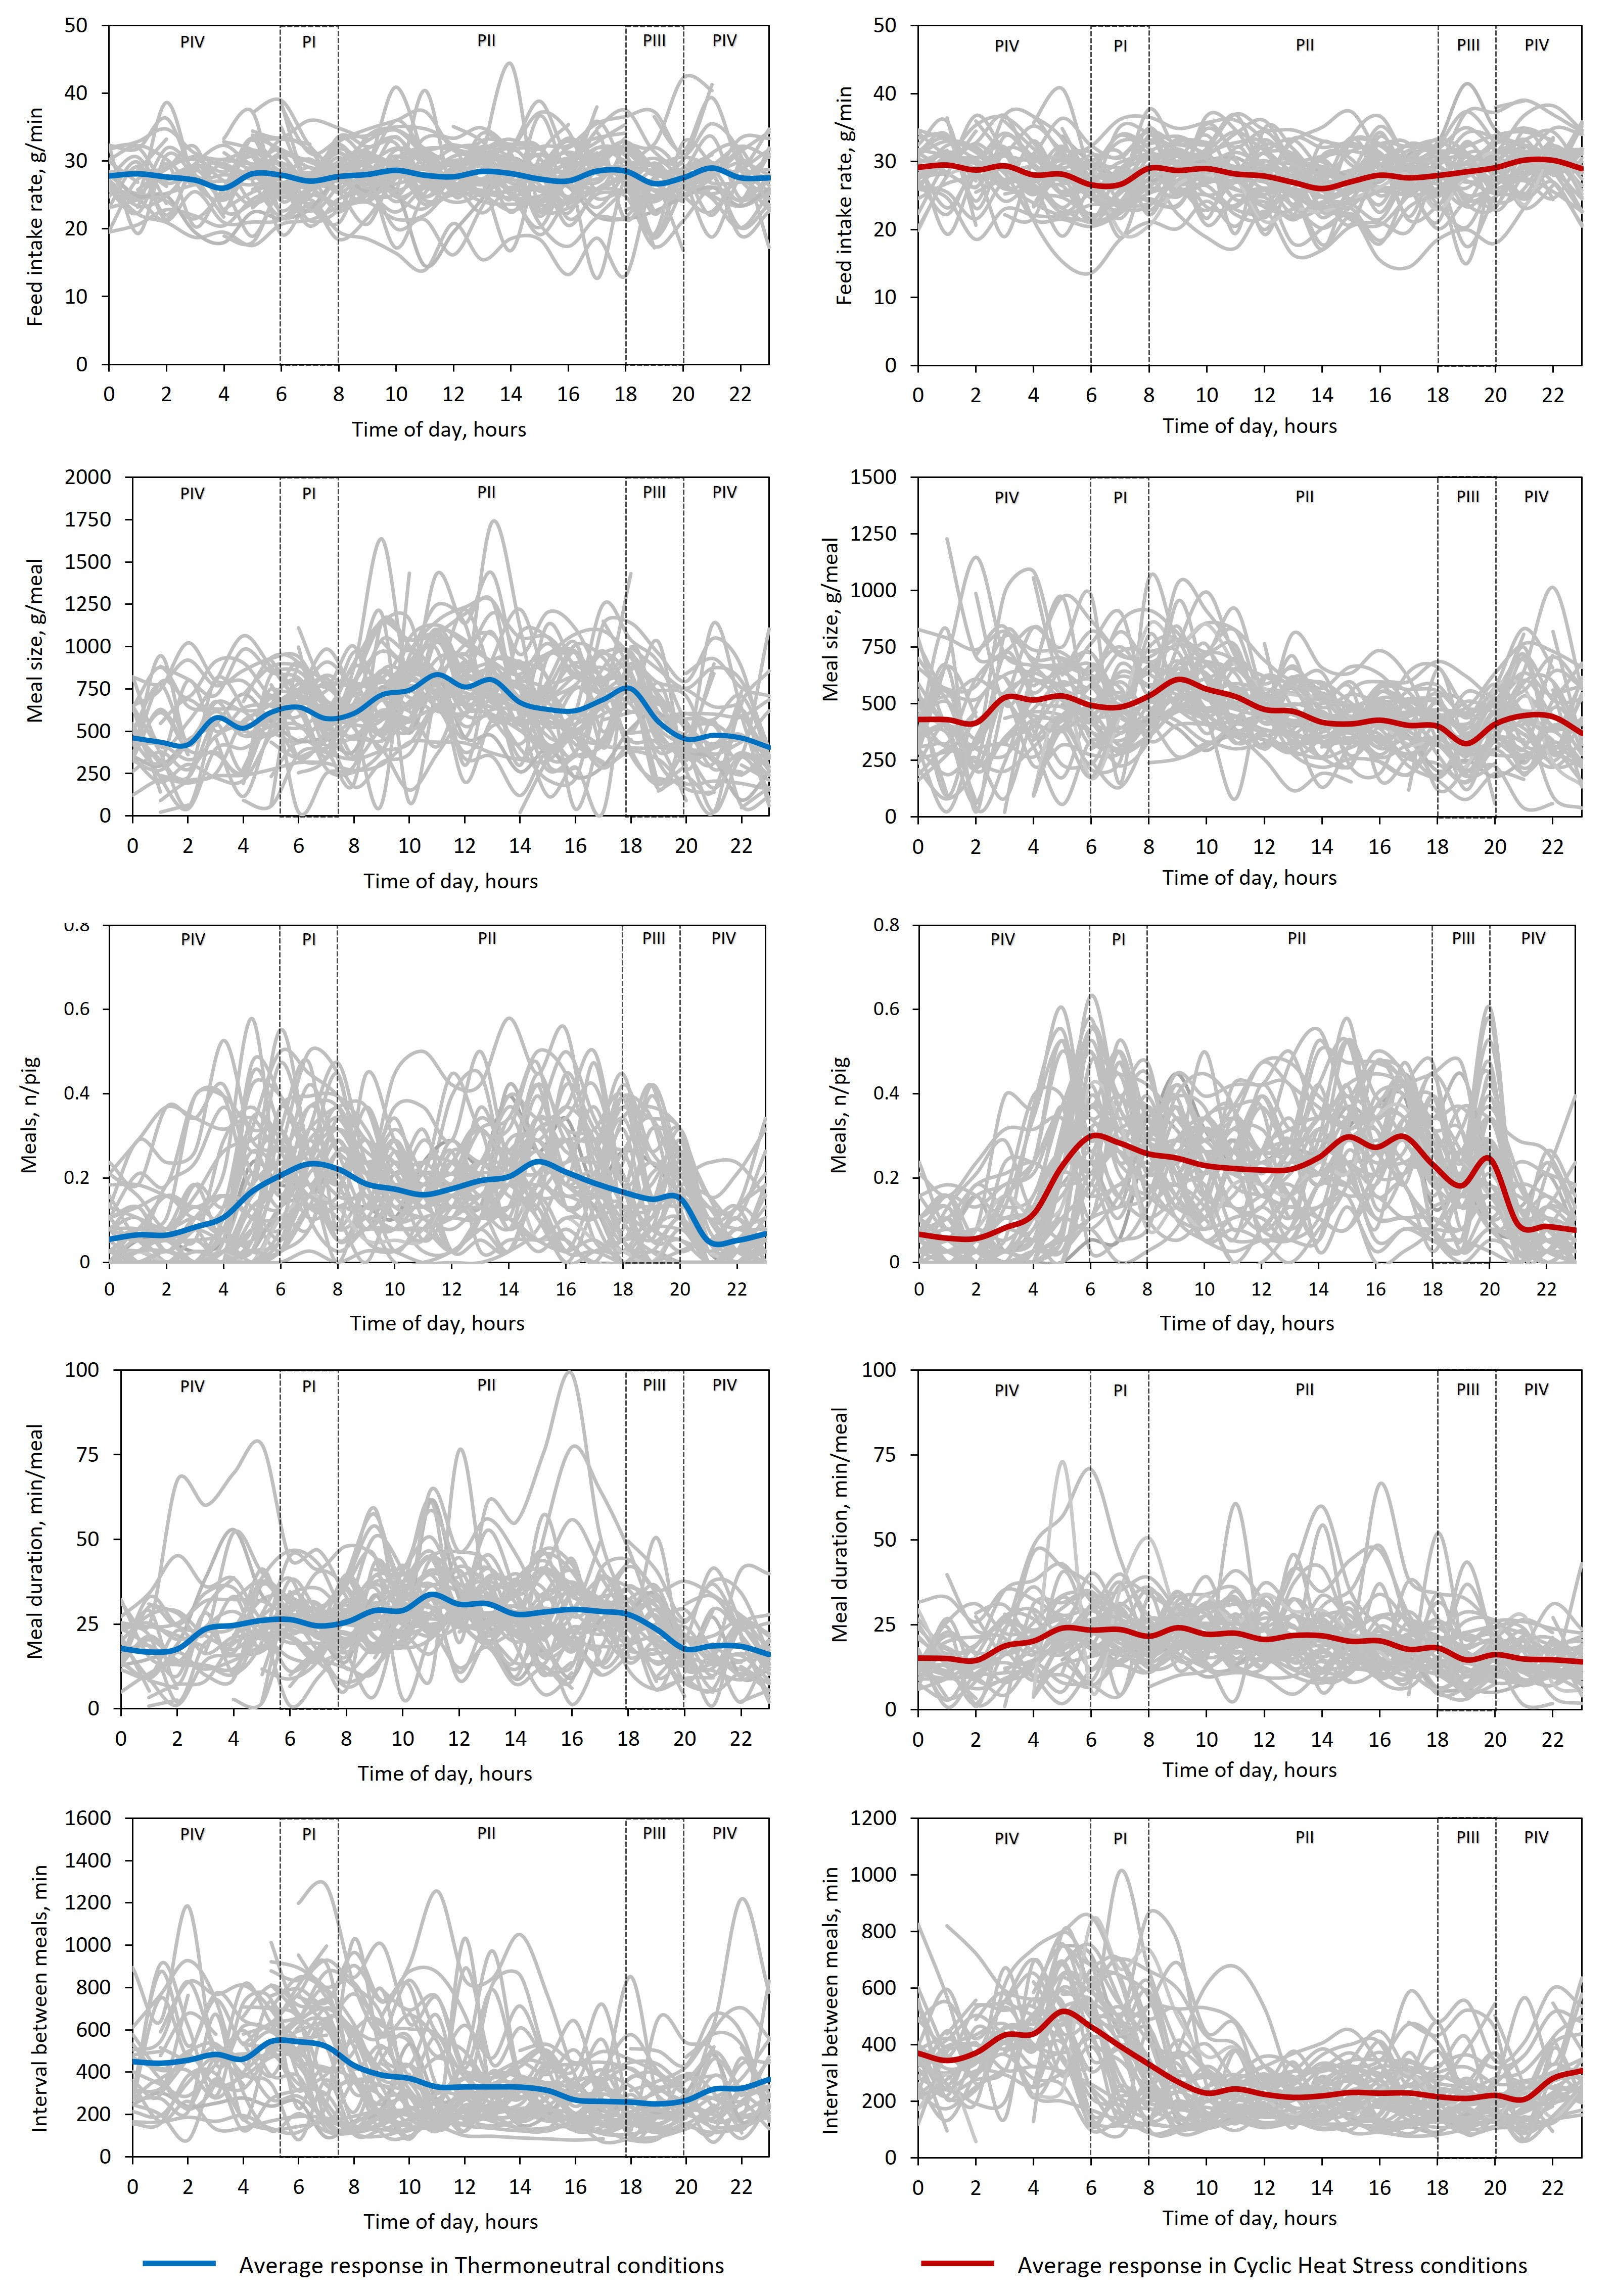
Supplementary Figure S1. Individual pig behavior profiles of pigs during the experimental period throughout 24 h-day according to ambient temperature (Thermoneutral vs. Cyclic heat stress) and periods of the day: PI (06-08 h); PII (08-18 h); PIII (18-20 h); PIV (20-06 h). The thermoneutrality condition was 24 h at 22°C, while the cyclic heat stress condition was 12 h at 22 °C, 20-08 h, and 12 h at 35 °C, 8-20 h.

