Supporting information

Strong external electric fields reduce explosive sensitivity. A theoretical investigation into the reaction selectivity in NH₂NO₂∙∙∙NH₃
Fu-de Ren, Ying-zhe Liu, Xiao-lei Wang, Li-li Qiu, Zi-hui Meng, Xiang Cheng, Yong-xiang Li

Supplementary Tables

Table S1 Barriers (E_{a}) and bond dissociation energies (BDE) at the MP2/6-311++G(2d,p) and CCSD(T)/6-311++G(2d,p)//MP2/6-311++G(2d,p) levels.
Table S2 The optimized geometrical parameters in the different field strengths and orientations at the MP2/6-311++G(2d,p) level.
Table S3 Mulliken charges and APT charges of the atoms as well as the index of imaginary vibration ( and ) of TS1 under the −x-direction field at the MP2/6-311++G(2d,p) level.
Table S4 Mulliken charges and APT charges of the atoms of TS2 under the −x-direction field at the MP2/6-311++G(2d,p) level.
Figure S1 Changes of the activation distances versus field strengths in the different field orientations for transition states at the MP2/6-311++G(2d,p) level.

Table S1 Barriers (E_{a}) and bond dissociation energies (BDE) at the MP2/6-311++G(2d,p) and CCSD(T)/6-311++G(2d,p)//MP2/6-311++G(2d,p) levels.
Field | E_{a,TS1}(MP2) | E_{a,TS1}(CCSD(T)) | E_{a,TS2}(MP2) | E_{a,TS2}(CCSD(T)) | BDE(MP2) | BDE(CCSD(T))
No field | 68.38 | 77.16 | 176.15 | 190.25 | 257.63 | 239.12
z-0.010 | 71.29 | 79.26 | 235.4 | 246.18 | 252.05 | 236.75
z-0.008 | 75.04 | 81.14 | 219.18 | 237.22 | 253.89 | 227.01
z-0.006 | 67.02 | 76.55 | 210.22 | 233.12 | 255.72 | 238.46
z-0.004 | 69.18 | 79.13 | 190.18 | 208.51 | 256.18 | 238.85
z-0.002 | 70.22 | 78.27 | 181.23 | 200.17 | 257.54 | 239.07
z+0.002 | 71.08 | 79.15 | 176.51 | 191.32 | 258.19 | 241.5
z+0.004 | 68.99 | 78.53 | 172.18 | 186.57 | 258.42 | 243.64
z+0.006 | 72.17 | 79.26 | 170.66 | 185.03 | 259.76 | 245.57
z+0.008 | 70.02 | 81.18 | 156.03 | 172.31 | 261.22 | 247.16
z+0.010 | 74.18 | 85.62 | 158.94 | 177.22 | 262.18 | 248.64
y-0.010 | 86.55 | 95.17 | 195.62 | 212.31 | 247.92 | 235.32
y-0.008 | 81.22 | 94.02 | 194.28 | 213.58 | 249.58 | 238.45
y-0.006 | 73.17 | 85.18 | 192.1 | 212.12 | 250.61 | 240.42
y-0.004 | 70.89 | 82.03 | 187.18 | 208.53 | 253.26 | 238.94
y-0.002 | 74.25 | 82.96 | 183.25 | 192.54 | 255.2 | 239.13
y+0.002 | 73.17 | 83.27 | 181.16 | 190.62 | 259.18 | 242.01
y+0.004 | 74.22 | 85.18 | 184.23 | 195.18 | 262.25 | 244.72
y+0.006 | 75.89 | 87.22 | 190.55 | 209.32 | 265.37 | 246.84
y+0.008 | 79.03 | 91.05 | 202.58 | 219.18 | 267.85 | 248.89
y+0.010 | 87.92 | 98.28 | 214.56 | 228.17 | 269.3 | 259.29
x+0.010 | 45.89 | 57.03 | 168.51 | 181.55
x+0.008 |  |  | 169.51 | 181.17
x+0.006 |  |  | 170.22 | 182.18
x+0.004 | 48.02 | 60.18 | 175.36 | 186.05 | 256.03 | 236.36
x+0.002 | 50.40 | 60.13 | 174.01 | 188.51 | 256.92 | 239.25
x-0.002 | 86.41 | 97.14 | 178.4 | 193.06 | 258.5 | 239.25
x-0.004 | 100.98 | 116.55 | 179.28 | 194.22 | 261.26 | 242.42
x-0.006 | 114.02 | 132.23 | 182.03 | 196.53 | 262.74 | 246.98
x-0.008 | 143.49 | 161.53 | 183.28 | 195.89 | 267.91 | 250.69
x-0.010 | 183.98 | 206.28 | 190.18 | 203.24 | 270.18 | 255.38
x-0.012 | 202.17 | 207.16 | 205.14 | 218.19
x-0.014 | 239.18 | 257.18 | 212.57 | 230.17
x-0.016 | 253.22 | 279.06 | 229.32 | 245.18
x-0.018 | 262.17 | 284.18 | 234.18 | 249.55
x-0.019 | 275.10 | 288.62 | 242.07 | 256.18
x-0.020 | 291.35 | 296.52 | 257.09 | 272.18

Table S2 The optimized geometrical parameters in the different field strengths and orientations at the MP2/6-311++G(2d,p) level.
Field | Intermolecular hydrogen exchange (TS1) |  |  |  |  |  | 1,3-Intramolecular hydrogen transfer (TS2)
Field | R_{O8∙∙∙H7} | R_{H7∙∙∙N6} | R_{N6∙∙∙H5} | R_{H5∙∙∙N1} | R_{N1-H4} | R_{H4∙∙∙O3} | R_{O8∙∙∙H7} | R_{H7-N6} | R_{N6∙∙∙H5} | R_{H5-N1} | R_{N1∙∙∙H4} | R_{H4∙∙∙O3}
Nofield | 1.607 | 1.073 | 1.100 | 1.580 | 1.019 | 2.260 | 2.700 | 1.018 | 1.905 | 1.040 | 1.291 | 1.320
z-0.010 | 1.483 | 1.128 | 1.137 | 1.523 | 1.018 | 2.247 | 2.244 | 1.020 | 2.129 | 1.030 | 1.288 | 1.314
z-0.008 | 1.528 | 1.113 | 1.131 | 1.530 | 1.019 | 2.250 | 2.262 | 1.020 | 2.078 | 1.032 | 1.286 | 1.318
z-0.006 | 1.553 | 1.099 | 1.123 | 1.545 | 1.017 | 2.255 | 2.307 | 1.020 | 2.033 | 1.033 | 1.285 | 1.320
z-0.004 | 1.572 | 1.085 | 1.115 | 1.562 | 1.019 | 2.256 | 2.376 | 1.019 | 1.987 | 1.035 | 1.283 | 1.324
z-0.002 | 1.591 | 1.077 | 1.108 | 1.573 | 1.019 | 2.258 | 2.491 | 1.018 | 1.945 | 1.038 | 1.287 | 1.322
z+0.002 | 1.613 | 1.072 | 1.096 | 1.582 | 1.019 | 2.263 | 3.200 | 1.017 | 1.872 | 1.044 | 1.294 | 1.316
z+0.004 | 1.627 | 1.067 | 1.088 | 1.588 | 1.018 | 2.265 | 4.019 | 1.016 | 1.872 | 1.045 | 1.298 | 1.310
z+0.006 | 1.650 | 1.060 | 1.080 | 1.596 | 1.020 | 2.266 | 3.805 | 1.016 | 1.842 | 1.050 | 1.300 | 1.310
z+0.008 | 1.658 | 1.057 | 1.075 | 1.600 | 1.020 | 2.269 | 3.948 | 1.016 | 1.827 | 1.054 | 1.304 | 1.307
z+0.01 | 1.688 | 1.055 | 1.061 | 1.612 | 1.019 | 2.272 | 4.534 | 1.017 | 1.829 | 1.055 | 1.312 | 1.300
y-0.010 | 1.681 | 1.060 | 1.072 | 1.618 | 1.021 | 2.245 | 2.735 | 1.016 | 1.907 | 1.043 | 1.297 | 1.315
y-0.008 | 1.667 | 1.066 | 1.081 | 1.613 | 1.019 | 2.247 | 2.722 | 1.016 | 1.909 | 1.042 | 1.294 | 1.318
y-0.006 | 1.640 | 1.068 | 1.090 | 1.600 | 1.019 | 2.252 | 2.713 | 1.016 | 1.908 | 1.042 | 1.293 | 1.318
y-0.004 | 1.622 | 1.072 | 1.095 | 1.587 | 1.020 | 2.256 | 2.708 | 1.018 | 1.908 | 1.041 | 1.293 | 1.319
y-0.002 | 1.610 | 1.072 | 1.097 | 1.583 | 1.019 | 2.260 | 2.703 | 1.018 | 1.906 | 1.040 | 1.292 | 1.320
y+0.002 | 1.608 | 1.070 | 1.098 | 1.581 | 1.019 | 2.257 | 2.711 | 1.017 | 1.906 | 1.040 | 1.292 | 1.320
y+0.004 | 1.626 | 1.068 | 1.092 | 1.592 | 1.018 | 2.256 | 2.713 | 1.018 | 1.907 | 1.041 | 1.293 | 1.318
y+0.006 | 1.640 | 1.063 | 1.083 | 1.598 | 1.019 | 2.254 | 2.719 | 1.019 | 1.909 | 1.041 | 1.294 | 1.317
y+0.008 | 1.658 | 1.061 | 1.072 | 1.610 | 1.020 | 2.254 | 2.725 | 1.017 | 1.912 | 1.043 | 1.295 | 1.315
y+0.010 | 1.672 | 1.058 | 1.068 | 1.616 | 1.020 | 2.253 | 2.730 | 1.017 | 1.915 | 1.044 | 1.297 | 1.314
x+0.010 | 1.715 | 1.052 | 1.071 | 1.635 | 1.018 | 2.221 | 2.218 | 1.016 | 2.075 | 1.025 | 1.307 | 1.326
x+0.008 | 1.712 | 1.055 | 1.080 | 1.629 | 1.017 | 2.223 | 2.239 | 1.018 | 2.068 | 1.030 | 1.300 | 1.327
x+0.006 | 1.714 | 1.052 | 1.083 | 1.625 | 1.018 | 2.236 | 2.327 | 1.017 | 2.005 | 1.033 | 1.299 | 1.323
x+0.004 | 1.716 | 1.053 | 1.092 | 1.613 | 1.018 | 2.244 | 2.458 | 1.017 | 1.988 | 1.035 | 1.295 | 1.323
x+0.002 | 1.658 | 1.062 | 1.095 | 1.598 | 1.018 | 2.252 | 2.534 | 1.018 | 1.943 | 1.037 | 1.293 | 1.322
x-0.002 | 1.562 | 1.084 | 1.106 | 1.559 | 1.019 | 2.268 | 3.017 | 1.018 | 1.874 | 1.044 | 1.290 | 1.317
x-0.004 | 1.521 | 1.097 | 1.114 | 1.534 | 1.019 | 2.278 | 3.314 | 1.018 | 1.853 | 1.047 | 1.289 | 1.313
x-0.006 | 1.481 | 1.111 | 1.124 | 1.507 | 1.020 | 2.288 | 2.940 | 1.018 | 1.833 | 1.053 | 1.286 | 1.313
x-0.008 | 1.443 | 1.127 | 1.137 | 1.476 | 1.020 | 2.300 | 2.956 | 1.019 | 1.809 | 1.058 | 1.284 | 1.311
x-0.010 | 1.467 | 1.117 | 1.100 | 1.606 | 1.026 | 2.303 | 2.955 | 1.019 | 1.785 | 1.064 | 1.283 | 1.310
x-0.012 | 1.563 | 1.089 | 1.076 | 1.727 | 1.028 | 2.300 | 2.956 | 1.020 | 1.756 | 1.072 | 1.282 | 1.308
x-0.014 | 1.402 | 1.102 | 1.058 | 1.652 | 1.029 | 2.322 | 2.949 | 1.020 | 1.725 | 1.081 | 1.281 | 1.306
x-0.016 | 1.331 | 1.145 | 1.128 | 1.418 | 1.027 | 2.350 | 2.932 | 1.021 | 1.687 | 1.092 | 1.281 | 1.304
x-0.018 | 1.256 | 1.258 | 1.253 | 1.382 | 1.025 | 2.368 | 2.904 | 1.021 | 1.637 | 1.110 | 1.282 | 1.302
x-0.019 | 1.620 | 1.283 | 1.280 | 1.300 | 1.025 | 2.371 | 2.882 | 1.022 | 1.600 | 1.125 | 1.283 | 1.302
x-0.020 | 1.187 | 1.315 | 1.315 | 1.255 | 1.024 | 2.382 | 2.835 | 1.022 | 1.535 | 1.154 | 1.286 | 1.299

Table S3 Mulliken charges and APT charges (in bold) of the atoms as well as the index of imaginary vibration ( and ) of TS1 under the −x-direction field at the MP2/6-311++G(2d,p) level.
 | 0.000 | -0.002 | -0.004 | -0.006 | -0.008 | -0.010 | -0.012 | -0.014 | -0.016 | -0.018 | -0.019 | -0.020
O8 | -0.444  -0.901 | -0.448  -0.916 | -0.452  -0.928 | -0.455  -0.938 | -0.457  -0.946 | -0.463  -0.936 | -0.474  -0.933 | -0.460  -0.928 | -0.452  -0.927 | -0.443  -0.923 | -0.439  -0.920 | -0.430  -0.918
H7 | 0.495  0.523 | 0.512  0.549 | 0.528  0.573 | 0.545  0.596 | 0.561  0.618 | 0.525  0.574 | 0.474  0.511 | 0.468  0.503 | 0.499  0.540 | 0.613  0.625 | 0.630  0.667 | 0.634  0.679
N6 | -0.786  -0.600 | -0.813  -0.628 | -0.840  -0.657 | -0.872  -0.689 | -0.907  -0.721 | -0.818  -0.646 | -0.718  -0.543 | -0.922  -0.629 | -1.023  -0.638 | -1.078  -0.754 | -1.145  -0.913 | -1.195  -0.922
H5 | 0.546  0.589 | 0.551  0.601 | 0.558  0.615 | 0.566  0.632 | 0.576  0.651 | 0.494  0.571 | 0.447  0.497 | 0.498  0.575 | 0.516  0.577 | 0.606  0.682 | 0.617  0.753 | 0.620  0.764
N1 | -0.656  -0.849 | -0.655  -0.846 | -0.654  -0.844 | -0.655  -0.843 | -0.656  -0.843 | -0.645  -0.768 | -0.693  -0.746 | -0.683  -0.775 | -0.652  -0.783 | -0.654  -0.825 | -0.612  -0.799 | -0.610  -0.838
 | 0.352 | 0.356 | 0.358 | 0.365 | 0.375 | 0.395 | 0.364 | 0.360 | 0.352 | 0.367 | 0.368 | 0.371
 | 0.355 | 0.376 | 0.399 | 0.412 | 0.421 | 0.371 | 0.357 | 0.353 | 0.340 | 0.421 | 0.430 | 0.433

Table S4 Mulliken charges and APT charges (in bold) of the atoms of TS2 under the −x-direction field at the MP2/6-311++G(2d,p) level.
 | 0.000 | -0.002 | -0.004 | -0.006 | -0.008 | -0.010 | -0.012 | -0.014 | -0.016 | -0.018 | -0.019 | -0.020
O3 | -0.306  -0.751 | -0.321  -0.771 | -0.340  -0.790 | -0.341  -0.798 | -0.351  -0.813 | -0.361  -0.828 | -0.371  -0.844 | -0.381  -0.861 | -0.391  -0.880 | -0.401  -0.901 | -0.406  -0.914 | -0.409  -0.930
H4 | 0.425  0.477 | 0.421  0.479 | 0.418  0.480 | 0.411  0.482 | 0.405  0.484 | 0.400  0.485 | 0.394  0.487 | 0.388  0.489 | 0.382  0.491 | 0.375  0.493 | 0.371  0.494 | 0.365  0.495
N1 | -0.527  -0.796 | -0.576  -0.821 | -0.620  -0.838 | -0.565  -0.837 | -0.570  -0.848 | -0.574  -0.860 | -0.579  -0.874 | -0.584  -0.887 | -0.590  -0.903 | -0.599  -0.923 | -0.606  -0.935 | -0.619  -0.953

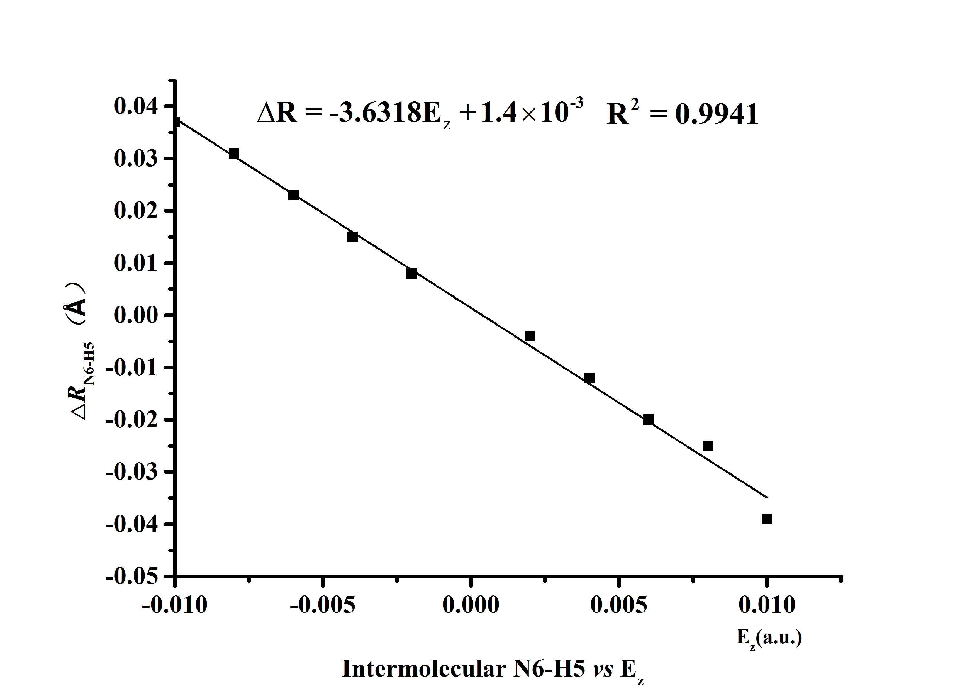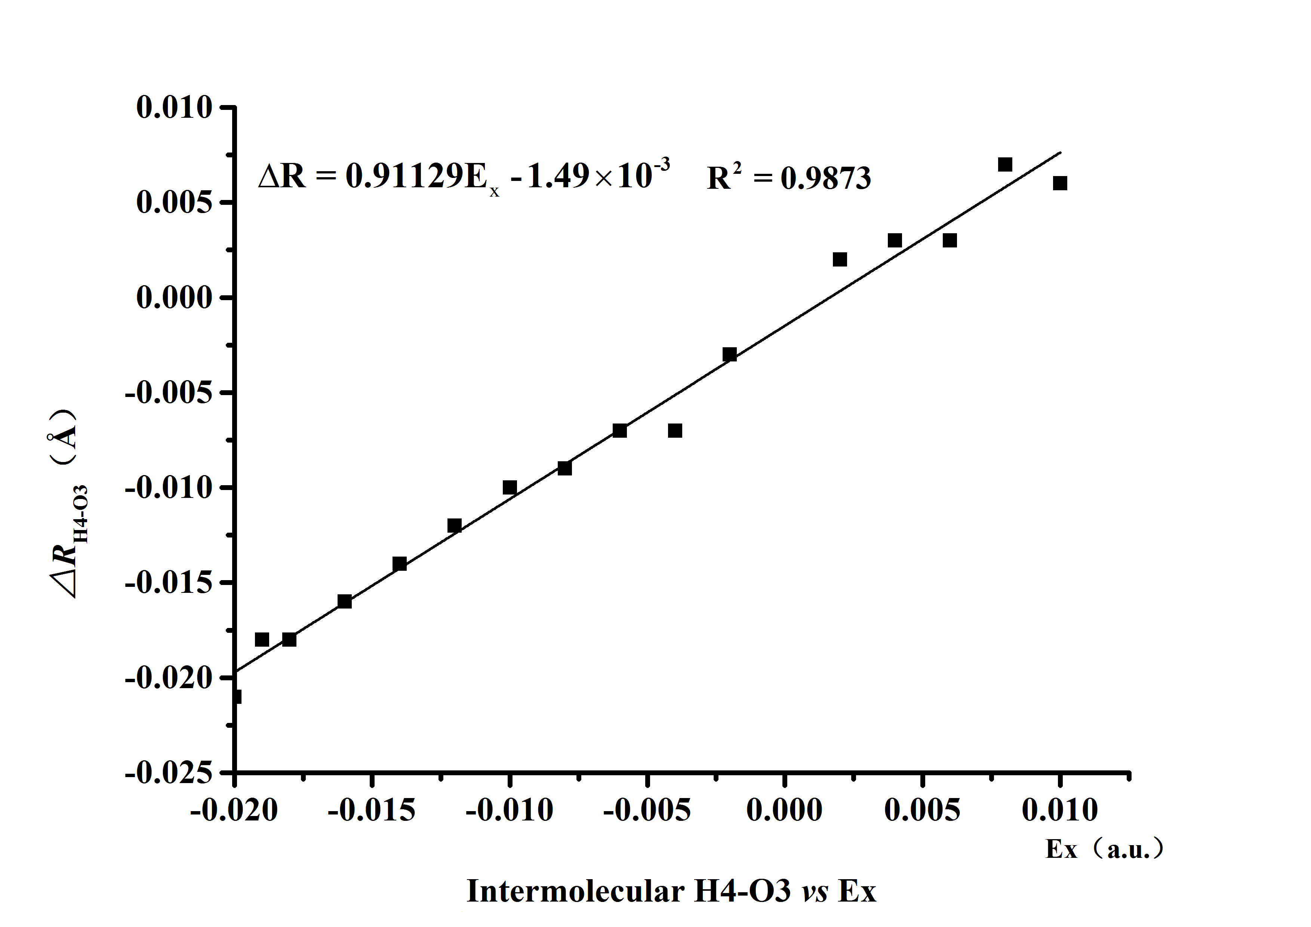
N6∙∙∙H5 distances vs. E_{z} (TS1) H4∙∙∙O3 distances vs. E_{x} (TS2)
Figure S1 Changes of the activation distances versus field strengths in the different field orientations for transition states at the MP2/6-311++G(2d,p) level.

