Supporting information
Molecular dynamics simulations suggest SARS-CoV-2 3CLpro mutations in Beta and Omicron variants do not alter binding affinities for cleavage sites of non-structural proteins
Vitor Martins de Freitas Amorim¹, Robson Francisco de Souza¹, Cristiane Rodrigues Guzzo¹,* and Anacleto Silva de Souza¹,*
¹Department of Microbiology, Institute of Biomedical Sciences, University of São Paulo, São Paulo, Brazil.
* Corresponding author
E-mail: crisguzzo@usp.br and crisguzzo@gmail.com
E-mail: anacletosilvadesouza@usp.br and anacletosilvadesouza@gmail.com
To whom correspondence should be addressed:
Cristiane R. Guzzo, Ph.D, Department of Microbiology, Institute of Biomedical Sciences, University of São Paulo, Av. Prof. Lineu Prestes, 1374, Cidade Universitária, 5508-900, São Paulo/SP, Brazil, +55 11 3091-7298; E-mail: crisguzzo@usp.br
Anacleto Silva de Souza, Ph.D, Department of Microbiology, Institute of Biomedical Sciences, University of São Paulo, Av. Prof. Lineu Prestes, 1374, Cidade Universitária, 5508-900, São Paulo/SP, Brazil, +55 11 3091-7298; E-mail: anacletosilvadesouza@usp.br
Keywords: main viral protease; infectivity; substrate binding affinity; evolution

BA.1 SGFRKMAFPSGKVEGCMVQVTCGTTTLNGLWLDDVVYCPRHVICTSEDMLNPNYEDLLIR 60
BETA SGFRKMAFPSGKVEGCMVQVTCGTTTLNGLWLDDVVYCPRHVICTSEDMLNPNYEDLLIR 60
H41A SGFRKMAFPSGKVEGCMVQVTCGTTTLNGLWLDDVVYCPRAVICTSEDMLNPNYEDLLIR 60
WT SGFRKMAFPSGKVEGCMVQVTCGTTTLNGLWLDDVVYCPRHVICTSEDMLNPNYEDLLIR 60
**************************************** *******************

BA.1 KSNHNFLVQAGNVQLRVIGHSMQNCVLKLKVDTANPKTPKYKFVRIQPGQTFSVLACYNG 120
BETA KSNHNFLVQAGNVQLRVIGHSMQNCVLKLRVDTANPKTPKYKFVRIQPGQTFSVLACYNG 120
H41A KSNHNFLVQAGNVQLRVIGHSMQNCVLKLKVDTANPKTPKYKFVRIQPGQTFSVLACYNG 120
WT KSNHNFLVQAGNVQLRVIGHSMQNCVLKLKVDTANPKTPKYKFVRIQPGQTFSVLACYNG 120
*****************************:******************************

BA.1 SPSGVYQCAMRHNFTIKGSFLNGSCGSVGFNIDYDCVSFCYMHHMELPTGVHAGTDLEGN 180
BETA SPSGVYQCAMRPNFTIKGSFLNGSCGSVGFNIDYDCVSFCYMHHMELPTGVHAGTDLEGN 180
H41A SPSGVYQCAMRPNFTIKGSFLNGSCGSVGFNIDYDCVSFCYMHHMELPTGVHAGTDLEGN 180
WT SPSGVYQCAMRPNFTIKGSFLNGSCGSVGFNIDYDCVSFCYMHHMELPTGVHAGTDLEGN 180
*********** ************************************************

BA.1 FYGPFVDRQTAQAAGTDTTITVNVLAWLYAAVINGDRWFLNRFTTTLNDFNLVAMKYNYE 240
BETA FYGPFVDRQTAQAAGTDTTITVNVLAWLYAAVINGDRWFLNRFTTTLNDFNLVAMKYNYE 240
H41A FYGPFVDRQTAQAAGTDTTITVNVLAWLYAAVINGDRWFLNRFTTTLNDFNLVAMKYNYE 240
WT FYGPFVDRQTAQAAGTDTTITVNVLAWLYAAVINGDRWFLNRFTTTLNDFNLVAMKYNYE 240
************************************************************

BA.1 PLTQDHVDILGPLSAQTGIAVLDMCASLKELLQNGMNGRTILGSALLEDEFTPFDVVRQC 300
BETA PLTQDHVDILGPLSAQTGIAVLDMCASLKELLQNGMNGRTILGSALLEDEFTPFDVVRQC 300
H41A PLTQDHVDILGPLSAQTGIAVLDMCASLKELLQNGMNGRTILGSALLEDEFTPFDVVRQC 300
WT PLTQDHVDILGPLSAQTGIAVLDMCASLKELLQNGMNGRTILGSALLEDEFTPFDVVRQC 300
************************************************************

BA.1 SGVT 304
BETA SGVT 304
H41A SGVT 304
WT SGVT 304
****

Figure S1. Multiple alignment of the amino acid sequence of 3CLpro^{H41A}, 3CLpro^{WT}, 3CLpro^{Beta} and 3CLpro^{BA.1}. Global multiple alignment (using Clustal W, [1]) of 3CLpro amino acid sequences from different SARS-CoV-2 strains. This alignment shows that the Beta and Omicron variants have substitutions at K90R (K3353R) and P132H (P3395H) respectively.

Table S1. Hydrogen bonding occupancies of potential 3CLpro inhibitors.
Inhibitor | Chemical structure | Residues (HBA) | Residues (HBD) | ΔG (kJ/mol) | Ref.
Amentoflavone | 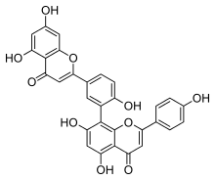 | Arg188 (15.5%), His164 (78.8%) | His41(33.8%), Tyr54 (23.8%), Gln192(45.1%) | -73.8 | [2]
Dalpanitin | 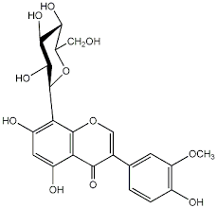 | Asn142 (33%), Arg188 (82.3%) | Gln192 (74.4%), Thr190 (18%), Asn142 (24.7%), Glu166 (67%) | -44.3 | [2]
Hinokiflavone | 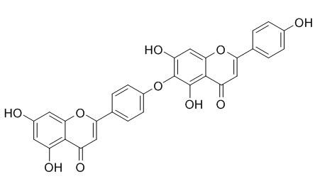 | His41 (19.7%), Thr (10.7%) | Thr26 (39.9%), His41 (40.1%), Arg188 (12.3%), Gly143 (10.4%) | -80.9 | [2]
Naringin | 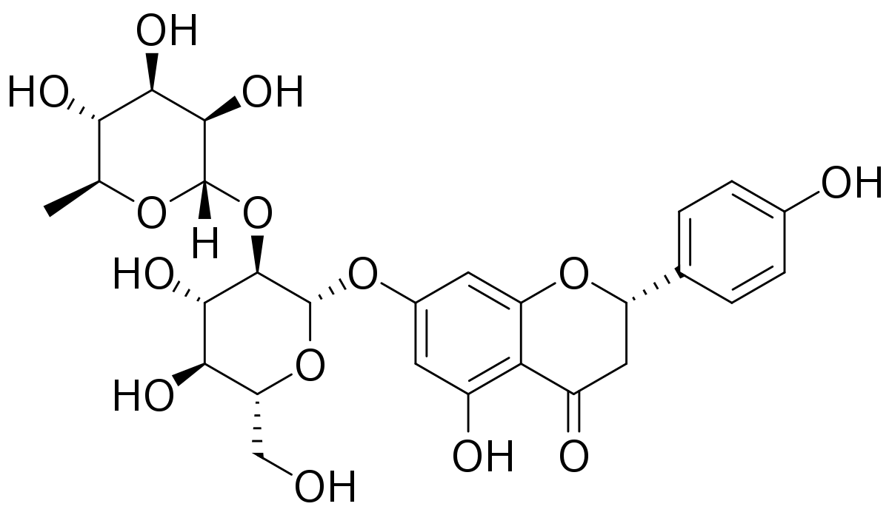 | Thr45 (25.2%), His41 (23.2%), His164 (39.8%), Met49 (24.7%) | Ser46 (42.7%), Ser144 (72.2%),  Cys145 (82%) | -69.0 | [2]
Dihydrostreptomycin | 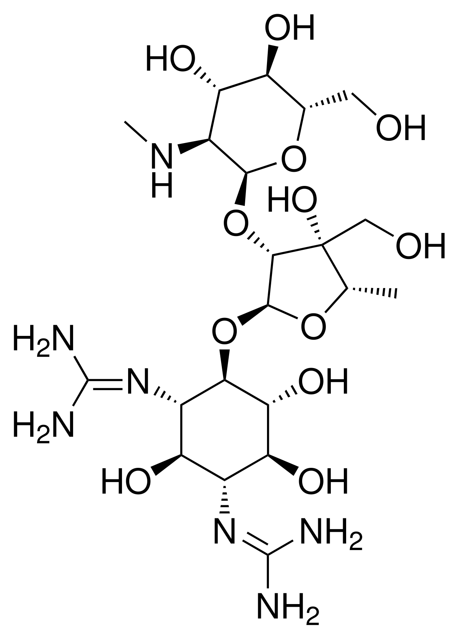 | Glu166 (88.9%), Asn142 (66.5%), Gln189 (36%), His41 (0.8%) | Glu166 (55.2%), Cys145 (13.8%), Asn142 (10%) | -365.0 | [3]
Viomycin | 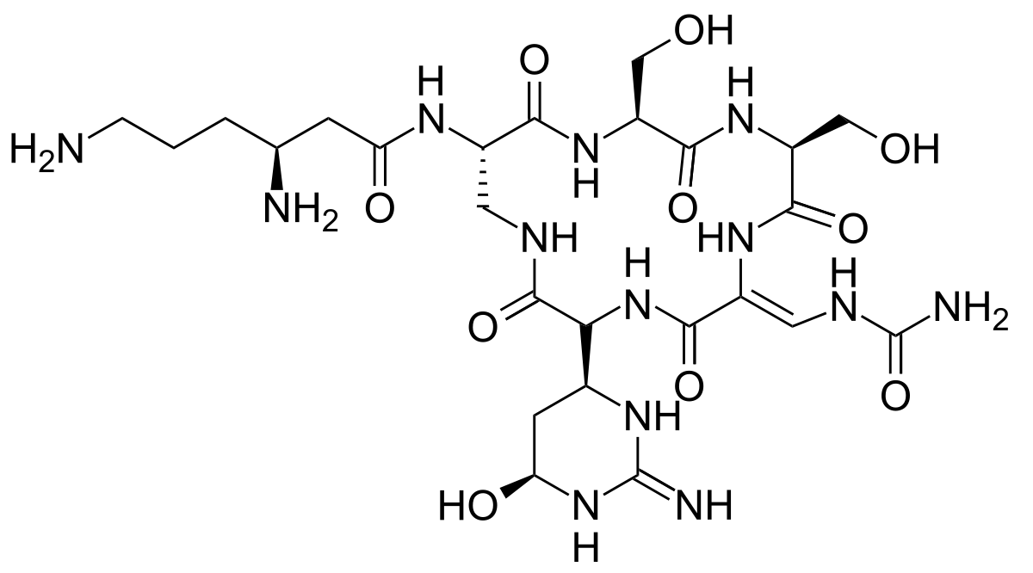 | Glu166 (57.9%), Asn142 (21.7%), Gln189 (16.2%), His41 (9.37%) | Glu166 (45.8%), Cys145 (13.1%), Asn142 (49.0%) | -377.2 | [3]
Fenoterol | 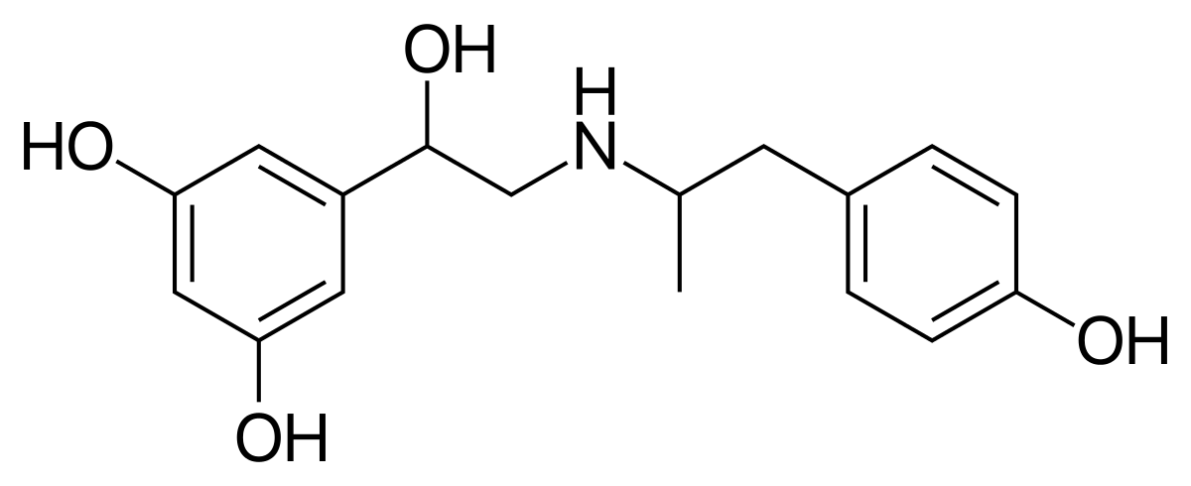 | His41 (56.7%) | Asn142 (9.8%) | -221.8 | [3]
Carvedilol |  | Glu166 (63.8%), | His41 (42%) | -203.7 | [4]
Nebivolol | 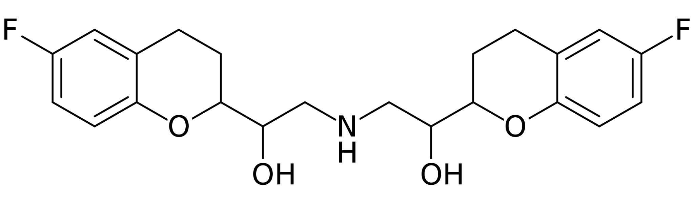 | His41 (59.5%) | Gln192 (75.3%) | -202.7 | [4]

References
1. Thompson, J.D.; Higgins, D.G.; Gibson, T.J. CLUSTAL W: Improving the Sensitivity of Progressive Multiple Sequence Alignment through Sequence Weighting, Position-Specific Gap Penalties and Weight Matrix Choice. Nucleic Acids Res. 1994, 22, 4673–4680.
2. Sawant, S.; Patil, R.; Khawate, M.; Zambre, V.; Shilimkar, V.; Jagtap, S. Computational Assessment of Select Antiviral Phytochemicals as Potential SARS-Cov-2 Main Protease Inhibitors: Molecular Dynamics Guided Ensemble Docking and Extended Molecular Dynamics. In Silico Pharmacol 2021, 9, 44.
3. de Souza, A.S.; de Souza, R.F.; Guzzo, C.R. Quantitative Structure-Activity Relationships, Molecular Docking and Molecular Dynamics Simulations Reveal Drug Repurposing Candidates as Potent SARS-CoV-2 Main Protease Inhibitors. J. Biomol. Struct. Dyn. 2021, 1–18.
4. Hamed, M.I.A.; Darwish, K.M.; Soltane, R.; Chrouda, A.; Mostafa, A.; Abo Shama, N.M.; Elhady, S.S.; Abulkhair, H.S.; Khodir, A.E.; Elmaaty, A.A.; et al. β-Blockers Bearing Hydroxyethylamine and Hydroxyethylene as Potential SARS-CoV-2 Mpro Inhibitors: Rational Based Design, , , and SAR Studies for Lead Optimization. RSC Adv. 2021, 11, 35536–35558.

