Supporting Information

Understanding the role of M13 bacteriophage thin films on a metallic nanostructure through a standard and dynamic model
Thanh Mien Nguyen ^{a, 1}, Cheol Woong Choi ^{b, d, 1}, Ji-Eun Lee ^{c, d, 1}, Damun Heo ^{e}, Eun Jung Choi ª, Jong-Min Lee ^{e, f,*}, Vasanthan Devaraj ^{a,*} and Jin-Woo Oh ^{a, g,*}
ªBio-IT Fusion Technology Research Institute, Pusan National University, Busan, 46241, Republic of Korea
^{b}Department of Internal Medicine, Medical Research Institute and Research Institute for Convergence of Biomedical Science and Technology, Pusan National University Yangsan Hospital, Yangsan-si, 50612, Republic of Korea
^{c}Department of Ophthalmology, Research Institute for Convergence of Biomedical Science and Technology, Pusan National University Yangsan Hospital, Yangsan-si, 50612, Republic of Korea
^{d}School of Medicine, Pusan National University, Yangsan 50612, Republic of Korea
^{e}School of Nano Convergence Technology, Hallym University, Chuncheon, 24252, Republic of Korea
^{f}Center of Nano Convergence Technology, Hallym University, Chuncheon, 24252, Republic of Korea
^{g}Department of Nanoenergy Engineering and Research Center for Energy Convergence Technology, Pusan National University, Busan 46214, Republic of Korea
¹These authors contributed equally
*Corresponding authors email:
jmlee@hallym.ac.kr (JML), devarajvasanthan@gmail.com (VD) and ojw@pusan.ac.kr (JWO)

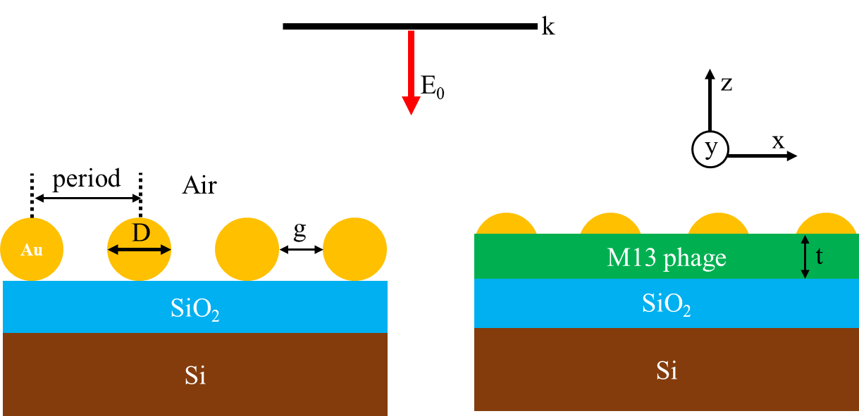
Figure S1. Schematic illustration of simulated model involving M13 phage/Au NPs/SiO₂/Si nanostructure and its geometrical parameters. A plane wave source is used to excite the sample in a normal direction from the top (+Z direction) with an incident electric field of E₀. The NP diameter D = 70 nm, interparticle or gap distance termed as “g”, and thickness of M13 phage as “t”. The period is set to “D+g”.

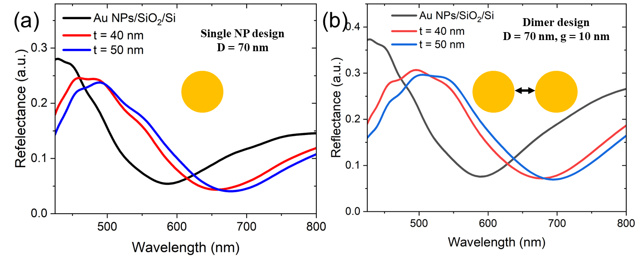
Figure S2. Simulated reflectance spectra from a single (a) and dimer (b) NP model (M13 phage/Au NPs/SiO₂/Si). The black solid line spectra represent the nanostructure without M13 phage. In both these cases, a PML boundary conditions were applied in XYZ directions.
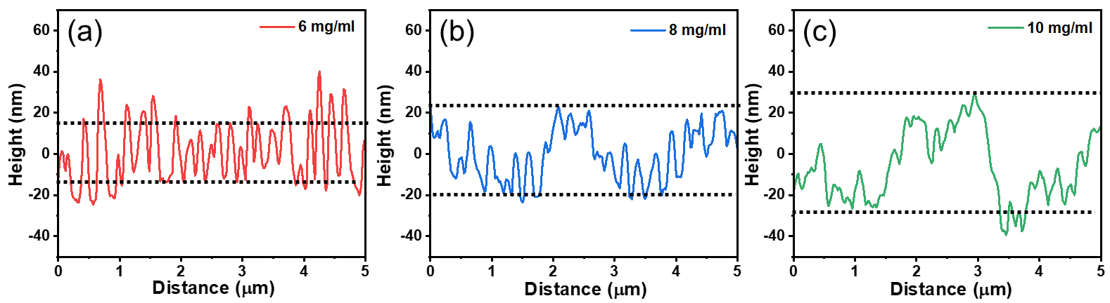
Figure S3. Measure height profiles for the samples coated with 6 mg/ml (a), 8 mg/ml (b), and 10 mg/ml (c) M13 phage concentration. The solid dotted lines is used for easy illustration of an average height obtained from the samples with different M13 phage’s concentration (30 nm, 40 nm, and 50 nm in order, respectively).

