Supplementary Material

Supplemental Figure S1. Plasmid maps of TRV2-GATA-TF, A and TRV2-SPL-TF, B.

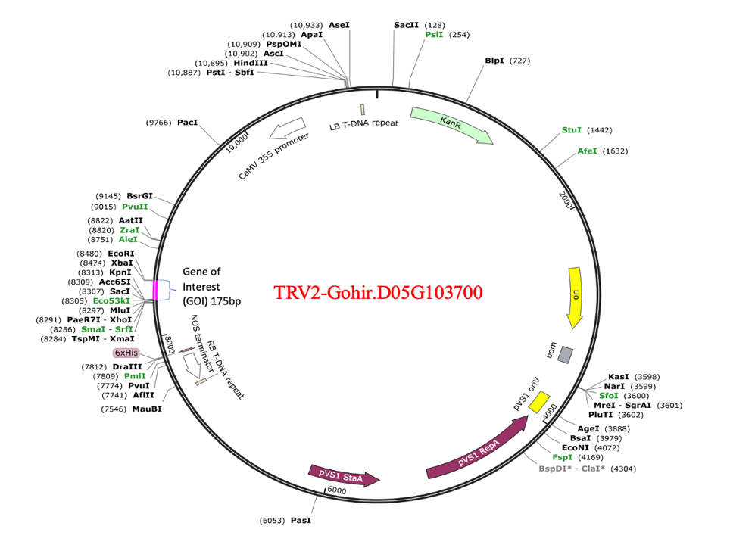
(A)
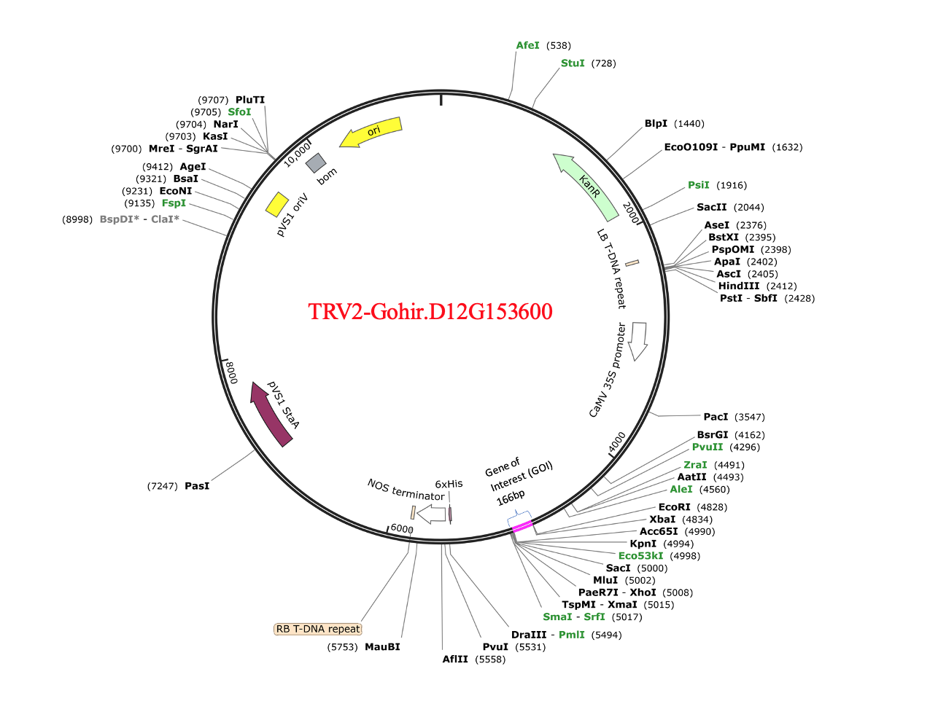
(B)

Supplemental Table S1. List of primers used in this study.
Primer name | Sequences
Gohir.D05G103700-F | ATGGTACCTGGAAGACGTTGAAGGACCT
Gohir.D05G103700-R | GTTCTAGACGGAAGATAAGCTGGCCAAA
Gohir.D12G153600-F | AAGGTACCTGCATTCTTGGATGGGAGGT
Gohir.D12G153600-R | TTTCTAGAGTGATGAAGCGGTGGTTTGT
GhAP1-F | GTGATGCTGAGGTCGCTTTGAT
GhAP1-R | ATGGACCAGTTGCCCTGAGATT
GhFUL-F | AGGAAATGACCCATCAGCCAC
GhFUL-R | GCTGCACTAGGATTACCCTCTTC
GhSOC1-F | AGCATGCAGTGGCAGCATCTGA
GhSOC1-R | TGGCTCTGACGCGGGTTACG
ACTIN1-F | CCTTCCAGCAGATGTGGATT
ACTIN1-R | GATCCCTAACTCTCCCCACA

Note: XbaI and KpnI restriction sites introduced in the PCR product via the primers are highlighted in orange.

Supplemental Table S2. Phenotypic data collected from Gohir.D05G103700, Gohir.D12G153600, and mock treated plants.
Gene | Plant ID | Plant Height (In) | No. of leaves/plant | No. of squares/plant | No. of bracts/square | Observations
Gohir.D05G103700 | G1 | 17.5 | 24 | 4 | 4 | 4 bract square
 | G2 | 18 | 29 | 5 | 4 | 4 bract square
 | G3 | 16 | 17 | 5 | 3 | 4th bract missing
 | G4 | 16 | 16 | 4 | 3 | 4th bract missing
 | G5 | 17.5 | 22 | 4 | 4 | 4 bract square
 | G6 | 17.5 | 21 | 5 | 4 | 4 bract square
Gohir.D12G153600 | P01 | 20 | 21 | 5 | 4 | 4 bract square
 | P02 | 17 | 19 | 6 | 4 | 4 bract square
 | P03 | 15 | 18 | 5 | 4 | 4 bract square
 | P04 | 17 | 19 | 5 | 4 | 4 bract square
 | P05 | 21 | 19 | 6 | 4 | 4 bract square
 | P06 | 19 | 23 | 6 | 4 | 4 bract square
Mock control | C1 | 17 | 17 | 4 | 4 | 4 bract square
 | C2 | 18 | 20 | 4 | 4 | 4 bract square
 | C3 | 18 | 23 | 5 | 4 | 4 bract square
 | C4 | 17 | 19 | 4 | 4 | 4 bract square
 | C5 | 19.5 | 26 | 7 | 4 | 4 bract square
 | C6 | 18 | 23 | 5 | 4 | 4 bract square
LSD_{(0.05)} |  | 1.81 | 4.30 | 0.99 | 0.36

Supplemental Table S3. List of the Tobacco rattle virus (TRV) based Virus Induced Gene Silencing (VIGS) constructs.

Clone name | Stock # | Description
YL192 | CD3-1039 | pTRV1. Tobacco rattle virus (TRV) based cDNA clone was placed between the duplicated CaMV 35S promoter and the nopaline synthase terminator in a T-DNA vector. This construct will be used in VIGS experiments with the following two TRV2 vectors.
YL156 | CD3-1040 | pTRV2-MCS. Tobacco rattle virus (TRV) based cDNA clone was placed between the duplicated CaMV 35S promoter and the nopaline synthase terminator in a T-DNA vector. This construct will be used to clone the hairpin oligos of the genes of interest (see Table 1).

