Supplementary Materials
Chemical profiling of diffusible and volatile secondary metabolites produced by Beauveria bassiana using GC-MS analysis: In vitro antimicrobial activity
Ippolito Camele ¹, Sadeek A. Sadeek ², Rocco Racioppi ³, and Hazem S. Elshafie ^{1,*}
¹ School of Agricultural, Forestry, Food and Environment al Sciences, University of Basilicata, Viale dell’Ateneo Lucano 10, 85100 Potenza, Italy; ippolito.camele@unibas.it (I.C.)
2 Department of Chemistry, Faculty of Science, University of Zagazig, Zagazig 44519, Egypt;
s_sadeek@zu.edu.eg (S.A.S.)
3 Department of Sciences, University of Basilicata, Viale dell’Ateneo Lucano 10, 85100 Potenza, Italy; rocco.raciopi@unibas.it (R.R.)

* Correspondence: hazem.elshafie@unibas.it; Tel.: 0039 0971205498; Fax: 0039 0971205503 (H.S.E.)

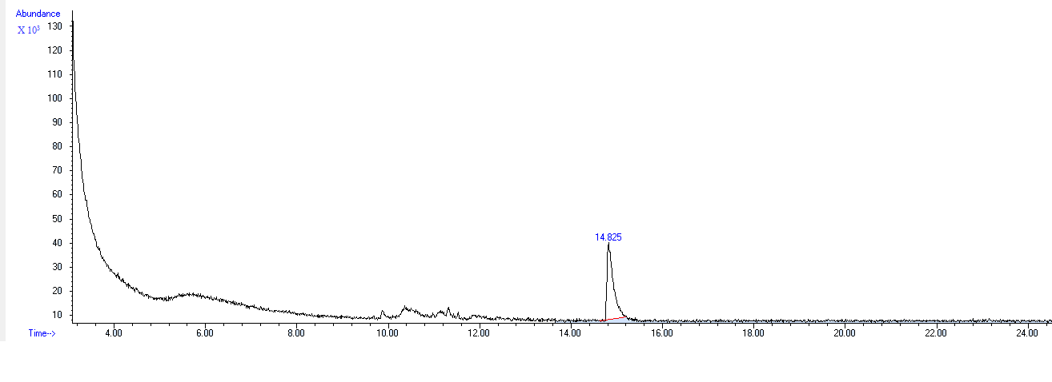
Fig. S1. Chromatogram of the purified diffusible metabolites of B. bassiana UniB2439-3
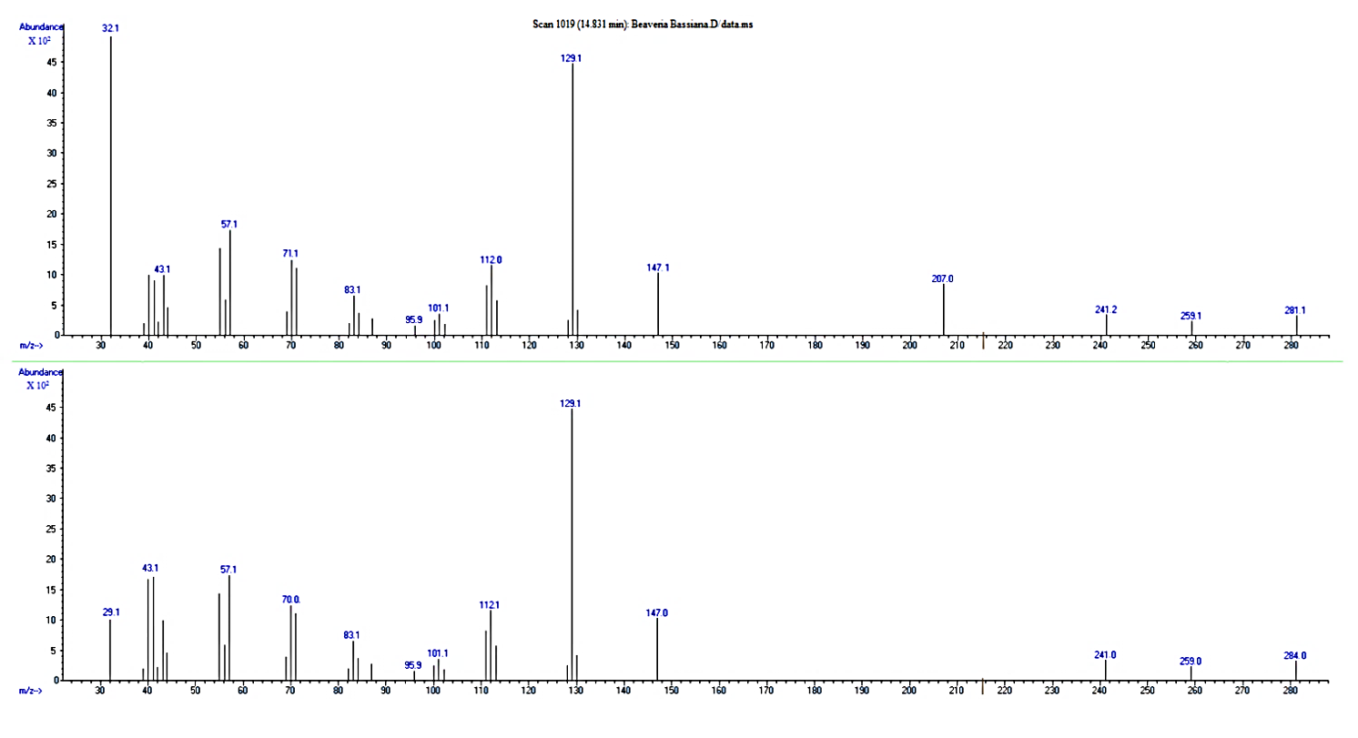
Fig. S2. Mass spectra of Hexanedioic acid, bis(2-ethylhexyl) ester

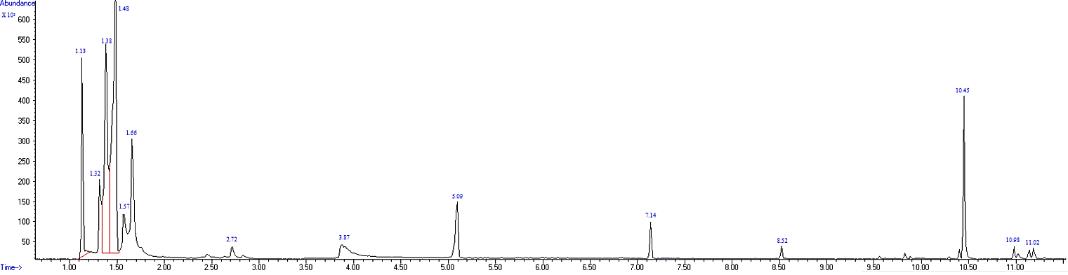
Fig. S3. Chromatogram of VOCs extracted from B. bassiana UniB2439-3

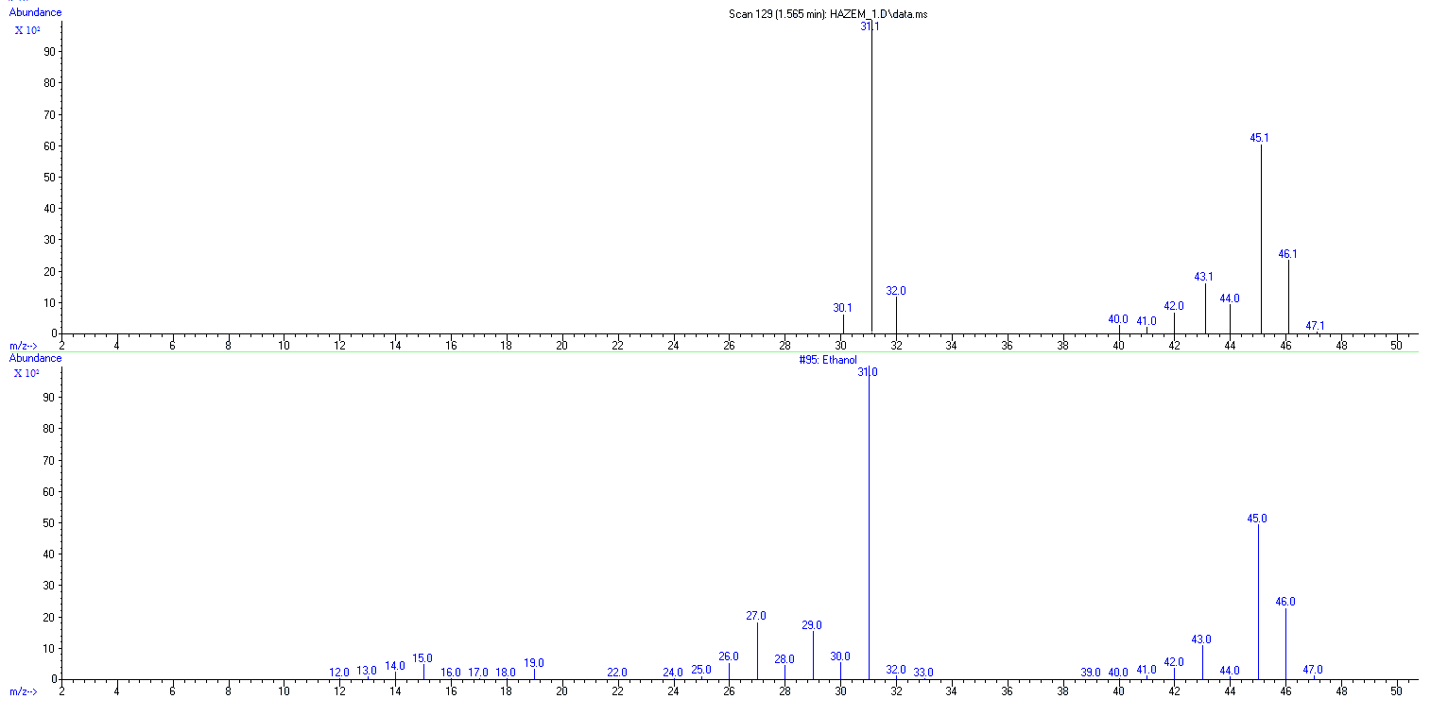
Fig. S4. Mass spectra of ethanol

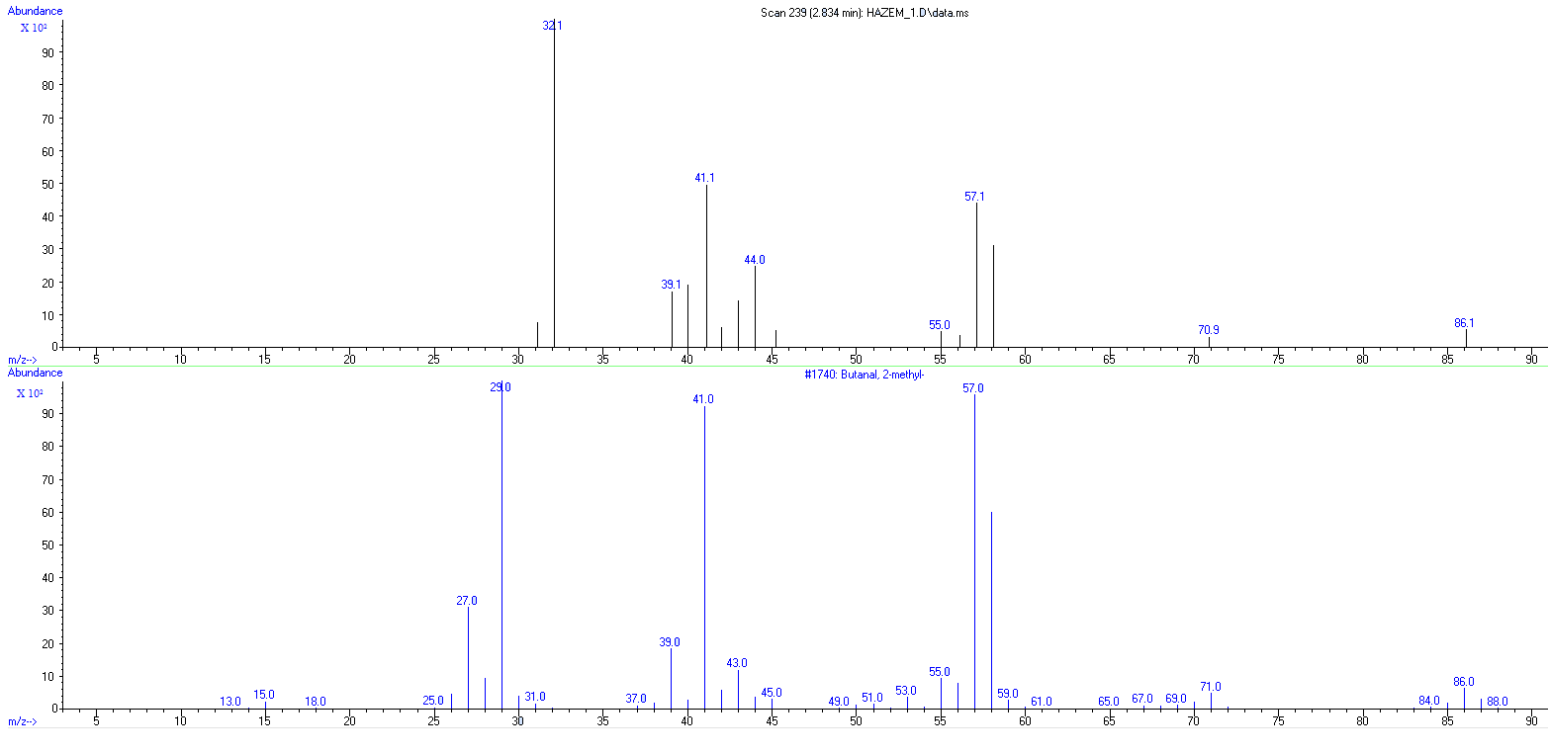
Fig. S5. Mass spectra of Butanal, 2-methyl
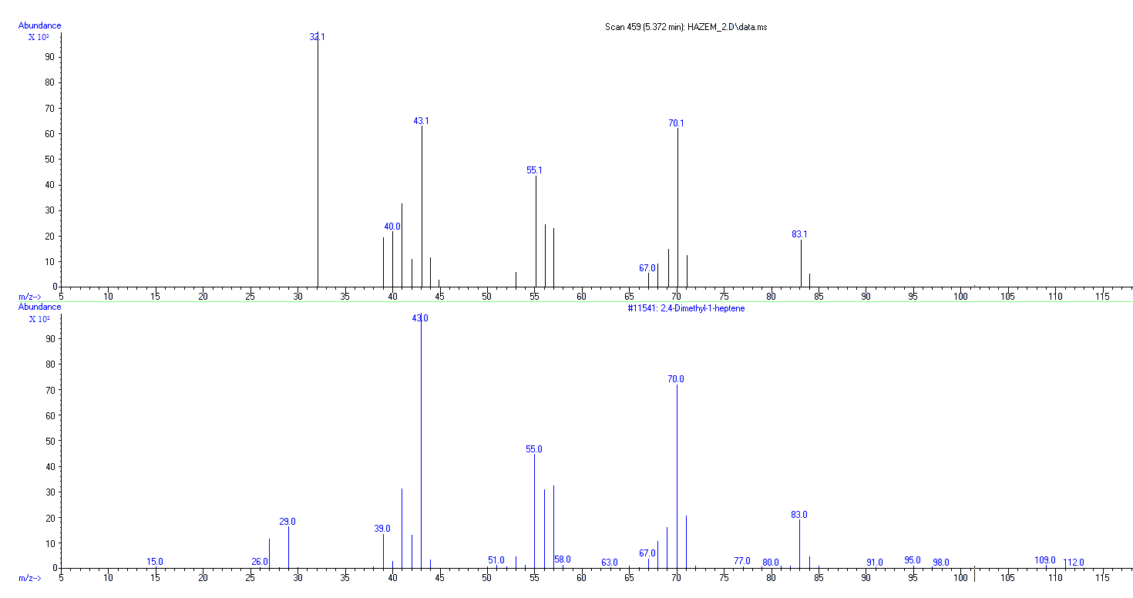
Fig. S6. Mass spectra of 2,4-Dimethyl-1-heptene

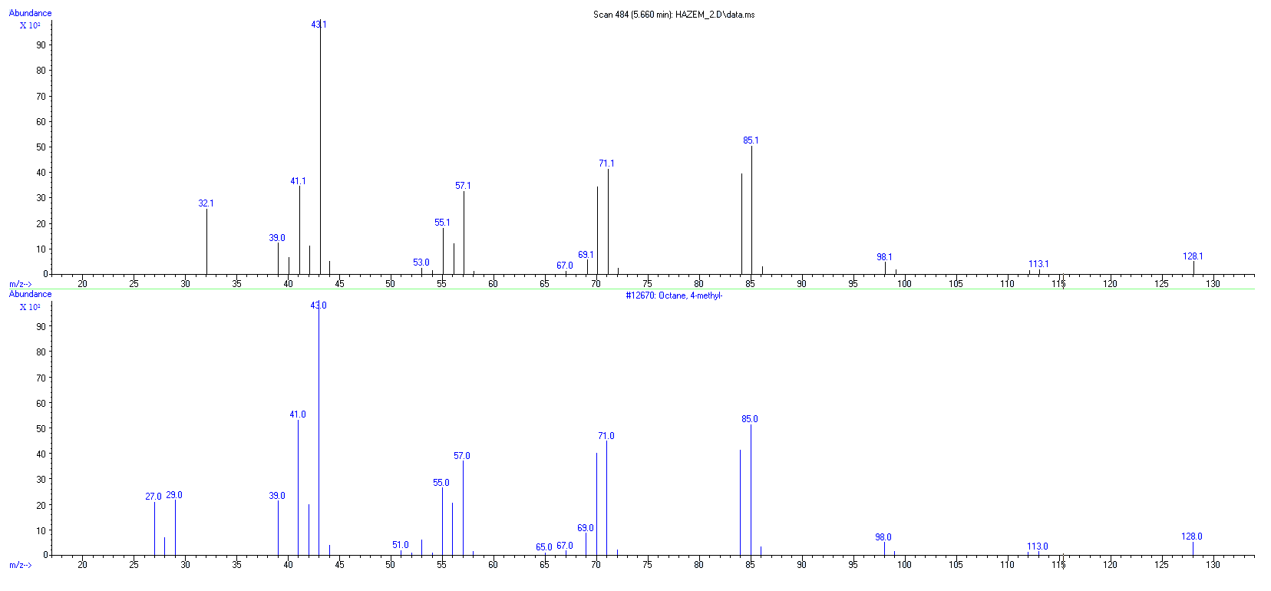
Fig. S7. Mass spectra of Octane, 4-methyl
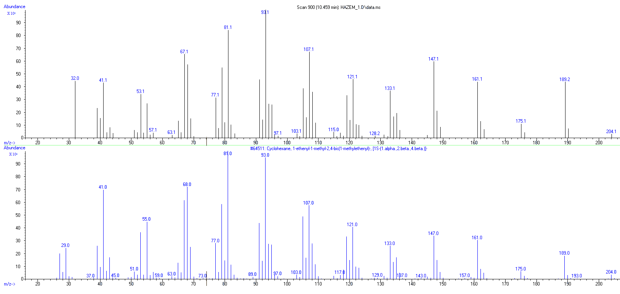
Fig. S8. Mass spectra of β-elemene

Table S1. The whole list of GC-MS analysis of VOCs extracted from B. bassiana UniB2439-3
RT¹  (min) | Area  (%) | Name | M.Wt²  (g/mol) | Formula | CAS³ | Probability of identification  (%)
1,11 | 2,75 | Carbon dioxide | 44,01 | CO₂ | 000124-38-9 | 80
1,21 | 1,24 | Benzaldehyde, 2-nitro-, diaminomethylidenhydrazone | 207.19 | C₈H₉N₅O₂ | 102632-31-5 | 43
1.4840 | 27.5713 | Nitrous oxide | 44.013 | N₂O | 010024-97-2 | 65
1,68 | 0,66 | Silanol, trimethyl- | 90.2 | C₃H₁₀OSi | 001066-40-6 | 74
1,77 | 0,72 | Acetone | 58.08 | C₃H₆O | 000067-64-1 | 79
2,03 | 0,61 | Formamide, N-methylthio | 75.14 | C₂H₅N_{S} | 018952-41-5 | 63
2.7184 | 1.3273 | Butanal, 3-methyl- | 86.13 | C₅H₁₀O | 000590-86-3 | 81
2.8337 | 0.4432 | Butanal, 2-methyl- | 86.13 | C₅H₁₀O | 000096-17-3 | 90
3.8835 | 3.7267 | 1-Butanol, 3-methyl- | 88.15 | C₅H₁₂O | 000123-51-3 | 83
4,98 | 1,68 | Arsenous acid, tris(trimethylsilyl) ester | 342.49 | C₉H₂₇AsO₃Si₃ | 055429-29-3 | 70
5,37 | 0,63 | 2,4-Dimethyl-1-heptene | 126.24 | C₉H₁₈ | 019549-87-2 | 90
5,56 | 0,76 | Heptane, 2,3-dimethyl- | 128.25 | C₉H₂₀ | 003074-71-3 | 87
5,66 | 1,99 | Octane, 4-methyl- | 128.25 | C₉H₂₀ | 002216-34-4 | 93
7,30 | 0,19 | Octane, 2,3,6,7-tetramethyl- | 170.33 | C₁₂H₂₆ | 052670-34-5 | 63
7,33 | 0,21 | Oxalic acid, 2-ethylhexyl nonyl ester | 328.5 | C₁₉H₃₆O₄ | 1000309-39-2 | 74
7,70 | 0,49 | Dodecane, 2,6,11-trimethyl- | 212.41 | C₁₅H₃₂ | 031295-56-4 | 69
7,76 | 5,47 | Decane, 3,6-dimethyl- | 170.33 | C₁₂H₂₆ | 017312-53-7 | 72
7,81 | 2,37 | Heptane, 2,4-dimethyl- | 128.25 | C₉H₂₀ | 002213-23-2 | 79
7,97 | 1,02 | 2-Undecene, 4-methyl- | 168.32 | C₁₂H₂₄ | 091695-32-8 | 63
8,09 | 0,54 | Oxalic acid, isohexyl neopentyl ester | 244.33 | C₁₃H₂₄O₄ | 1000309-73-0 | 64
8,15 | 2,37 | Decane, 3,7-dimethyl- | 170.33 | C₁₂H₂₆ | 017312-54-8 | 87
8,27 | 0,65 | Sulfurous acid, hexyl 2-pentyl ester | 236.37 | C₁₁H₂₄O₃S | 1000309-15-6 | 69
9,56 | 0,68 | Decane, 2,3,5-trimethyl- | 184.36 | C₁₃H₂₈ | 062238-11-3 | 80
9,62 | 0,14 | Dodecane, 2,6,10-trimethyl- | 212.41 | C₁₅H₃₂ | 003891-98-3 | 72
9,66 | 0,18 | Hexadecane | 226.44 | C₁₆H₃₄ | 000544-76-3 | 78
9,72 | 0,30 | Dodecane, 2,6,10-trimethyl- | 212.41 | C₁₅H₃₂ | 003891-98-3 | 64
9,89 | 0,40 | Heptadecane | 240.5 | C₁₇H₃₆ | 000629-78-7 | 72
10,30 | 0,37 | 7-Chloro-2,3-dihydro-3-(4-N,N-dimethylaminobenzylidene)-5-phenyl-1H-1,4-benzodiazepin-2-one | 401.9 | C₂₄H₂₀ClN₃O | 055056-35-4 | 46
10,39 | 0,20 | 3,6-Dioxa-2,4,5,7-tetrasilaoctane, 2,2,4,4,5,5,7,7-octamethyl- | 294.68 | C₁₀H₃₀O₂Si₄ | 004342-25-0 | 65
10,46 | 0,93 | Cyclohexane, 1-ethenyl-1-methyl-2,4-bis(1-methylethenyl)-, [1S-(1.alpha.,2.beta.,4.beta.)]- | 204.35 | C₁₅H₂₄ | 000515-13-9 | 91
11,19 | 0,40 | 3-Hydroxybromoazepam, bis(trimethylsilyl)- deriv | 476.5 | C₂₀H₂₆BrN₃O₂Si₂ | 1000079-50-7 | 72
11,42 | 0,22 | 2-Amino-2-oxo-acetic acid, N-[3,4-dimethylphenyl]-, ethyl ester | 221.25 | C₁₂H₁₅NO₃ | 024451-17-0 | 77
11.8436 | 0.6504 | Diethyl Phthalate | 222.24 | C₁₂H₁₄O₄ | 000084-66-2 | 90
12,01 | 9,06 | Silane, [[4-[1,2-bis[(trimethylsilyl)oxy]ethyl]-1,2-phenylene]bis(oxy)]bis[trimethyl- | 458.9 | C₂₀H₄₂O₄Si₄ | 056114-62-6 | 70
- RT: retention time is the amount of time a compound spends on the column after it has been injected.
- M.Wt: molecular weight, also called molecular mass, is a measure of the sum of the atomic weight values of the atoms in a molecule.
- CAS: is a registry number, is a unique numerical identifier assigned by the Chemical Abstracts Service (CAS), US to every chemical substance described in the open scientific literature.

