Supplementary material

Overview of all included studies
Author, year | Study period | Country | Total sample size | Temperature category
 |  |  |  | TG 1 | TG 2 | TG 3
Algarni et al., 2014 | 1990-2000 | Toronto, Canada | 128 |  | 75 | 53
Apaydin et al., 2009 | 1993-2006 | Izmir, Turkey | 161 |  |  | 161
Arnaoutakis et al. 2016 | 2009-2014 | Philadelphia, USA | 589 | 118 |  | 471
Bakhtiary et al. 2008 | 2000-2006 | Frankfurt, Germany | 120 | 120
Buonocore et al. 2016 | 2007-2014 | Brugge, Belgium,  Naples, Italy | 111 |  | 111
Cho et al. 2014 | 1998-2012 | Seoul, Korea | 268 | 268
Czerny et al. 2011 | 2005-2010 | Berne, Switzerland | 523 | 523
Della Corte et al. 2006 | 1997-2004 | Naples, Italy | 202 |  | 202
Di Bartolomeo et al. 2000 | 1996-1998 | Bologna, Italy | 57 |  | 57
Di Bartolomeo et al. 2001 | 1996-2000 | Bologna, Italy | 96 |  | 96
Di Bartolomeo et al 2010 | 2007-2009 | Bologna, Italy | 67 | 67
Di Bartolomeo et al. 2016 | 1994-2014 | Bologna, Italy | 154 | 154
Di Eusanio et al. 2002 | 1995-2001 | Bologna, Italy | 289 |  | 161 | 128
Di Eusanio et al. 2013 | 1996-2011 | Bologna, Italy | 473 |  | 473
Di Mauro et al.2013 | 1988-2009 | Riyadh, Saudi Arabia | 456 |  | 456
Dossche et al. 2000 | 1995-1999 | Nieuwegein, The Netherlands | 163 |  | 163
Ehrlich et al. 2000 | 1984-1998 | New York, USA | 124 |  |  | 124
Ehrlich et al. 2000 | 1986-1998 | New York, USA | 433 |  |  | 433
El-Sayed Ahmad et al. 2017 | 2000-2016 | Frankfurt, Germany | 63 | 63
El-Sayed Ahmad et al. 2017 | 2000-2015 | Frankfurt, Germany | 587 | 587
Estrera et al. 2010 | 2005-2007 | Houston, USA | 64 |  |  | 64
Fleck et al. 2003 | 1997-2003 | Vienna, Austria | 160 |  |  | 160
Forteza et al. 2009 | 1990-2008 | Madrid, Spain | 105 |  |  | 105
Ganapathi et al. 2014 | 2005-2013 | Durham, North Carolina | 440 |  |  | 440
Gatti et al. 2017 | 1999-2015 | Trieste, Italy | 344 |  |  | 344
Gegouskov et al. 2018 | 2008-2017 | Sofia, Bulgaria | 117 | 117
Gong et al. 2016 | 2014-2015 | Beijing, China | 74 | 39 |  | 35
Guan et al. 2016 | 2013-2015 | Beijing, China | 62 |  | 62
Hagl et al. 2001 | 1988-1999 | New York, New York | 51 |  |  | 51
Hata et al. 2013 | 2005-2011 | Tokyo, Japan | 91 | 91
Hata et al. 2016 | 2001-2015 | Tokyo, Japan | 64 | 64
Hata et al. 2017 | 2006-2017 | Tokyo, Japan | 187 | 187
Hiroaka et al. 2014 | 2008-2012 | Okayama, Japan | 200 |  | 200
Immer et al. 2008 | 1994-2004 | Berne, Switzerland | 265 |  |  | 265
Jacobs et al . 2001 | 1995-2000 | Maastricht, The Netherlands | 50 | 50
Jassar et al. 2016 | 2009-2015 | Philadelphia, USA | 100 | 100
Kaku et al. 2014 | 2002-2011 | Yamanashi, Japan | 107 | 107
Kamiya et al. 2007 | 1999-2005 | Heidelberg, Germany | 377 | 252 | 125
Kaneko et al. 2014 | 2002-2012 | Boston, USA | 467 |  |  | 467
Kazui et al. 2000 | 1990-1999 | Hamamatsu, Japan | 220 |  | 220
Keeling et al. 2018 | 2000-2015 | Atlanta, Georgia | 3265 |  | 2586 | 679
Keeling et al. 2019 | 2000-2015 | Atlanta, Georgia | 1169 |  | 1169
Keenan et al. 2016 | 2005-2014 | Durham, USA | 310 |  | 155 | 155
Khaladj et al. 2008 | 1999-2006 | Hannover, Germany | 623 | 623
Krähenbühl et al. 2008 | 1996-2005 | Berne, Switzerland | 1742 |  | 907 | 835
Krähenbühl et al. 2010 | 2004-2007 | Berne, Switzerland | 292 |  | 292
Kücüker et al. 2005 | 1996-2004 | Ankara, Turkey | 181 | 181
Kunihara et al. 2005 | 1995-2004 | Homburg, Germany | 511 | 238 |  | 273
Legras et al. 2012 | 2000-2009 | Paris, France | 63 |  |  | 63
Leontyev et al. 2013 | 2006-2013 | Leipzig, Germany | 51 | 51
Leshnower et al. 2012 | 2004-2011 | Atlanta, Georgia | 500 | 277 | 223
Leshnower et al. 2013 | 2004-2012 | Atlanta, Georgia | 624 | 624
Leshnower et al. 2015 | 2004-2012 | Atlanta, Georgia | 288 | 206 | 82
Liu et al. 2016 | 2005-2011 | Beijing, China | 626 |  | 626
Liu et al. 2018 | 2014-2016 | Beijing, China | 154 | 154
Liu et al. 2019 | 2017-2019 | Beijing, China | 188 | 188
Lu et al. 2012 | 2005-2011 | Shanghai, China | 263
Ma et al. 2018 | 2015-2017 | Chengdu, China | 62 | 62
Matalanis et al. 2015 | 2005-2014 | Melbourne, Australia | 64 | 64
Matsuyama et al. 2012 | 2006-2008 | Tokyo, Japan | 186 | 186
Matt et al. 2017 | 2010-2016 | Basel, Switzerland | 141 |  | 141
Minatoya et al. 2008 | 2002-2005 | Osaka, Japan | 229 | 67 | 81 | 81
Neri et al. 2004 | 1999-2003 | Siena, Italy | 67 |  | 44 | 23
Nota et al. 2014 | 2008-2013 | Shiga, Japan | 116 | 116
Numata et al. 2012 | 2004-2011 | Fukui, Japan | 164 | 164
Oishi et al. 2019 | 2008-2017 | Fukuoka, Japan | 62 | 62
Okita et al. 2013 | 2002-2012 | Kobe, Japan | 438 |  | 438
Pacini et al. 2007 | 1996-2005 | Bologna, Italy | 305 | 189 | 116
Pacini et al. 2012 | 2005-2011 | Bologna, Italy | 95 | 95
Pacini et al. 2014 | 1996-2011 | Bologna, Italy | 304 | 110 | 194
Park et al. 2018 | 2012-2017 | Daegu, South Korea | 138 |  | 138
Patel et al. 2011 | 1993-2010 | Ann Arbor, USA | 721 |  |  | 721
Perreas et al. 2012 | 1993-2010 | Athens, Greece | 207 |  |  | 207
Preventza et al. 2013 | 2011-2012 | Houston, USA | 68 |  | 68
Preventza et al. 2014 | 2005-2012 | Houston, USA | 112 |  | 112
Preventza et al. 2015 | 2005-2013 | Houston, USA | 157 |  | 157
Preventza et al. 2016 | 2005-2015 | Houston, USA | 710 | 166 | 262 | 116
Preventza et al. 2016 | 2011-2015 | Houston, USA | 258 | 118 | 140
Qian et al. 2013 | 2007-2012 | Chengdu, China | 54 | 21 | 33
Salem et al. 2019 | 2007-2015 | Kiel, Germany | 148 |  | 148
Saritas et al. 2010 | 2002-2007 | Ankara, Turkey | 100 | 100
Sasaki et al. 2005 | 1992-2003 | Nagoya, Japan | 74 |  |  | 74
Shen et al. 2018 | 2014-2017 | Changsha, China | 89 | 37 | 52
Shihata et al. 2011 | 2001-2009 | Alberta, Canada | 124 |  |  | 124
Sinatra et al. 2001 | 1992-1998 | Rome, Italy | 85 |  |  | 85
Skripochnik et al. 2013 | 2006-2011 | New York, USA | 108 |  | 108
Song et al. 2013 | 2008-2011 | Seoul, Korea | 107 | 107
Spindel et al. 2018 | 2007-2015 | New York, USA | 148 |  | 148
Stamou et al. 2010 | 2000-2008 | St. Louis, USA | 124 |  |  | 124
Stamou et al. 2018 | 2000-2014 | St. Louis, USA | 132 | 27 |  | 105
Suenaga et al. 2015 | 2000-2013 | Nagasaki, Japan | 80 | 80
Suguira et al. 2012 | 2003-2011 | Yokohama, Japan | 203 | 94 | 109
Sun et al. 2017 | 2014-2016 | Jilin, China | 82 | 42 | 40
Suzuki et al. 2013 | 2008-2012 | Shiga, Japan | 105 | 105
Takayama et al. 2009 | 2004-2007 | New York, USA | 136 | 136
Tarola et al. 2017 | 2008-2014 | Ontario, Canada | 106 | 106
Tasdemir et al. 2002 | 1996-2001 | Ankara, Turkey | 104 | 104
Tong et al. 2017 | 2006-2014 | Guangzhou, China | 203 | 203
Tsai et al. 2013 | 2006-2009 | Houston, Texas, USA | 221 |  | 143 | 78
Uchino et al. 2017 | 2008-2015 | Hiroshima, Japan | 159 | 159
Urbanski et al. 2006 | 2002-2005 | Bad Neustadt, Germany | 100 | 100
Urbanski et al. 2010 | 2005-2008 | Bad Neustadt, Germany | 200 | 200
Urbanski et al. 2011 | 2005-2009 | Bad Neustadt, Germany | 347 | 347
Urbanski et al. 2012 | 2007-2011 | Bad Neustadt, Germany | 122 | 122
Urbanski et al. 2013 | 2004-2012 | Bad Neustadt, Germany | 131 | 131
Urbanski et al. 2019 | 2004-2017 | Bad Neustadt, Germany | 1000 | 1000
Vallabhajosyula et al. 2015 | 2008-2012 | Philadelphia, USA | 376 | 75 |  | 301
Vohra et al. 2012 | 2000-2008 | Southampton, United Kingdom | 100 |  |  | 100
Wiedemann et al. 2013 | 1987-2011 | Vienna, Austria | 329 | 91 |  | 238
Yu et al. 2019 | 2013-2015 | Shanghai, China | 98 |  | 98
Zierer et al. 2005 | 1999-2003 | Frankfurt, Germany | 74 | 18 | 56
Zierer et al. 2007 | 1984-2005 | Frankfurt, Germany | 175 | 50 | 125
Zierer et al. 2011 | 2000-2009 | Frankfurt, Germany | 245 | 245
Zierer et al. 2012 | 2000-2011 | Frankfurt, Germany | 1002 | 1002
Zierer et al. 2014 | 2000-2012 | Frankfurt, Germany | 492 | 492
Zierer et al. 2016 | 2000-2015 | Frankfurt, Germany | 453 | 453
Ziganshin et al. 2014 | 2003-2013 | New Haven, USA | 490 |  |  | 490

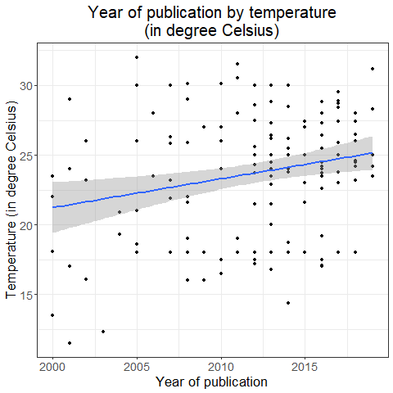
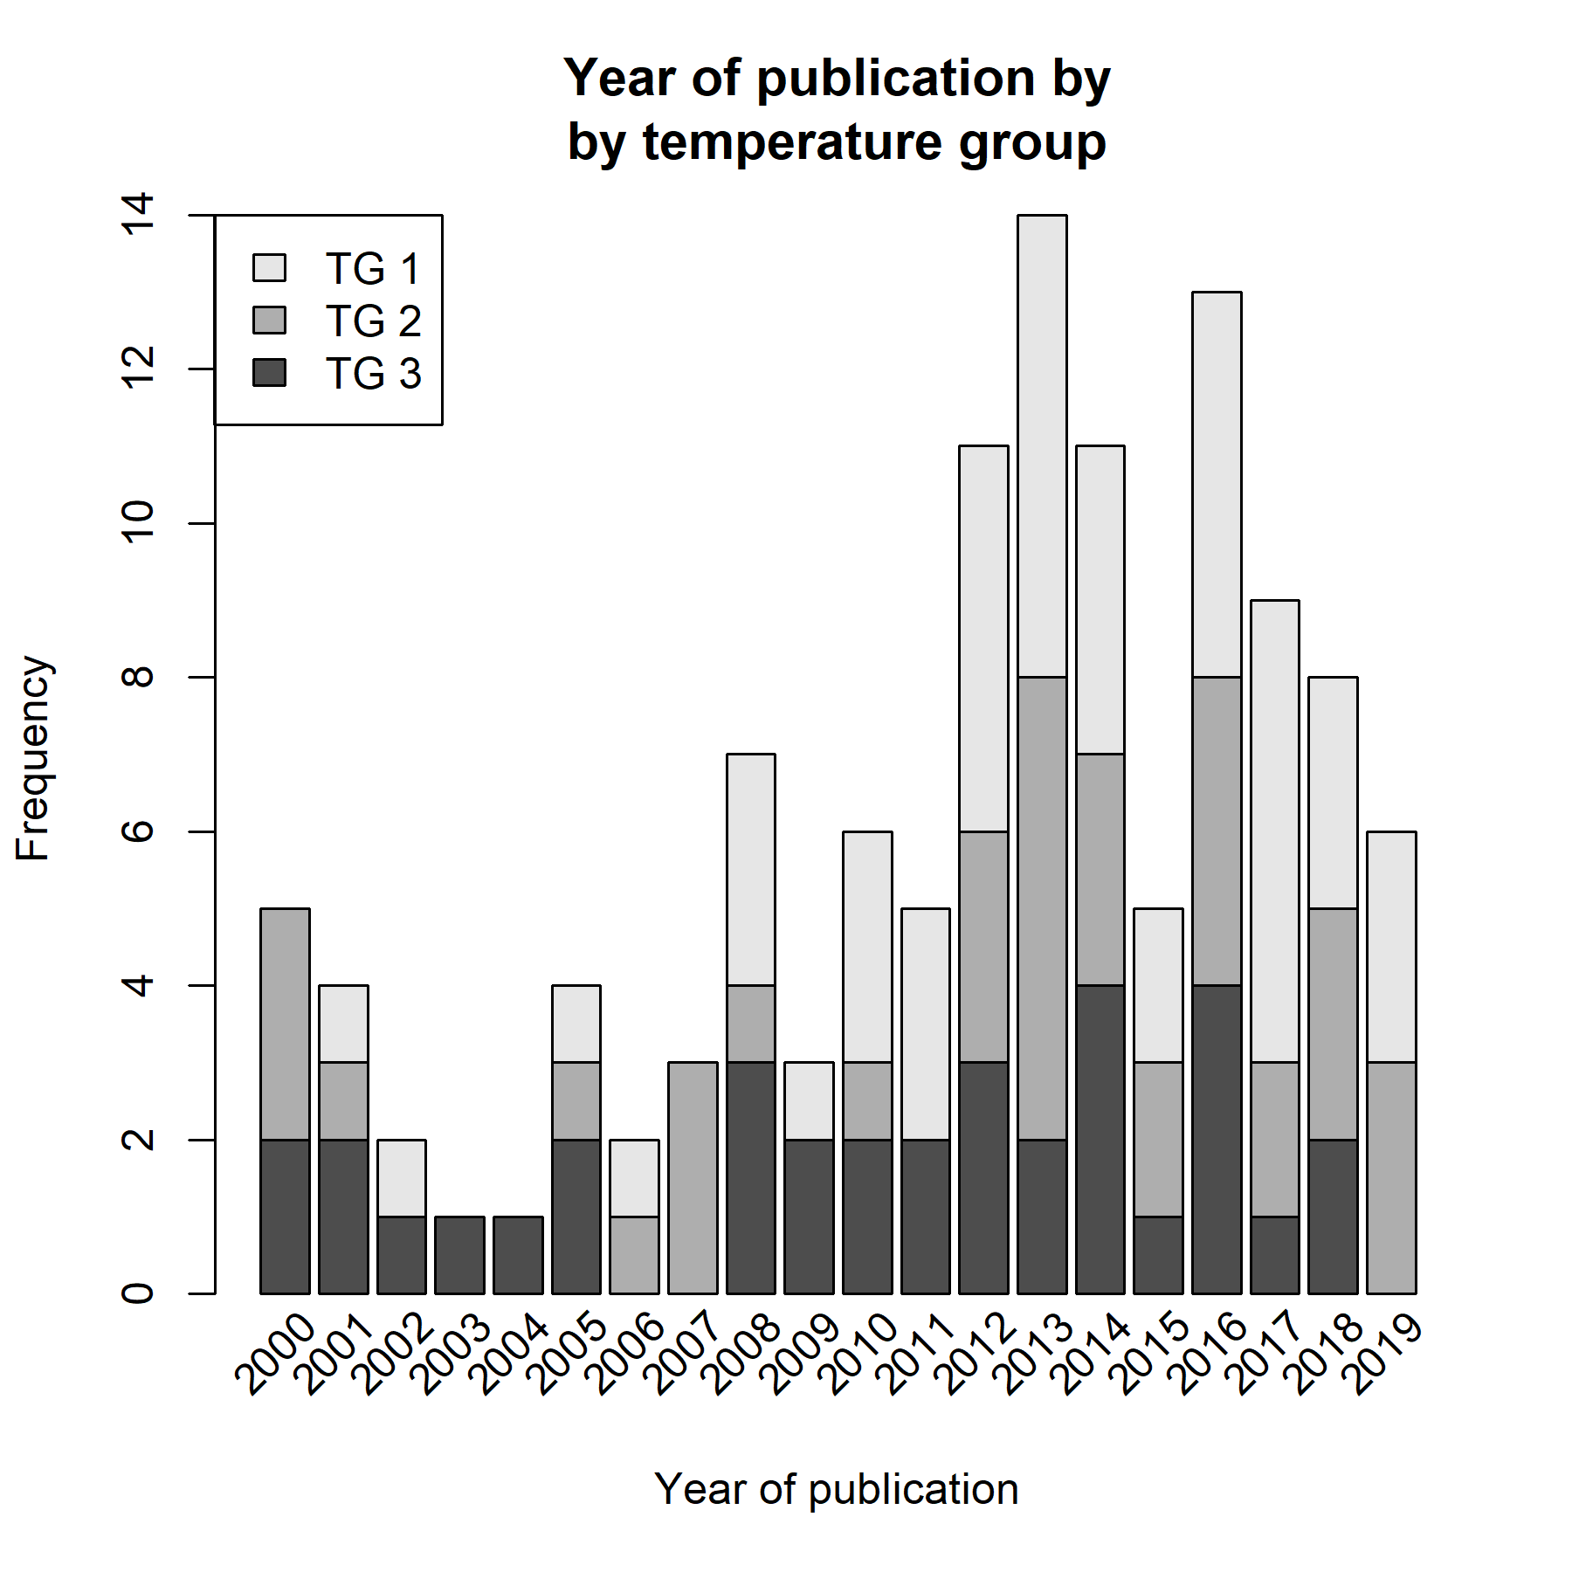
Distribution of all included studies depending on publication year and temperature

Early mortality shown as a function of the temperature
