Supplementary Material

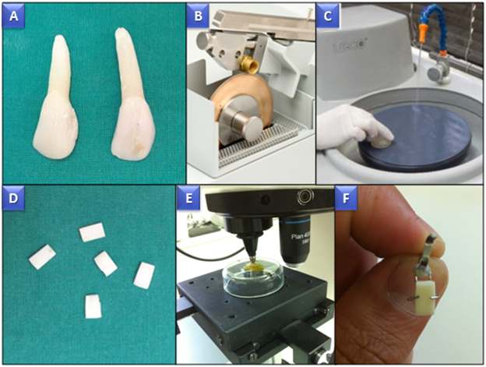

Supplementary Figure. Enamel and dentin slab preparation. A. Selected bovine incisors. B. Diamond saw used to cut bovine incisors. C. Polishing a slab in the automatic polisher. D. Dimensioned bovine enamel slabs. E. Measurement of the initial Knoop surface microhardness with the microindenter. F. Mounting an enamel slab in the holder device, secured with composite resin.

