Neurobehavioral Effects of Fermented Rice Bran Extract in Zebrafish Larvae model
Supplementary Materials
Neurobehavioral Effects of Fermented Rice Bran Extract in Zebrafish Larvae model
Jin Sil Chae^{1,2,†}, Seong Soon Kim^{1,†}, Kyu-Seok Hwang^{1,†}, Hyemin Kan¹, Jung Yoon Yang¹, Byunghoi Lee¹, Dae-Seop Shin¹, Byounghee Park³, and Myung Ae Bae^{1,2,*}
¹ Bio Platform Technology Research Center, Korea Research Institute of Chemical Technology, Daejeon 34114, Republic of Korea
² Department of Medicinal Chemistry and Pharmacology, University of Science and Technology, Daejeon 34113, Republic of Korea
³ R&D Center, Raphagen Inc., Seoul 07286, Republic of Korea

* Correspondence: mbae@krict.re.kr (M.A. B.)
† These authors contributed equally on this work

Fig. S1. Schematic illustrating the purification of RBF30
Fermented rice bran
mixed with 5 kinds of strains
Purification
(30.50% EtOH fraction)
Concentration
Slurry
Filtration
Drying
Milling
3 times
RBF30
Fig. S2. Behavioral effects of ethanol (EtOH) fractions 0 to 100 % (v/v) of various concentrations of RBF30 in 5 dpf zebrafish larvae. Data was represented as means ± standard error of the mean (n=18). Significance was set at ***p ≤ 0.001 versus control and #p ≤ 0.05 between RBF30 and 0.5% DMSO control.

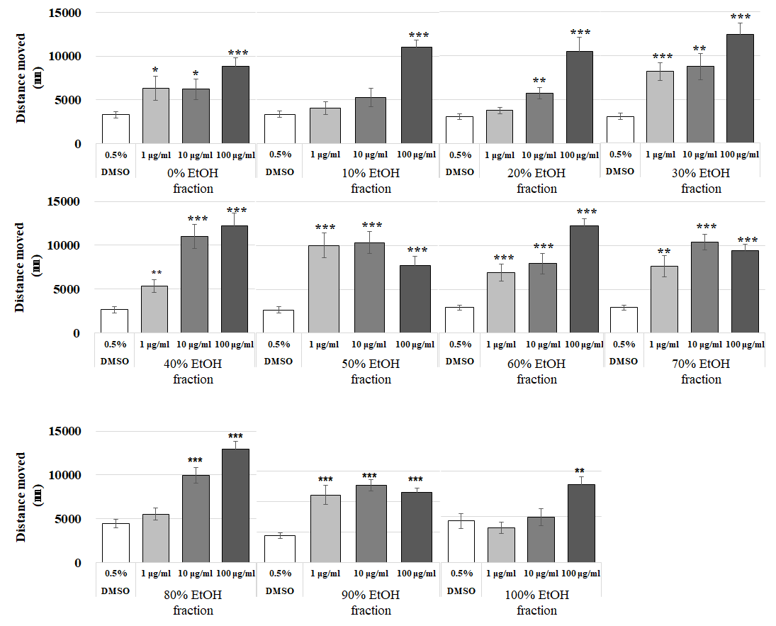

Fig. S3. Larval locomotor activity in 5 dpf zebrafish larvae. Distance moved (percentage of control) of control, pentylenetetrazole (PTZ), modafinil (MDF), and RBF30-treated larvae. Data was represented as means ± standard error of the mean (n=18). Significance was set at **p ≤ 0.01 and ***p ≤ 0.001 versus control.
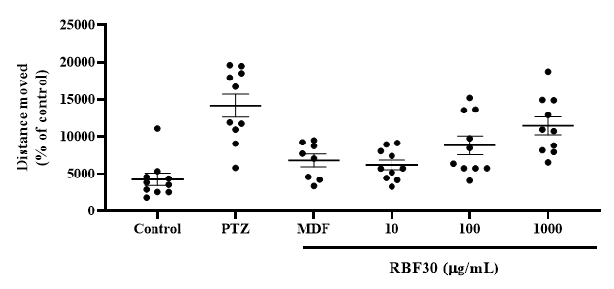
Fig. S4. Larval locomotor activity in alternating periods of light and dark after administration of MDF and PTZ. (A and B) Total distance moved under alternating light/dark cycles in each 2-minute period. (C) Distance moved (percentage of control) of control and, MDF or PTZ-treated larvae in each 10-minute light–dark period. Data was represented as means ± standard error of the mean (n=8). Significance was set at **p ≤ 0.01 and ***p ≤ 0.001 versus control.
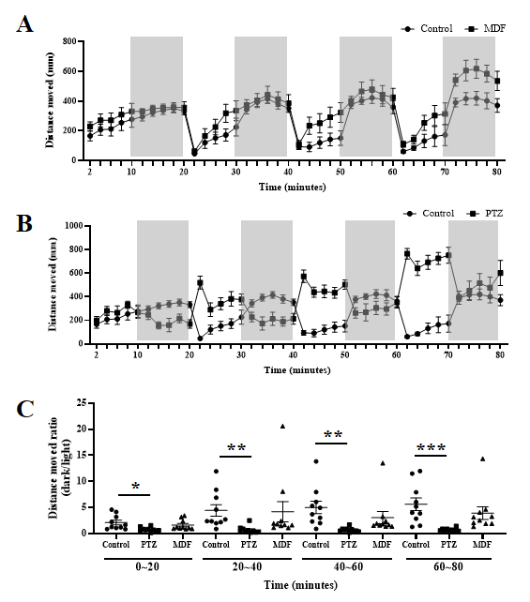
Fig. S5. (A) UV spectrums scan of RB30 and RBF30 at wavelengths from 210 nm to 500 nm. (B and C) Full MS Scan (ESI⁺) of RB30 and RBF30 at m/z 50 to 500. The integral peak was assumed as a niacin ([M+H]⁺ 124 ion).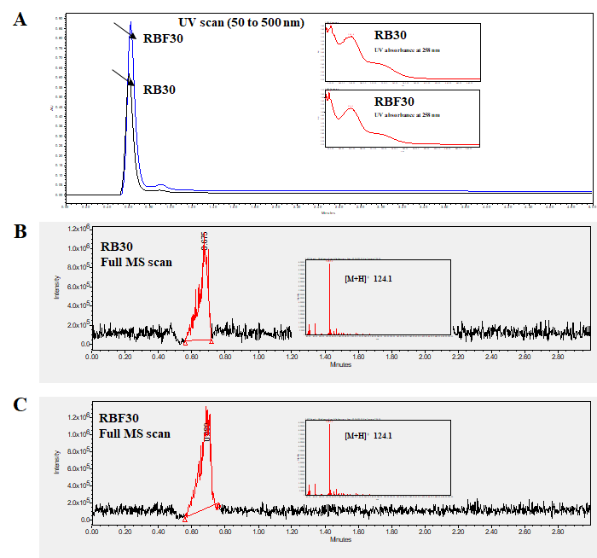
Fig. S6. Niacin contents in RB30 and RBF30.
