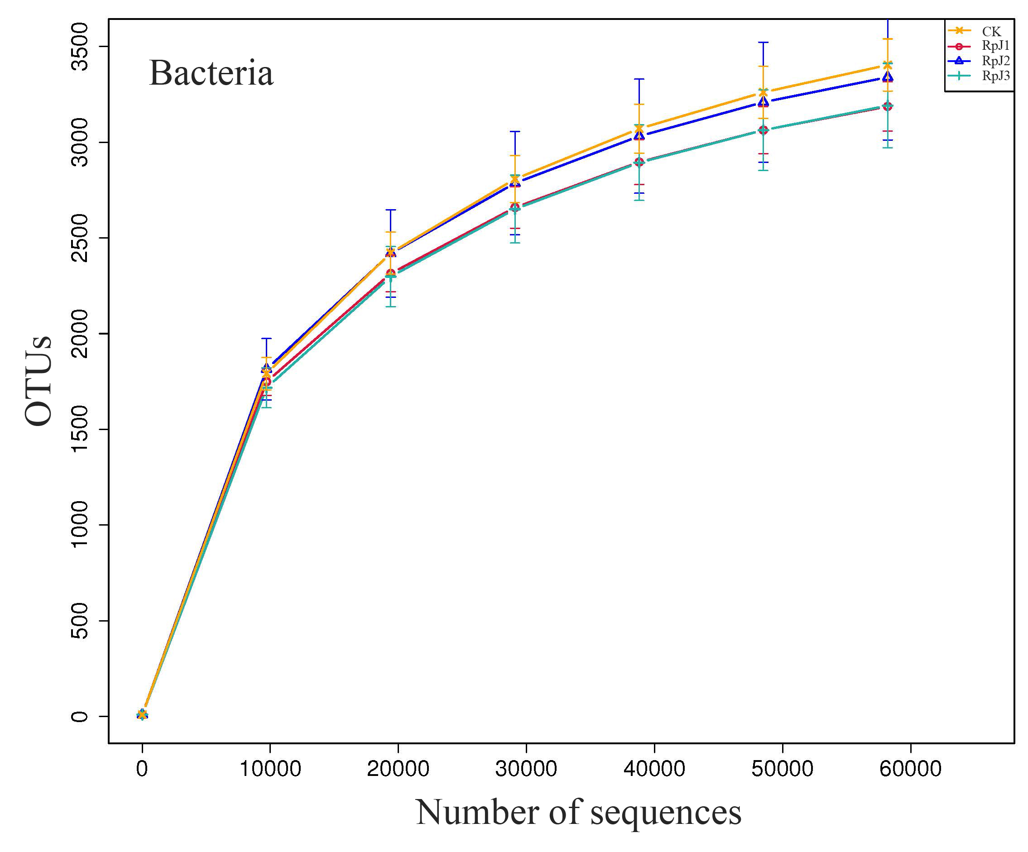
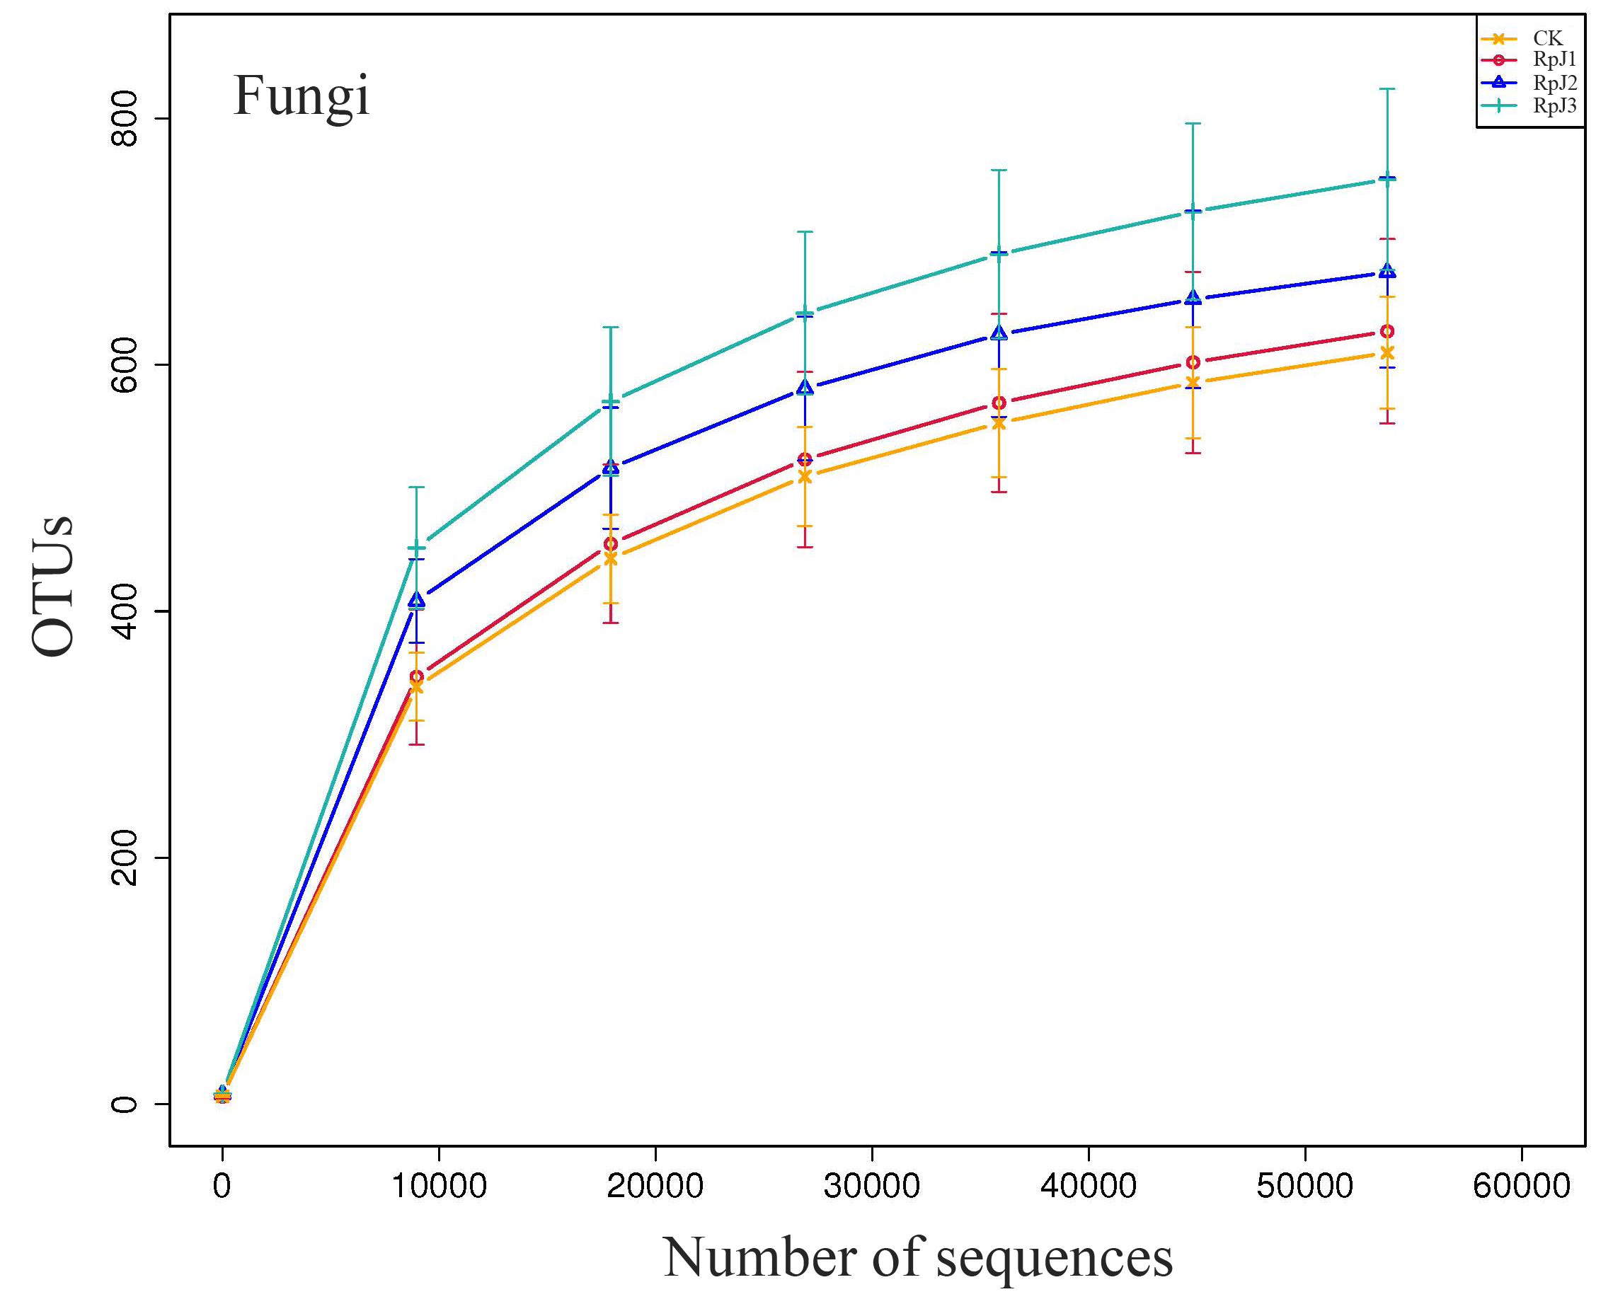
Figure S1 Rarefaction curve of soil bacteria (A) and fungi (B). AH: Robinia pseudoacacia;

Table S1 Soil properties in different treatments
Variables | CK |  | RPJ1 |  | RPJ2 |  | RPJ3
 | Mean | SD | Mean | SD | Mean | SD | Mean | SD
SH/ (cm) | 74.00 c | 12.30 | 88.17 bc | 10.02 | 94.53 ab | 21.64 | 107.80 a | 10.33
GD/ (mm) | 7.75 a | 1.37 | 8.34 a | 0.35 | 6.80 a | 0.78 | 7.50 a | 0.84
LA/ (cm²) | 541.42 a | 278.82 | 857.34 a | 167.28 | 606.24 a | 90.41 | 728.83 a | 192.89
RNN | 31.33 b | 7.64 | 161.67 a | 67.17 | 55.33 b | 25.74 | 76.00 b | 38.97
RNV/ (cm³) | 0.45 b | 0.15 | 1.14 a | 0.22 | 0.67 ab | 0.42 | 0.45 b | 0.42
RNDW/ (g) | 0.18 a | 0.13 | 0.17 a | 0.20 | 0.19 a | 0.12 | 0.13 a | 0.12
RNC/% | 0.53 b | 0.16 | 1.07 a | 0.26 | 0.55 b | 0.16 | 0.45 b | 0.25
Note: Treatments: CK (control, add microbial liquid medium without microbes), RPJ1 (NL-11), RPJ2 (NL-11 + NL-15), and RPJ3 (NL-1 + NL-11 + NL-15). SH, height; GD, basal diameter; LA, leaf areas; RNN, root nodules number; RNV, root nodules volume; RNDW, root nodules dry weight; RV, root volume; RNC, root nodules contribution. Means are the average values of same treatment (n=3). Different letters indicate significance at a 0.05 probability level (p < 0.05) using the LSD test.

