Table 1.
 | Overall (N=97)
GA
Mean (SD) | 28.56 (2.73)
Median (Q1, Q3) | 29.00 (27.00, 30.00)
Min - Max | 23.00 - 35.00
Non missing N | 97
Birth Weight
Mean (SD) | 1091.48 (287.93)
Median (Q1, Q3) | 1110.00 (870.00, 1320.00)
Min - Max | 520.00 - 1495.00
Non missing N | 97
Year
2017 | 24 (24.7%)
2018 | 24 (24.7%)
2019 | 24 (24.7%)
2020 | 8 (8.2%)
2021 | 17 (17.5%)
Non missing N | 97
Single/Twin
T | 36 (37.5%)
S | 60 (62.5%)
Non missing N | 96
Missing N | 1
Delivery
V | 14 (14.6%)
CS | 82 (85.4%)
Non missing N | 96
Missing N | 1
MA
Mean (SD) | 32.62 (6.11)
Median (Q1, Q3) | 33.00 (28.50, 37.50)
Min - Max | 19.00 - 46.00
Non missing N | 95
Missing N | 2
DM ml
Mean (SD) | 4015.88 (3840.05)
Median (Q1, Q3) | 2900.00 (500.00, 7100.00)
Min - Max | 12.00 - 12200.00
Non missing N | 68
Missing N | 29
Start MEF
Mean (SD) | 1.78 (1.03)
Median (Q1, Q3) | 2.00 (1.00, 2.00)
Min - Max | 1.00 - 7.00
Non missing N | 96
Missing N | 1
MOM
NO | 29 (30.5%)
YES | 66 (69.5%)
Non missing N | 95
Missing N | 2
Start MOM
Mean (SD) | 4.11 (1.93)
Median (Q1, Q3) | 4.00 (3.00, 5.00)
Min - Max | 1.00 - 12.00
Non missing N | 65
Missing N | 32
FEF
Mean (SD) | 18.53 (14.30)
Median (Q1, Q3) | 15.00 (9.00, 22.00)
Min - Max | 3.00 - 80.00
Non missing N | 86
Missing N | 11
Days of hospitalization
Mean (SD) | 62.14 (25.76)
Median (Q1, Q3) | 58.00 (45.25, 76.00)
Min - Max | 22.00 - 161.00
Non missing N | 94
Missing N | 3
Weight at discharge
Mean (SD) | 2538.55 (529.59)
Median (Q1, Q3) | 2390.00 (2157.50, 2802.50)
Min - Max | 1781.00 - 4960.00
Non missing N | 96
Missing N | 1
Feeding at discharge
FM | 51 (52.6%)
MOM | 35 (36.1%)
MOM+FM | 11 (11.3%)
Non missing N | 97
Average daily weight increment
Mean (SD) | 24.02 (7.22)
Median (Q1, Q3) | 23.00 (19.67, 26.85)
Min - Max | 12.20 - 71.30
Non missing N | 92
Missing N | 5

Table n° 2
Trend over the years
Year | 2017 | 2018 | 2019 | 2020 | 2021 | p
n° | 24 | 24 | 24 | 8 | 17
GA (mean (SD)) | 27.29 (2.37) | 28.58 (2.89) | 29.00 (2.59) | 29.25 (3.28) | 29.35 (2.57) | 0.097
Weight (mean (SD)) | 1030.00 (316.32) | 1085.46 (281.31) | 1139.29 (298.99) | 1052.50 (243.35) | 1137.65 (270.64) | 0.680
Sing_Twins = S (%) | 17 (70.83) | 16 (66.67) | 15 (65.22) | 5 ( 62.50) | 7 ( 41.18) | 0.372
CS (%) | 18 (78.26) | 21 (87.50) | 18 (75.00) | 8 (100.00) | 17 (100.00) | 0.117
Maternal age (mean (SD)) | 31.86 (6.15) | 32.38 (6.98) | 31.04 (5.71) | 33.75 (4.13) | 35.65 (5.48) | 0.168
MOM = YES (%) | 16 (66.67) | 15 (62.50) | 21 (91.30) | 1 ( 14.29) | 13 ( 76.47) | 0.003
Start MOM (mean (SD)) | 4.44 (2.16) | 4.47 (2.53) | 4.00 (1.63) | 4.00 (0.00) | 3.30 (1.16) | 0.602
DM ml (mean (SD)) | 3211.25 (3324.12) | 4599.29 (4045.35) | 3200.57 (3510.58) | 9883.33 (2116.99) | 2125.00 (1935.94) | <0.001
Start MEF (mean (SD)) | 1.52 (0.73) | 2.04 (1.40) | 1.67 (0.48) | 2.38 (1.92) | 1.65 (0.61) | 0.180
FEF (mean (SD)) | 22.77 (21.76) | 15.58 (7.37) | 16.22 (10.72) | 20.88 (14.95) | 19.89 (12.75) | 0.433
Length of stay (mean (SD)) | 65.71 (30.32) | 68.54 (28.76) | 60.58 (22.10) | 59.50 (19.34) | 52.12 (21.49) | 0.331
Average daily weight increment (mean (SD)) | 21.08 (3.44) | 22.27 (4.46) | 23.83 (5.72) | 21.55 (3.95) | 31.36 (11.25) | <0.001
GA Gestational Age, MOM: Mother’s Own Milk, CS: Cesarean Section, MEF: Minimal Enteral Feeding, FEF: Full Enteral Feeding, DM: Donor Milk
Table n°3
MOM feeding during hospitalization
 | NO | YES | p
n° | 29 | 66
GA (mean (SD)) | 29.28 (2.95) | 28.23 (2.57) | 0.084
Weight (mean (SD)) | 1169.24 (291.62) | 1059.64 (281.78) | 0.087
Sing_Twins = S (%) | 14 (50.00) | 44 (66.67) | 0.198
CS (%) | 24 (82.76) | 56 (86.15) | 0.910
Maternal Age (mean (SD)) | 32.00 (7.19) | 32.83 (5.68) | 0.553
Start MOM (mean (SD)) | 3.00 (2.83) | 4.07 (1.84) | 0.429
Length of stay (mean (SD)) | 57.34 (27.31) | 64.59 (25.00) | 0.213
Average daily weight increment (mean (SD)) | 23.38 (4.44) | 24.43 (8.26) | 0.527
Start MEF (mean (SD)) | 1.90 (1.18) | 1.72 (0.98) | 0.457
FEF (mean (SD)) | 14.88 (7.30) | 19.53 (15.73) | 0.162
GA: Gestational Age, MOM: Mother’s Own Milk, CS: Cesarean Section, MEF: Minimal Enteral Feeding, FEF: Full Enteral Feeding
Table n°4
Feeding at discharge
 | FM vs MOM vs MOM+FM | FM vs MOM
 | p | p
GA (mean (SD)) | 0.101 | 0.032
Weight (mean (SD)) | 0.182 | 0.065
Sing_Twins = S (%) | 0.584 | 0.460
CS (%) | 0.323 | 0.538
Maternal Age (mean (SD)) | 0.048 | 0.059
Start MOM (mean (SD)) | 0.032 | 0.009
Length of stay (mean (SD)) | 0.622 | 0.733
Average daily weight increment (mean (SD)) | 0.845 | 0.562
Start MEF (mean (SD)) | 0.719 | 0.670
FEF (mean (SD)) | 0.225 | 0.620
GA: Gestational Age, MOM: Mother’s Own Milk, CS: Cesarean Section, MEF: Minimal Enteral Feeding, FEF: Full Enteral Feeding, FM: Formulated Milk

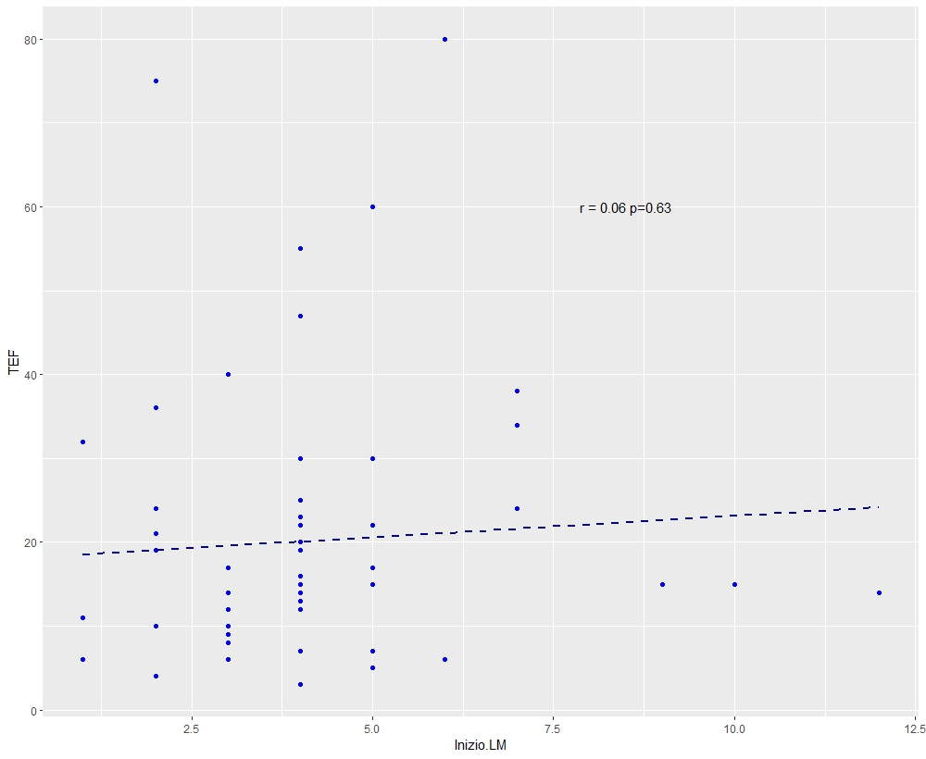
Figure 1
FEF
Start MOM
Vs
FEF
Start MOM

