Supplementary Materials for
Phytoplankton dynamics and biogeochemistry of the Black Sea.
Vladimir Silkin*, Larisa Pautova, Oleg Podymov, Valeryi Chasovnikov, Anna Lifanchuk, Alexey Fedorov and Agnislava Kluchantseva
Shirshov Institute of Oceanology, Russian Academy of Sciences, Moscow, Russia,
* Corresponding author: vsilkin@mail.ru
This file includes:
Fig S1 -S3
Table S1 – S4

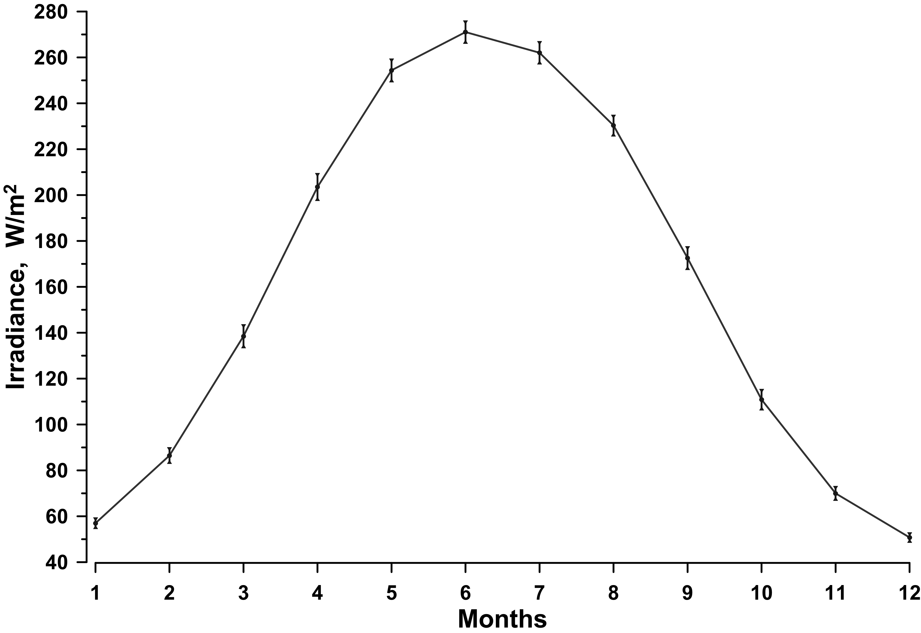
Fig S1. Annual irradiance dynamics on the water surface based on long-term (2006-2021) data.

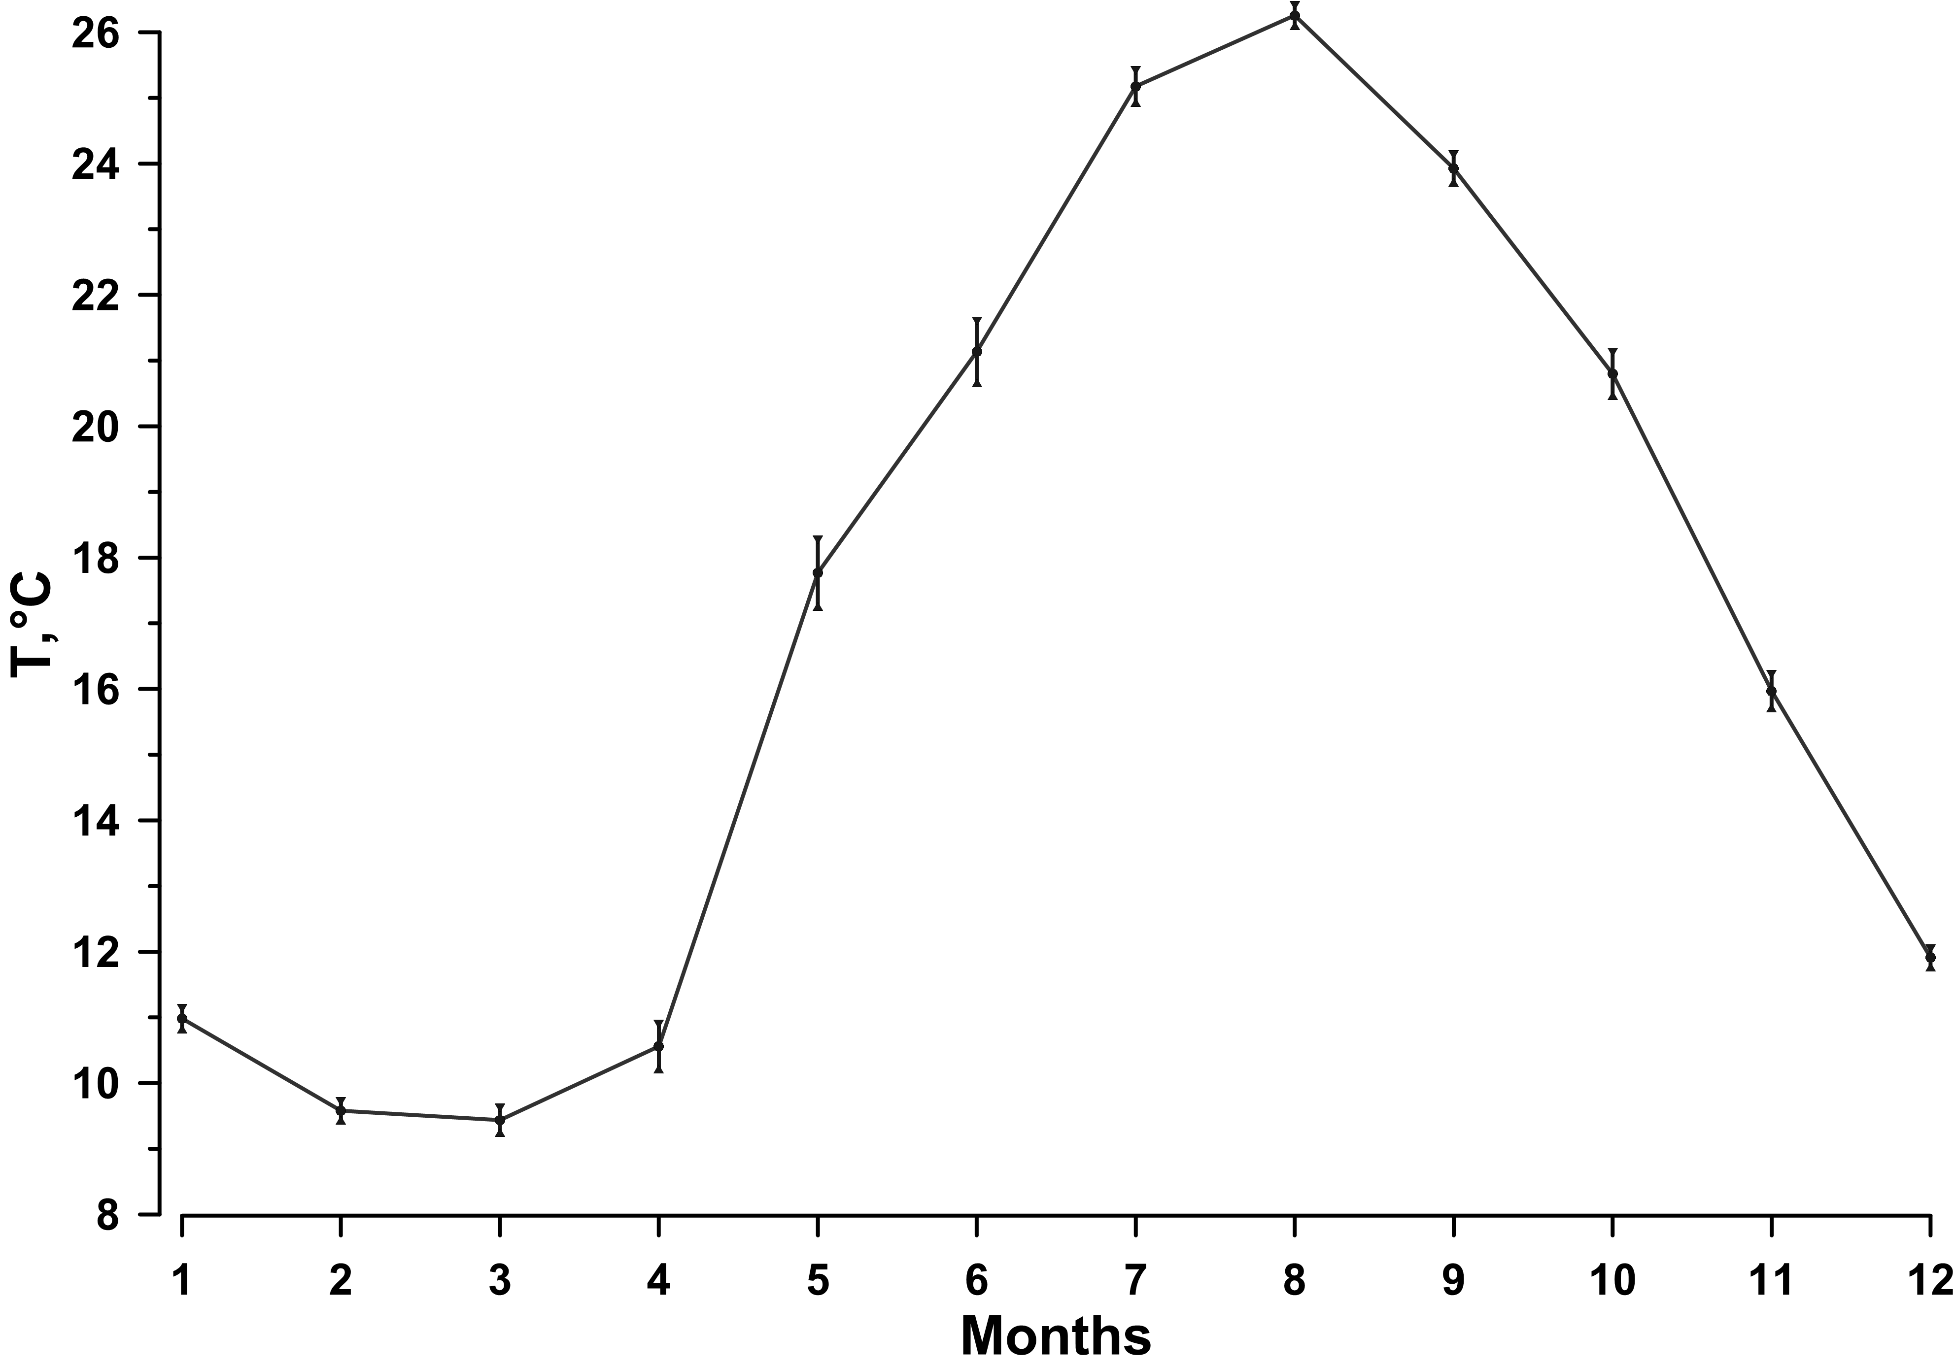
Fig S2. Annual dynamics of water surface temperature based on long-term (2006-2021) data.

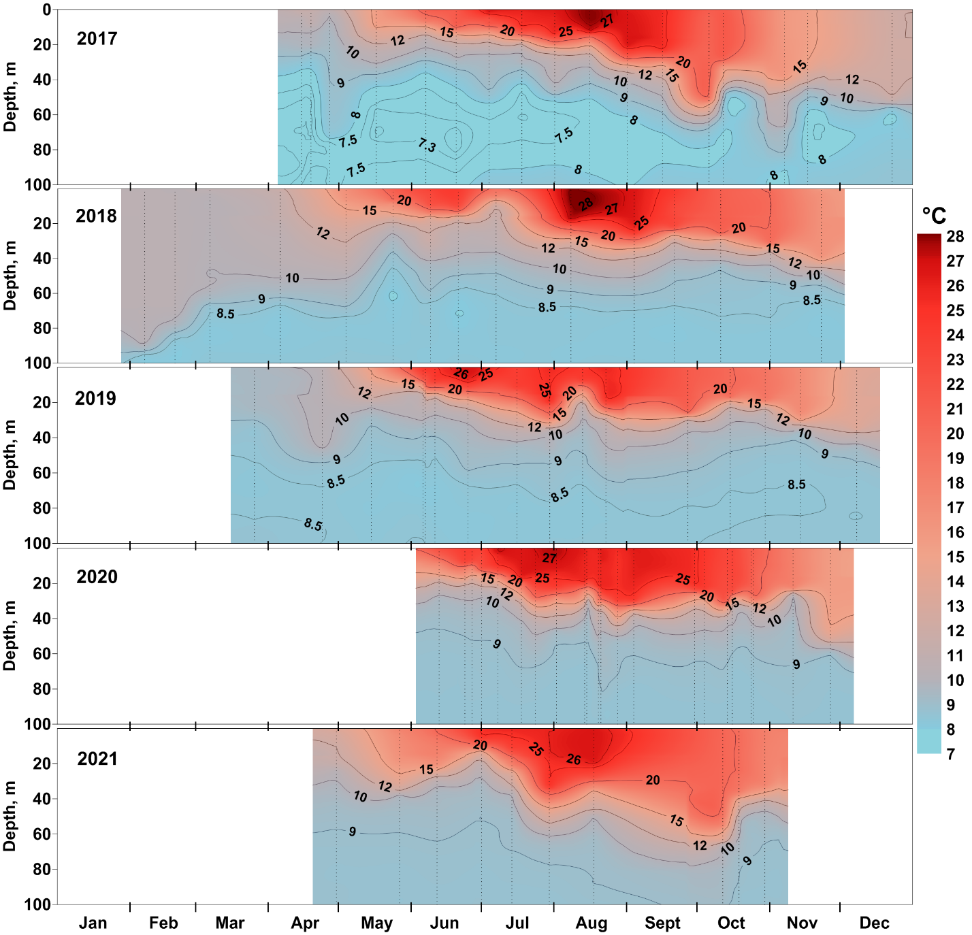
Fig S3. Seasonal dynamic of water temperature at station with depth 500 m from 2017 to 2021.

Table S1. The scheme of experiment for study the influence of nitrates and phosphates supply on phytoplankton growth.
Variant of experiment | Nitrates (N) | Phosphates (P)
1 | - | -
2 | + | -
3 | - | +
4 | + | +

Table S2. The phytoplankton composition of the upper mixed layer during the dominance of coccolithophorids in late spring and early summer 2017, 2018 and 2019.
Statistic  parameters | Diatoms |  | Dinoflagellates |  | Coccolithphores |  |  | Small  flagellates
 | mg m⁻³ | % | mg m⁻³ | % | 10⁶  Cells L⁻¹ | mg m⁻³ | % | mg m⁻³ | %
2017
Max | 1427 | 49 | 76.73 | 18 | 9.65 | 1737.22 | 99.00 | 42.11 | 12
Min | 0 | 49 | 3.09 | 0.26 | 1.0 | 188.01 | 49.35 | 4.15 | 0.29
Average | 37.96 | 1.43 | 19.75 | 1.96 | 6.9 | 1241.29 | 94.67 | 16.99 | 1.49
2018
Max | 23 | 10.07 | 78 | 35.76 | 1.5 | 264 | 74.51 | 141 | 41.06
Min | 0 | 0.07 | 22 | 7.44 | 0.16 | 29 | 22.73 | 12 | 6.46
Average | 10 | 4.54 | 42 | 18.29 | 0.66 | 119 | 48.61 | 58 | 22.21
2019
Max | 36 | 13.00 | 2468 | 81.47 | 6.0 | 1085 | 87.06 | 112 | 17.18
Min | 0 | 0.00 | 20 | 4.95 | 0.19 | 35 | 14.35 | 20 | 1.83
Average | 13 | 2.12 | 162 | 18.68 | 2.7 | 488 | 69.15 | 54 | 8.40

Table S3. The composition of phytoplankton of the upper mixed layer during the dominance of large diatoms in the summer of 2017-2021
Stations | Depth | Diatoms |  | Dinoflagellates |  | Coccolithophores |  | Small flagellates
 | m | mg m⁻³ | % | mg m⁻³ | % | mg m⁻³ | % | mg m⁻³ | %
15.08.2017
500 m | 0 m | 1451.2 | 96.86 | 10.87 | 0.73 | 8.64 | 0.58 | 25.56 | 1.71
500 m | 5 m | 1609.7 | 98.25 | 14.48 | 0.88 | 4.55 | 0.28 | 7.51 | 0.46
500 m | 10 m | 439.4 | 92.08 | 16.22 | 3.40 | 10.94 | 2.29 | 5.25 | 1.10
19.07.2019
100 m | 0 m | 71.2 | 36.74 | 27.77 | 14.32 | 70.50 | 36.37 | 24.37 | 12.57
100 m | 10 m | 215 | 67.29 | 32.30 | 10.11 | 53.45 | 16.73 | 18.75 | 5.87
22.07.2020
500 m | 0 m | 3619.4 | 98.48 | 10.80 | 0.29 | 0.00 | 0.00 | 40.86 | 1.11
500 м | 15 м | 4300.9 | 95.52 | 87.15 | 1.94 | 17.,44 | 0.39 | 84.39 | 1.87
31.07.2020
500 m | 14 m | 1462.4 | 96.54 | 22.69 | 1.50 | 0.00 | 0.00 | 29.28 | 1.93
 |  |  | 16.08.2020
500 m | 0 m | 733.9 | 88.18 | 2.29 | 0.28 | 11.40 | 1.37 | 44.14 | 5.30
26.08.2020
500 m | 0 m | 365.3 | 84.29 | 2.63 | 0.61 | 3.17 | 0.73 | 49.63 | 11.45
500 m | 10 m | 257.75 | 77.35 | 46.46 | 13.94 | 10.02 | 3.01 | 18.15 | 5.45
17.08.2021
500 m | 0 m | 3914.82 | 95.32 | 23.05 | 0.56 | 7.26 | 0.18 | 137.89 | 3.36

Table S4. Vertical distribution of nitrogen and phosphorus concentrations during the dominance of coccolithophore E. huxleyi (11.06.2020) and large diatoms P. calcar-avis (26.08.2021) at the station above a depth of 500 m.
E. huxleyi
m | P | N
1 | 0.22 | 0.31
14 | 0.16 | 0.36
33 | 0.18 | 0.29
50 | 0.20 | 0.42
70 | 0.26 | 1.19
90 | 0.32 | 1.29
107 | 0.42 | 2.26
119 | 0.78 | 3.73
127 | 1.23 | 5.97
131 | 1.30 | 5.94
139 | 1.34 | 6.19
151 | 1.38 | 3.38
154 | 1.62 | 3.42
P. calcar-avis
1 | 0.06 | 1.31
10 | 0.04 | 1.35
36 | 0.04 | 1.56
50 | 0.07 | 1.64
70 | 0.15 | 2.25
98 | 1.10 | 5.00
111 | 1.13 | 6.80
122 | 1.26 | 4.01
129 | 1.36 | 3.91
135 | 0.36 | 1.44
138 | 2.57 | 1.99
142 | 6.62 | 2.23
146 | 6.90 | 3.49
150 | 7.05 | 5.44

