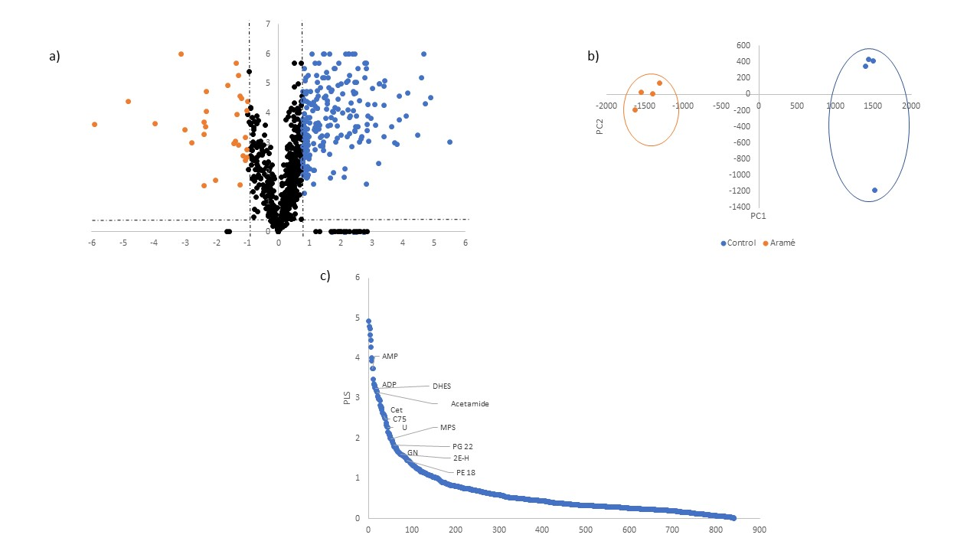
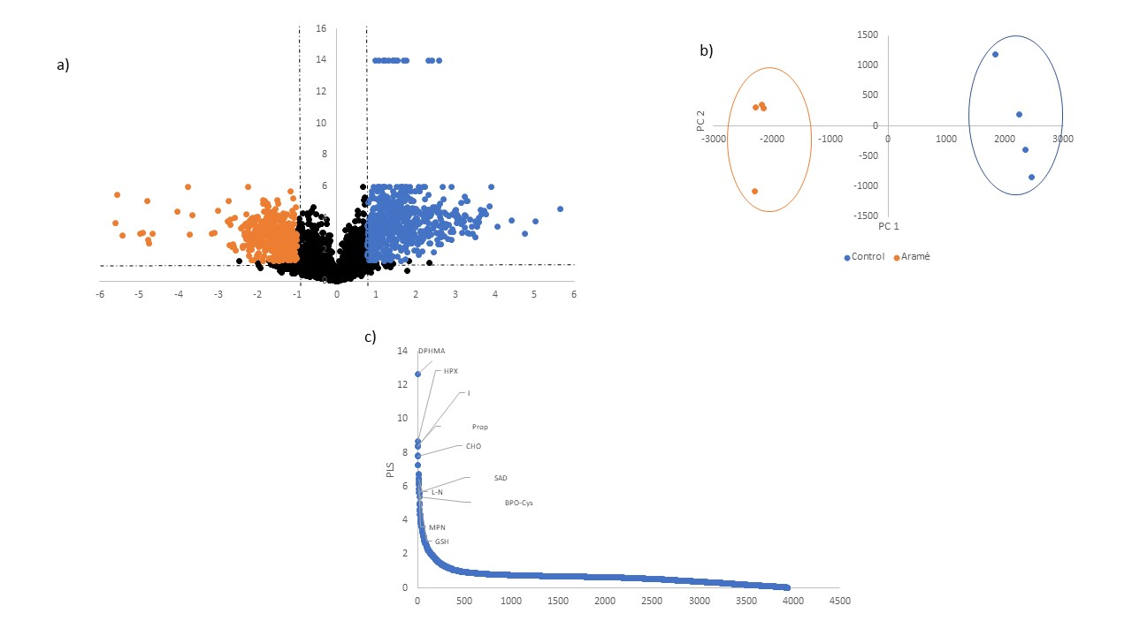
(1)
(2)
Figure S1 - Analysis of compounds that vary in the presence or absence of Aramé, for Caco-2 cells, in positive (1) and negative (2) mode. a) volcano plot; b) PCA plot; c) PLS plot. DPHMA - (1,4-dimethyl-4-propylheptyl) -(2-methylbutyl)amine; HPX -Hypoxanthine; Prop - 3-[7-[4-(2-acetamido-4-methyl-thiazol-5-yl)sulfonylpiperazino]-5-methyl-[1,2,4]triazolo[1,5-a]pyrimidin-6-yl ]ethyl ester propionic acid; I – Inosine; CO – Choline; AMP - Adenosine Monophosphate; L-N - L-Norleucine; MPN - 1-Monopalmitin; GSH – Glutathione; SAD - Succinyl Adenosine; BPO-Cys - Benzylpenicilloyl-Cysteine; DHES - 1-[1-(2-Dodekoxyethoxy)ethoxy]ethyl hydrogen sulfate; Acetamida - 2-keto-N-[6-(4-neopentylpiperazino)-3-pyridyl]-2-(2-phenyl-5,6,7,8-tetrahydroindolizin-3-yl)acetamide; Cet - Cetoleucine; U -Uridine; MPS - 1-(2-Metoxy-octadecanyl)-sn-glycero-3-phosphoserine, GN – Guanosine; PG 22 - PG (22:6(4Z,7Z,10Z,13Z,16Z,19Z)/0:0); 2E-H - 2E-Hexenedioylcarnitine; PE 18 - 1-(9Z-Octadecenoyl)-sn-glycero-3-Phosphoethanolamine; C75 – C75 trans.
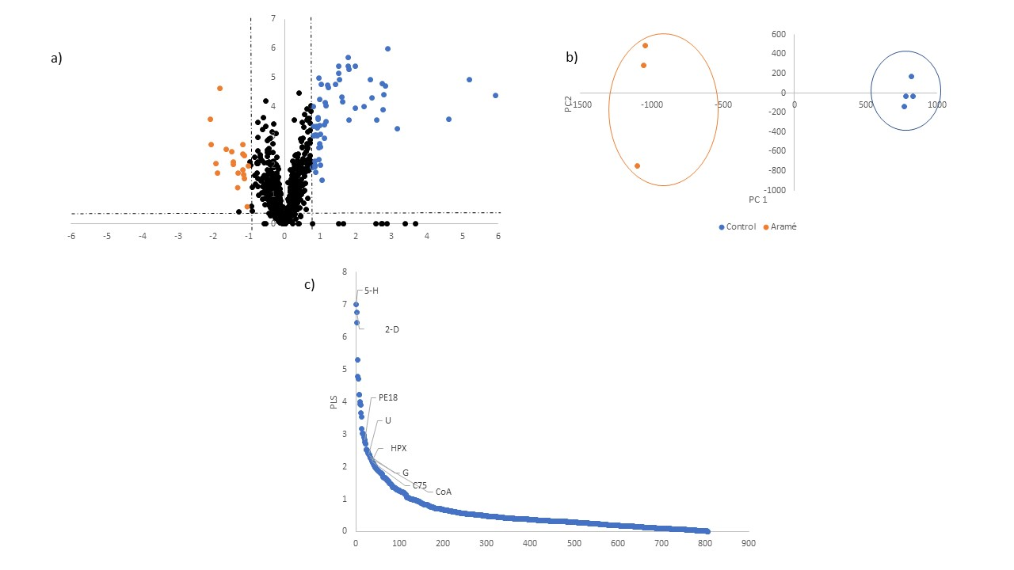
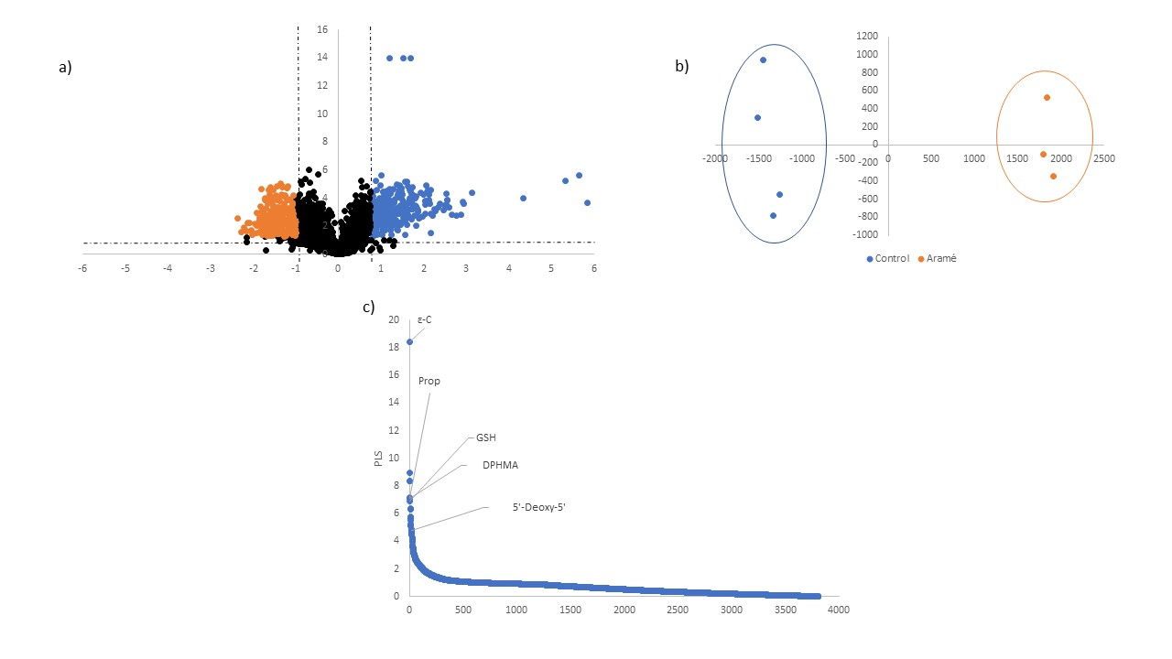
(2)
(1)
Figure S2 - Analysis of compounds that vary in the presence or absence of Aramé, for Hep-G2 cells, in positive (1) and negative (2) mode. a) volcano plot; b) PCA plot; c) PLS plot. ε-C – ε- Caprolactam; HPX -Hypoxanthine; Prop - 3-[7-[4-(2-acetamido-4-methyl-thiazol-5-yl)sulfonylpiperazino]-5-methyl-[1,2,4]triazolo[1,5-a]pyrimidin-6-yl ]ethyl ester propionic acid; DPHMA - (1,4-dimethyl-4-propylheptyl) -(2-methylbutyl)amine; GSH – Glutathione; I – Inosine; 5’ – Deoxy – 5’ - 5'-methylthioadenosine ; 5-H - 5-hydroxyeicosatetraenoic acid; 2-D - 2-Dodecylbenzenesulfonic acid; PE 18 - 1-(9Z-Octadecenoyl)-sn-glycero-3-Phosphoethanolamine; U – Uridine; G - 1-(3-Ethylsulfinylcyclohexyl)-2-methyl-3-[2-[(5-methyl-2-thienyl)sulfonylamino]ethyl]guanidine ; C75 – C75 trans; CoA – coenzyme A.
2)
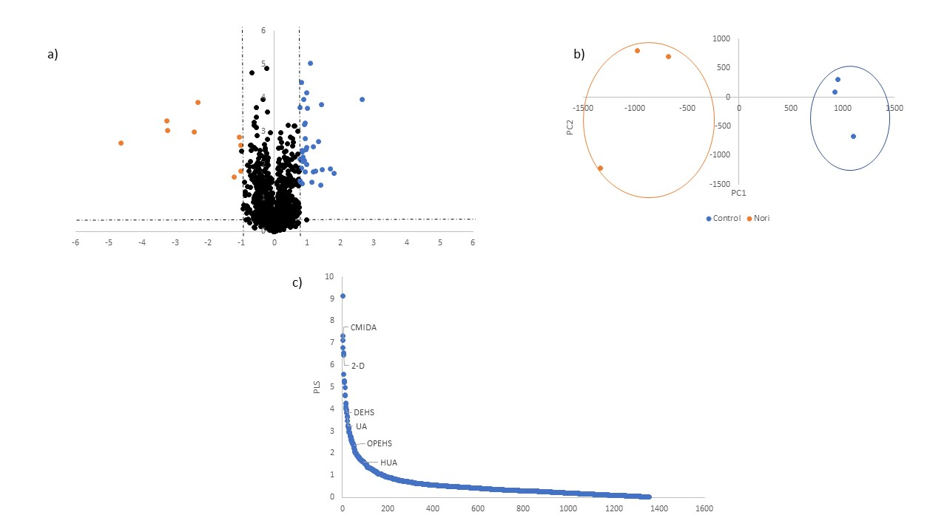
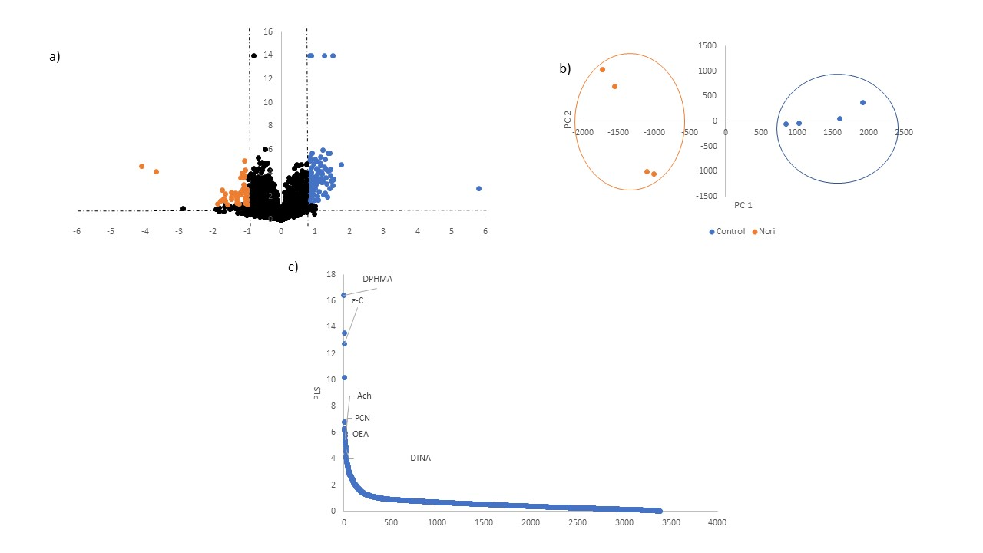
Figure S3 - Analysis of compounds that vary in the presence or absence of Nori, for Caco-2 cells, in positive (1) and negative (2) mode. a) volcano plot; b) PCA plot; c) PLS plot; d) log₂(fold change) chart. DPHMA - (1,4-dimethyl-4-propylheptyl) -(2-methylbutyl) amine; ε-C – ε- Caprolactam; Ach - Acetylcholine; PCN - Phenacylamine; OEA - Oleamide; DINA - Dibenzyl-[4-(3,7-ditert-butyl-4H-diazepin-5-yl)phenyl]amine; CMIDA - 2-keto-N-[6-(4-neopentylpiperazino)-3-pyridyl]-2-(2-phenyl-5,6,7,8-tetrahydroindolizin-3-yl)acetamide; 2-D - 2-Dodecylbenzenesulfonic acid; DEHS - 1-[1-(2-Dodekoxyethoxy)ethoxy]ethyl hydrogen sulfate; UA – Undecanedioic Acid; OPEHS - 2-[3-[3-[3-(3-Octoxypropoxy)propoxy]propoxy]propoxy]ethyl hydrogen sulfate; HUA - 2-hydroxy-10-undecanoic acid.
(2)
(1)
2)
2)

(2)
(1)
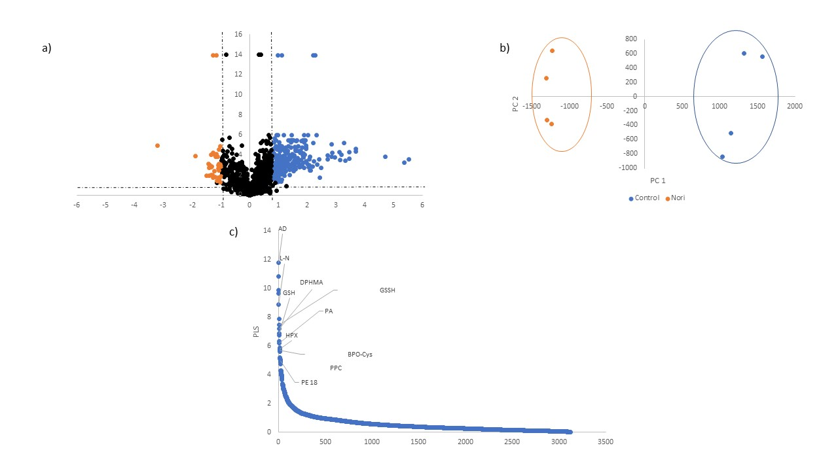
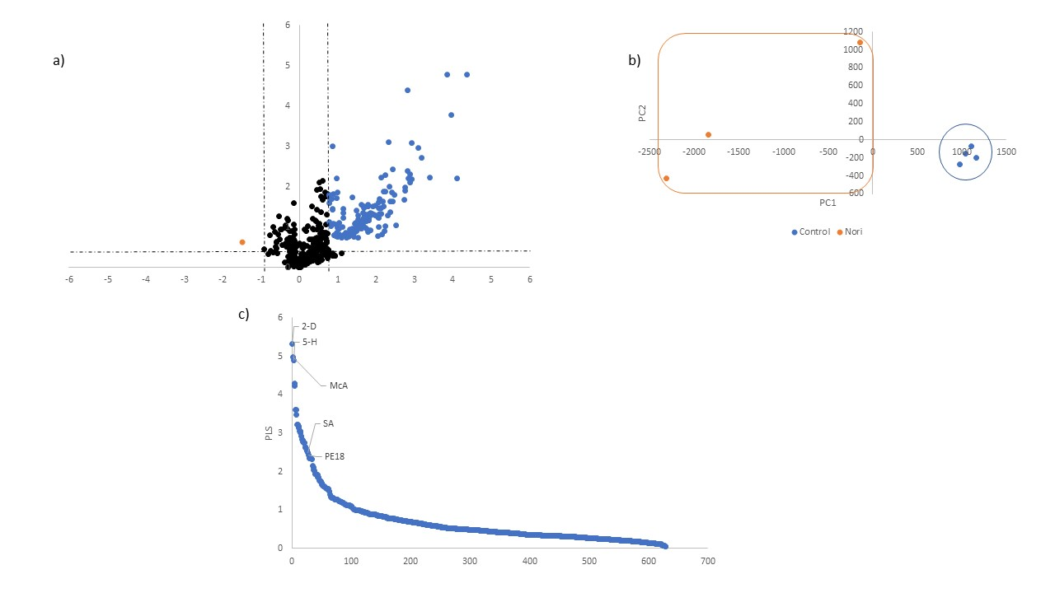
Figure S4 - Analysis of compounds that vary in the presence or absence of Nori, for Hep-G2 cells, in positive (1) and negative (2) mode. a) volcano plot; b) PCA plot; c) PLS plot. AD - Adenosine; L-N - L-Norleucine; GSSH – Glutathione; DPHMA - (1,4-dimethyl-4-propylheptyl) -(2-methylbutyl) amine; GSH – Glutathione; PA – Palmitic Amide; HPX – Hypoxanthine; BPO-Cys - Benzylpenicilloyl-Cysteine; PE18 - 1-(9Z-Octadecenoyl)-sn-glycero-3-Phosphoethanolamine; PPC - 1-Palmitoylphosphatidylcholin; 2-D - 2-Dodecylbenzenesulfonic acid; 5-H - 5-hydroxyeicosatetraenoic acid; McA - Methoxyacetic Acid; SA - 2-[[2-acetamido-3-carboxy-propanoyl]amino] succinic acid.

