Sugarcane pulp lunch-boxes produce more microparticles in acidic foods
Yi Hu^{b}, Chunru Mo^{c}, Zhiwei Wang^{b}, Wenwen Yu^{a, c*}, Changying Hu^{b, c*}
ª State Key Laboratory of Food Science and Technology, Nanchang University, Nanchang 330047, China.
^{b} Packaging Engineering Institute, Jinan University, Zhuhai, Guangdong, 519070, China.
^{c} Department of Food Science & Engineering, Jinan University, Huangpu West Avenue 601, Guangzhou City, 510632, Guangdong, China.

Supplementary Information
Prepared for Submission
To Journal of Science of food and agriculture

Item | Description | Page
Figure S1 | The leaking phenomenon of lunchbox when contacting with the 95% EtOH food simulant. | S3
Figure S2 | Infrared spectra of 15 SCP lunchboxes. | S4
Figure S3 | Frequency distribution curve in various conditions. | S5

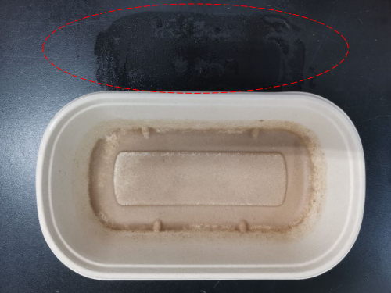
Figure S1. The leaking phenomenon of lunchbox when contacting with the 95% EtOH food simulant.
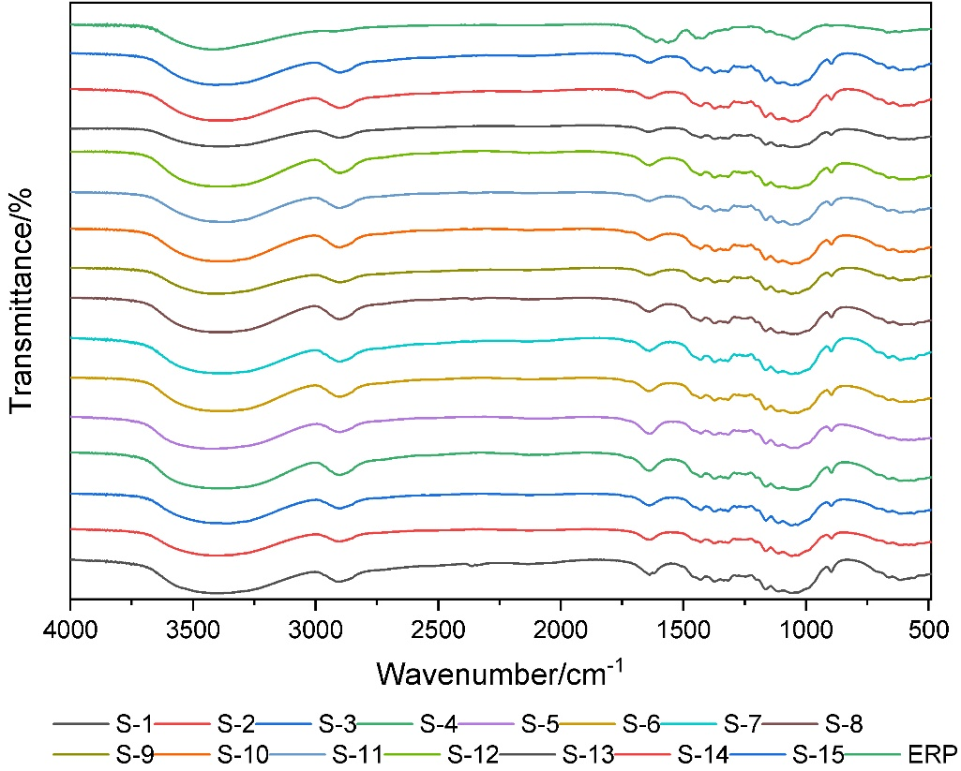
Figure S2. Infrared spectra of 15 SCP lunchboxes.

