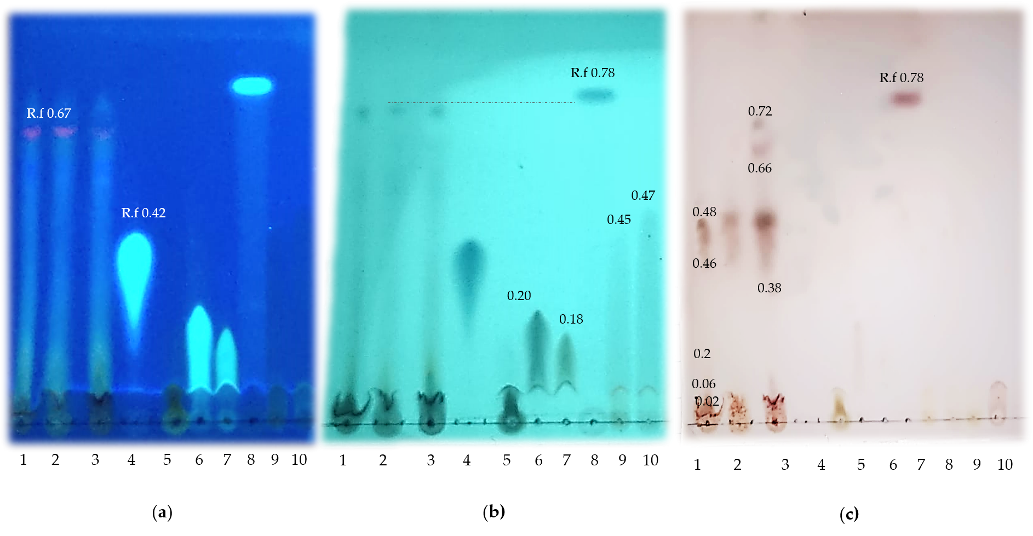
Suplementary Figure S1. Qualitative characterization of GPM by thin layer chromatography. (a) UV (254 nm); (b) UV (365 nm); (c) Revealed plate. 1 (sample GPM), 2 (Sample dried pomace); 3 (sample fresh pomace); 4 (ferulic acid); 5 (GA); 6 (CGA), 7 (CA); 8 (RES); 9(CAT); 10 (EC). *Rf (Retard factor).

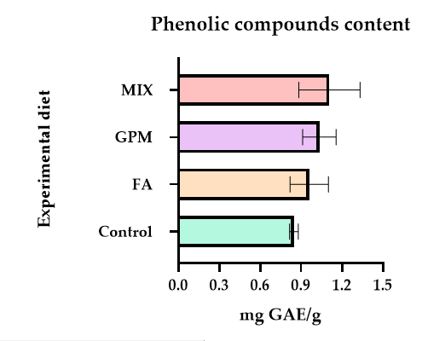
Supplementary Figure S2. Phenolic compounds content in experimental diets. Control (basal diet, DB without additives); FA, DB + 25 mg FA/ kg feed; GPM, BD + 2.5% GPM/ kg; and MIX, BD + 25 mg FA + 2.5% GPM/kg. GAE: Gallic acid equivalents. Bars are the mean ±standard error of 3 replicates.

Supplementary Figure S3. Antioxidant capacity of experimental diets. Control (basal diet, DB without additives); FA, DB + 25 mg FA/ kg feed; GPM, BD + 2.5% GPM/ kg; and MIX, BD + 25 mg FA + 2.5% GPM/kg. Bars are the mean ±standard error of 3 replicates.
Supplementary Table S1. Hematological and biochemical parameters of finishing pigs supplemented with ferulic acid and grape pomace.
Variables | Treatments |  |  |  |  |  |  |  |  |  |  |  | p- value
 | FA |  | 0 |  |  |  | 25 mg |  |  |  | SEM |  | FA |  | GPM |  | FA x GPM
 | GPM |  | 0 |  | 2.5% |  | 0 |  | 2.5%
Hematological parameters
Red blood cells  ( 10^¹²/µL) |  |  | 5.16 |  | 5.22 |  | 4.92 |  | 5.44 |  | 0.14 |  | 0.931 |  | 0.062* |  | 0.137
Hemoglobin, g/dL |  |  | 15.24 |  | 15.40 |  | 14.54 |  | 15.91 |  | 0.40 |  | 0.810 |  | 0.082* |  | 0.169
Hematocrit, % |  |  | 45.08 |  | 45.51 |  | 42.91 |  | 46.98 |  | 1.19 |  | 0.770 |  | 0.081* |  | 0.158
MCV, fL |  |  | 87.1ab |  | 87.09ab |  | 87.28a |  | 86.33b |  | 0.19 |  | 0.170 |  | 0.031 |  | 0.050
MCH, pg |  |  | 29.55 |  | 28.34 |  | 29.47 |  | 29.56 |  | 0.61 |  | 0.533 |  | 0.268 |  | 0.469
MCHC, g/dL |  |  | 33.81 |  | 33.87 |  | 33.87 |  | 33.84 |  | 0.02 |  | 0.200 |  | 0.882 |  | 0.331
RDW-CV, % |  |  | 18.07 |  | 18.61 |  | 19.66 |  | 18.5 |  | 0.64 |  | 0.273 |  | 0.665 |  | 0.256
Platelets (10^³/µL) |  |  | 218.0 |  | 220.3 |  | 163.8 |  | 224.6 |  | 25.5 |  | 0.349 |  | 0.245 |  | 0.275
White blood cells (10^⁹/µL) |  |  | 15.32 |  | 17.44 |  | 17.039 |  | 17.236 |  | 1.32 |  | 0.584 |  | 0.409 |  | 0.483
Granulocytes, % |  |  | 35.39 |  | 33.45 |  | 39.51 |  | 34.33 |  | 2.77 |  | 0.384 |  | 0.259 |  | 0.577
Lymphocytes, % |  |  | 52.13 |  | 56.03 |  | 50.34 |  | 54.40 |  | 2.53 |  | 0.512 |  | 0.184 |  | 0.975
Medium cells, % |  |  | 11.1 |  | 9.99 |  | 11.02 |  | 10.44 |  | 1.53 |  | 0.905 |  | 0.609 |  | 0.865
Biochemical parameters
Glucose, mg/dL |  |  | 66.55 |  | 69.035 |  | 69.41 |  | 76.76 |  | 5.16 |  | 0.290 |  | 0.345 |  | 0.729
Total proteins, g/dL |  |  | 6.475 |  | 6.493 |  | 6.524 |  | 6.347 |  | 0.22 |  | 0.839 |  | 0.733 |  | 0.674
Albumin, g/dL |  |  | 4.163 |  | 3.457 |  | 3.147 |  | 3.416 |  | 0.30 |  | 0.221 |  | 0.264 |  | 0.268
Globulins, g/dL |  |  | 2.436 |  | 3.008 |  | 3.064 |  | 2.867 |  | 0.30 |  | 0.440 |  | 0.550 |  | 0.220
A: G ratio |  |  | 2.3 |  | 1.276 |  | 1.243 |  | 1.166 |  | 0.51 |  | 0.281 |  | 0.312 |  | 0.379
CK, U/L |  |  | 1290.5 |  | 1695.6 |  | 1141.6 |  | 1430.9 |  | 226.3 |  | 0.386 |  | 0.148 |  | 0.813
Hormonal levels
Cortisol, µg/dL |  |  | 2.189 |  | 1.563 |  | 2.275 |  | 1.66 |  | 0.39 |  | 0.82 |  | 0.155 |  | 0.982
GH, ng/mL |  |  | 0.143 |  | 0.086 |  | 0.036 |  | 0.456 |  | 0.20 |  | 0.572 |  | 0.400 |  | 0.309
IGF-1, ng/mL |  |  | 158.37 |  | 102.02 |  | 132.05 |  | 155.73 |  | 26.61 |  | 0.634 |  | 0.551 |  | 0.164
FA: ferulic acid; GPM: grape pomace meal. MCV: mean corpuscular volume; MCH: mean corpuscular hemoglobin; MCHC: mean corpuscular hemoglobin concentration; RDW-CV: ), erythrocyte distribution; CK: creatine kinase; GH: growth hormone; IGF-1: insulin growth factor 1. A: G, albumin: globulins ratio. Means with different letters, indicate significant difference (p<0.05). * Trends (p<0.10). SEM: Standard error of the mean.

