Supplementary data
- In vitro drug metabolism of DMB
  - Identification of dubermatinib in vitro phase I metabolites
    - Identification of the DMB M2 metabolites
DMB's N-demethylation metabolite, M2 PIP, was detected at 23.1 minutes. Fragment ions at m/z 299 and 206 were generated by collision induced dissociation (CID) of the molecular ion peak (MIP) at m/z 502. (Figure S1A). A daughter ion at m/z 299 was formed, which matched the other fragment ions at m/z 206, indicating that the N-demethylation occurred at the sulphonamide moiety (part B of DMB) (Figure S1B).
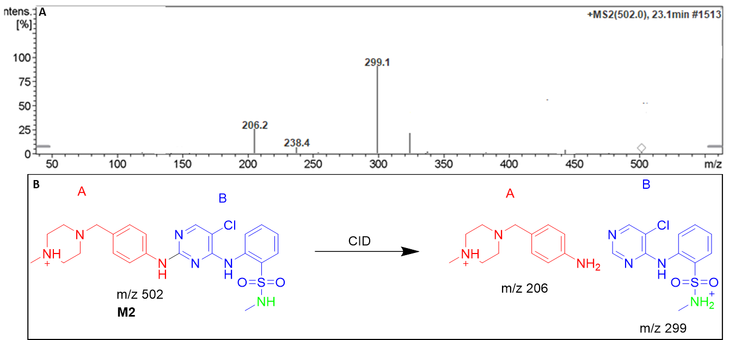
Figure S1. Positive ion MS/MS mass spectrum of M2 at 23.1 min (A). Proposed structural formulas of M2 and corresponding MS/MS fragments (B).

    - Identification of the DMB M3 metabolite
At 24.4 minutes, the N-demethylation metabolite of DMB, M3 PIP, was detected. Fragment ions with masses of 285 and 192 were produced through collision-induced dissociation (CID) of the MIP at m/z 474. (Fig. S2A). N-demethylation was likely performed on the piperazine ring, as evidenced by the formation of a daughter ion at m/z 285. (part A of DMB). Other N-demethylation process of two methyl group occurred at sulphonamide group (part B DMB), as indicated by the production of a daughter ion at m/z 192. (Fig. S2B).
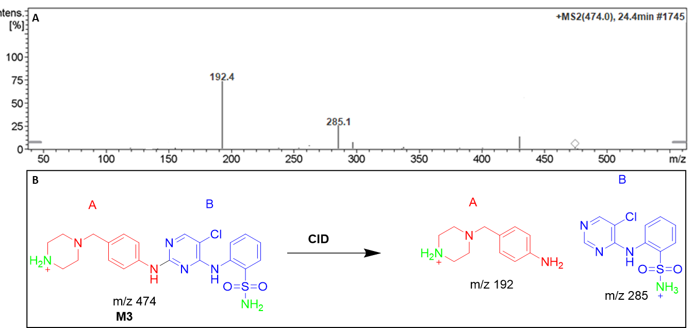
Figure S2. Positive ion MS/MS mass spectrum of M3at 24.4 min (A). Proposed structural formulas of M3 and corresponding MS/MS fragments (B).

    - Identification of the DMB M4 metabolite
At 25.1 minutes, the DMB hydroxylation metabolite M4 PIP was detected. There were fragment ions with m/z values of 313, 222, and 117 generated by CID of the MIP at m/z 532. (Fig. S3A). The m/z 222 daughter ion, along with the m/z 313 and m/z 117 fragment ions, revealed that the hydroxylation happened in the piperazine moiety (part A of DMB) (Fig. S3B).
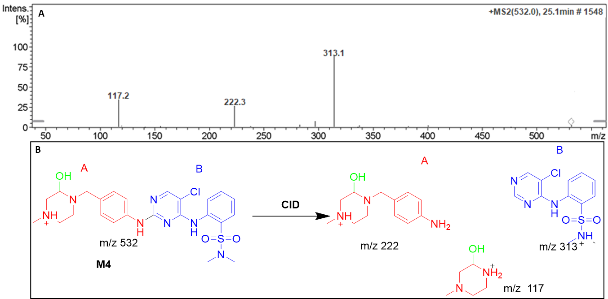

Figure S3. Positive ion MS/MS mass spectrum of the M4 peak (A). Proposed structural formulas of M4 and corresponding MS/MS fragments (B).

    - Identification of the DMB M5 metabolite
Around 27.5 minutes in, the M5 PIP showed up. Dechlorination was followed by hydroxylation of the pyrimidine ring, resulting in the M5 metabolite. There were fragment ions at m/z 295, 206, and 98 produced by CID of MIP at m/z 498. (Fig. S4A). A daughter ion at m/z 295 was formed, which matched the other fragment ions at m/z 206 and m/z 98, indicating that a dechlorination followed by hydroxylation reaction took place at the pyrimidine ring (part B of the DMB structure) (Fig. S4B).

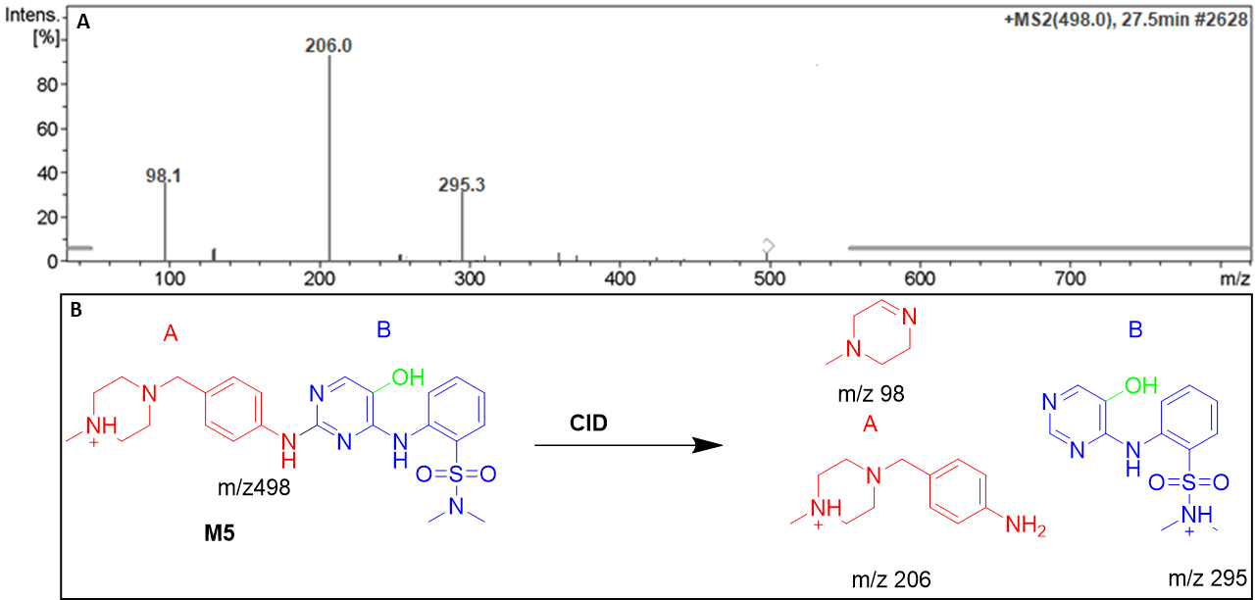
Figure S4. Positive ion MS/MS mass spectrum of M5 at 27.5 min (A). Proposed structural formulas of M5 and corresponding MS/MS fragments (B).

    - Identification of the DMB M6 metabolite
At 28.1 minutes, the M6 PIP was detected. N-demethylation, dechlorination, and hydroxylation all resulted to the M6 metabolite. Fragment ions with masses of 295 and 192 were produced when CID was applied to MIP at m/z 484. (Fig. S5A). Dechlorination and subsequent hydroxylation reactions, as indicated by the formation of a daughter ion at m/z 295, likely occurred in the pyrimidine ring (region B of the DMB structure) (Fig. S5B). As the DMB structure's piperazine ring produced a daughter ion at m/z 192, this indicated that N-demethylation had taken place there (Fig. S5B).
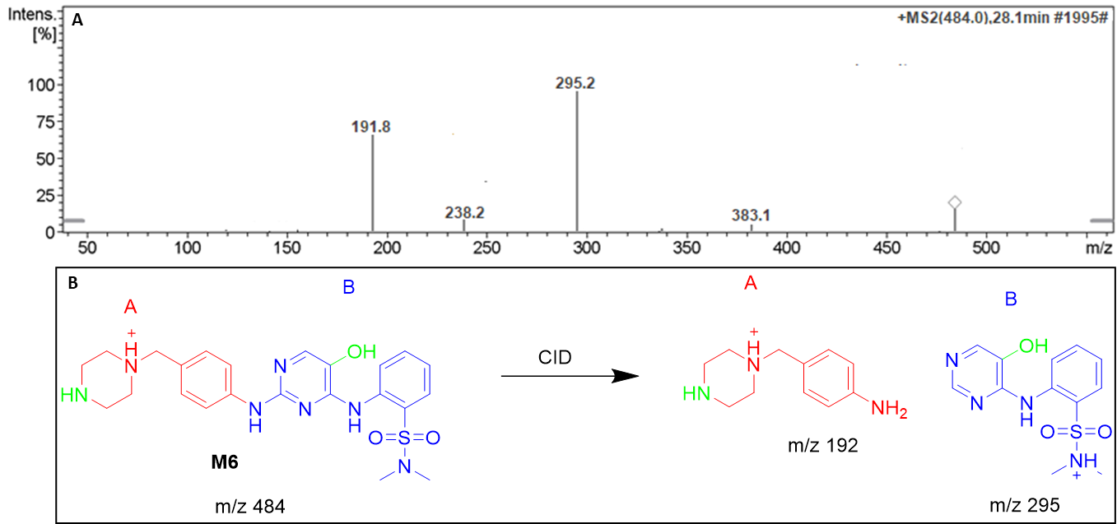
Figure S5. Positive ion MS/MS mass spectrum of M6 at 28.1 min (A). Proposed structural formulas of M6 and corresponding MS/MS fragments (B).

    - Identification of the M7 DMB metabolite
The M6 PIP appeared at 28.6 min. The metabolite M6 was the net product of dechlorination of chlorine group and double hydroxylation. The CID of the MIP at m/z 514 generated fragment ions at m/z 295, 222, and 117 (Fig. S6A). The production of the daughter ion at m/z 295 indicated the dechlorination followed by hydroxylation reactions occurred pyrimidine ring (part B of the DMB structure) (Fig. S6B). The production of a daughter ions at m/z 222 and 117 suggested that there was another hydroxylation reaction occurred at piperazine ring in part A of DMB structure (Fig. S6B).

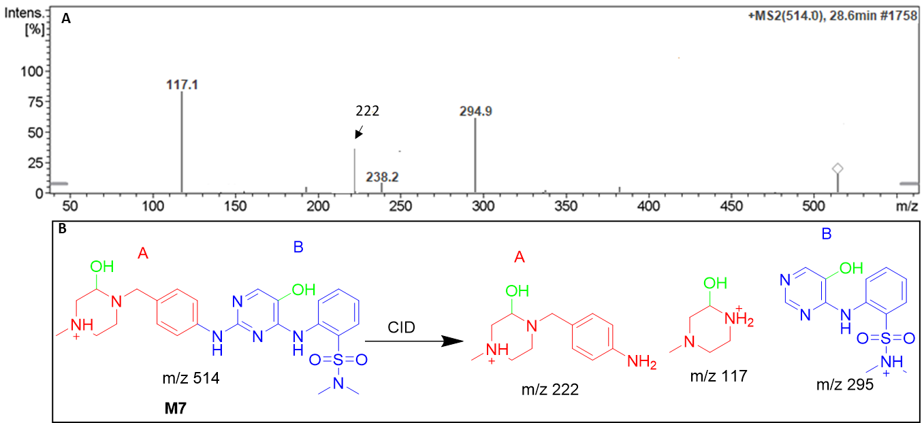

Figure S6. Positive ion MS/MS mass spectrum of M6 at 28.6 min. (A). Proposed structural formulas of M7 and its corresponding MS/MS fragments (B).

3.Identification of in vitro reactive metabolites of dubermatinib.

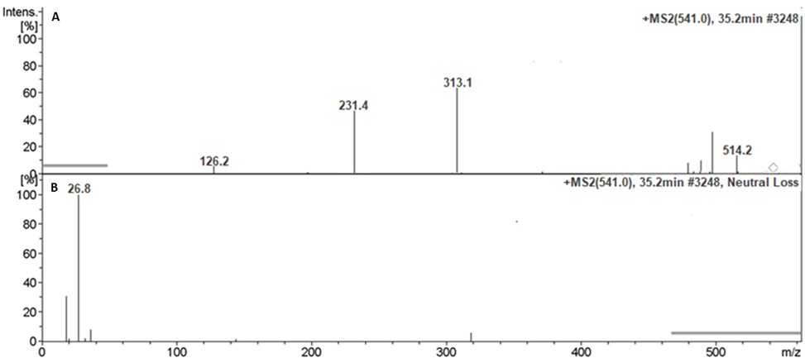
Figure S7. Fragment ions of DMB541CN. (A). Constant neutral loss scan of DMB541CN (B).
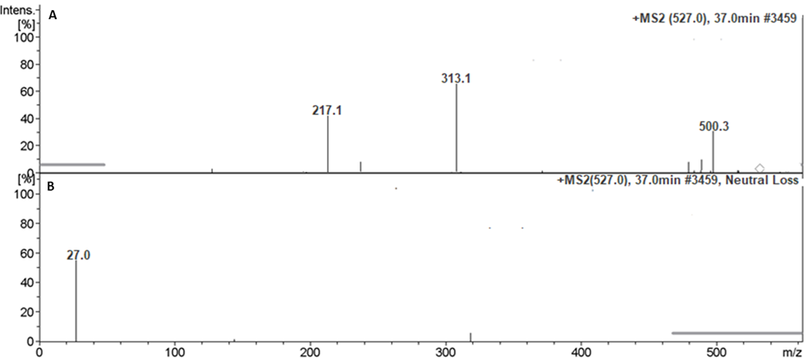
Figure S8. Fragment ions of DMB527CN (A). Constant neutral loss scan of DMB527CN (B).

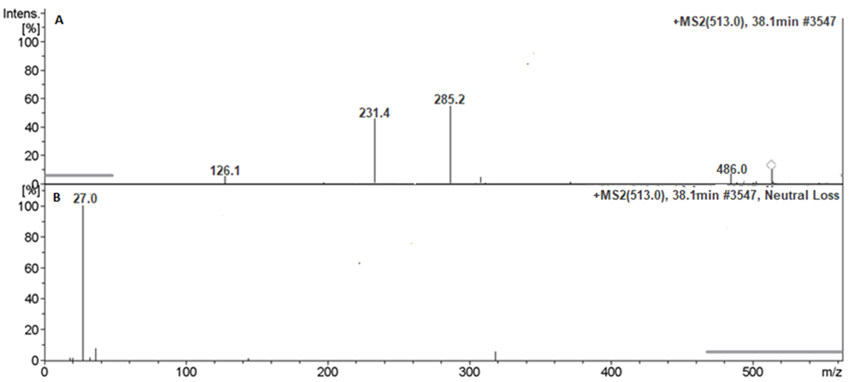
Figure S19. Fragment ions of DMB513CN (A). Constant neutral loss scan of DMB513CN (B).

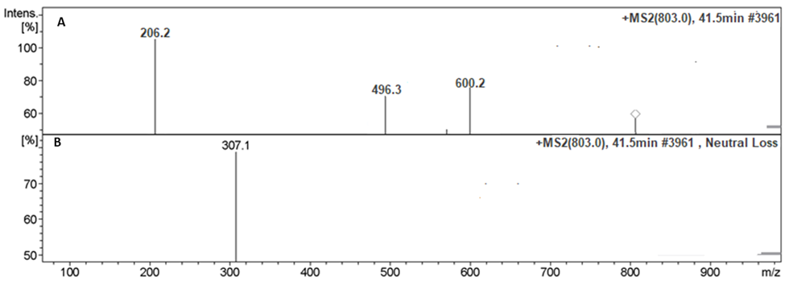
Figure S10: Fragment ions of DMB803GSH (A). Constant neutral loss scan of DMB803GSH (B).

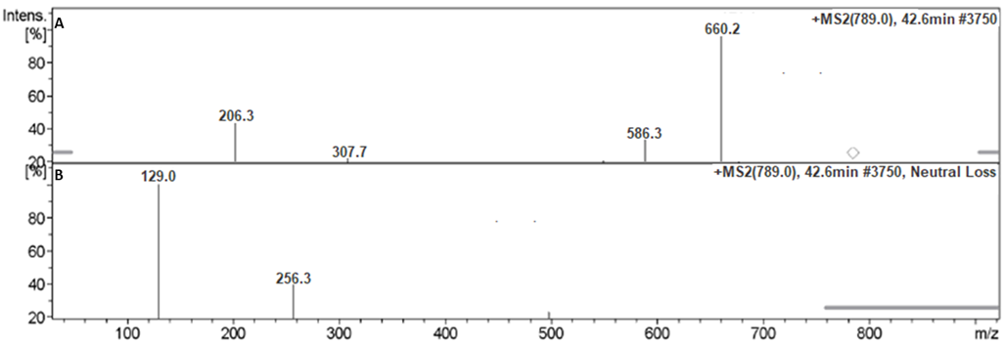
Figure S11. Fragment ions of DMB789GSH(A). Constant neutral loss scan of DMB789GSH(B).

