Supplementary material to
Read this first!
How to prepare a manuscript for submission to a chemical science journal
Anja Dekanski¹ and Aleksandar Dekanski²
¹Karolinska Institute, Department of Physiology and Pharmacology, Solna vägen 9, Solna, Sweden
²University of Belgrade, Institute of Chemistry, Technology and Metallurgy, Department of Electrochemistrz, Njegoševa 12, Belgrade, Serbia
Examples of the most common omissions and errors
in the technical preparation of manuscripts
All Figures and Tables in this Supplemental Material are based on real ones found in submitted manuscripts to several different journals, but the data in them has been changed and some of them modified to highlight the mistakes made. Since they do not represent real results, the sources are not cited.
Title and keywords
An example of a too long and too extensive title, whose almost all words are repeated as keywords is shown in Figure 1. A much clearer and shorter title can be: Trace and selective determination of chobalt(II), with the keywords: Cathodic adsorptive stripping voltammetry; water and salt samples; presence of pyrogallol red.
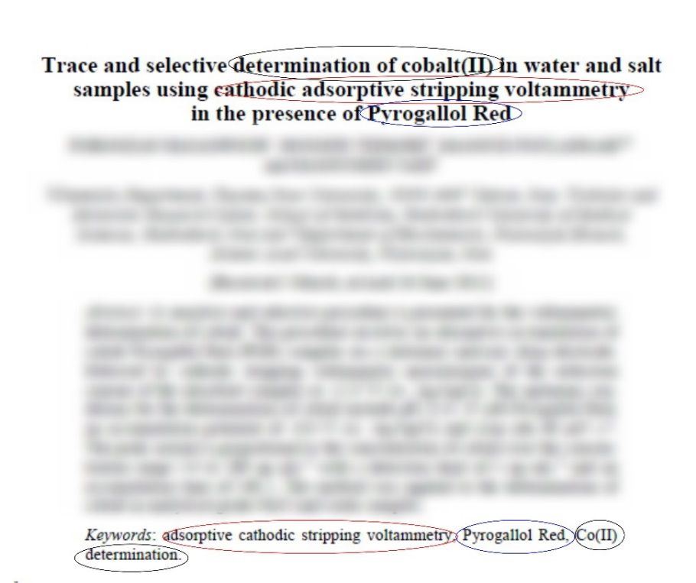
Figure S-1. Poorly created title and wrong choice of keywords
Illustrations
Figure S-2 shows a completely unclear and useless illustration. As the names and units shown on the axes are missing, the reader cannot know what is shown in the figure. Even reading of figure caption can't help with that. Two sets of data are shown, (a) and (b), but without a legend it is not clear which data refer to which set.
Figure S-2. Unclear and useless illustration
An example of poorly selected ranges of presented data and unclear axis names is illustrated in Figure S-3a. It should look like in Figure 3b. A very common mistake is the one made in naming the y-axis on this graph: logarithmic quantities must always be displayed together with its units, because, for example, it is not the same whether the current density whose logarithmic values are presented, are expressed in
A dm⁻² or in mA cm- ² or… It is similar with the name of the x-axis, without unit of time the presented results have do not make any sense.
A B
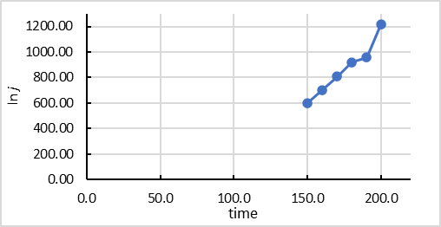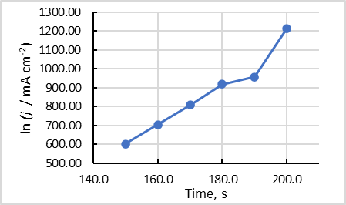
Figure S-3. A - wrong and A - good presentation of the same results
Probably the most common mistakes in articles from chemistry and related fields is the presentation of thermogravimetric analysis (TGA) data. Figure 4 shows three graphs that illustrate those errors^{1,2}. Although these Figures are probably clear to anyone who is even the least familiar with TGA, science implies precise and clear communication, so the y-axes on the graphs are not correct. In Figure 4A, the name of the y-axis is Weight (%), although percent is not a unit of weight. It is obvious that the relative mass loss of the sample during heating is shown on that axis. It would be most accurate if, instead, the mass of the sample, which decreases during heating, is presented on the axis. If it was decided to be a relative change expressed in percentages, the name of the axis should have been: Mass loss, %, with range from 100 to 0 %, not from 0 to 100 %, as it is wrongly shown in Figure 4B a. An alternative is for the axis range to remain from 0 to 100 %, but the axis name to be: Residual mass loss, % or even very precise: ((m-m_{t} / m)100) / %, where m is starting mass of sample and m_{t} mass of sample at temperature t / °C. Analogously, the y-axis in Figure 4B b should be, for example: d (Mass loss) dt⁻¹ / % °C⁻¹ or (d(m-m_{t} / m)100) dt⁻¹ / % °C⁻¹. In addition, x-axis in all figures would be more correct to write as t / °C or Temperature, °C
A B
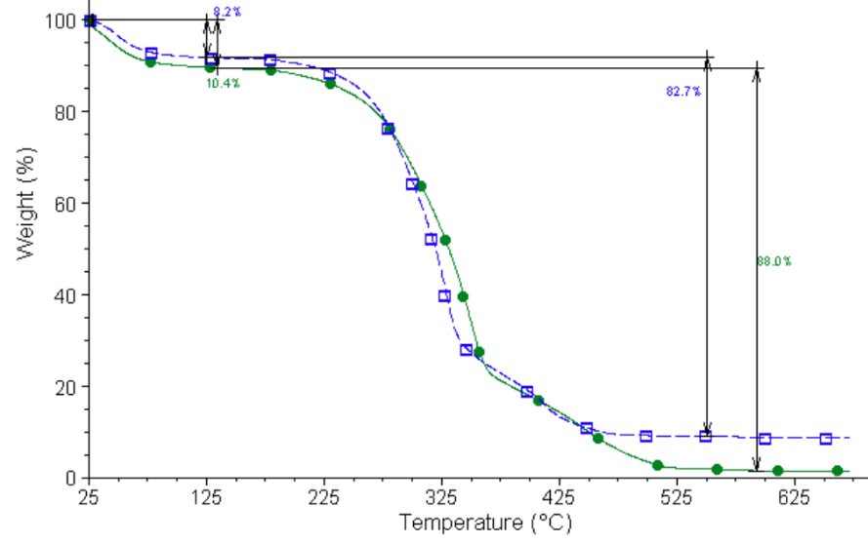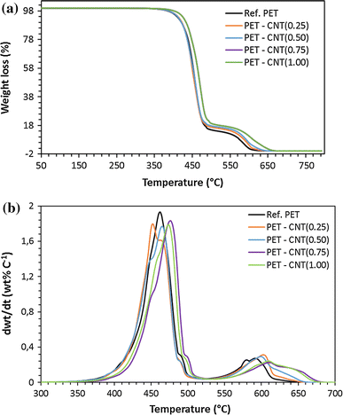
Figure S-4. Examples of poorly named axes on TGA plots
Although electronic publishing made it possible for lower quality and resolution and different formats of illustrations (compared to publishing on paper) to be acceptable, it is necessary that they meet a certain minimum. Figure S-5 shows the same figure in different resolutions. Figure S-5A is .gif format illustration with the resolution of 100 dpi, while Figure S-5B is in .tif format and resolution of 600 dpi. In addition, on the first one, the font size is insufficient for the data from the figure to be easily and clearly read.
A B
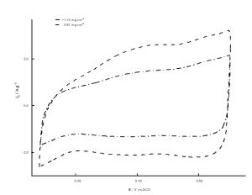
Figure S-5. The same illustration prepared A - poor and B - good
Tables
Several omissions were illustrated in Table S-I:
1. In all columns, except for the column titled Plasticizer, all values are equal, so the tabular presentation is completely unnecessary. The table can be replaced with only one sentence in the text, which would list all reactants and their quantities, except for Plasticizer, which should be written that it was not present in Exp. 18, 0.4 l of RA was added in Exp. 19, and 0.4 l of ESO was added in Exp. 20.
2. Although it would probably be clear to the reader that the numerical quantities shown in the table refer to the quantities and volumes of reactants, the names of the columns are misleading. Starch, plasticizer, 15% H₂O₂, catalyst and hydroquinone are not physical quantities and cannot have any numerical value. These are their masses or volumes, so the column headings should be as, for example, in Table S-II.
3. In table caption it is stated that the reaction conditions are also shown, but there is no such data, the table only contains the quantities of reactants. Therefore, the title of the table should be as in Table S-II
Table S-I. Quantities of reactants and reaction conditions used in experiments
Sample | Starch, [kg] | Plasticizer, [l] |  | 15% H₂O₂, [l] | Catalyst, [kg] |  | Quinone, [kg]
Exp 18 | 200 | - |  | 20 | Cu citrate | 0.03 | 0.4
Exp 19 | 200 | RA | 0.4 | 20 | Cu citrate | 0.03 | 0.4
Exp 20 | 200 | ESO | 0.4 | 20 | Cu citrate | 0.03 | 0.4

Table S-II. Quantities of reactants used in the experiments
Sample | Mass, kg |  |  | Volume, l
 | Starch | Catalyst (Cu-citrate) | Quinone | Plasticizer | 10 % H₂O₂
Exp 18 | 200 | 0.03 | 0.4 | - | 20
Exp 19 | 200 | 0.03 | 0.4 | 0.4 RA | 20
Exp 20 | 200 | 0.03 | 0.4 | 0.4 ESO | 20

Manuscript preparation
A drastic example of ignoring or not reading the Instructions for Authors and not knowing the elementary principles of good writing of a scientific article is illustrated in Figure S-6.
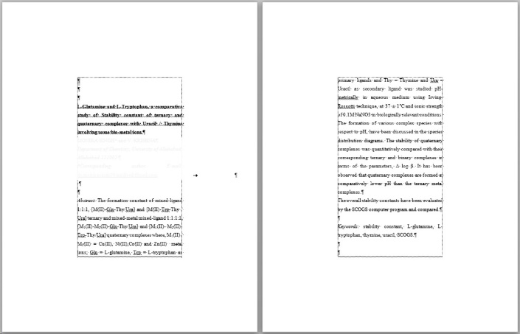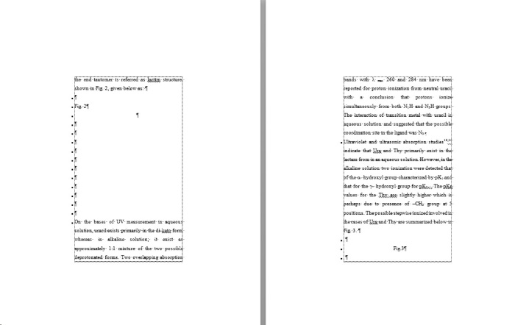

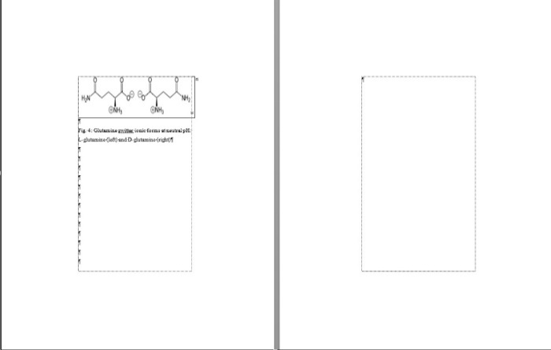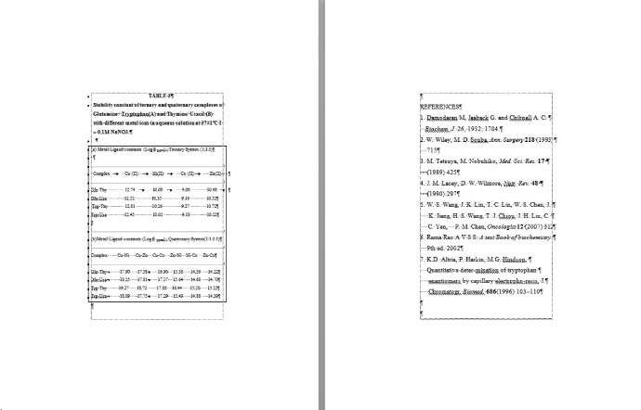
Figure S-6. Screenshots of eight pages of a manuscript submitted for publication in a scientific journal

There are so many errors on the presented 8 pages that it is difficult even to count them. From clearly wrong margins, through unnecessary blank pages and the use of consecutive spaces and new lines to format text and tables, to an incorrectly and inconsistently formatted reference list.... For such a new submission, one can expect nothing more than desktop rejection, even without reading the article itself.

Corresponding author: dekanski@ihtm.bg.ac.rs

