Supplementary information

Table S1. Means and LSD for Wet Gluten for both varieties at different N application rates at sowing for both seasons.
Variety | Season | Nrate (kg/ha)
 |  | 0 | 50 | 100 | 150 | 200
Jandaroi | 2020 | 32.04aA | 32.12aA | 33.04aA | 34.19aBC | 34.52aC
DBA Lillaroi |  | 34.72bBC | 34.62bBC | 36.09bD | 36.59bD | 38.11bE
LSD |  | 1.029
 |  | 0 | 20 | 40 | 80 | 160
Jandaroi | 2021 | 21.74aA | 22.34aA | 23.58aB | 25.08aC | 28.03aD
DBA Lillaroi |  | 20.99aA | 21.88aA | 23.45aB | 25.15aC | 29.20bD
LSD |  | 1.126
For each season, values with the same lowercase letter in the same column are not significantly different and values with the same upper case letter in the same row are not significantly different, p<0.05.

Table S2. Means and LSD for screenings for both varieties at different FCR inoculation rates at sowing for both seasons.
Variety | Season | FCR Inoculation (g/m)
 |  | 0 | 0.5 | 2.0
Jandaroi | 2020 | 2.88aA | 4.99aB | 4.97aB
DBA Lillaroi |  | 3.18aA | 3.8bA | 3.56bA
LSD |  | 0.976
 |  | 0 | 0.75 | 1.5
Jandaroi | 2021 | 0.83aA | 0.96aB | 0.95aB
DBA Lillaroi |  | 0.97bA | 0.97aA | 1.06aA
LSD |  | 0.127
For each season, values with the same lowercase letter in the same column are not significantly different and values with the same upper case letter in the same row are not significantly different, p<0.05.

Table S3. Means and LSD for SY for both varieties at different disease application rates - Tamworth 2020.
Variety | FCR Inoculation (g/m)
 | 0 | 0.5 | 2.0
Jandaroi | 73.96a | 73.79a | 73.95a
DBA Lillaroi | 75.16b | 75.27b | 75.69c
LSD | 0.325
Different letters in the same column indicate statistically significant differences at p < 0.05.

Table S4. Means and LSD for GI, MPT and RBD for both varieties at different inoculation application - Tamworth 2020.
Variety | Dough measure | FCR Inoculation (g/m)
 |  | 0 | 0.5 | 2.0
Jandaroi | MPT | 3.45b | 3.24a | 3.22a
DBA Lillaroi |  | 2.78c | 2.71c | 2.72c
LSD |  | 0.124
Jandaroi | RBD | 47.5a | 47.8a | 50a
DBA Lillaroi |  | 50.6c | 56.2b | 58.5b
LSD |  | 4.095
Jandaroi | GI | 92.9b | 86.6a | 83.1a
DBA Lillaroi |  | 67.7d | 57.1c | 53.8c
LSD |  | 3.88
Different letters in the same column indicate statistically significant differences at p < 0.05.

Table S5. Means and LSD for % Fusarium infection for both varieties at different disease application rates - Tamworth 2021.
Variety | FCR Inoculation (g/m)
 | 0 | 0.75 | 1.5
Jandaroi | 1.60aA | 45.60aB | 69.40aC
DBA Lillaroi | 1.40aA | 49.40bB | 69.60aC
LSD | 3.03
Values with the same lowercase letter in the same column are not significantly different and values with the same upper case letter in the same row are not significantly different, p<0.05.

Table S6. Means and LSD for % Fusarium infection for both varieties at different disease and nitrogen application rates - Tamworth 2020.
Variety | Disease  (g/m) |  | Nrate (kg/ha)
 |  |  | 0 | 50 | 100 | 150 | 200
Jandaroi | 0 |  | 2.0aA | 6.0aA | 7.0aA | 6.0aA | 6.0aA
 | 0.5 |  | 30.0bA | 32.0bA | 46.0bB | 45.0bB | 54.0bC
 | 2.0 |  | 72.0cA | 72.0cA | 76.0cAB | 80.0cAB | 83.0cB
DBA Lillaroi | 0 |  | 5.0aA | 6.3aA | 4.0aA | 7.3aA | 4.0aA
 | 0.5 |  | 38.0bA | 42.0dA | 47.0bAB | 53.0bBC | 58.0bC
 | 2.0 |  | 75.0cA | 77.0cAB | 85.0cBC | 86.0cBC | 89.0cC
LSD |  |  | 9.08
Values with the same lowercase letter in the same column are not significantly different and values with the same upper case letter in the same row are not significantly different, p<0.05.

Table S7. Mean SE-HLPC data for two durum wheat varieties at 4N rates and 2 CR inoculations in mature grain from 2021 season.
Variety | N rate  (kg/ha) | CR  (g/m) | P/M | Gli/Glu | UPP% | %SolA | %SolB | %SolC | %InsolA | %InsolB | %InsolC | Total Area
Jandaroi | 0 | 0 | 1.01 | 0.74a | 28.47 | 35.79 | 34.46a | 12.62 | 14.19e | 2.21 | 0.72 | 43752809
Jandaroi | 0 | 1.5 | 1.02 | 0.73a | 25.36 | 37.71 | 34.82ab | 11.88 | 12.77de | 2.13 | 0.70 | 43620193
Jandaroi | 40 | 0 | 0.95 | 0.78abc | 25.47 | 36.16 | 35.23abcd | 13.33 | 12.34cd | 2.17 | 0.76 | 44883926
Jandaroi | 40 | 1.5 | 0.97 | 0.76ab | 27.62 | 35.58 | 34.95abc | 12.93 | 13.54de | 2.23 | 0.76 | 44816265
Jandaroi | 80 | 0 | 0.96 | 0.78abc | 26.17 | 36.12 | 35.71abcdef | 12.64 | 12.71de | 2.13 | 0.69 | 46813416
Jandaroi | 80 | 1.5 | 0.91 | 0.82bc | 26.25 | 34.92 | 36.28cdefg | 13.71 | 12.32cd | 2.10 | 0.67 | 47870491
Jandaroi | 160 | 0 | 0.98 | 0.78abc | 28.04 | 35.52 | 36.11bcdefg | 11.51 | 13.85de | 2.32 | 0.69 | 54017130
Jandaroi | 160 | 1.5 | 0.90 | 0.83bc | 27.49 | 34.24 | 36.64efgh | 13.11 | 13.04de | 2.25 | 0.71 | 52463957
DBA Lillaroi | 0 | 0 | 0.94 | 0.78abc | 19.40 | 39.05 | 36.11bcdefg | 13.01 | 9.37ab | 1.80 | 0.66 | 43496710
DBA Lillaroi | 0 | 1.5 | 0.90 | 0.79abc | 21.22 | 37.14 | 35.03abcd | 15.36 | 9.93ab | 1.84 | 0.71 | 41210808
DBA Lillaroi | 40 | 0 | 0.96 | 0.76ab | 19.34 | 39.42 | 35.48abcde | 13.37 | 9.45ab | 1.69 | 0.59 | 42665147
DBA Lillaroi | 40 | 1.5 | 0.92 | 0.80abc | 19.13 | 38.69 | 36.34defgh | 13.45 | 9.12ab | 1.76 | 0.64 | 43772307
DBA Lillaroi | 80 | 0 | 0.86 | 0.84c | 19.43 | 37.18 | 37.01fgh | 14.59 | 8.89a | 1.72 | 0.61 | 46187819
DBA Lillaroi | 80 | 1.5 | 0.92 | 0.81bc | 18.85 | 38.94 | 37.39gh | 12.57 | 9.01a | 1.55 | 0.54 | 46761999
DBA Lillaroi | 160 | 0 | 0.94 | 0.82bc | 22.29 | 37.71 | 37.69h | 11.07 | 10.79bc | 2.09 | 0.64 | 52503063
DBA Lillaroi | 160 | 1.5 | 0.90 | 0.84c | 21.40 | 37.01 | 37.70h | 12.65 | 10.12ab | 1.91 | 0.62 | 51863401
 |  | LSD | 0.113 | 0.0711 | 3.37 | 2.996 | 1.379 | 2.942 | 1.761 | 0.238 | 0.046
 | Fpr | V | <0.05 | <0.05 | <.001 | <.001 | <.001 | ns | <.001 | <.001 | <.001
 |  | Nrate | ns | <0.05 | ns | ns | <.001 | ns | <0.05 | <0.05 | ns
 |  | CR | ns | ns | ns | ns | ns | ns | ns | ns | ns
 |  | Interactions | ns | ns | ns | ns | ns | ns | ns | ns | ns
Numbers with alike lower case letters in the same column are not significantly different, p <0.05. Fpr=probability for significance and level for each factor.

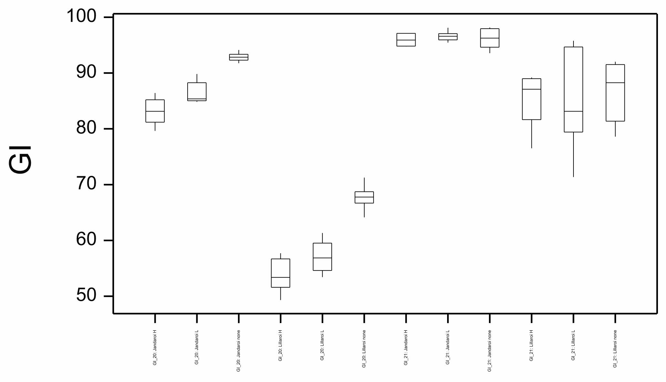
J2 J0.5 J0 L2 L0.5 L0 J1.5 J0.75 J0 L1.5 L0.75 L0
2020 2021
LSD
LSD
Figure S1. Boxplot showing gluten index (GI) for both varieties at different CR inoculation rates (g/m) for 2020 and 2021 seasons. LSD statistic shown for each year

