Supplementary Materials
Biological activity of Beauveria bassiana and chemical profile of its volatile secondary metabolites using SPME-GC/MS analysis
Ippolito Camele ¹, Sadeek A. Sadeek ², Rocco Racioppi ³, and Hazem S. Elshafie ^{1,*}
¹ School of Agricultural, Forestry, Food and Environment al Sciences, University of Basilicata, Viale dell’Ateneo Lucano, 10, 85100 Potenza, Italy; ippolito.camele@unibas.it (I.C.)
2 Department of Chemistry, Faculty of Science, University of Zagazig, 44519 Zagazig, Egypt;
s_sadeek@zu.edu.eg (S.A.S.)
3 Department of Sciences, University of Basilicata, Viale dell’Ateneo Lucano 10, 85100 Potenza, Italy; rocco.raciopi@unibas.it (R.R.)

* Correspondence: hazem.elshafie@unibas.it; Tel.: 0039 0971205498; Fax: 0039 0971205503 (H.S.E.)

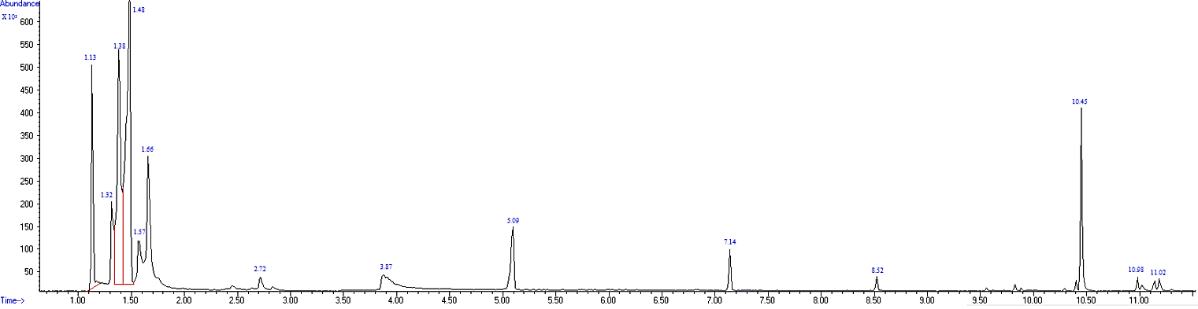
Fig. S1. Chromatogram of VOCs extracted from B. bassiana UniB2439-3

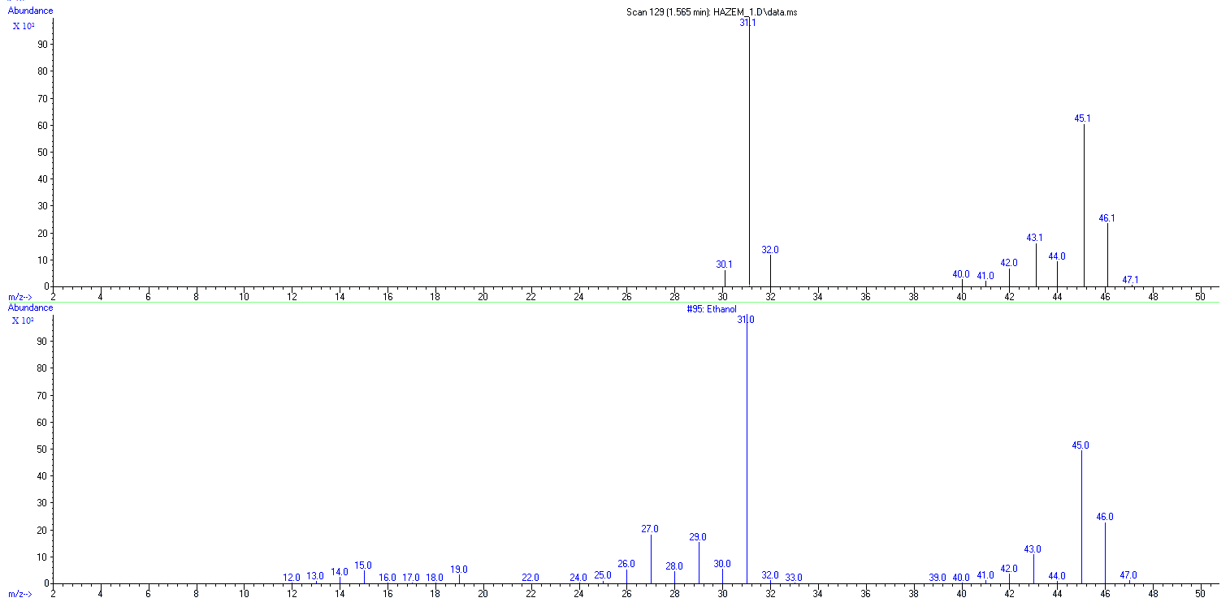
Fig. S2. Mass spectra of ethanol

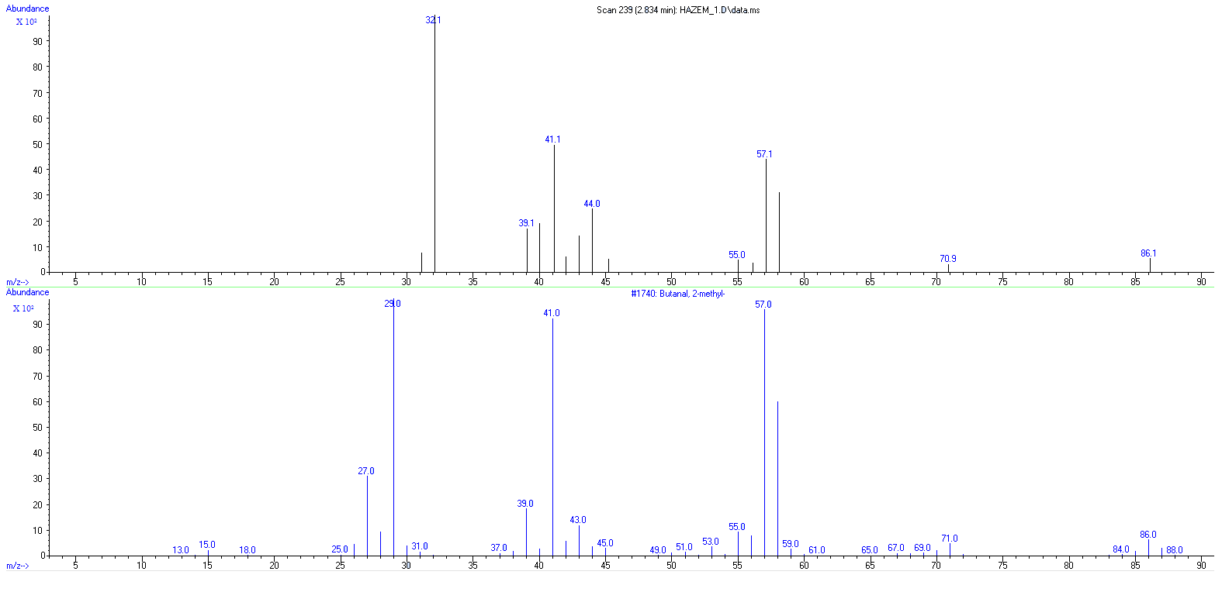
Fig. S3. Mass spectra of Butanal, 2-methyl

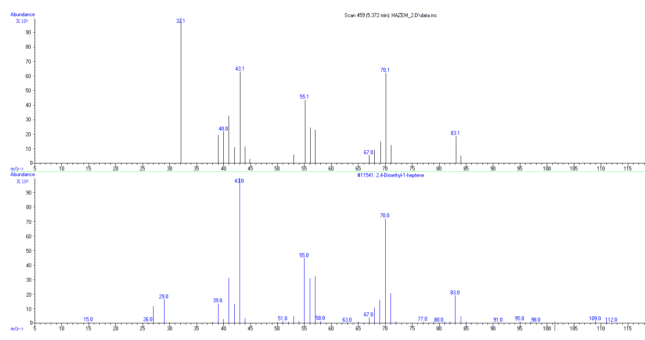
Fig. S4. Mass spectra of 2,4-Dimethyl-1-heptene

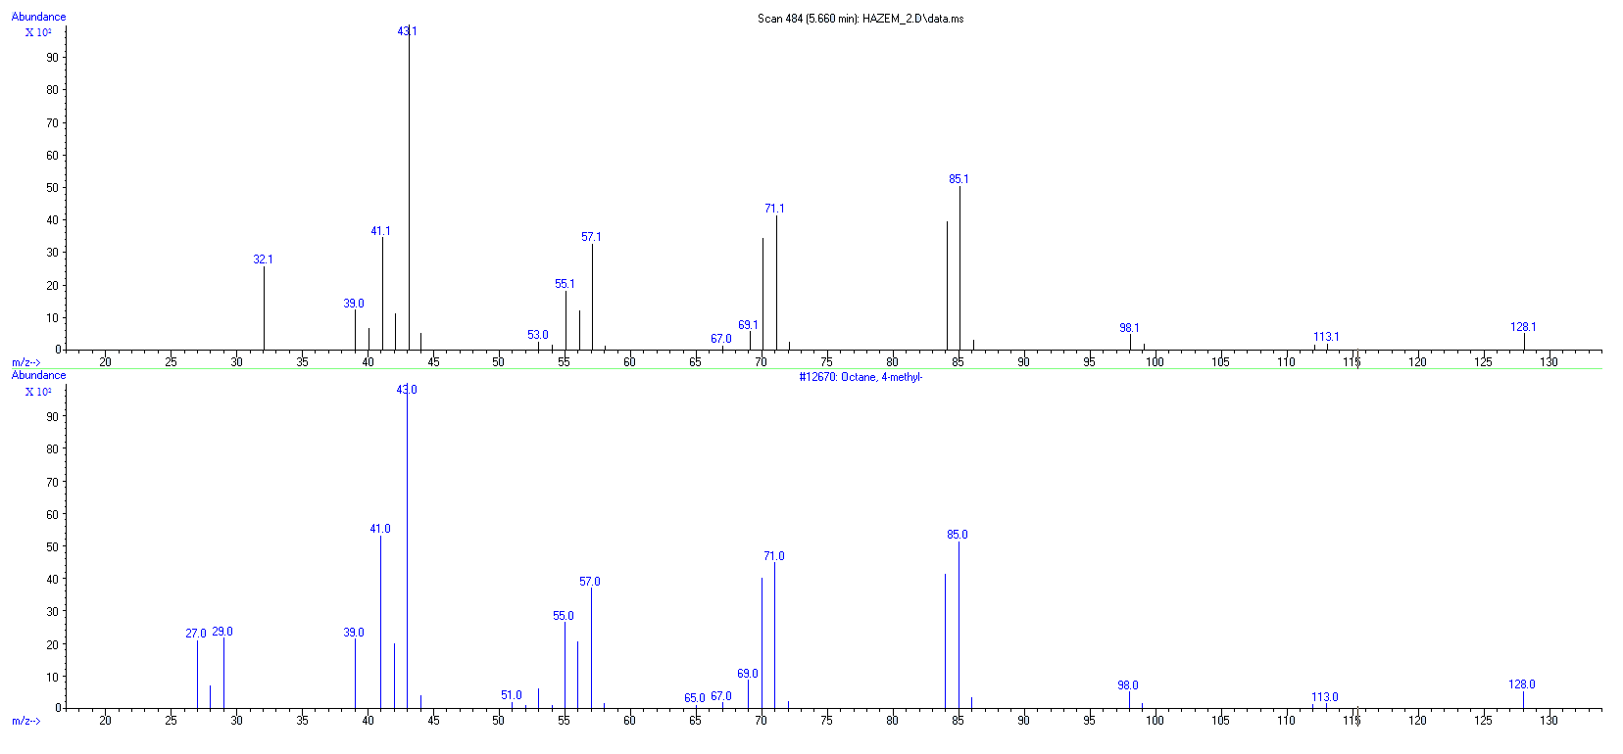
Fig. S5. Mass spectra of Octane, 4-methyl

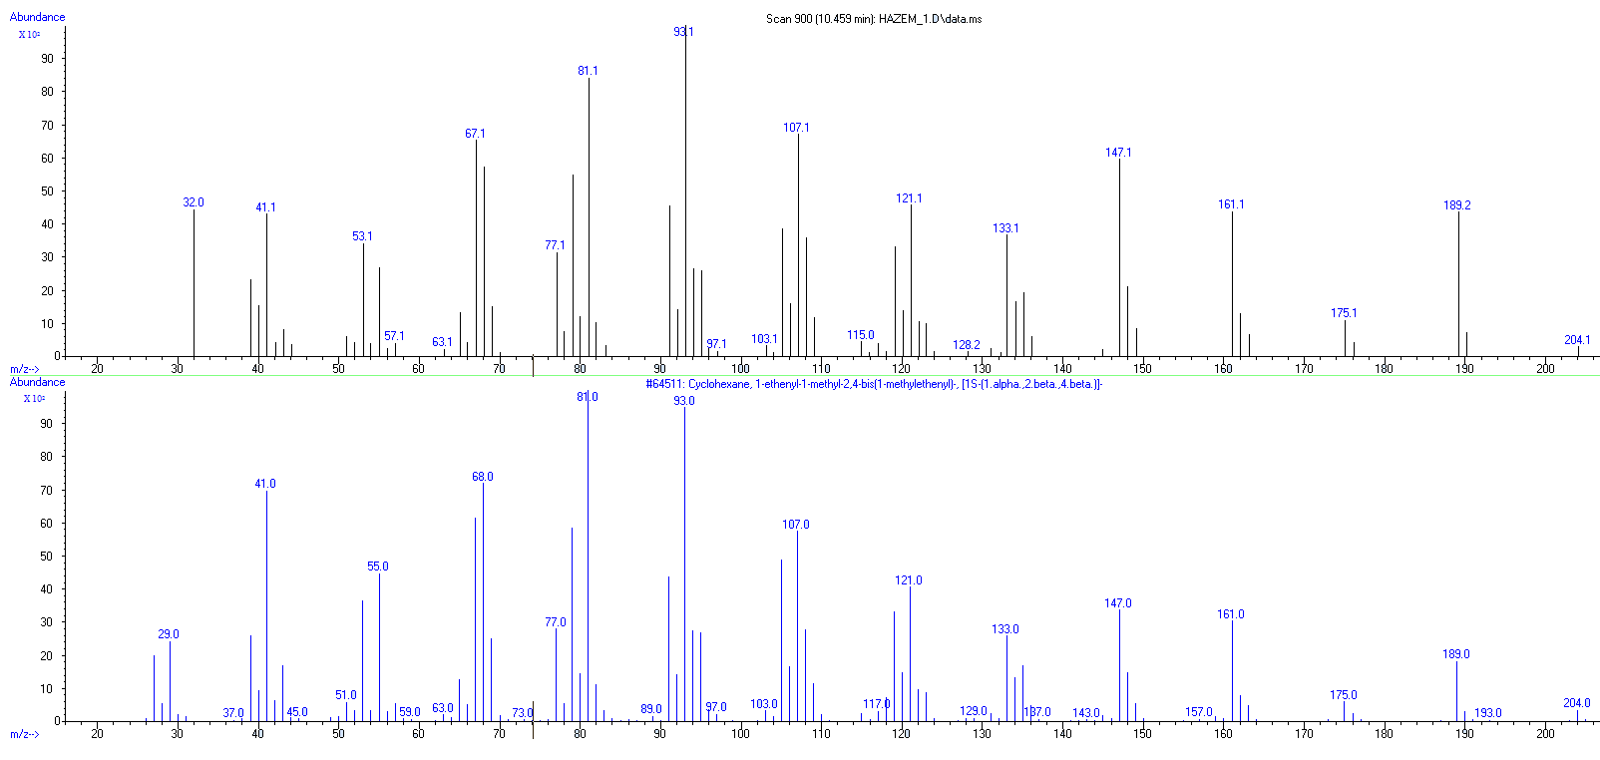
Fig. S6. Mass spectra of β-elemene

Table S1. Antagonistic antibacterial activity of the five studied isolates of Beauveria sp.
 | Diameter of inhibition zone (mm)
 |  | UniB2439-1 | UniB2439-2 | UniB2439-3 | UniB2439-4 | UniB2439-5
G+ve | B. cereus | 10±1.2bc | 12±0.8b | 20±1.4a | 15±1.5b | 8±0.8c
 | B. megaterium | 8±1.4c | 7±0.9c | 15±3.2a | 11±1.2b | 10±2.4b
 | B. mojavensis | 12±0.2b | 15±0.8b | 22±2.4a | 12±2.4bc | 10±2.1bc
 | C. michiganensis | 10±3.2b | 10±0.7b | 19±1.4a | 8±1.2c | 7±1.2c
G-ve | X. campestris | 7±1.2b | 5±0.7b | 10±2.2a | 0±02c | 5±0.7b
 | X. vesicatoria | 5±2.3c | 10±2.2ab | 12±3.2a | 8±0.7ab | 6±0.8b
 | P. aeruginosa | 0±0c | 3±1.2ab | 0±0c | 5±1.2a | 0±0c
 | P. fluorescens | 2±1.2b | 8±0.8a | 6±0.8ab | 0±0c | 0±0c
Values followed by different letters in each horizontal row for each tested bacteria are significantly different at P < 0.05 according to one-way ANOVA combined with Tukey B post hoc test by using SPPS program. Data are expressed as the mean of inhibition zone diameter (mm) for three

Table S2. The whole list of SPME-GC/MS analysis of VOCs extracted from B. bassiana UniB2439-3.
RT¹  (min) | Area  (%) | Name | M.Wt²  (g/mol) | Formula | CAS³ | Probability of identification  (%)
1,11 | 2,75 | Carbon dioxide | 44,01 | CO₂ | 000124-38-9 | 80
1,21 | 1,24 | Benzaldehyde, 2-nitro-, diaminomethylidenhydrazone | 207.19 | C₈H₉N₅O₂ | 102632-31-5 | 43
1.4840 | 27.5713 | Nitrous oxide | 44.013 | N₂O | 010024-97-2 | 65
1,68 | 0,66 | Silanol, trimethyl- | 90.2 | C₃H₁₀OSi | 001066-40-6 | 74
1,77 | 0,72 | Acetone | 58.08 | C₃H₆O | 000067-64-1 | 79
2,03 | 0,61 | Formamide, N-methylthio | 75.14 | C₂H₅N_{S} | 018952-41-5 | 63
2.7184 | 1.3273 | Butanal, 3-methyl- | 86.13 | C₅H₁₀O | 000590-86-3 | 81
2.8337 | 0.4432 | Butanal, 2-methyl- | 86.13 | C₅H₁₀O | 000096-17-3 | 90
3.8835 | 3.7267 | 1-Butanol, 3-methyl- | 88.15 | C₅H₁₂O | 000123-51-3 | 83
4,98 | 1,68 | Arsenous acid, tris(trimethylsilyl) ester | 342.49 | C₉H₂₇AsO₃Si₃ | 055429-29-3 | 70
5,37 | 0,63 | 2,4-Dimethyl-1-heptene | 126.24 | C₉H₁₈ | 019549-87-2 | 90
5,56 | 0,76 | Heptane, 2,3-dimethyl- | 128.25 | C₉H₂₀ | 003074-71-3 | 87
5,66 | 1,99 | Octane, 4-methyl- | 128.25 | C₉H₂₀ | 002216-34-4 | 93
7,30 | 0,19 | Octane, 2,3,6,7-tetramethyl- | 170.33 | C₁₂H₂₆ | 052670-34-5 | 63
7,33 | 0,21 | Oxalic acid, 2-ethylhexyl nonyl ester | 328.5 | C₁₉H₃₆O₄ | 1000309-39-2 | 74
7,70 | 0,49 | Dodecane, 2,6,11-trimethyl- | 212.41 | C₁₅H₃₂ | 031295-56-4 | 69
7,76 | 5,47 | Decane, 3,6-dimethyl- | 170.33 | C₁₂H₂₆ | 017312-53-7 | 72
7,81 | 2,37 | Heptane, 2,4-dimethyl- | 128.25 | C₉H₂₀ | 002213-23-2 | 79
7,97 | 1,02 | 2-Undecene, 4-methyl- | 168.32 | C₁₂H₂₄ | 091695-32-8 | 63
8,09 | 0,54 | Oxalic acid, isohexyl neopentyl ester | 244.33 | C₁₃H₂₄O₄ | 1000309-73-0 | 64
8,15 | 2,37 | Decane, 3,7-dimethyl- | 170.33 | C₁₂H₂₆ | 017312-54-8 | 87
8,27 | 0,65 | Sulfurous acid, hexyl 2-pentyl ester | 236.37 | C₁₁H₂₄O₃S | 1000309-15-6 | 69
9,56 | 0,68 | Decane, 2,3,5-trimethyl- | 184.36 | C₁₃H₂₈ | 062238-11-3 | 80
9,62 | 0,14 | Dodecane, 2,6,10-trimethyl- | 212.41 | C₁₅H₃₂ | 003891-98-3 | 72
9,66 | 0,18 | Hexadecane | 226.44 | C₁₆H₃₄ | 000544-76-3 | 78
9,72 | 0,30 | Dodecane, 2,6,10-trimethyl- | 212.41 | C₁₅H₃₂ | 003891-98-3 | 64
9,89 | 0,40 | Heptadecane | 240.5 | C₁₇H₃₆ | 000629-78-7 | 72
10,30 | 0,37 | 7-Chloro-2,3-dihydro-3-(4-N,N-dimethylaminobenzylidene)-5-phenyl-1H-1,4-benzodiazepin-2-one | 401.9 | C₂₄H₂₀ClN₃O | 055056-35-4 | 46
10,39 | 0,20 | 3,6-Dioxa-2,4,5,7-tetrasilaoctane, 2,2,4,4,5,5,7,7-octamethyl- | 294.68 | C₁₀H₃₀O₂Si₄ | 004342-25-0 | 65
10,46 | 0,93 | Cyclohexane, 1-ethenyl-1-methyl-2,4-bis(1-methylethenyl)-, [1S-(1.alpha.,2.beta.,4.beta.)]- | 204.35 | C₁₅H₂₄ | 000515-13-9 | 91
11,19 | 0,40 | 3-Hydroxybromoazepam, bis(trimethylsilyl)- deriv. | 476.5 | C₂₀H₂₆BrN₃O₂Si₂ | 1000079-50-7 | 72
11,42 | 0,22 | 2-Amino-2-oxo-acetic acid, N-[3,4-dimethylphenyl]-, ethyl ester | 221.25 | C₁₂H₁₅NO₃ | 024451-17-0 | 77
- RT: retention time is the amount of time a compound spends on the column after it has been injected.
- M.Wt: molecular weight, also called molecular mass, is a measure of the sum of the atomic weight values of the atoms in a molecule.
- CAS: is a registry number, is a unique numerical identifier assigned by the Chemical Abstracts Service (CAS), US to every chemical substance described in the open scientific literature.
The eventual fragmentation of the acquired volatile metabolites, as described here, is also shown in Table (S2). Beauvericin was fragmented into carbon dioxide and nitrous oxide. Whereas, bassianolide was converted to butanal, 3-methyl with 81% or butanol, 3-methyl with 83%. Regarding bassianin, GC-MS analysis showed that this compound was converted into 2,4-Dimethyl-1-heptene with 90%. Whereas, beauveriolide was fragmented into butanal, 3-methyl with 81%, carbon dioxide and nitrous oxide. Regarding cyclosporine, results demonstrated that this compound was fragmented into butanal, 2-methyl- (90%), butanal, 3-methyl- (81%), 1-butanol, 3-methyl- (83%), carbon dioxide and nitrous oxide.

