Supplementary Material

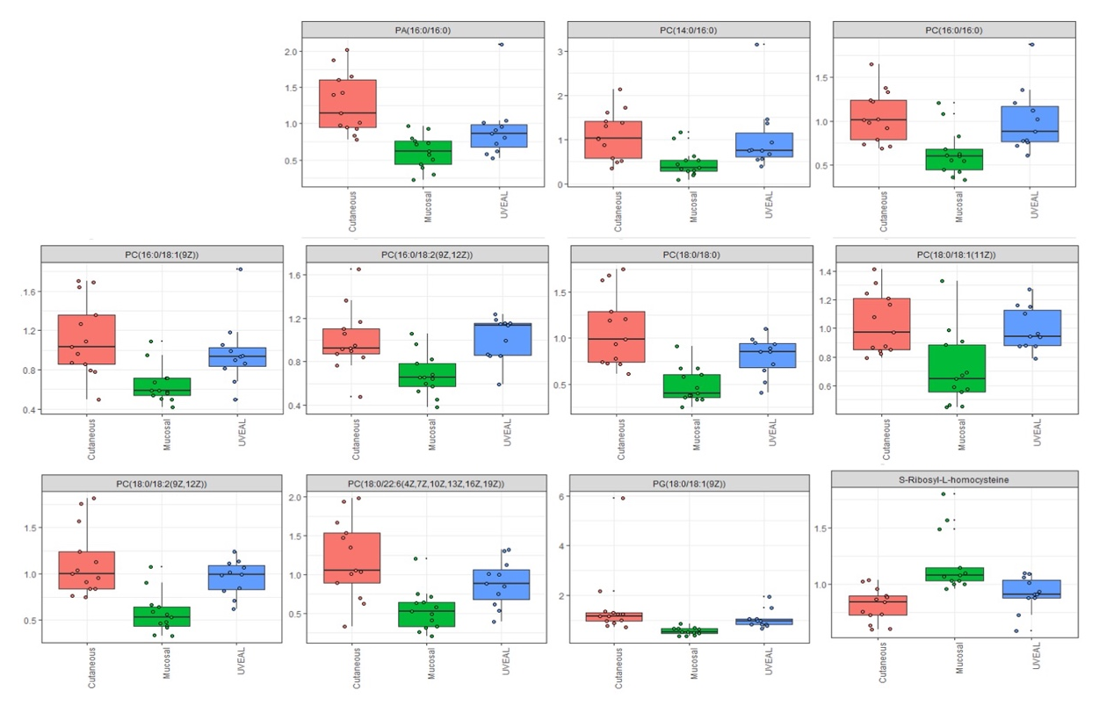

Figure S1: Characterization of phosphatidic acid (PA), phosphatidylcholine (PC), glycerophospholipid (PG), and s-ribosyl-l-homocysteine according to the melanoma subtypes.

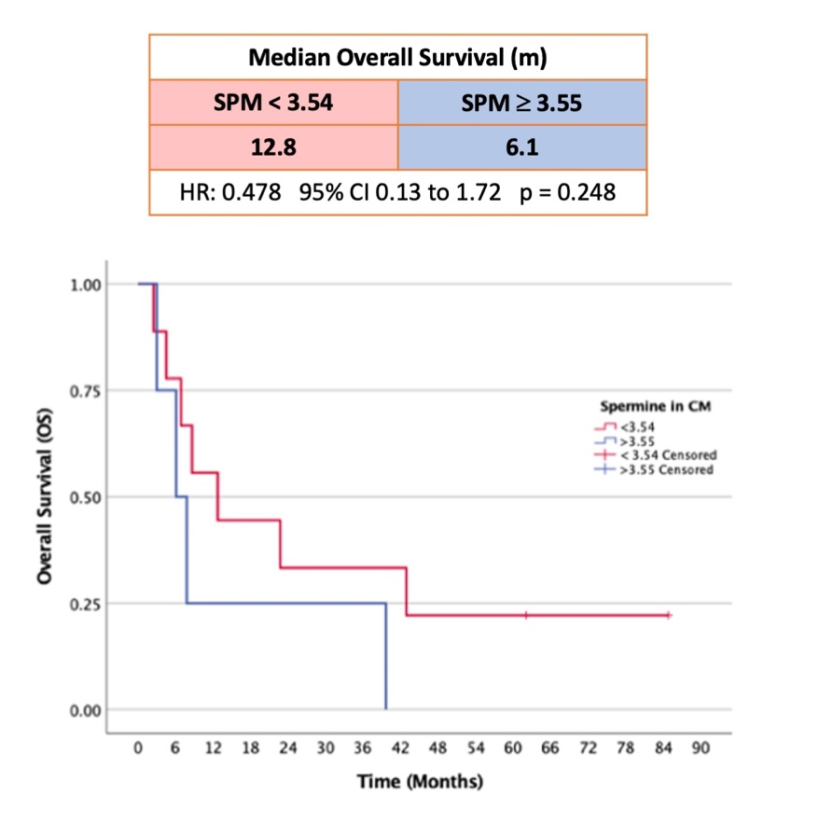

Figure S2: Overall survival of cutaneous melanoma patients according to SPM levels. SPM cut-off point used for analysis was in the 70th percentile.

