**Synthesis of calix (4) resorcinarene based amphiphilic macrocycle as an efficient nanocarrier for Amphotericin-B to enhance its oral bioavailability**

Imdad Ali1, Amjad Ali*2, Li Guo2, Riaz Ullah3, Mahmood Fazal1, Suliman Yousef Alomar4, Naushad Ahmad5, Muhammad Raza Shah1*

1H.E.J. Research Institute of Chemistry, International Centre for Chemical and Biological Sciences, University of Karachi, Karachi 74200, Pakistan

2Research School of polymeric materials, school of materials science & engineering, jiangsu university, Zhenjiang, 212013, P.R china.

3Department of Pharmacognosy, College of Pharmacy King Saud University Riyadh Saudi Arabia.

4Zoology Department, College of Science, King Saud University, Riyadh-11451, Kingdom of Saudi Arabia

5Department of Chemistry, College of Science, King Saud University, Riyadh-11451, Kingdom of Saudi Arabia.

**\*Corresponding author:** E-mail address [Amjadali@zju.edu.cn](mailto:Amjadali@zju.edu.cn) (Associate Prof. Dr. Amjad Ali); [raza.shah@iccs.edu](mailto:raza.shah@iccs.edu) (Prof. Dr. Muhammad Raza Shah)

**Yield:** 340 mg, 90.90 %, m.p, 52.1-53.9 ºC

**FT-IR (KBR):** 2918.7 (CH3), 2847.9 (CH2), 1693.8 (aromatic CH), 1255.1 cm-1 (-O- ether)

**EI-MS:** observed mass is 375.1 m/z and calculated mass 374.3 m/z

**1HNMR (400 MHz, CDCl3) δ:** 0.85 (t, 3H, CH3, *J* = 6.8 Hz), 1.25 (m, 30H, CH2), 1.76 (t, 2H, CH2, *J* = 8.0 Hz), 3.99 (t, 2H, CH2, *J* = 6.4 Hz), 6.95 (d, 2H, CH, *J* = 8.8 Hz), 7.78 (d, 2H, CH, *J* = 8.4 Hz), 9.85 (s, 1H, CHO)

**Yield:** 1530 mg, 87.27 % , m.p, 170-180 ºC

**FT-IR (KBR):** 3453.7 (OH), 2921.8 (CH3), 2850.3 (CH2), 1610.5(C=C of aromatic ring), 1262.1cm-1 (ether)

**ESI-MS:** observed mass 1867.4 m/z,

**1HNMR (400 MHz, CDCl3 + MeOD) δ**: 0.78 (t, 12H, CH2, *J* = 7.2 Hz), 1.18 (m, CH2, 120H), 1.67 (t, 8H, CH2, *J*= 5.6 Hz), 3.31 (t, 8H, CH2, *J*= 4 Hz), 3.77 (t, 8H, OH, *J* = 6 Hz), 5.43 (s, 4H, CH), 6.25 (d, 4H, CH), 6.50 (d, 8H, CH, *J* = 6.4 Hz), 6.64 (d, 8H, CH, *J* = 7.6 Hz), 7.23 (s, 2H, CH).

**2. Oral pharmacokinetic study**

Oral bioavailability studies were performed on local species of rabbits (Oryctolagus Cuniculus). Eighteen male rabbits, (average weight of 1.5 kg) were used in the study. The animals were housed under standard conditions (i.e. at 25 °C, and 12 h day-night cycles having access to food and water). Before carrying the study, animals fasted for 12 h with free access to water only. Animals were divided into three groups each of six animals. First group was given Amphotericin-B loaded resorcinarene based amphiphilic macrocycles niosomal suspension orally at 5 mg per kg body weight. Animals in second and third groups were given commercially available Amphotericin B suspension and capsules (powder suspended in 0.5% Tween 80) orally at 5 mg per kg body weight respectively as reference standards. Blood samples (1 mL each) were collected in heparinised tubes by means of marginal ear vein catheter using insulin plastic syringe at 0, 1, 2, 4, 8, 16, 24 and 36 h time intervals. Plasma from blood was separated by centrifuging it at 4000 rpm for 12 min and stored at −80 °C for further analysis. Pharmacokinetic parameters were investigated by the linear trapezoidal rule using non-compartmental model from the individual plasma drug concentration-time curves for Amphotericin B after the oral administration of its resorcinarene based amphiphilic macrocycles niosomal suspension or the commercial brands. The values of peak height (Cmax) and peak time (Tmax) were obtained directly from the individual plasma drug concentration time curves. Concentration versus time findings were used to calculate various pharmacokinetic parameters like area under the concentration–time curve from zero to the last measurable plasma concentration point (AUC0−24), mean residence time (MRT), area under the first moment Curve (AUM0-24) and clearance (Cl).

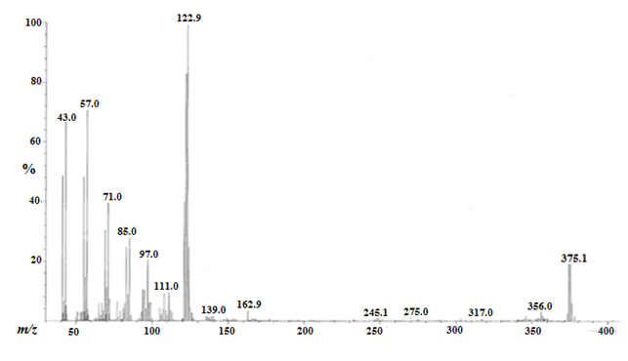

**FigureS1.** EI-MS spectrum of intermediate compound **1**



**FigureS2.** 1H-NMRspectrum of intermediate compound **1**

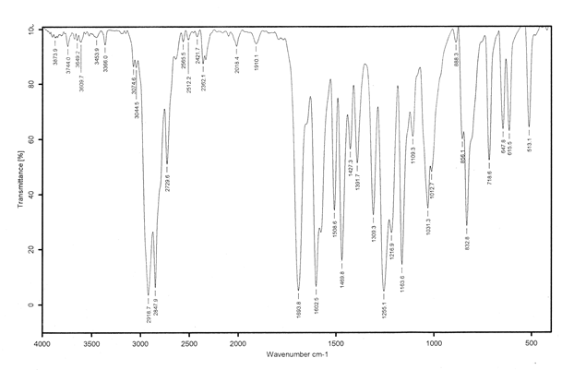

**FigureS3.** FT-IR spectrum of intermediate compound **1**

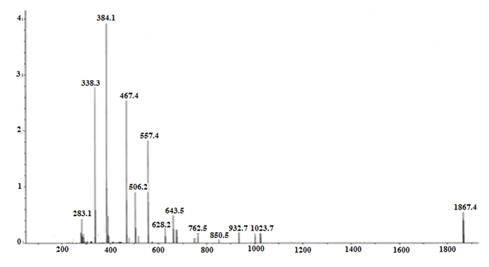

**FigureS4.** ESI-MS spectrum of amphiphilic supramolecular macrocycle (**R-C-18**)

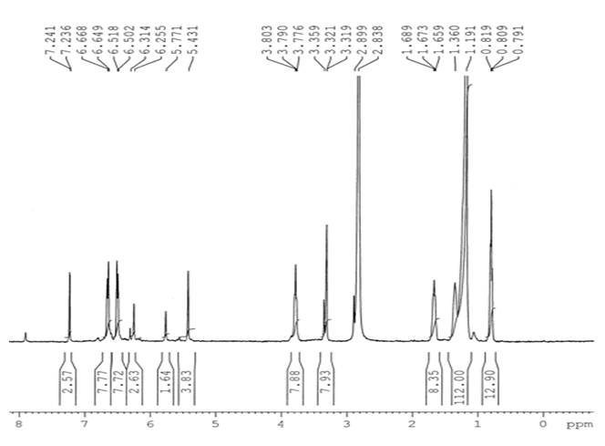

**FigureS5.** 1H-NMR spectrum of amphiphilic supramolecular macrocycle (**R-C-18**)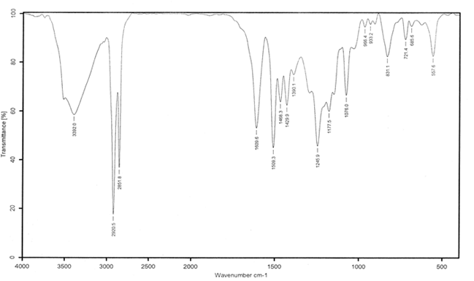

**FigureS6.** FT-IR spectrum of amphiphilic supramolecular macrocycle (**R-C-18**)