Supporting Information

Cu(II)/polydopamine-modified glass fiber separators towards high-performance zinc-ion batteries
Fengcan Ma, Kaixuan Xie, Siheng Wu, Chi Zhang, Xiaodie Liao, and Qinghong Wang*
¹School of Chemistry and Materials Science, Jiangsu Normal University, Xuzhou, Jiangsu 221116, China
*Correspondence: wangqh@jsnu.edu.cn
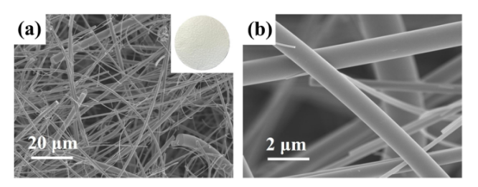
Figure S1. (a, b) SEM images of pristine GF separator. Insert in (a) is the photo of pristine GF.

Figure S2. EIS test of the stainless steel//stainless steel cells with different separators.
Figure S3. EDS images of Zn foils after Zn deposition for 10 min at 1 mA cm⁻². In the symmetric cells using Cu(II)-PDA/GF separator.

Figure S4. Coulombic efficiency of Zn plating/stripping on Cu at the current density of 1 mA cm⁻² with the fixed capacity of 1 mAh cm⁻² in Cu//Zn cells with different separators.
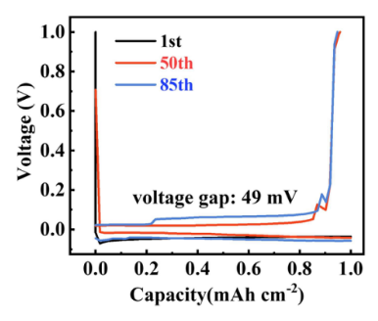
Figure S5. Voltage and capacity distribution of Cu//Zn cells with pristine GF separator.
Figure S6. Cycling performance of the symmetrical cells with pristine GF and Cu(II)-PDA/GF separator at the current density of 2 mA cm⁻² with the fixed capacity of 2 mAh cm⁻².

Table S1. Data for GF and Cu-PDA/GF separators obtained from electrolyte absorption experiments.
Separators | GF | Cu(II)-PDA/GF
Wa(g) | 0.02491 | 0.02419
Wb(g) | 0.4085 | 0.5644
Electrolyte absorption (%) | 1540 | 2234

