Table 1. Pharmacokinetic, drug likeness and toxicity parameters of synthesized benzo[d]thiazol-2 amine derivatives and reference standard drug.
CCª | GIA^{b} | BBB^{c} | Log Kp | CAR^{d} | MUT^{e} | RE^{f} | SI^{g} | BS^{h} | ABS (%)^{i} | Lipinski
G-1 | High | No | -4.38 | Non-toxic | Non-toxic | Non-toxic | Non-toxic | 0.55 | 97.28 | Yes
G-2 | High | No | -5.39 | Non-toxic | Non-toxic | Non-toxic | Non-toxic | 0.55 | 97.28 | Yes
G-3 | Low | No | -4.78 | Non-toxic | Non-toxic | Non-toxic | Non-toxic | 0.55 | 78.64 | Yes
G-4 | High | No | -4.96 | Non-toxic | Non-toxic | Non-toxic | Non-toxic | 0.55 | 87.77 | Yes
G-5 | High | No | -4.69 | Non-toxic | Non-toxic | Non-toxic | Non-toxic | 0.55 | 97.28 | Yes
G-6 | High | No | -4.46 | Non-toxic | Non-toxic | Non-toxic | Non-toxic | 0.55 | 97.28 | Yes
G-7 | High | No | -4.90 | Non-toxic | Non-toxic | Non-toxic | Non-toxic | 0.55 | 93.71 | Yes
G-8 | High | No | -4.73 | Non-toxic | Non-toxic | Non-toxic | Non-toxic | 0.55 | 96.12 | Yes
G-9 | Low | No | -4.78 | Non-toxic | Non-toxic | Non-toxic | Non-toxic | 0.55 | 78.64 | Yes
G-10 | High | No | -5.27 | Non-toxic | Non-toxic | Non-toxic | Non-toxic | 0.55 | 87.77 | Yes
G-11 | High | No | -3.99 | Non-toxic | Non-toxic | Non-toxic | Non-toxic | 0.55 | 97.28 | Yes
G-12 | High | No | -4.46 | Non-toxic | Non-toxic | Non-toxic | Non-toxic | 0.55 | 97.28 | Yes
G-13 | High | No | -5.39 | Non-toxic | Non-toxic | Non-toxic | Non-toxic | 0.55 | 97.28 | Yes
Ind. | High | Yes | -5.45 | Non-toxic | Non-toxic | Non-toxic | Non-toxic | 0.85 | 85.94 | Yes

ª Compound Code
^{b} GI absorption
^{c} Blood brain barrier permeation
^{d} Carcinogenicity.
^{e} Mutagenicity.
^{f} Reproductive effects.
^{g} Skin irritation.
^{h} Bioavailability score.
^{i}Absorption

Table 2. Structures of newly synthesized benzo[d]thiazol-2-amine derivatives.
G1 | G2
G3 | G4
G5 | G6
G7 | G8
G9 | G10
G11 | G12
G13

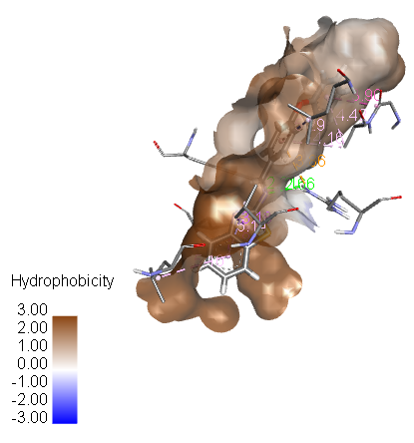  G-1 | 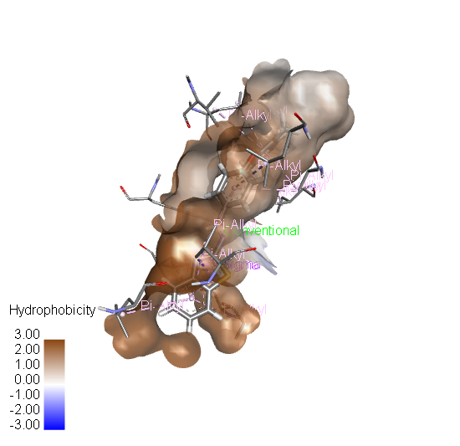  G-2
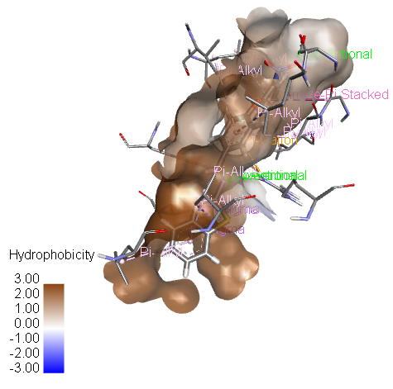  G-3 | 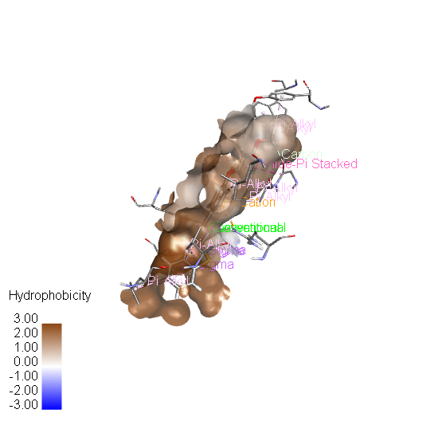  G-4
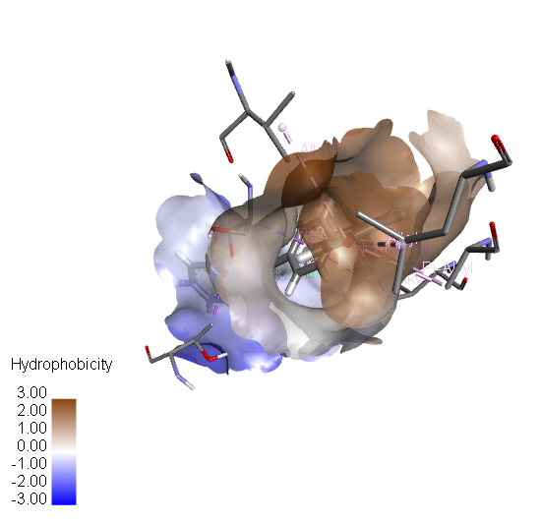  G-5 | 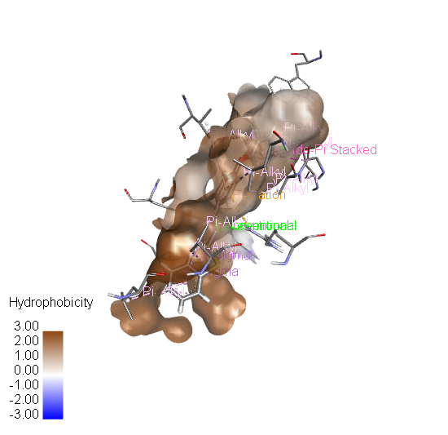  G-6
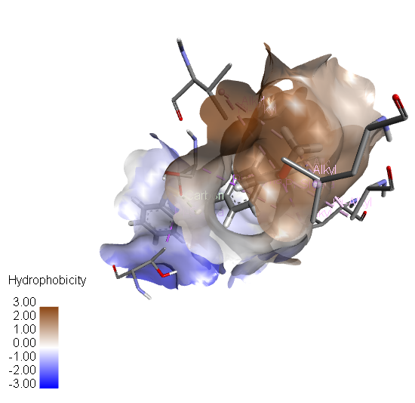  G-7 | 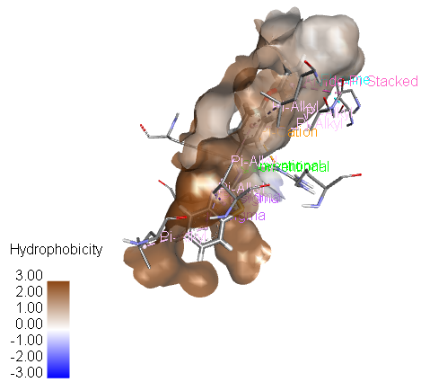  G-8
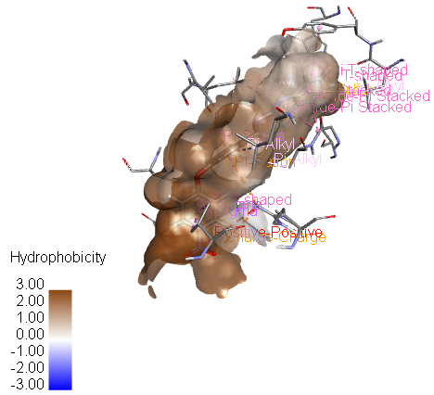  G-9 | 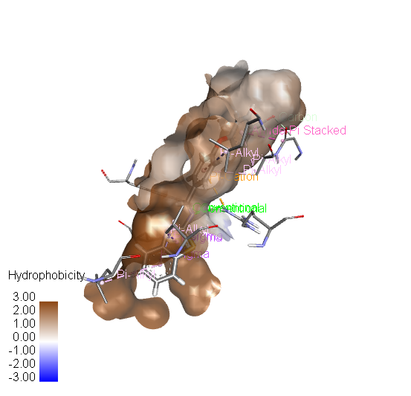  G-10
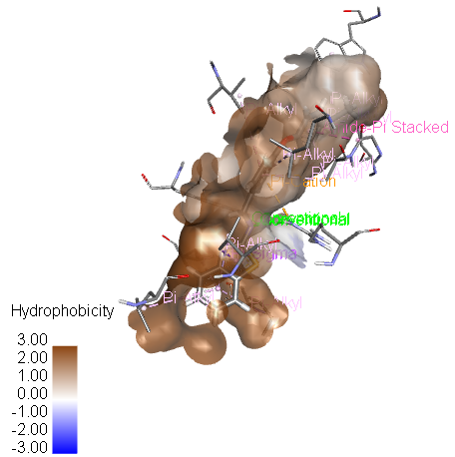  G-11 | 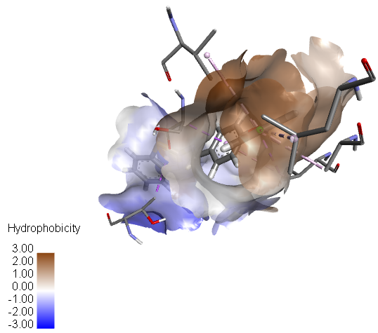  G-12
G-13

Figure 1. The hydrophobic interactions surfaces for molecule G-1, G-2, G-3, G-4, G-5, G-6, G-7, G-8, G-9, G-10, G-11 and G-12 with COX-1.
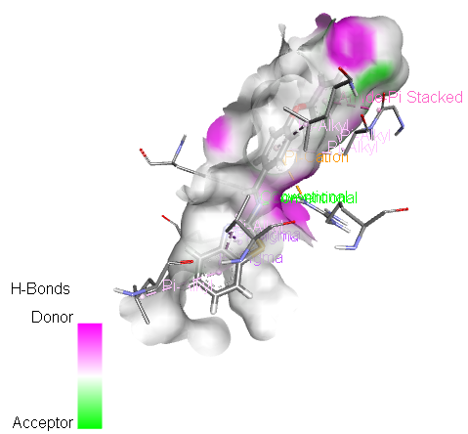  G-1 | 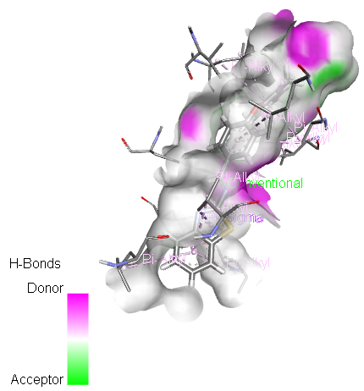  G-2
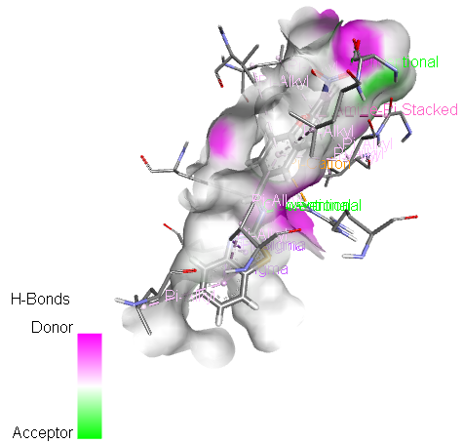  G-3 | 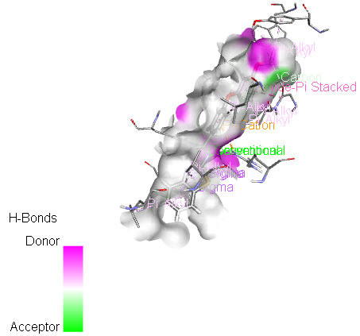  G-4
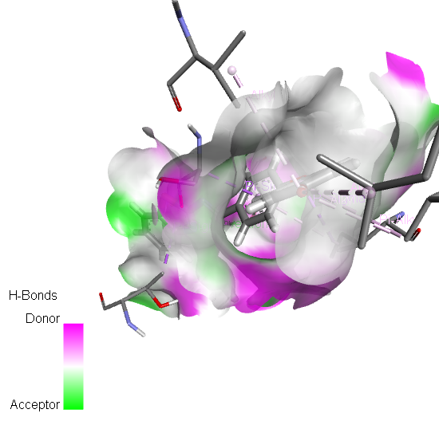  G-5 | 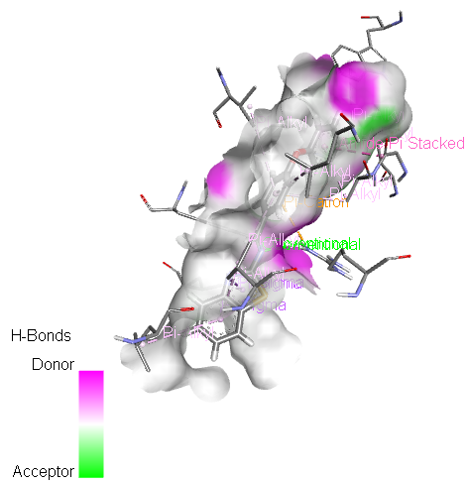  G-6
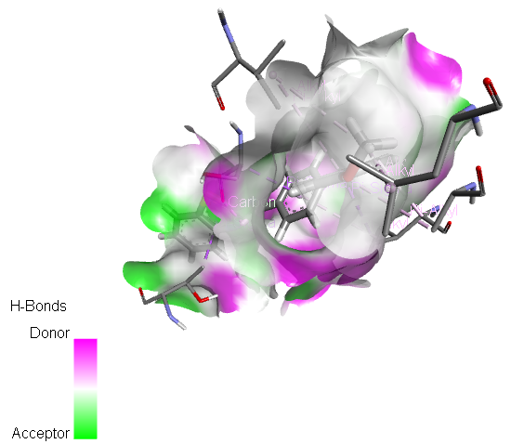  G-7 | 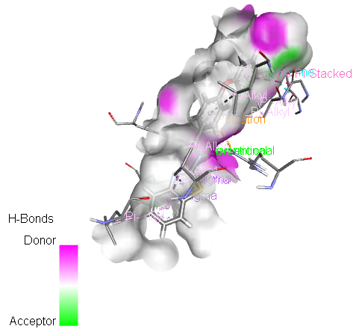  G-8
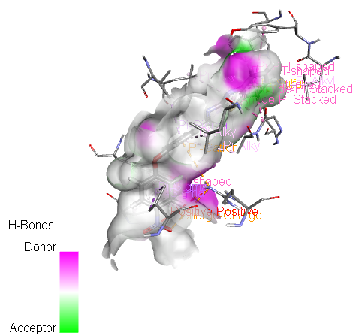  G-9 | 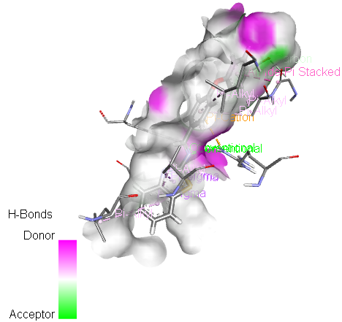  G-10
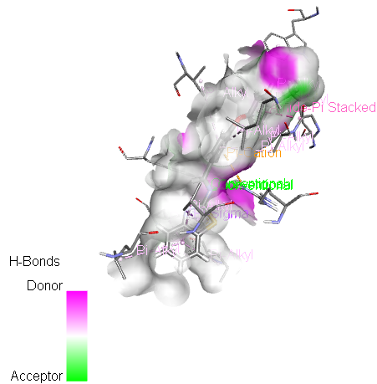  G-11 | 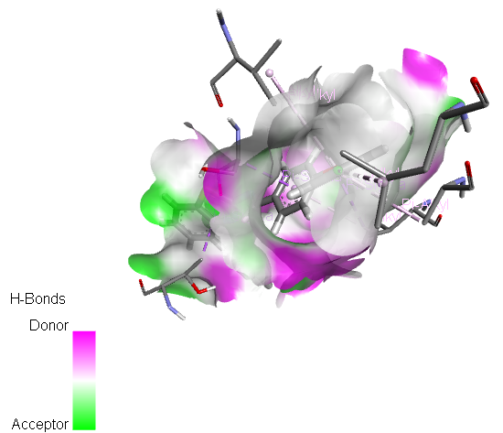  G-12
G-13

Figure 2. The hydrogen bond surfaces for molecule G-1, G-2, G-3, G-4, G-5, G-6, G-7, G-8, G-9, G-10, G-11 and G-12 with COX-1.

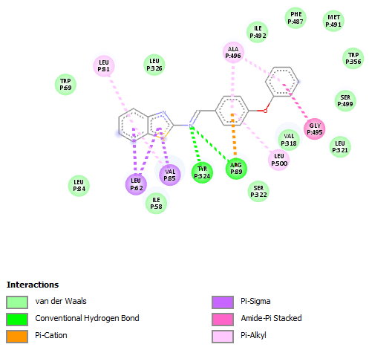  G-1 | 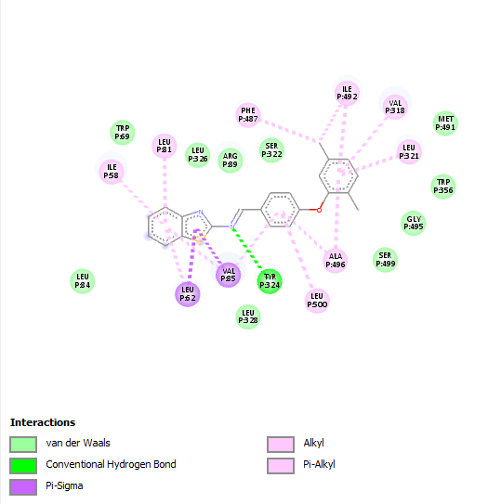  G-2
G-3 | 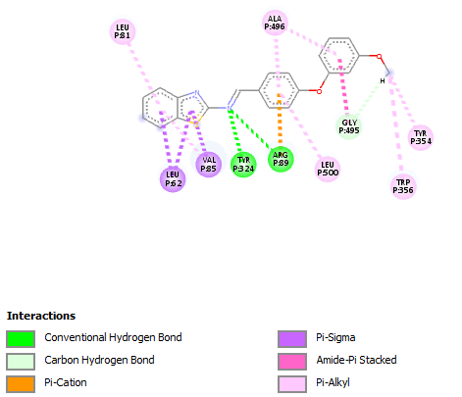  G-4
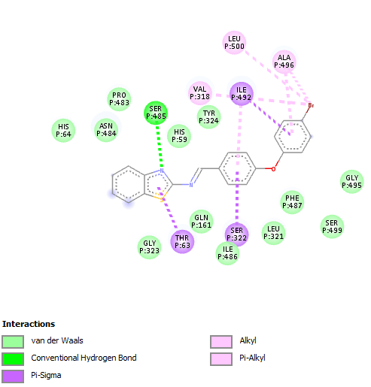  G-5 | 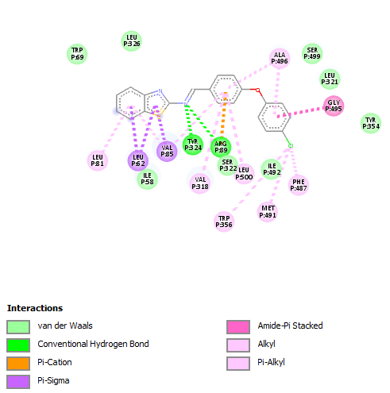  G-6
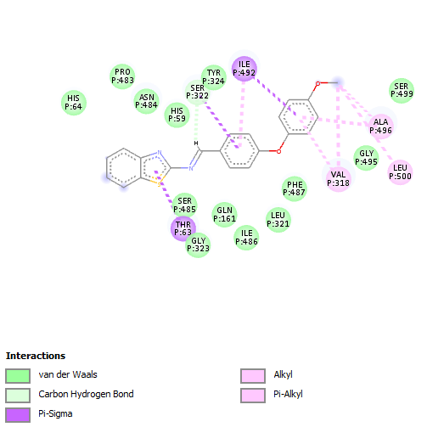  G-7 | 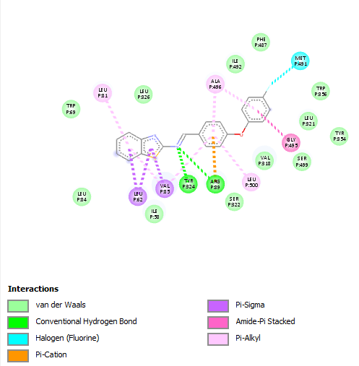  G-8
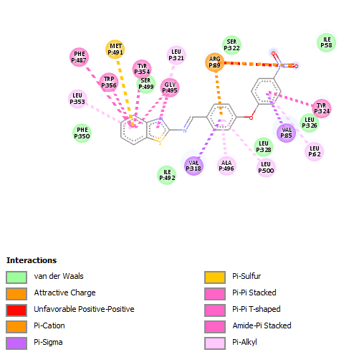  G-9 | 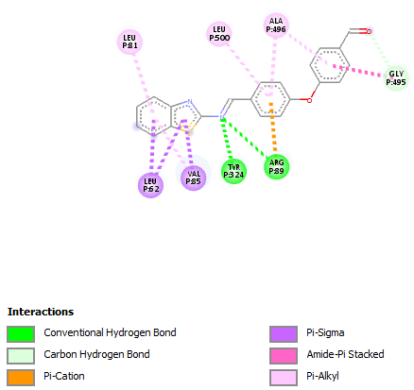  G-10
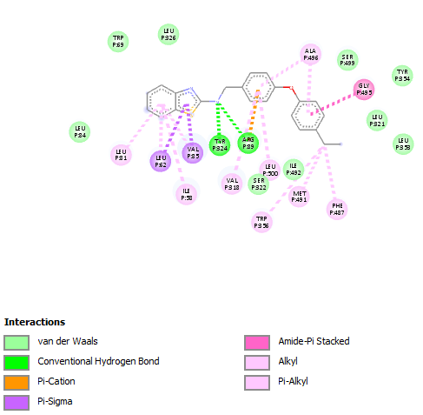  G-11 | 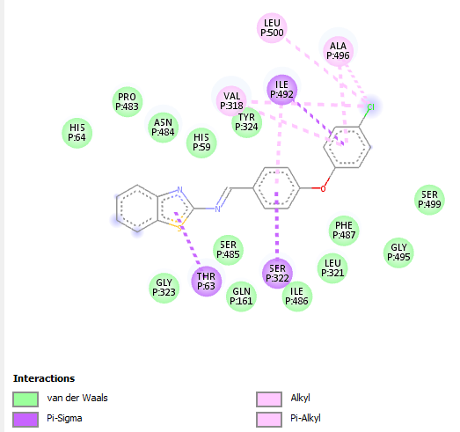  G-12
G-13 | 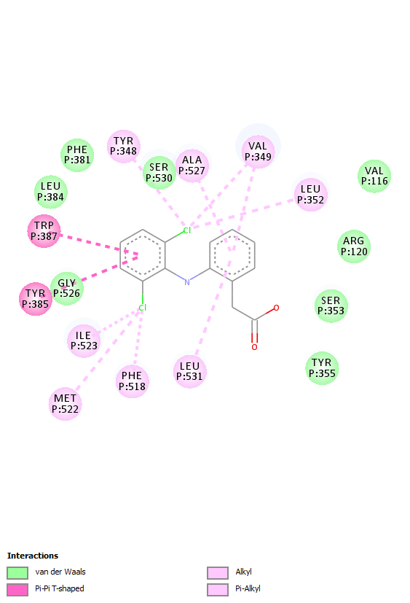  Diclofenac Sodium
Figure 3: COX-1 complex with G-1, G-2, G-3, G-4, G-5, G-6, G-7, G-8, G-9, G-10, G-11, G-12 and G-13.

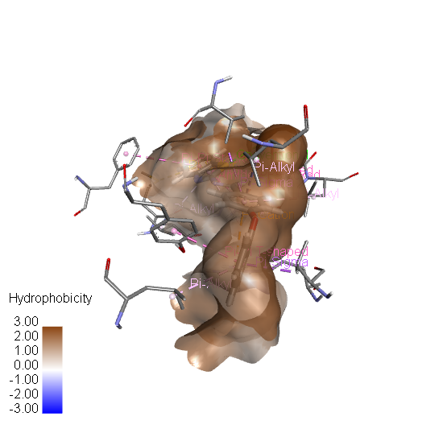  G-1 | 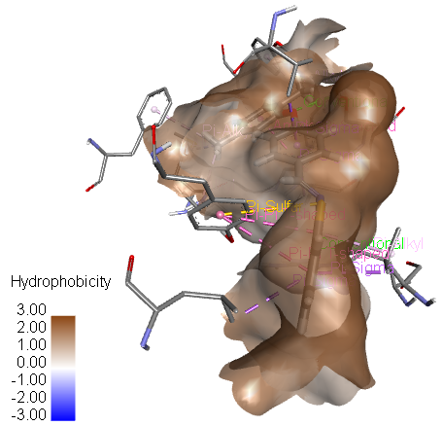  G-2
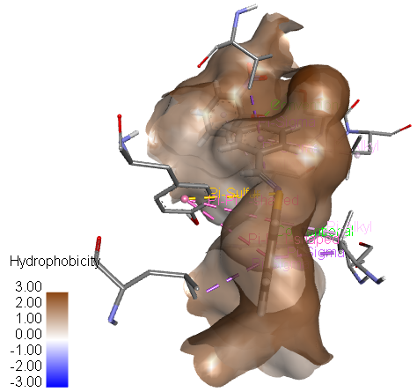  G-3 | 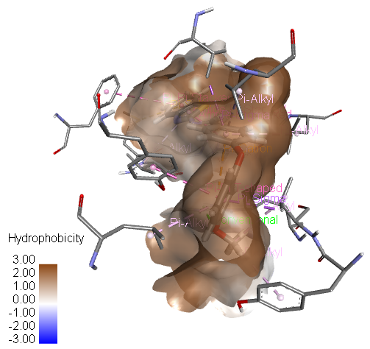  G-4
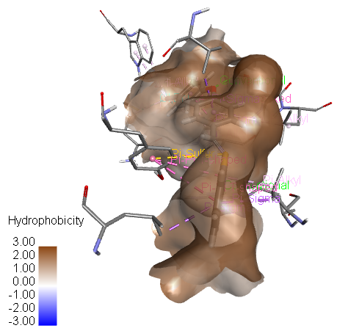  G-5 | 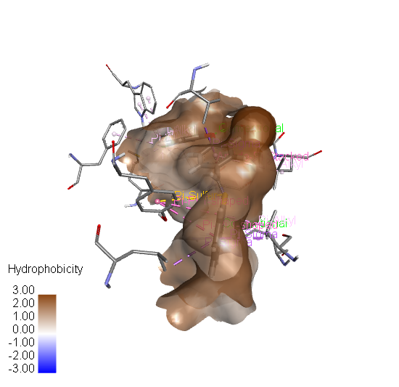  G-6
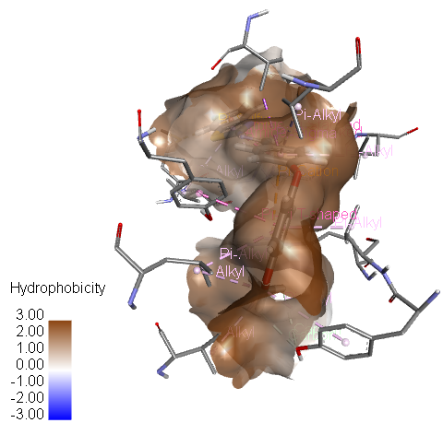  G-7 | 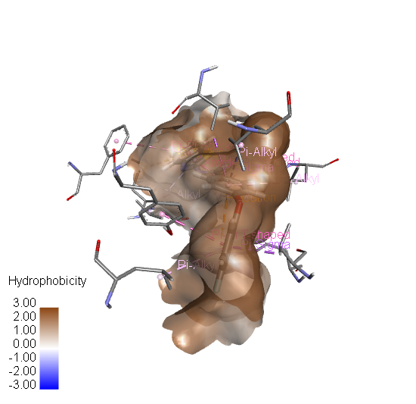  G-8
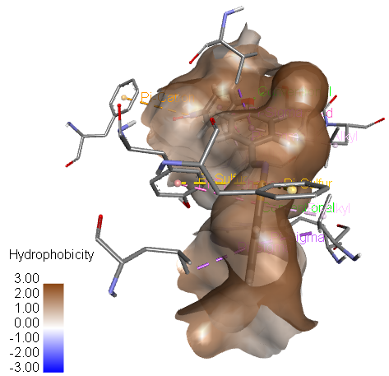  G-9 | 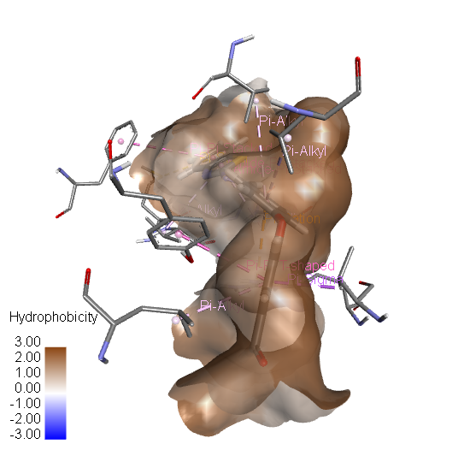  G-10
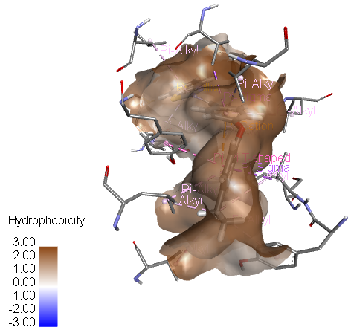  G-11 | 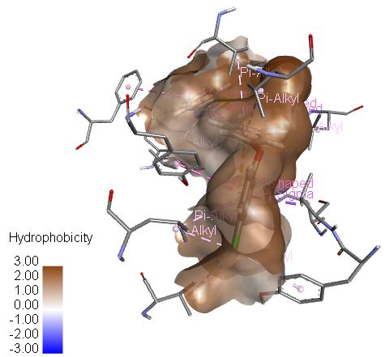  G-12
G-13
Figure 4. Hydrophobic interactions surfaces for molecule G-1, G-2, G-3, G-4, G-5, G-6, G-7, G-8, G-9, G-10, G-11, G-12 and G-13 with COX-2.

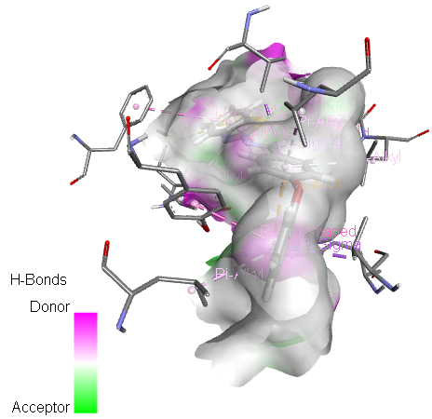  G-1 | 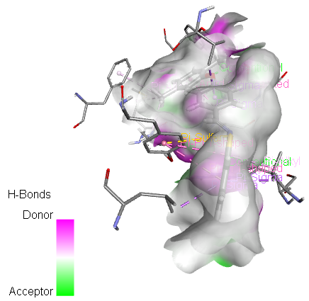  G-2
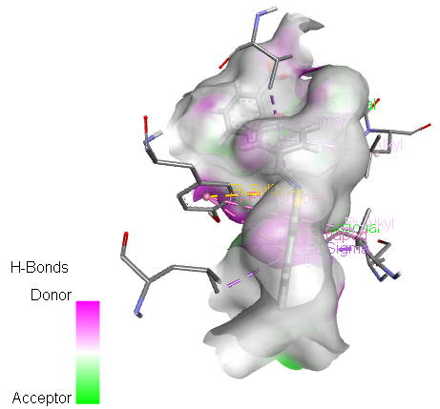  G-3 | 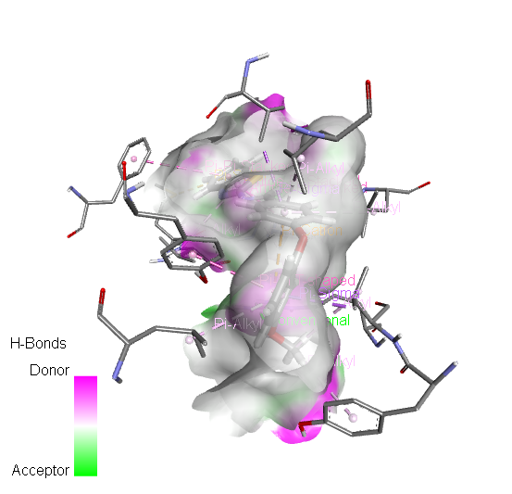  G-4
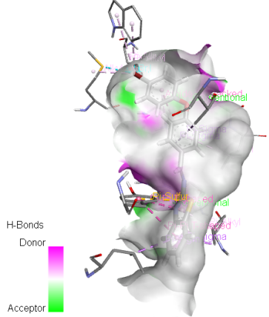  G-5 | 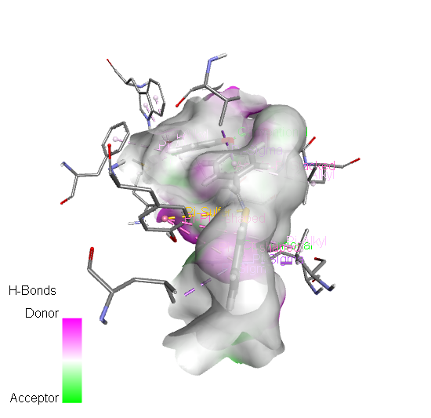  G-6
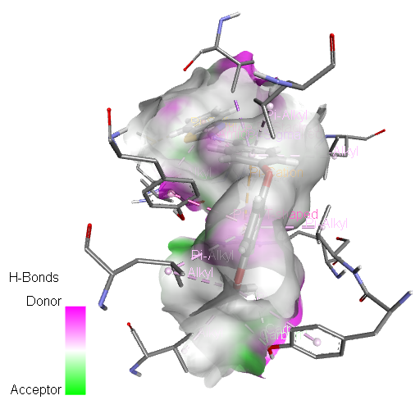  G-7 | 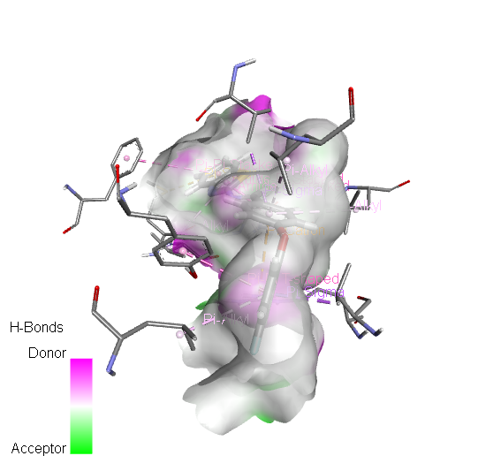  G-8
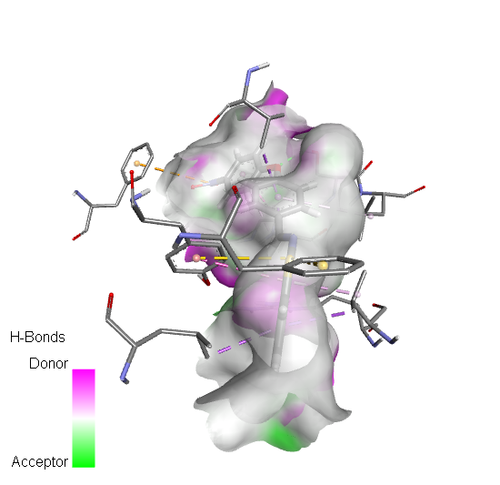  G-9 | 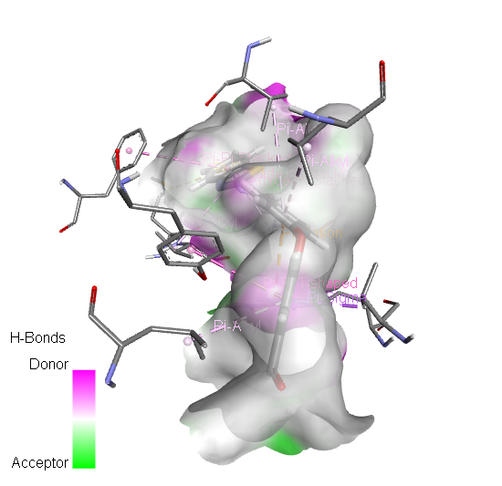  G-10
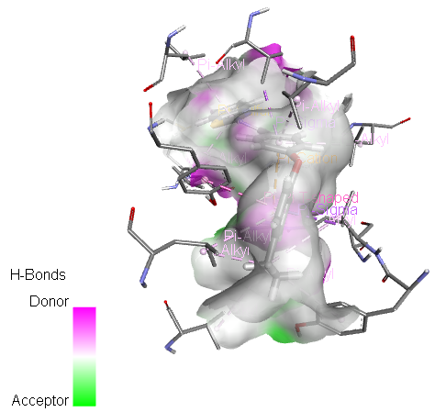  G-11 | 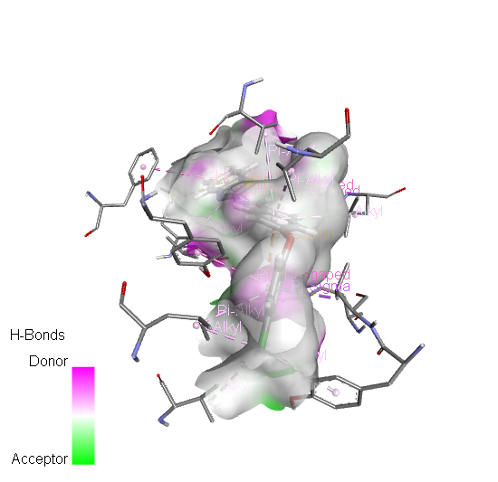  G-12
G-13
Figure 5. The hydrogen bond surfaces for molecule G-1, G-2, G-3, G-4, G-5, G-6, G-7, G-8, G-9, G-10, G-11, G-12 and G-13 with COX-2
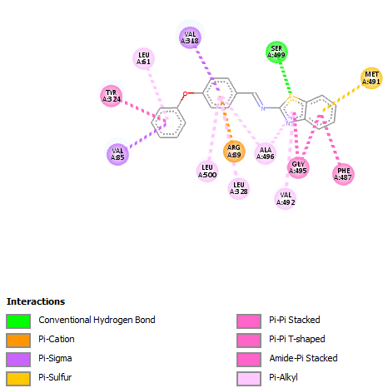  G-1 | 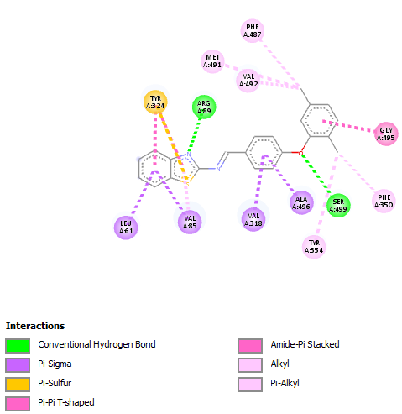  G-2
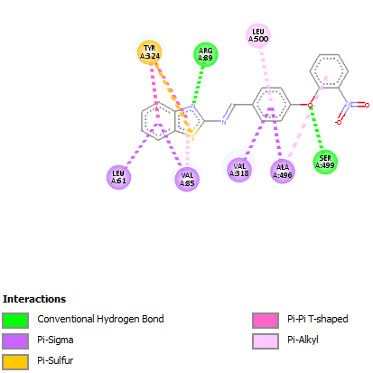  G-3 | 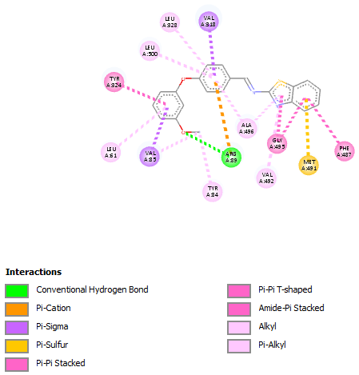  G-4
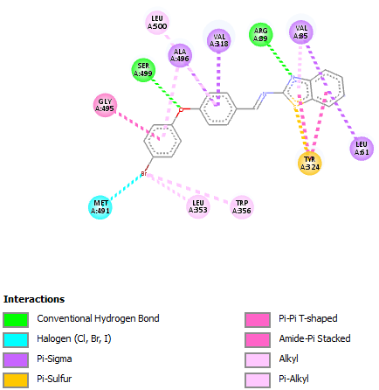  G-5 | 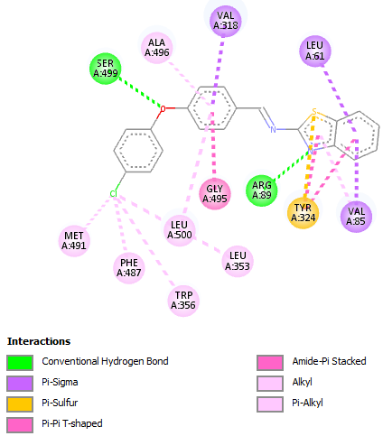  G-6
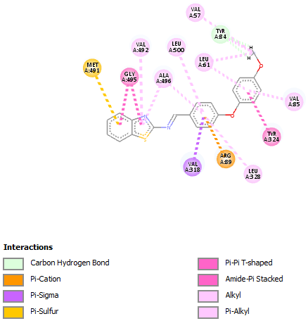  G-7 | 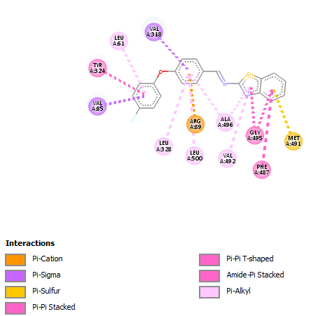  G-8
G-9 | 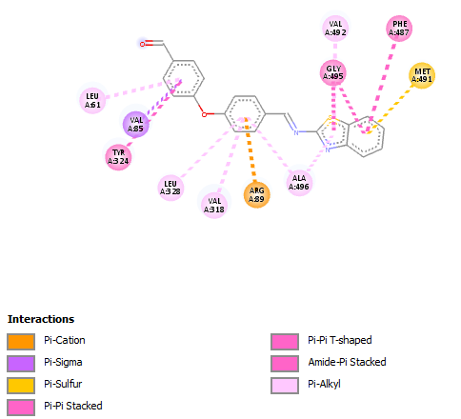  G-10
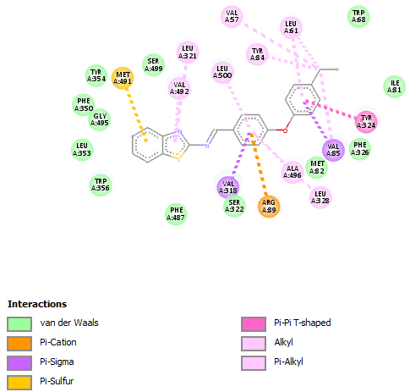  G-11 | G-12
G-13 | 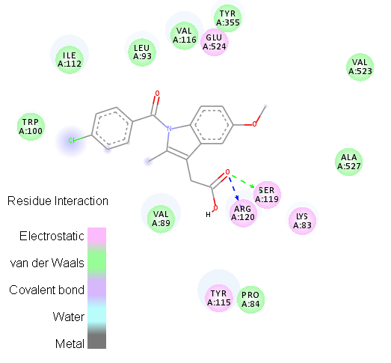  Indomethacin
Figure 6. COX-2 complex with G-1, G-2, G-3, G-4, G-5, G-6, G-7, G-8, G-9, G-10, G-11, G-12, G-13 and Indomethacin.

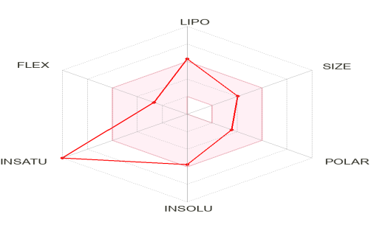  G-1 | 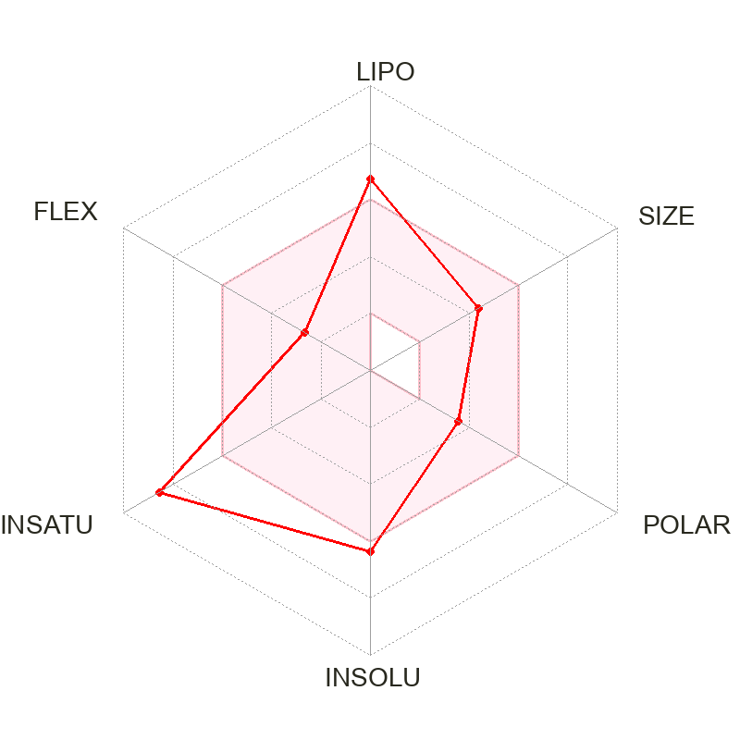  G-2
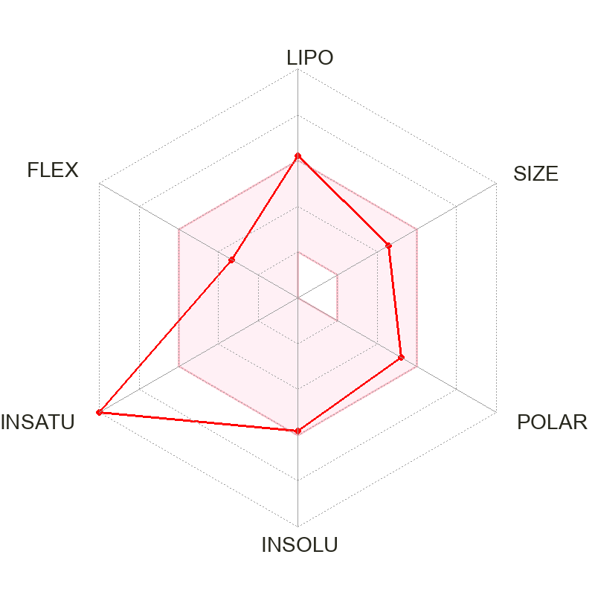  G-3 | 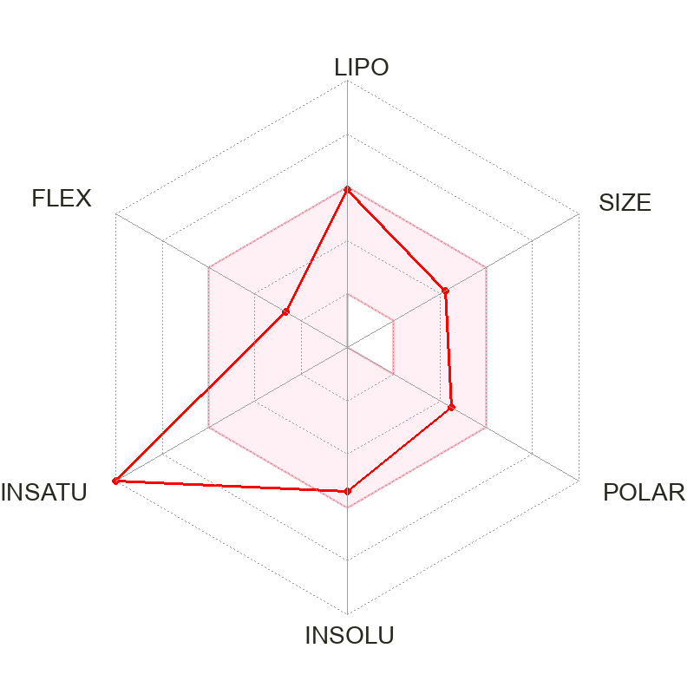  G-4
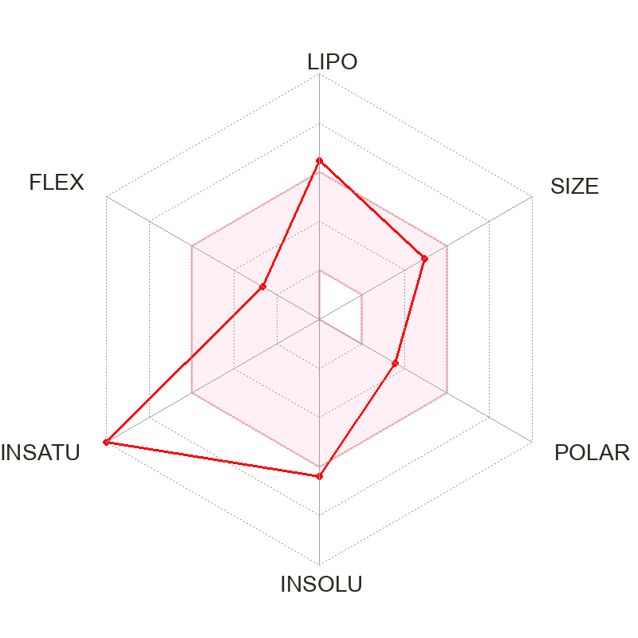  G-5 | 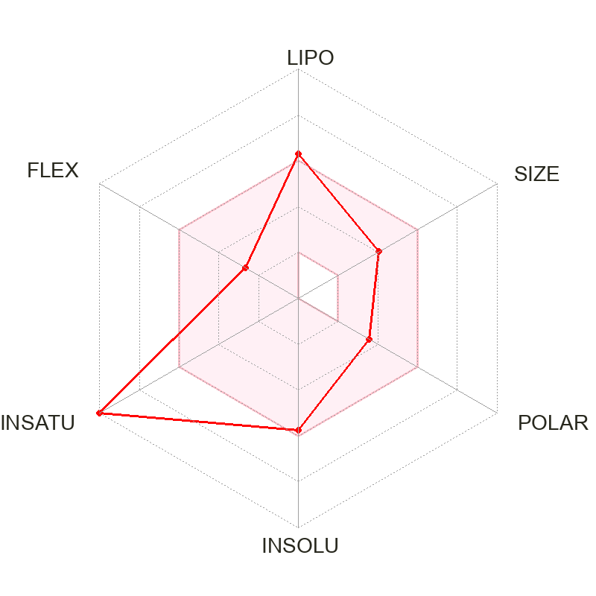  G-6
G-7 | 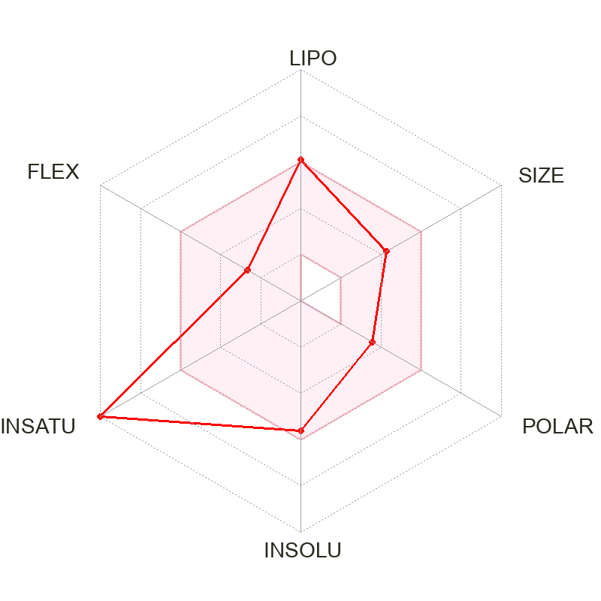  G-8
G-9 | 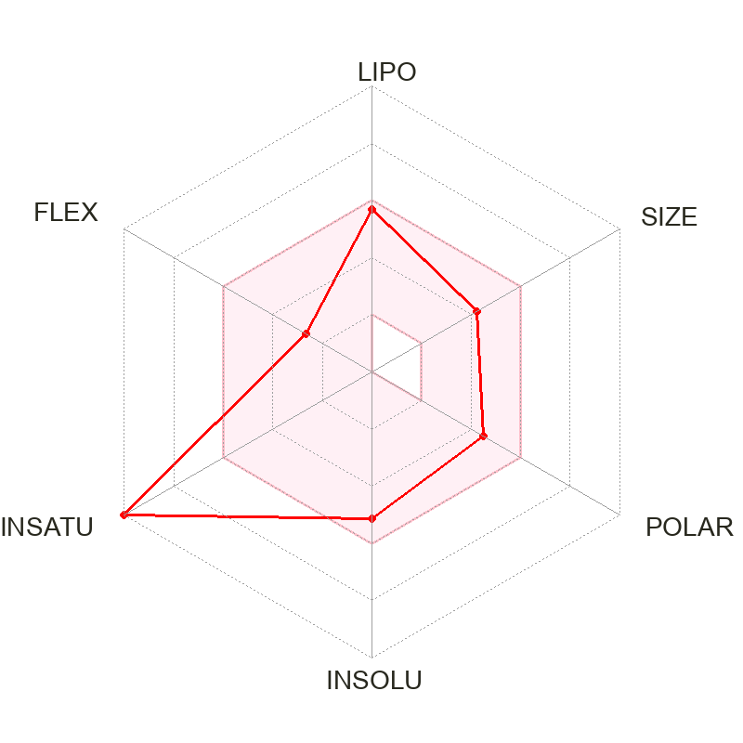  G-10
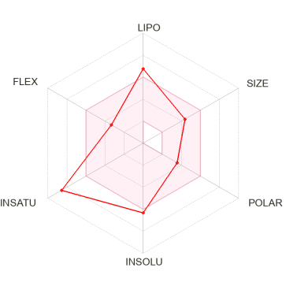  G-11 | 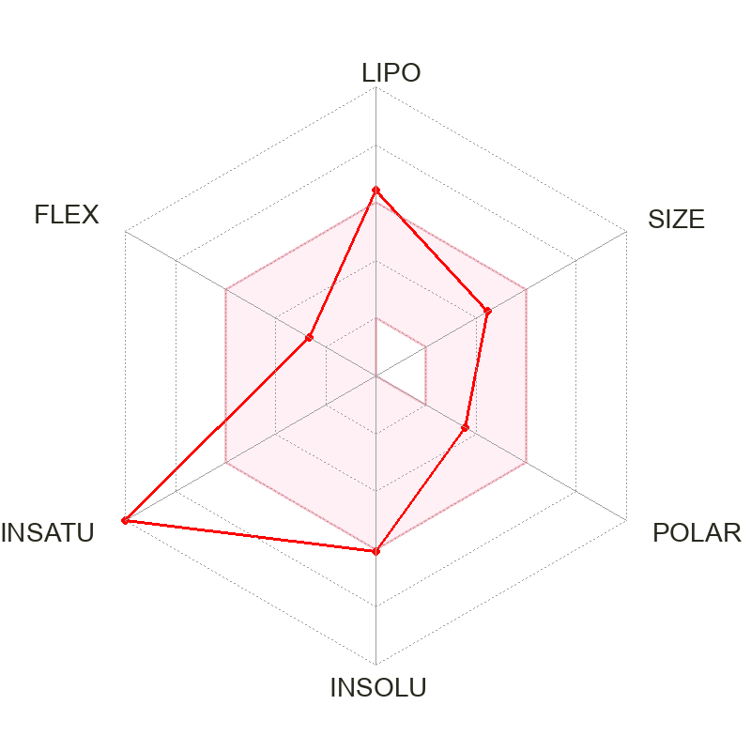  G-12
G-13
Figure 7. Bioavailability radar graph of benzo(d)thiazol-2-amine derivatives G-1-G-13 (pink area reflects the allowed values of drug likeness properties of the molecule).

