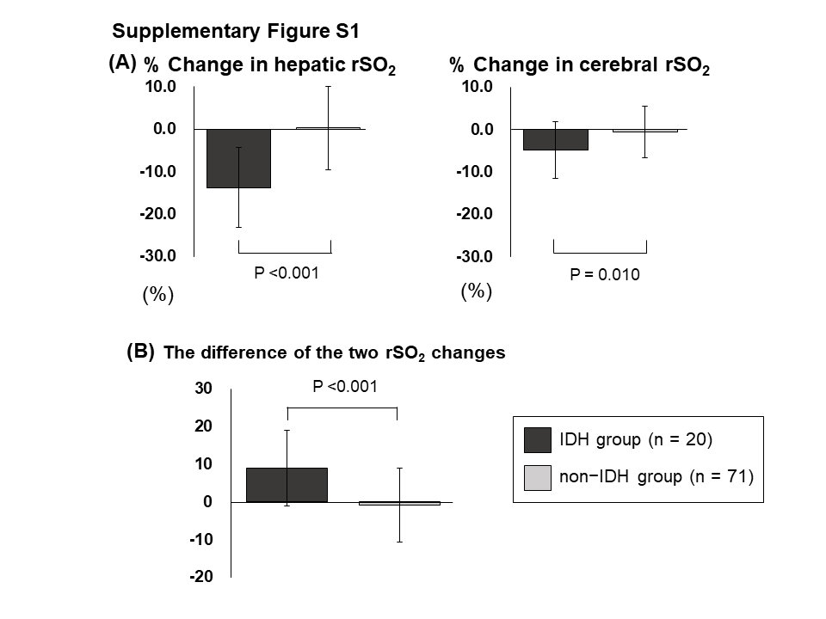
Supplementary Fig. S1. Comparison of IDH group (n = 20) and non-IDH group (n = 71). (A) % changes in hepatic and cerebral rSO₂ in IDH group and non-IDH group. (B) The difference in the two rSO2 changes in IDH group and non- IDH group. The difference in the two rSO2 changes was calculated using “% change in cerebral rSO₂ - % change in hepatic rSO₂.”
Abbreviations: rSO₂, regional tissue oxygen saturation; IDH, intradialytic hypotension.

