Tables
Table S1. Features of the isolates used in this study.
Study Nr. | ST | Plasmid-borne carbapenemase(s) | Plasmid-borne ESBL | Plasmid-borne additional β-lactamase(s) | ADC | intrinsic oxacillinase | Plasmid-borne 16S RMTase | Cefiderocol MIC | Acquired carbapenem resistance marker(s)
1 | 2 | blaOXA-23 |  | blaTEM-12 | blaADC-73 | blaOXA-66 | armA | 1 | OXA-23
2 | 2 | blaOXA-23 |  | blaTEM-12 | blaADC-73 | blaOXA-66 | armA | 0.5 | OXA-23
3 | 2 | blaOXA-23 |  | blaTEM-12 | blaADC-73 | blaOXA-66 | armA | 1 | OXA-23
4 | 2 | blaOXA-23 |  | blaTEM-12 | blaADC-73 | blaOXA-66 | armA | 1 | OXA-23
5 | 2 | blaOXA-23 |  | blaTEM-12 | blaADC-73 | blaOXA-66 | armA | 1 | OXA-23
6 | n.d. | blaOXA-23 |  |  | blaADC-73 | blaOXA-66 | armA | 1 | OXA-23
7 | 604 | blaOXA-23 |  | blaTEM-12 | blaADC-73 | blaOXA-66 | armA | 1 | OXA-23
8 | n.d. | blaOXA-23 |  |  | blaADC-175 | blaOXA-69 |  | 1 | OXA-23
9 | n.d. | blaOXA-72 |  |  | blaADC-74 | blaOXA-69 |  | 64 | OXA-72
10 | 1 | blaOXA-72 |  | blaTEM-12 | blaADC-81 | blaOXA-92 |  | 1 | OXA-72
11 | 636 | blaOXA-72 |  | blaTEM-12 | blaADC-73 | blaOXA-66 |  | 1 | OXA-72
12 | 2 | blaOXA-72 |  |  | blaADC-30 | blaOXA-66 |  | 0.5 | OXA-72
13 | 1 | blaOXA-72 |  | blaTEM-12 | blaADC-81 | blaOXA-92 |  | 1 | OXA-72
14 | 2 | blaOXA-23 |  |  | blaADC-33 | blaOXA-115 |  | 2 | OXA-23
15 | 2 | - |  | blaTEM-12 | blaADC-30 | blaOXA-66 |  | 1 | -
16 | 1 | blaOXA-23 | blaGES-22 |  | blaADC-38 | blaOXA-69 |  | 1 | OXA-23/GES-ESBL
17 | 2 | blaOXA-23 |  |  | blaADC-30 | blaOXA-66 |  | 1 | OXA-23
18 | 25 | blaNDM-1 |  |  | blaADC-26 | blaOXA-64 |  | 4 | NDM-1
19 | 103 | blaNDM-2 |  |  | blaADC-203 | blaOXA-70 |  | 2 | NDM-2
20 | 1 | blaNDM-1/blaOXA-23 |  | blaTEM-12 | blaADC-11 | blaOXA-69 |  | 2 | NDM-1/OXA-23
21 | 107 | blaOXA-24 |  |  | blaADC-87 | blaOXA-51 |  | 0.5 | OXA-24
22 | 1 | blaOXA-23 | blaPER-1 |  | blaADC-11 | blaOXA-69 |  | 8 | OXA-23/PER-ESBL
23 | 20 | blaOXA-23 |  | blaTEM-12 | blaADC-74 | blaOXA-69 |  | 0.25 | OXA-23
24 | 1 | blaOXA-23 |  |  | blaADC-187 | blaOXA-69 |  | 1 | OXA-23
25 | 1 | blaOXA-23 | blaPER-1 |  | blaADC-11 | blaOXA-69 |  | 64 | OXA-23/PER-ESBL
26 | 108 | - |  |  | blaADC-152 | blaOXA-132 |  | 0.5 | -
27 | 25 | blaOXA-58 |  |  | blaADC-26 | blaOXA-64 |  | 0.125 | OXA-58
28 | 113 | - | blaGES-11 |  | blaADC-57 | blaOXA-64 |  | 1 | GES-ESBL
29 | 113 | blaGES-14 |  |  | blaADC-57 | blaOXA-64 |  | 0.5 | GES-carba
30 | 47 | blaOXA-58 |  |  | blaADC-1 | blaOXA-260 |  | 8 | OXA-58
31 | 3 | - |  |  | blaADC-119 | blaOXA-71 |  | 0.5 | -
32 | 15 | blaOXA-58 |  |  | blaADC-2 | blaOXA-51 |  | 0.25 | OXA-58
33 | 2 | - |  |  | blaADC-30 | blaOXA-109 |  | 0.5 | -
34 | 636 | blaOXA-72 |  |  | blaADC-74 | blaOXA-66 | armA | 4 | OXA-72
35 | 78 | blaOXA-72 | blaCTX-M-115 | blaCARB-14 | blaADC-152 | blaOXA-90 |  | 0.25 | OXA-72/CTX-M-ESBL
36 | 2 | blaOXA-23 |  | blaTEM-12 | blaADC-73 | blaOXA-66 | armA | 0.5 | OXA-23
112 | 85 | blaNDM-1 |  |  | blaADC-25 | blaOXA-94 |  | 4 | NDM-1
38 | 25 | blaOXA-23 |  |  | blaADC-26 | blaOXA-64 | armA | 0.5 | OXA-23
39 | 2 | blaOXA-23 |  |  | blaADC-73 | blaOXA-66 | armA | 1 | OXA-23
40 | 2 | blaOXA-23 |  |  | blaADC-73 | blaOXA-66 | armA | 0.5 | OXA-23
41 | 25 | blaOXA-23 |  |  | blaADC-26 | blaOXA-64 | armA | 0.25 | OXA-23
42 | 400 | - | blaGES-11 |  | blaADC-179 | blaOXA-100 |  | 1 | GES-ESBL
43 | 2 | blaOXA-23 |  |  | blaADC-73 | blaOXA-66 | armA | 0.5 | OXA-23
44 | 492 | blaNDM-1/blaOXA-72 |  |  | blaADC-30 | blaOXA-66 | armA | 16 | NDM/OXA-72
45 | 45 | blaOXA-72 | blaPER-1 |  | blaADC-11 | blaOXA-66 |  | 64 | OXA-72/PER-ESBL
46 | 2 | blaNDM-1/blaOXA-23 |  |  | blaADC-11 | blaOXA-66 | armA | 16 | NDM-1/OXA-23
47 | 2 | blaOXA-23 |  | blaTEM-12 | blaADC-188 | blaOXA-66 | armA | 2 | OXA-23
48 | 2 | blaOXA-23 |  | blaTEM-12 | blaADC-73 | blaOXA-66 | armA | 0.5 | OXA-23
49 | 78 | blaOXA-72 | blaCTX-M-115 | blaCARB-14 | blaADC-152 | blaOXA-90 |  | 0.25 | OXA-72/CTX-M-ESBL
50 | 164 | blaOXA-23 |  | blaCARB-16 | blaADC-52/199 | blaOXA-92 |  | 1 | OXA-23
51 | novel ST | blaOXA-72 |  |  | blaADC-185 | blaOXA-66 |  | 1 | OXA-72
52 | 85 | blaNDM-1 |  |  | blaADC-25 | blaOXA-94 |  | 64 | NDM-1
53 | 164 | blaOXA-23/blaOXA-58 |  | blaCARB-16 | blaADC-25 | blaOXA-91 |  | 2 | OXA-23/OXA-58
54 | 2 | blaOXA-23 |  | blaTEM-12 | blaADC-73 | blaOXA-66 | armA | 0.5 | OXA-23
55 | 78 | blaOXA-72 |  |  | blaADC-152 | blaOXA-90 | armA | 0.125 | OXA-72
56 | 25 | blaOXA-23 | blaPER-7 |  | blaADC-26 | blaOXA-64 | armA | 64 | OXA-23/PER-ESBL
57 | 575 | blaOXA-23 | blaPER-7 |  | blaADC-76 | blaOXA-144 | armA | 64 | OXA-23/PER-ESBL
58 | 2 | blaOXA-23 |  |  | blaADC-73 | blaOXA-66 | armA | 0.5 | OXA-23
59 | 2 | blaOXA-23 |  |  | blaADC-73 | blaOXA-66 |  | 0.5 | OXA-23
60 | 2 | blaOXA-23 |  | blaTEM-12 | blaADC-73 | blaOXA-66 | armA | 0.5 | OXA-23
61 | 2 | blaOXA-23 |  |  | blaADC-33 | blaOXA-115 |  | 4 | OXA-23
62 | 2 | blaOXA-23 |  | blaTEM-12 | blaADC-185 | blaOXA-66 | armA | 2 | OXA-23
63 | 2 | blaOXA-23 |  | blaTEM-12 | blaADC-73 | blaOXA-66 | armA | 0.5 | OXA-23
64 | 2 | blaOXA-23 |  |  | blaADC-73 | blaOXA-66 | armA | 0.5 | OXA-23
65 | 2 | blaOXA-23 |  |  | blaADC-73 | blaOXA-66 | armA | 1 | OXA-23
66 | 592 | blaOXA-72 | blaCTX-M-115 |  | blaADC-185 | blaOXA-69 | armA | 1 | OXA-72/CTX-M-ESBL
67 | 164 | blaOXA-23 |  | blaCARB-16 | blaADC-25 | blaOXA-91 |  | 4 | OXA-23
68 | 2 | blaOXA-23 |  |  | blaADC-73 | blaOXA-66 | armA | 0.5 | OXA-23
69 | 1902 | blaOXA-23 | blaPER-7 |  | blaADC-26 | blaOXA-64 | armA | 64 | OXA-23/PER-ESBL
70 | 2 | blaOXA-23 |  |  | blaADC-73 | blaOXA-66 | armA | 0.5 | OXA-23
71 | 2 | blaOXA-23 |  |  | blaADC-73 | blaOXA-66 | armA | 0.5 | OXA-23
72 | 2 | blaOXA-23 |  |  | blaADC-73 | blaOXA-66 | armA | 0.5 | OXA-23
73 | 2 | blaOXA-23 |  |  | blaADC-73 | blaOXA-66 | armA | 16 | OXA-23
74 | 2 | blaOXA-23 |  |  | blaADC-30 | blaOXA-66 |  | 1 | OXA-23
75 | 2 | blaOXA-23 |  |  | blaADC-73 | blaOXA-66 | armA | 0.5 | OXA-23
76 | 2 | blaOXA-23 |  |  | blaADC-73 | blaOXA-66 | armA | 1 | OXA-23
77 | 641 | blaOXA-23 |  |  | blaADC-30 | blaOXA-66 | armA | 2 | OXA-23
78 | 25 | blaOXA-23 | blaPER-7 |  | blaADC-26 | blaOXA-64 | armA | 64 | OXA-23/PER-ESBL
79 | 2 | blaOXA-23 |  |  | blaADC-73 | blaOXA-66 | armA | 1 | OXA-23
80 | 492 | blaNDM-1/blaOXA-72 |  |  | blaADC-30 | blaOXA-66 | armA | 4 | NDM-1/OXA-72
81 | 78 | blaOXA-72 | CTX-M-115 | blaCARB-14 | blaADC-152 | blaOXA-90 | armA | 1 | OXA-72/CTX-M-ESBL
82 | 641 | blaOXA-23 |  |  | blaADC-30 | blaOXA-66 | armA | 4 | OXA-23
83 | 2 | blaOXA-23 |  |  | blaADC-73 | blaOXA-66 | armA | 1 | OXA-23
84 | 2 | blaOXA-23 |  |  | blaADC-73 | blaOXA-66 |  | 1 | OXA-23
85 | 2 | blaOXA-23 |  | blaTEM-12 | blaADC-25 | blaOXA-115 | armA | 8 | OXA-23
86 | 2 | blaOXA-23 |  |  | blaADC-73 | blaOXA-66 | armA | 0.5 | OXA-23
87 | 2 | blaOXA-23 |  |  | blaADC-73 | blaOXA-66 | armA | 0.5 | OXA-23
88 | 2 | blaOXA-23 |  |  | blaADC-73 | blaOXA-66 | armA | 0.5 | OXA-23
89 | n.d. | blaOXA-72 |  |  | blaADC-185 | blaOXA-66 | armA | 1 | OXA-72
90 | 164 | blaOXA-23 |  | blaCARB-16 | blaADC-199 | blaOXA-91 |  | 8 | OXA-23
91 | 2 | blaOXA-23/blaOXA-72 |  |  | blaADC-73 | blaOXA-66 | armA | 2 | OXA-23/OXA-72
92 | 2 | blaOXA-23/blaOXA-72 |  |  | blaADC-56 | blaOXA-66 | armA | 64 | OXA-23/OXA-72
93 | 2 | blaOXA-23 |  |  | blaADC-73 | blaOXA-66 | armA | 0.25 | OXA-23
94 | 492 | blaNDM-1/blaOXA-72 |  |  | blaADC-30 | blaOXA-66 | armA | 2 | NDM-1/OXA-72
95 | 164 | blaOXA-23 |  | blaCARB-16 | blaADC-152 | blaOXA-91 |  | 8 | OXA-23
96 | 2 | blaOXA-23 |  |  | blaADC-73 | blaOXA-66 | armA | 0.5 | OXA-23
97 | 2 | blaOXA-23 |  |  | blaADC-73 | blaOXA-66 | armA | 0.5 | OXA-23
98 | 2 | blaOXA-23 |  |  | blaADC-73 | blaOXA-66 | armA | 0.5 | OXA-23
99 | 2 | blaOXA-23 |  |  | blaADC-73 | blaOXA-66 | armA | 0.5 | OXA-23
100 | 2 | blaOXA-23 |  |  | blaADC-73 | blaOXA-66 | armA | 1 | OXA-23
ST, sequency type; ADC, Acinetobacter-derived cephalosporinase; 16S RMTase, 16S rRNA methyltransferase; MIC, minimal inhibitory concentration

Table S2. MIC-based susceptibility rates of the A.baumannii isolates towards second-line and last-resort antibiotics
Antibiotic | MIC range (μg/ml) | MIC₅₀ (μg/ml) | MIC₉₀ (μg/ml) | Breakpoint |  |  |  | Susceptible (%) | Intermediate (%) | Resistant (%)
 |  |  |  | Source^{(1, 2)} | S ≤ | I = | R >
Cefiderocol | 0.125 to >64 | 1 | 4 | EUCAST PK-PD (A. baumannii) | 2 |  | 2 | 76 (76) |  | 24 (24)
 |  |  |  | CLSI (A. baumannii) | 4 | 8 | 8 | 83 (83) | 5 (5) | 12 (12)
Tigecycline | 0.19-32 | 2 | 4 | EUCAST (E. coli, C. koseri) | 0.5 |  | 0.5 | 9 (9) |  | 91 (91)
Eravacycline | 0.032-4 | 0.5 | 1 | EUCAST (E. coli) | 0.5 |  | 0.5 | 61 (61) |  | 39 (39)
Ceftazidime-avibactam | 1 to >256 | >256 | >256 | EUCAST (P. aeruginosa) | 8 |  | 8 | 3 (3) |  | 97 (97)
Ceftolozane-tazobactam | 2 to >256 | 96 | >256 | EUCAST (P. aeruginosa) | 4 |  | 4 | 2 (2) |  | 98 (98)
Ampicillin-sulbactam | 8 to >256 | >256 | >256 | CLSI (A. baumannii) | 8/4 | 16/8 | 16/8 | 1 (1) | 5 (5) | 94 (94)
Colistin | 0.125-128 | 0.5 | 1 | EUCAST (A. baumannii) | 2 |  | 2 | 96 (96) |  | 4 (4)

Table S3. DD-based susceptibility rates of the A.baumannii isolates towards first-line antibiotics
Antibiotic | Breakpoint (mm) |  |  | Susceptible (%) | Intermediate (%) | Resistant (%)
 | S ≥ | R < | Source^{(1, 2)}
Piperacillin-tazobactam | 21 | 18 | CLSI |  |  | 100 (100)
Ceftazidime | 18 | 15 | CLSI |  | 1 (1) | 99 (99)
Cefepime | 18 | 15 | CLSI | 1 (1) | 2 (2) | 97 (97)
Imipenem | 24 | 21 | EUCAST | 1 (1) | 2 (2) | 97 (97)
Meropenem | 21 | 15 | EUCAST |  | 5 (5) | 95 (95)
Ciprofloxacin | 50 | 21 | EUCAST |  |  | 100 (100)
Levofloxacin | 23 | 20 | EUCAST | 1 (1) | 2 (2) | 97 (97)
Gentamicin | 17 | 17 | EUCAST | 6 (6) |  | 94 (94)
Tobramycin | 17 | 17 | EUCAST | 19 (19) |  | 81 (81)
Amikacin | 19 | 19 | EUCAST | 6 (6) |  | 94 (94)

Figures
Figure S1. Distribution of growth inhibition zones of first-line antibiotics. The vertical dashed and continous lines denote the EUCAST and when not available the CLSI susceptible and resistant CBPs for A. baumannii.
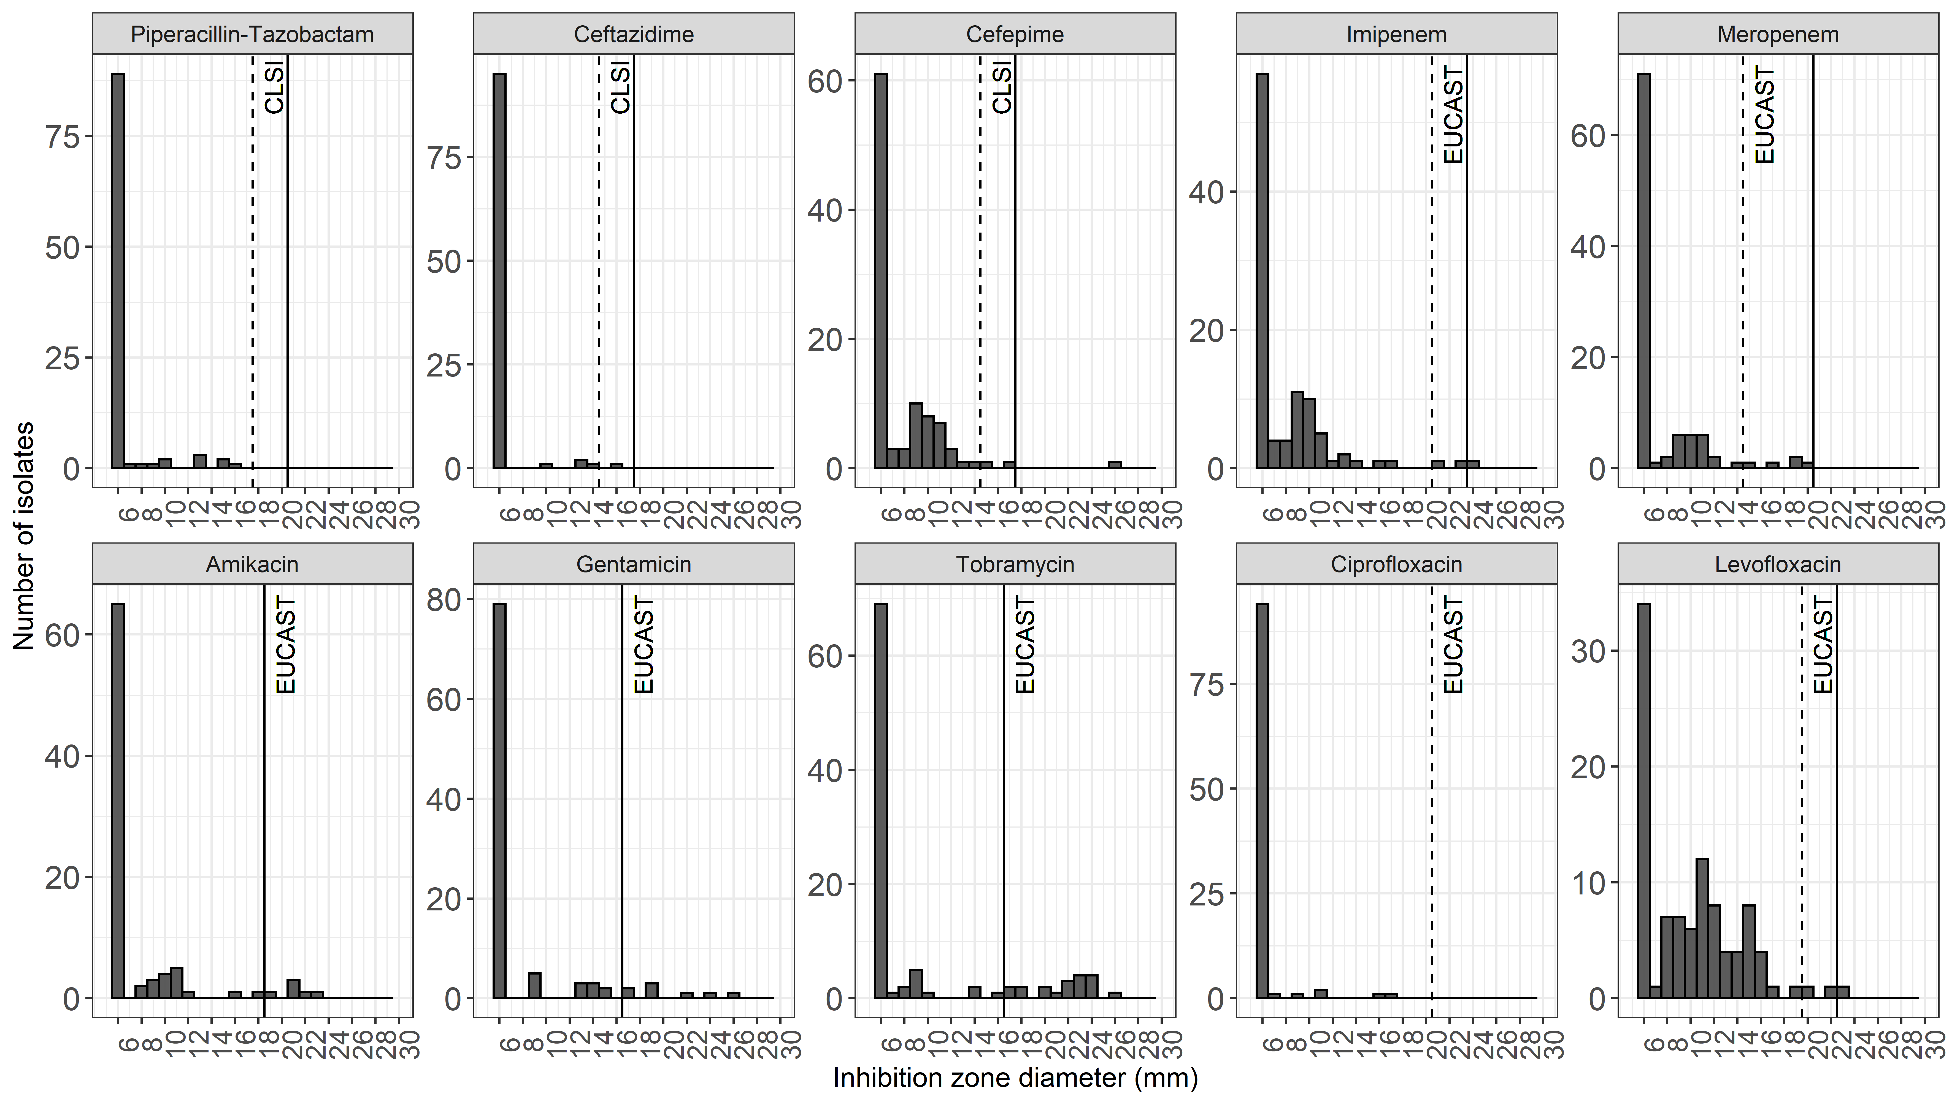
Figure S2. Distribution of MICs of second-line and last-resort antibiotics. The vertical dashed and continous lines denote the EUCAST susceptible and resistant CBPs for A. baumannii and when not available for P. aeruginosa and E. coli. Colistin MICs were determined by BMD, while for the others by E-test.
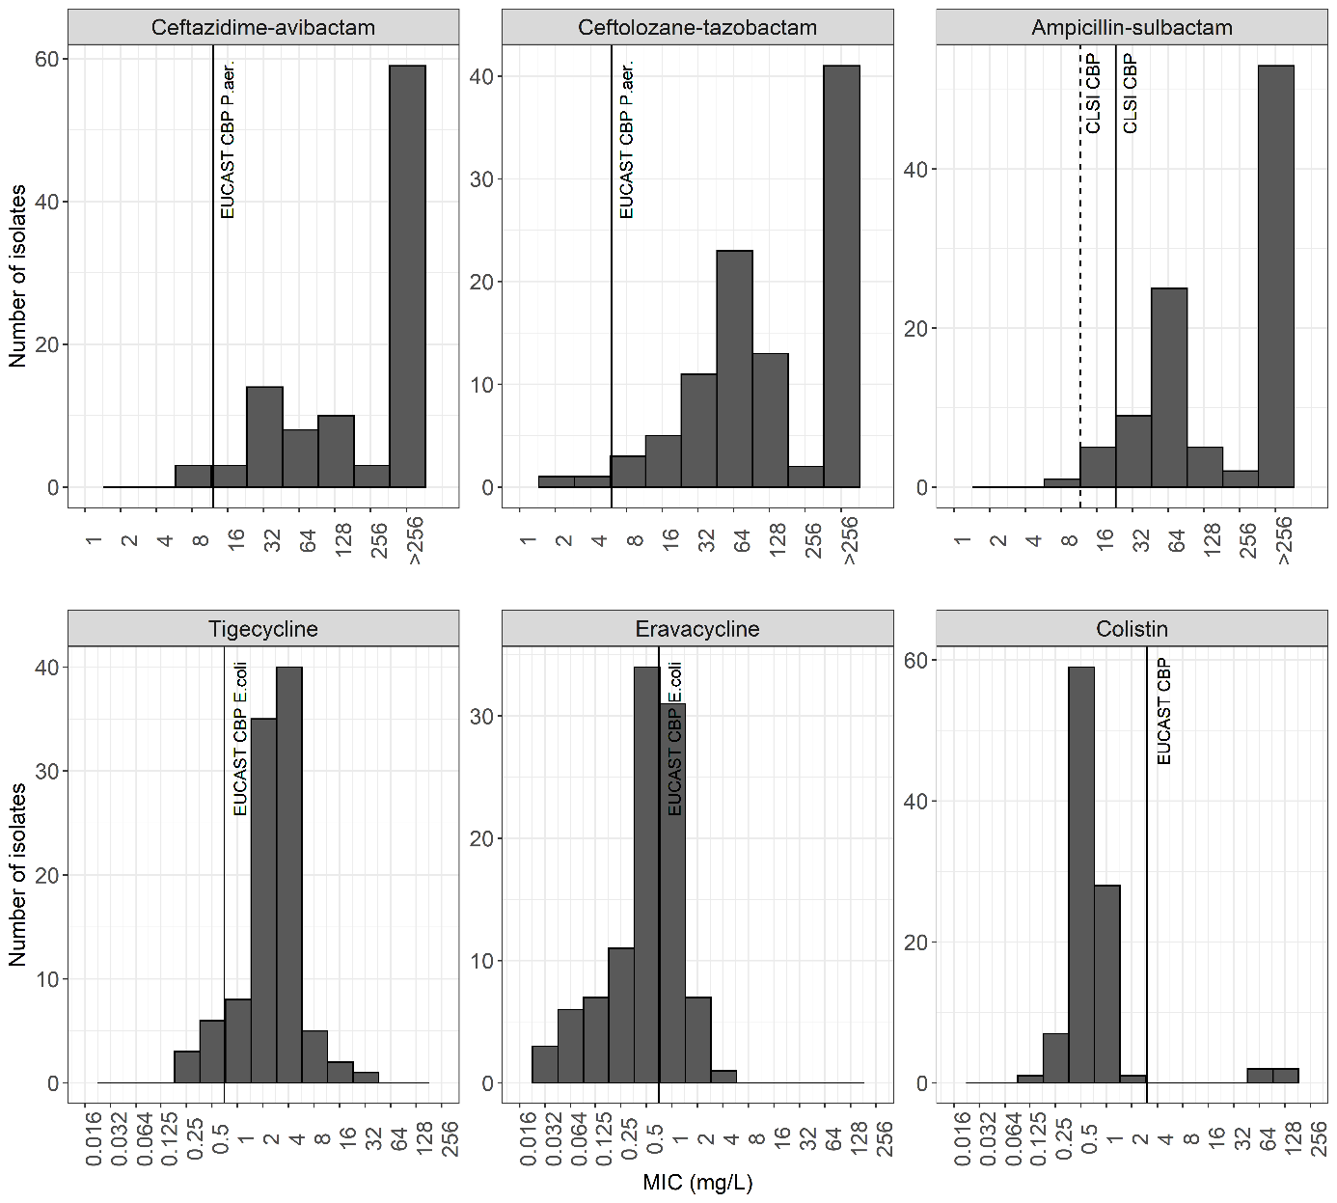
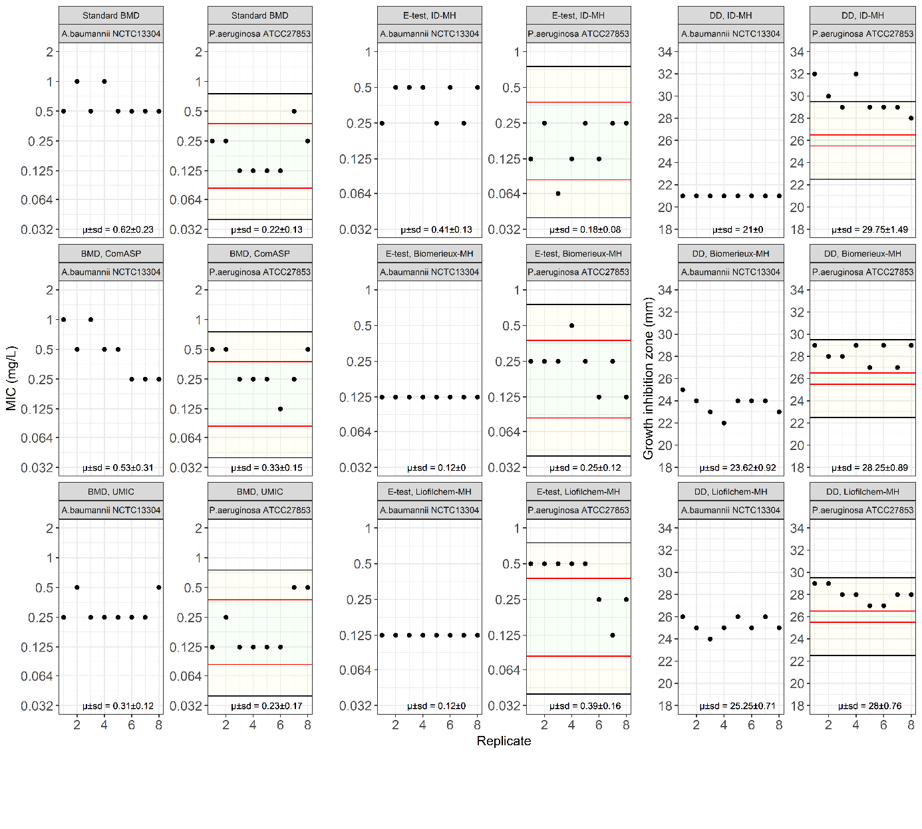
Figure S3. Quality control. Cefiderocol MICs values obtained with the standard BMD, ComASP, UMIC, and by E-test on iron-depleted MH-agar (ID-MH), Biomerieux MH-agar (Biomerieux-MH), Liofilchem MH-agar (Liofilchem-MH) plates, and disc diffusion (DD) growth inhibition zones on ID-MH-agar, Biomerieux-MH-agar and Liofilchem MH-agar plates of A.baumannii NCTC13304 and P.aeruginosa ATCC27853. Replica numbers are on the x axis and MICs on the y axis. Green and yellow areas reflect the EUCAST targets and ranges for P.eruginosa ATCC27853, respectively.

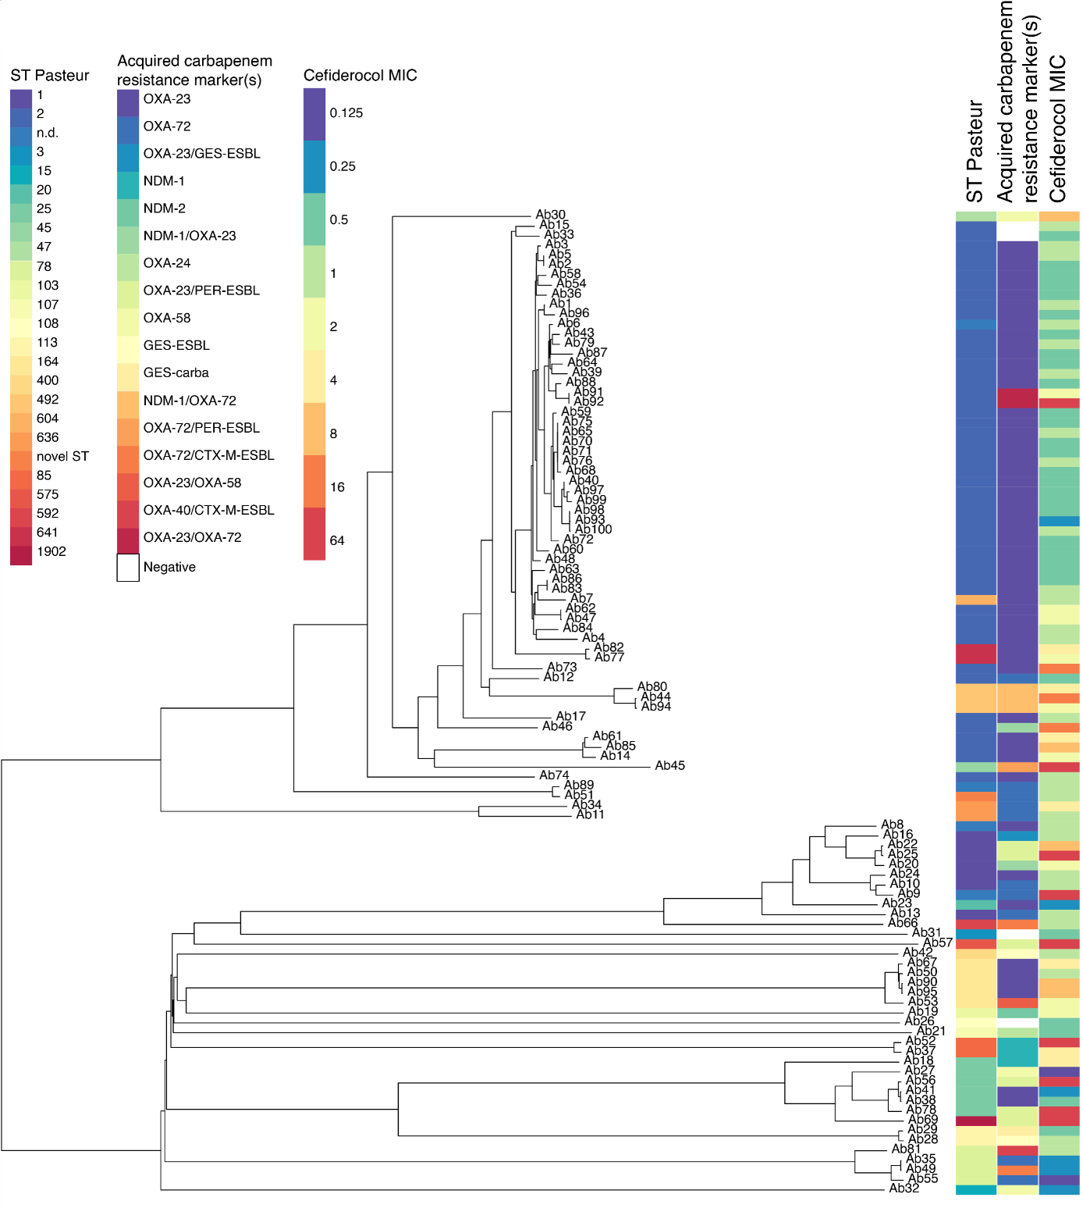
Figure S4. Phylogenetic neighbor joining tree generated in Ridom Seqspere+ based on core genes with associated metadata. In columns from left to right: ST Pasteur, acquired carbapenemase resistance markers, cefiderocol MIC.

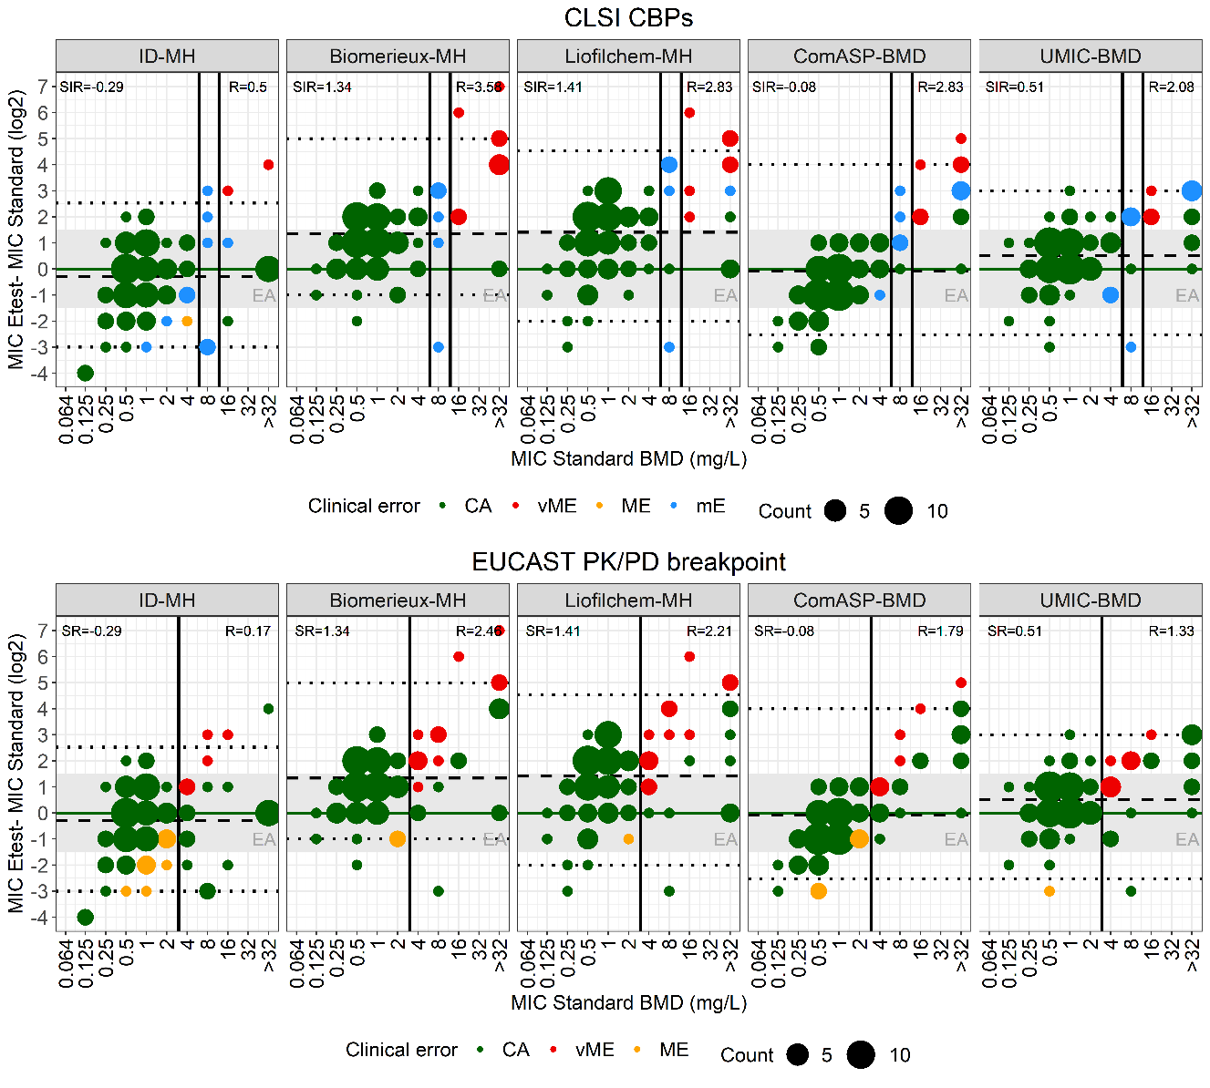
Figure S5. Performance of E-test on different MH-agars and ComASP and UMIC BMD assays. Blant-Altmann comparison between MICs determined by E-test on iron-depleted MH-agar (ID-MH), Biomerieux MH-agar (Biomeriux-MH), Liofilchem MH-agar (Liofilchem-MH) and with the commercial BMD assays ComASP and UMICs versus MICs determined with the standard BMD method. Standard BMD MICs are on the x axis and E-test/ComASP/UMIC MICs on the y axis. Isolates were categorized based on the BMD MICs and the CLSI CBPs for A. baumannii (top figures) or the EUCAST PK-PD breakpoint (bottom figures). Standard MICs/E-test or ComASP/UMIC MICs were classified as categorical agreement in green, very major error in red, major error in orange, and minor error in blue. The darkgreen horizontal lines indicate identity between the two methods. The black dashed horizontal lines and numbers indicate the mean log₂ differences of the susceptible (S), intermediate (I) and resistant (R) populations. Percentiles 2.5 and 97.5 are indicated by black dotted horizontal lines. The vertical lines indicate the CLSI CBPs (top) and the EUCAST PK-PD breakpoint (bottom). The gray highlighted areas denote essential agreement (MIC ± 1-fold dilution of the reference MIC).
Figure S6. Cefiderocol resistant A. baumannii isolate showing colonies emerging within the inhibition zones of DD and E-test performed on iron-depleted MH-agar (ID-MH), but not on Biomerieux MH-agar (Biomerieux-MH) and Liofilchem MH-agar (Liofilchem-MH).
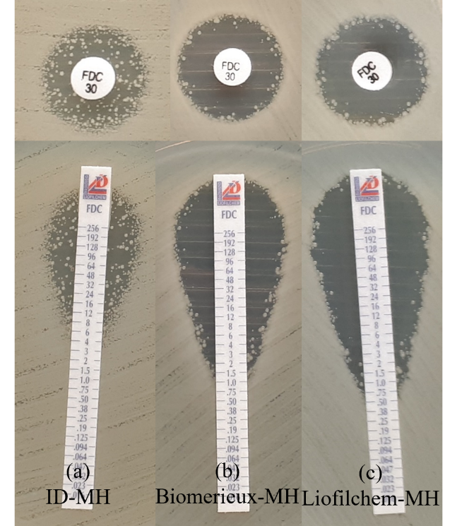
Figure S7. Performance of the DD on ID-MH-agar combined with E-test on ID-MH-agar, UMIC or ComASP. MICs as determined by E-test on ID-MH-agar, UMIC or ComASP (on the x axis) versus DD performed on ID-MH-agar (on the y axis). Colours reflect the MICs determined with the standard BMD method. Categorization errors between the DD/E-test, DD/UMIC and DD/ComASP values (based on the rule whereby by discrepant category resistance overtakes susceptibility) and standard BMD MICs are indicated on top of the count numbers. The red dashed and continous lines denote the CLSI CBPs. The black dashed line denote the regression line. CA, categorical agreement; mE, minor error; ME, major error; vME, very major error.
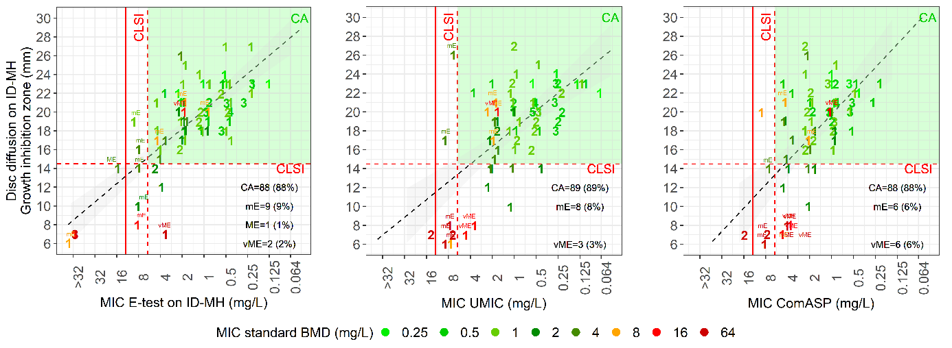
References
1. EUCAST. 2022. European Committee on Antimicrobial Susceptibility Testing. Breakpoint tables for interpretation of MICs and zone diameters Version 120:https://www.eucast.org/fileadmin/src/media/PDFs/EUCAST_files/Breakpoint_tables/v_11.0_Breakpoint_Tables.pdf.
2. CLSI. 2022. Clinical and Laboratory Standards Institute. Performance Standards for Antimicrobial Susceptibility Testing, 32nd Edition

