Table S1. List of primers used in this study for qPCR analysis
Gene symbol | Accession  number | Gene  description | Primer sequence (5´-3´)  Forward/Reverse | Amplicon length
ACT | ID6828205 | Actin 2 | GCCCCACGAGCTGTGTTC/  TCTGGCCCATTCCAACCA | 73 nt
SCL1 | DQ683579 | Scarecrow-like 1 | CGCCTCCTATTCTGGGTGAGTA/  GCCAACCCATCACCAAAATG | 118 nt
TUB | ID2842854 | β-Tubulin | CTCGTGCTGTTCTCATGGATCT/  TGGCCGAAAACGAAGTTGTC | 100 nt
UBI | ID3924917 | Polyubiquitin 3 | AGGAATCAACCCTTCACCTTGTC/  GAACTCTCCACCTCCAAAGTGATG | 100 nt

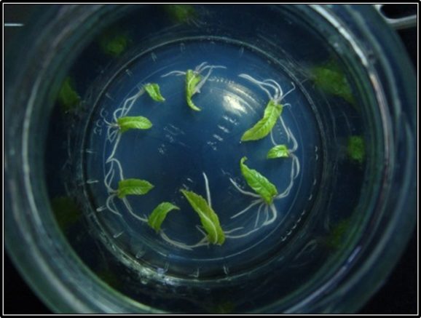
Figure S1. In vitro rooted leaves excised from microshoots established from chestnut basal sprouts. Leaves were placed abaxial side down on medium containing 25 µM IBA for 5 days and then transferred to IBA-free medium.

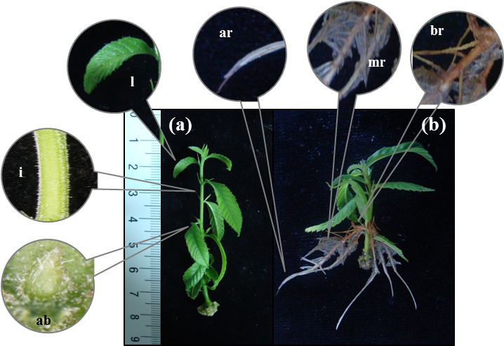
Figure S2. Plant material excised from microshoots at the end of proliferation (a) and rooting phases (b). ab: axillary buds; ar: apical section of the root; br: basal section of the root; i: internodes; l: leaf; mr: middle section of the root.

Figure S3. Influence of the ontogenetic stage on the rooting response of microshoots derived from basal shoots (BS microshoots) and from crown branches (CR Microshoots) and of leaves excised from these microshoots (BS leaves, CR Leaves).

