Supporting Information

Improved electrochemical performance of Li-Rich Cathode Materials via Spinel Li₂MoO₄ Coating
Shuhao Zhang ¹, Yun Ye ^{1,2,} Qinghao Lai ¹ Tie Liu ³ Shuang Yuan ^{1,}*
1 School of Metallurgy, Northeastern University, Shenyang 110819, China
2 Key Laboratory for Ecological Metallurgy of Multimetallic Mineral, Ministry of Education, Northeastern University, Shenyang 110819, China
3 Key Laboratory of Electromagnetic Processing of Materials (Ministry of Education), Northeastern University, Shenyang 110819, China
* Correspondence: yuans@smm.neu.edu.cn; Tel.: 86-024-83681171

Table S1. Composition of cational elements in sample Pristine, 1wt%, 3wt% and 5wt% as measured by ICP-OES.
Samples | Sampling quality(g) | Constant volume(mL) | Measured  element | Instrument  reading(mg/L) | Converted  content  (mg/kg) | Sample element content(%)
Pristine | 0.0548 | 25 | Li | 2.011 | 91734.5 | 9.17%
 | 0.0548 | 25 | Li | 2.011 | 91723.9 | 9.17%
 | 0.0548 | 25 | Mn | 7.587 | 346126.4 | 34.61%
 | 0.0548 | 25 | Mn | 7.584 | 345969.7 | 34.60%
 | 0.0548 | 25 | Co | 1.978 | 90258.6 | 9.03%
 | 0.0548 | 25 | Co | 1.979 | 90285.8 | 9.03%
 | 0.0548 | 25 | Ni | 1.701 | 77585.9 | 7.76%
 | 0.0548 | 25 | Ni | 1.710 | 78006.2 | 7.80%
1wt% | 0.0644 | 25 | Mo | 1.352 | 5248.0 | 0.52%
 | 0.0644 | 25 | Mo | 1.358 | 5271.7 | 0.53%
3wt% | 0.0557 | 25 | Mo | 3.430 | 15394.1 | 1.54%
 | 0.0557 | 25 | Mo | 3.429 | 15389.2 | 1.54%
5wt% | 0.0486 | 25 | Mo | 5.057 | 26011.3 | 2.60%
 | 0.0486 | 25 | Mo | 5.061 | 26032.0 | 2.60%

Table S2. ICP-OES results of the obtained samples.
 | Target material |  | ICP data
Pristine | Li1.2Mn0.54Co0.13Ni0.13O2 |  | Li1.127Mn0.537Co0.131Ni0.113O2
Mass proportion of Li₂MoO₄ coating layer
Designed | 1wt% | 3wt% |  | 5wt%
ICP data | 0.95wt% | 2.79wt% |  | 4.71wt%
The design value is the mass fraction of (NH₄)₂MoO₄ relative to Li-rich materials, while the experimental value is the mass fraction of Li₂MoO₄ relative to the overall sample.

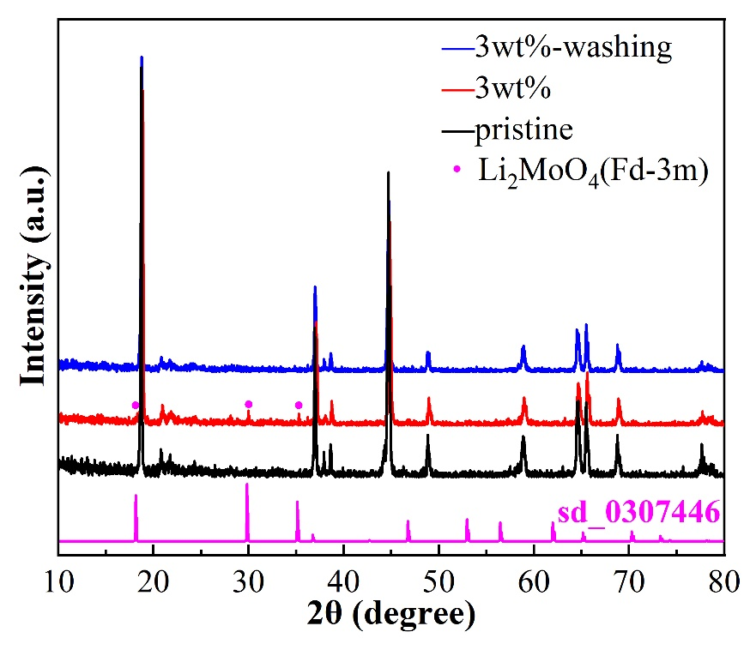

Figure S1. XRD spectrum analysis of spinel Li2MoO4 phase.
The peaks observed near 18, 30, and 35° are completely matched with the peaks of pure Li₂MoO₄ with spinel Fd-3m crystal structure (sd_0307446), and based on the good water solubility of Li₂MoO₄, the peak of Li₂MoO₄ disappears after washing with deionized water [1].
https://materials.springer.com/isp/crystallographic/docs/sd_0307446

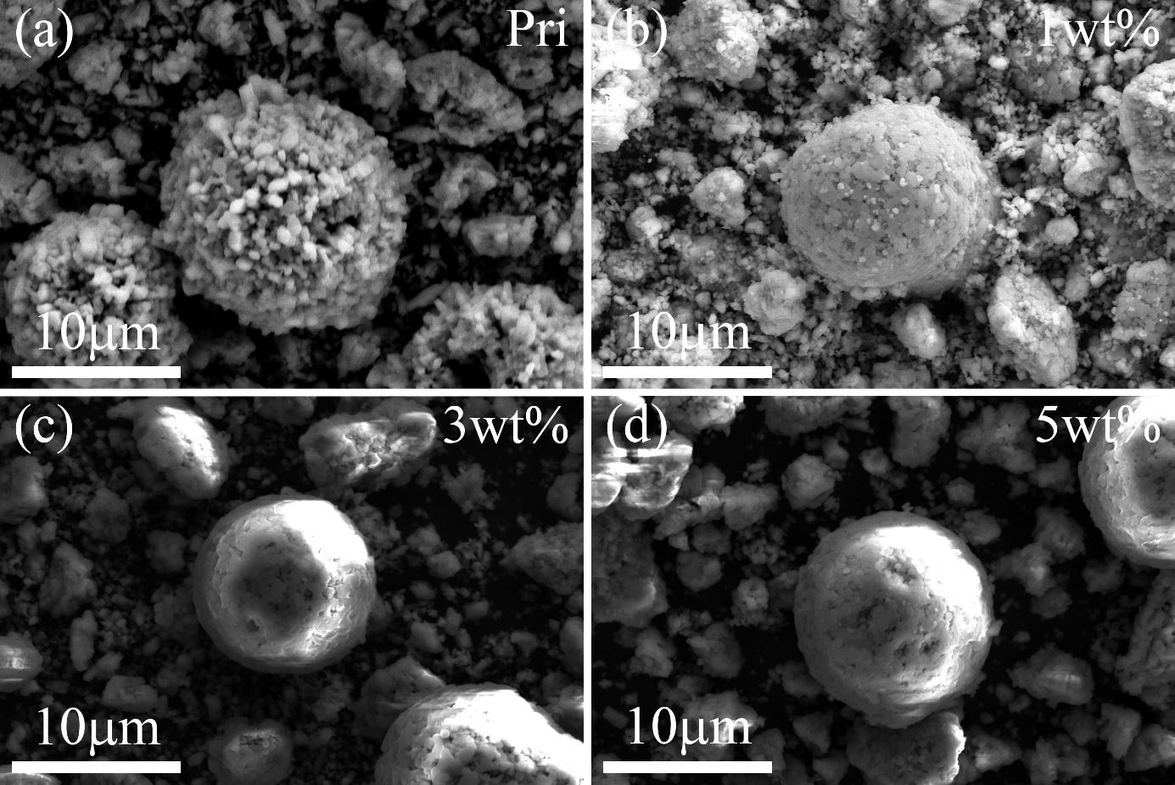

Figure S2. SEM images for (a) Pristine, (b) 1wt%, (c) 3wt%, (d) 5wt%.

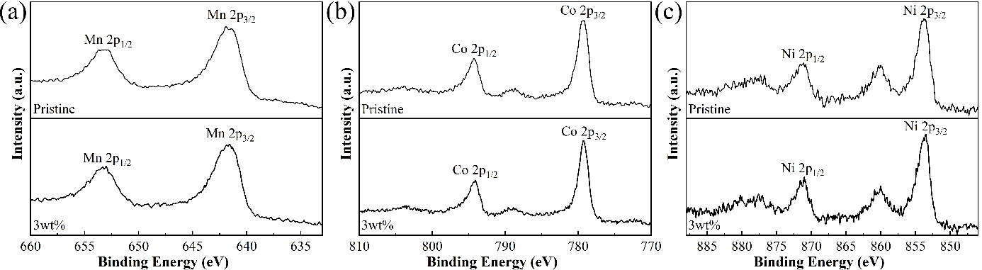

Figure S3. XPS spectra of (a) Mn 2p, (b) Co 2p, and (c) Ni 2p for Pristine and 3wt% sample.

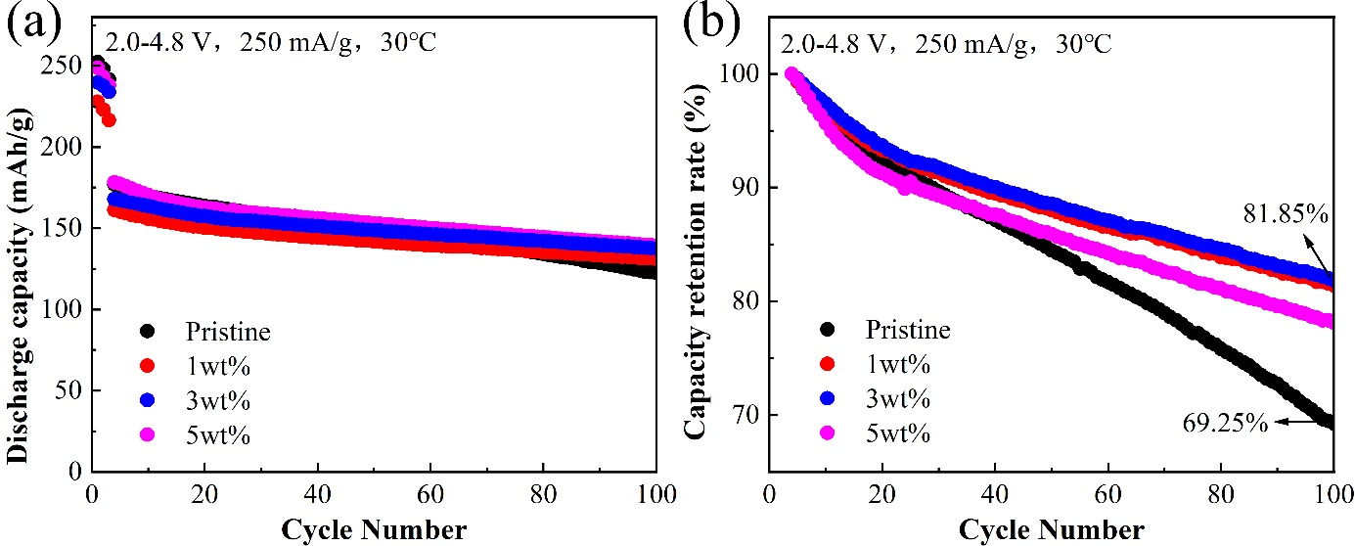

Figure S4. The cyclic performance (a) and capacity retention rate (b) of four samples at 1C.

References
- Zhu Z, Gao R, Waluyo I, Dong Y H, Hunt A, Lee J, Li J. Stabilized Co-Free Li-Rich Oxide Cathode Particles with An Artificial Surface Prereconstruction. Advanced Energy Materials, 2020, 10(35).

