Highly efficient photocathodic protection performance of 2D/2D ZIS@CNNs composites under visible light
Weitao Liª, Zhanyuan Yang ª, Yanhui Li ^{a, b}, Pengfei Zhang ª, Hong Li ^{a *}
ª College of Mechanical and Electrical Engineering, Qingdao University, 308 Ningxia Road, Qingdao 266071, China
^{b} State Key Laboratory of Bio-Fibers and Eco-Textiles, Qingdao University, 308 Ningxia Road, Qingdao 266071, China
Corresponding Author
*Hong Li. Email: lhqdio1987@163.com. Tel: + 86-532-85953679
Email addresses
WTL: Lwtsty2022@163.com; ZYY: yzyqdu@163.com; YHL: liyanhui@tsinghua.org.cn; PFZ: pzhan12@qq.com; HL: lhqdio1987@163.com

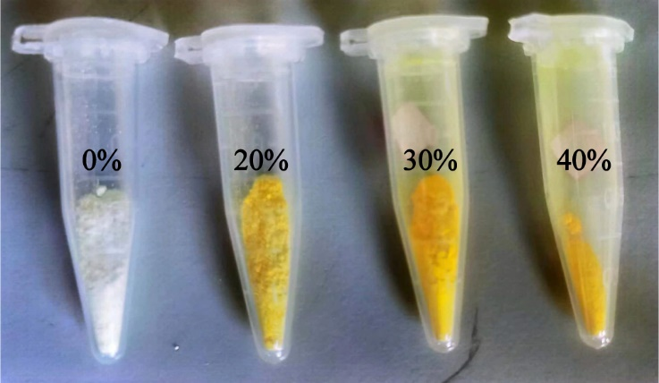
Fig. S1. Picture of CNNs and three different ZIS@CNNs composite material.

Fig. S2. Schematic diagrams of experimental setup for (a) OCP, EIS, Tafel (b) photocurrent densities tests.

Fig. S3. OCP-t curves of 304 SS coupled with CNNs and 30% ZIS@CNNs composite.

Table S1 Comparison of 2D/2D ZIS@CNNs photoanode with other photoanodes.
Samples | Metal | Photocurrent density | Ref
WO₃/ZnWO₄/ZnO | 316L SS | 8 μA·cm⁻² | [1]
1D-p-g-C₃N₄@RGO | 304 SS | 10 μA cm^{–2} | [2]
SrTiO₃ | 304 SS | 9.2 μA cm^{–2} | [3]
C-vacancy g-C₃N₄/GO/WO₃ | 304 SS | 16 μA cm^{–2} | [4]
g-C₃N₄/rGO/ZnS | 304 SS | 15 μA cm^{–2} | [5]
STO/g-CN | 304 SS | 8.2 μA·cm⁻² | [6]
polyaniline/graphitic carbon nitride | Fe | 11 μA·cm⁻² | [7]
g-C₃N₄/epoxy | Q235 | 0.4 μA·cm⁻² | [8]
2D/2D ZIS@CNNs | 316 SS | 17 μA cm^{–2} | This work

References
[1] Feng, C.; Chen, Z. ; Tian, J.; Jing, J.; Ma, L.; Hou, J. Fabrication of three-dimensional WO₃/ZnWO₄/ZnO multiphase heterojunction system with electron storage capability for significantly enhanced photoinduced cathodic protection performance. J Mater Sci Technol, 2021, 90, 183-193.
[2] Qian, B.; Yang, X.; Li, X.; Song, Z. Fabrication of 1D/2D p-g-C₃N₄@RGO heterostructures with superior visible-light photoelectrochemical cathodic protection performance. J Solid State Electr, 2020, 24, 1669-1678.
[3] Kong, C.; Su, X.; Qing, D.; Zhao, Y.; Wang, J.; Zeng, X. Controlled synthesis of various SrTiO₃ morphologies and their effects on photoelectrochemical cathodic protection performance. Ceram Int, 2022, 48, 20228-20236.
[4]. Zheng, H.; Zheng, H.; Jiang, S.; Liu, Y.; Sun, X.; Wang, D.; Zhou, Y.; Zhu, M.; Zhang, D.; Zhang, L. Improved photocathodic protection performance of C-vacancy g-C₃N₄/GO/WO₃ for 304 stainless steel. J Phys Chem Solids, 2022, 160, 110270.
[5] Zheng, H; Liu, Y.; Zhou, Y.; Zhao, D.; Yun, L.; Zhang, D.; Zhang, L. Improved photocathodic protection performance of g-C₃N₄/rGO/ZnS for 304 stainless steel. J Phys Chem Solids, 2021, 148, 109672.
[6] Kong, C.; Qing, D.; Su, X.; Zhao, Y.; Wang, J.; Zeng, X. Improved photoelectrochemical cathodic protection properties of a flower-like SrTiO₃ photoanode decorated with g-C₃N₄, J Alloy Compd, 2022, 924, 166629.
[7] Guo, F.; Li, L.; Shi, Y.; Shi, W.; Yang, X.; Li, H. Achieving superior anticorrosion and antibiofouling performance of polyaniline/graphitic carbon nitride composite coating, Prog Org Coat, 2023, 179, 107512.
[8] Guo, F.; Li, L.; Shi, Y.; Shi, W.; Yang, X. Synthesis of N-deficient g-C₃N₄/epoxy composite coating for enhanced photocatalytic corrosion resistance and water purification. J Mater Sci, 2023, 58, 4223-4239.

