Supplementary Figures:
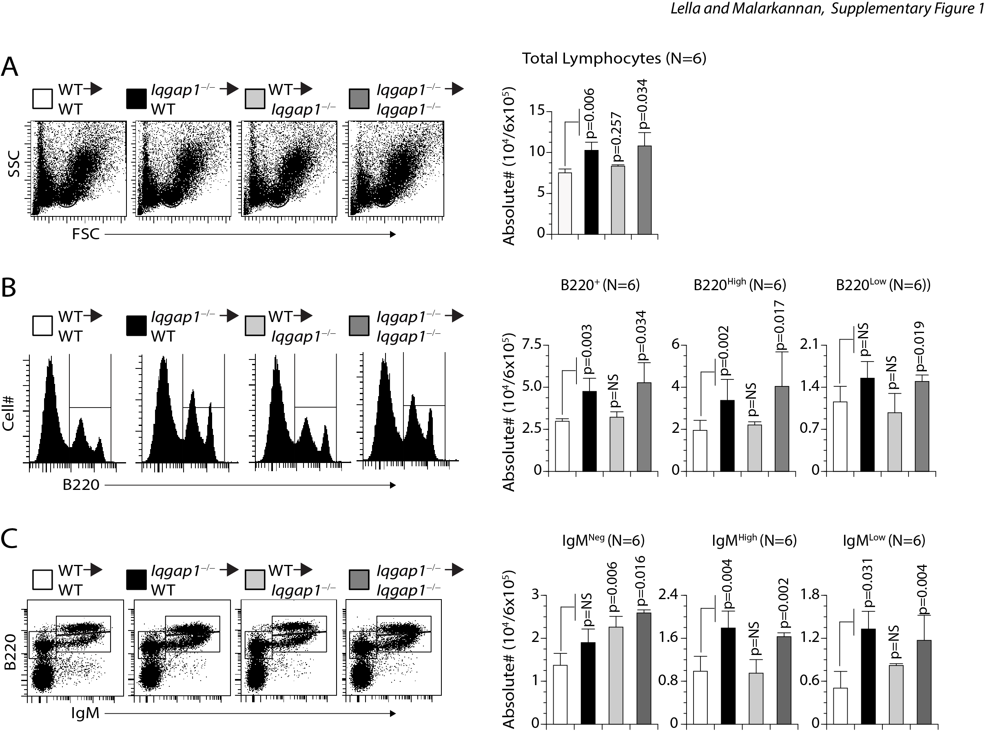

Supplementary Figure 1. Dysregulated early B cell development in the BM of Iqgap1^{−/−} mice is B cell-intrinsic. Indicated host mice were sub-lethally irradiated and reconstituted with donor-derived 5 × 10⁵ BM cells. Eight weeks later, cells from the host BM were harvested and analyzed. A, B) Viable cells within the lymphocyte gate were analyzed for the absolute number of total B cells. Staining with anti-B220 antibody indicated the presence of both B220^{High} and B220^{Low} B cells in both the WT and Iqgap1^{−/−} mice. Total cell numbers in each subset were enumerated from six reconstituted mice and shown on right-side panels. C) Absolute numbers of reconstituted B220⁺IgM⁻ pro/pre-B, B220⁺IgM⁺ immature B, and B220^{Hi} recirculating B cells were defined using anti-B220 and anti-IgM antibodies, and their numbers were calculated from live lymphocyte gates. Data shown on the left are representative panels. Data shown are from two independent experiments with three mice each. Data are shown with the mean ± SEM. Statistical significance was calculated using Student’s t-test, and p-values are shown below each graph.

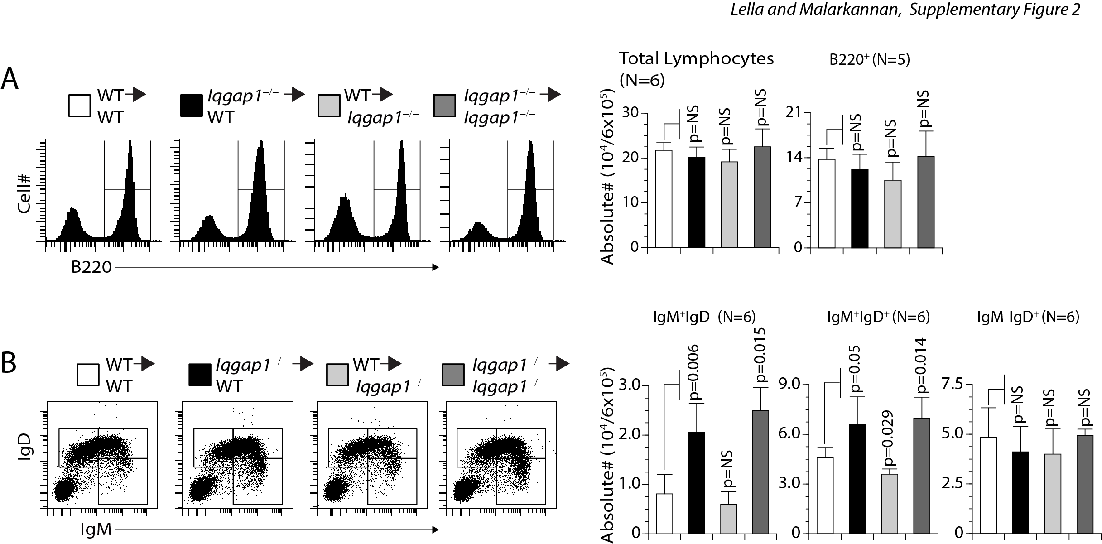
Supplementary Figure 2. Impairment in the splenic B cell development in Iqgap1^{−/−} mice is cell-intrinsic. Indicated host mice were sub-lethally irradiated and reconstituted with donor-derived 5 × 10⁵ BM cells. Eight weeks later, cells from the host spleens were harvested and analyzed. A) Absolute total splenic B cells were comparable between the WT and Iqgap1^{−/−} mice. Viable cells within the lymphocyte gate were analyzed for the absolute number of total B cells using an anti-B220 antibody. Data shown represent the B220⁺ B cells per spleen from both strains. B) Absolute numbers of immature and mature B cells do not differ between the WT and Iqgap1^{−/−} mice. Total splenic B cells were stained with anti-B220, anti-IgM, and anti-IgD antibodies. Data shown represent the B220⁺IgM⁺ immature B and B220⁺IgM⁺IgD⁺ or B220⁺IgM⁻IgD⁺ mature B cells. Data represent absolute numbers of immature or mature B cells per spleen from both strains. Data are shown with the mean ± SEM. Statistical significance was calculated using Student’s t-test, and p-values are shown below each graph.

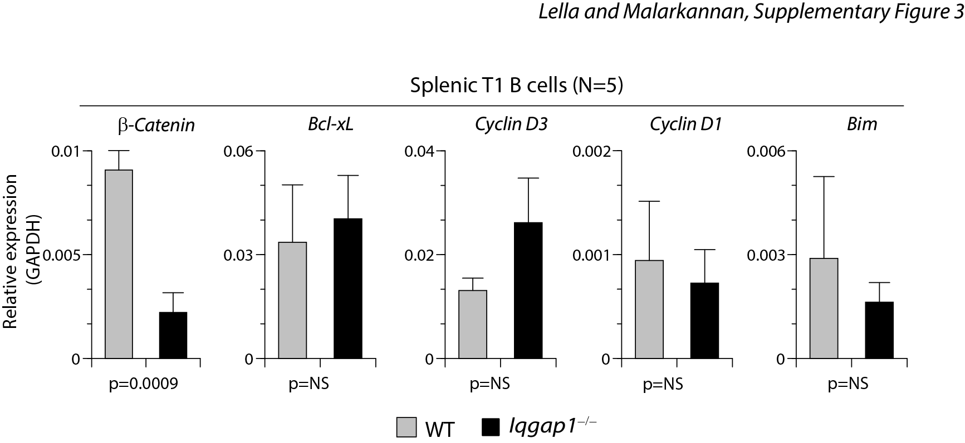
Supplementary Figure 3. Expression levels Ccnd3 is moderately increased, and β-catenin is significantly decreased in T1 B cells. Total mRNA was isolated from sorted splenic T1 B cells. RTqPCR was performed to quantify the expression levels of β-catenin, Bcl-xl, Ccnd3, Ccnd1, and Bim. Statistical significance was calculated using Student’s t-test, and p-values are shown below each graph.

