Supporting Information

Selective functionalization of carbonyl closo-decaborate [2-B₁₀H₉CO]¯ with building block properties via Grignard reagents
Nadine Mahfouz,^{1,2} Fatima Abi-Ghaida,^{1,}* Wael Kotob,¹ Ahmad Mehdi,^{2,}* and Daoud Naoufal^{1,}*
¹ Inorganic and Organometallic Coordination Chemistry Laboratory LCIO, Lebanese University, Faculty of Sciences, Lebanon, dnaoufal@ul.edu.lb, fghaida@ul.edu.lb
² Institut Charles Gerhardt ICGM, Université de Montpellier, CNRS, ENSCM, Montpellier, 34090, France, ahmad.mehdi@umontpellier.fr
* Correspondence: fghaida@ul.edu.lb , ahmad.mehdi@umontpellier.fr, dnaoufal@ul.edu.lb

Table of Content
1. ¹¹B NMR spectra for all compounds with carbonyl-closodecaborate(1) 2
2. Product (PPh₄)(MgBr)[2-B₁₀H₉C(O)CH₂CH₃] (2) 3
2.1. ¹H NMR Spectra 3
2.2. ¹³C NMR spectra 4
2.3. ³¹P NMR spectra 5
2.4. Mass spectrometry ESI/MS 6
3. Product (PPh₄) (MgBr)[2-B₁₀H₉C(O)(CH₂)₄CH₃] (3) 6
3.1. ¹H NMR Spectra 6
3.2. ¹³C NMR Spectra 7
3.3. ³¹P NMR spectra 8
3.4. Mass spectrometry ESI/MS 8
4. Product (PPh₄) (MgCl)[2-B₁₀H₉C(O)C₃H₇] (4) 9
4.1. ¹H NMR spectra 9
4.2. ¹³C NMR spectra 10
4.3. ³¹P NMR spectra 11
4.4. Mass spectrometry ESI/MS 11
5. Product (PPh₄) (MgCl)[2-B₁₀H₉C(O)CH₂CH=CH₂] (5) 12
5.1. ¹³C NMR spectra 12
5.2. ³¹P NMR spectra 13
5.3. Mass spectrometry ESI/MS 13
6. Product (PPh₄) (MgBr)[2-B₁₀H₉C(O)CH=CH₂] (6) 14
6.1. ¹³C NMR spectra 14
6.2. ³¹P NMR spectra 15
6.3. Mass spectrometry ESI/MS 15
7. Product (PPh₄) (MgBr)[2-B₁₀H₉C(O)C≡CCH₃] (7) 16
7.1. ³¹P NMR spectra 16

¹¹B NMR spectra for all compounds with carbonyl-closodecaborate(1)

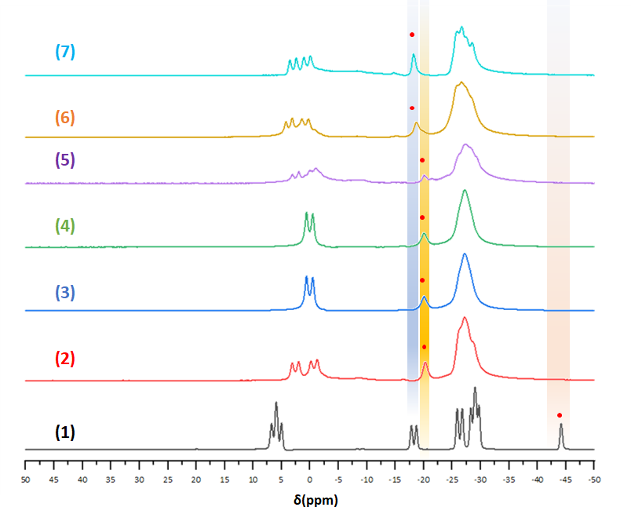
Fig. S 1. ¹¹B NMR spectrum for all compounds with carbonyl-closodecaborate (1)

Product (PPh₄)(MgBr)[2-B₁₀H₉C(O)CH₂CH₃] (2)

¹H NMR Spectra
¹H NMR (δ ppm, DMSO-d6): 0.65 (3 H, d, CH₃), 2.23 (2 H, quadruplet, CH₂), 7.5-7.8 (20 H, m, H of PPh₄⁺).
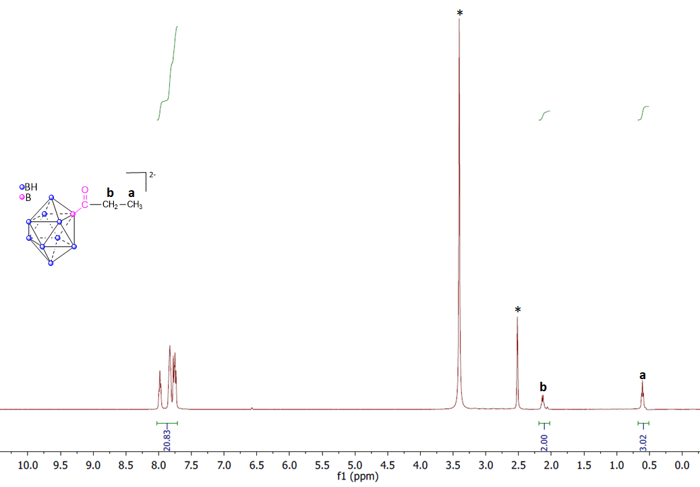
Fig. S 2. ¹H NMR spectrum of Product (2) in DMSO-d6

¹³C NMR spectra
¹³C NMR (δ ppm, DMSO-d6): 157.30 (a), 135.52 (g), 134.88 (f), 130.45 (e), 118.73(d), 8.65 (b), 1.13 (c).

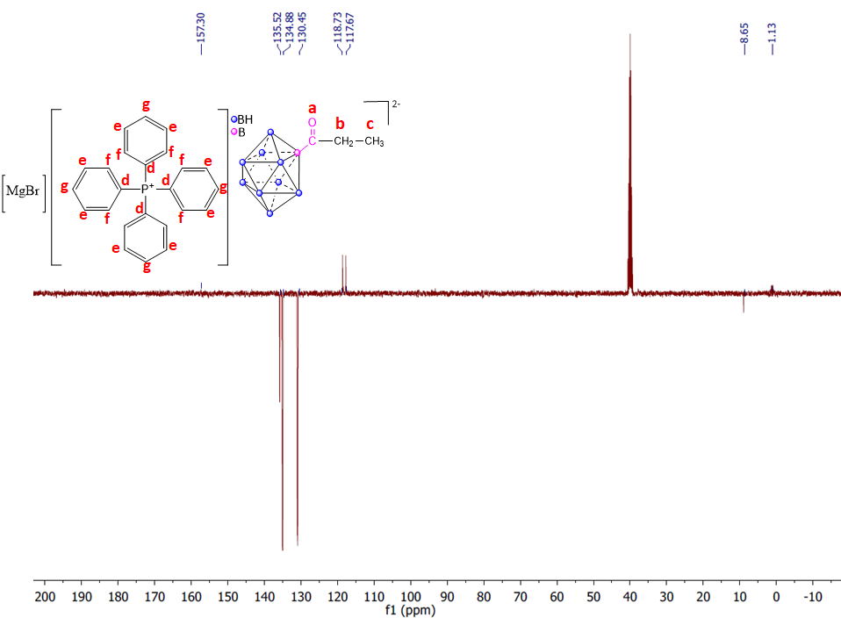
Fig. S 3. ¹³C NMR Spectrum of product (2). Attributed carbons (a to g) are annotated on the structure

³¹P NMR spectra
³¹P NMR (DMSO-d6): 22.59
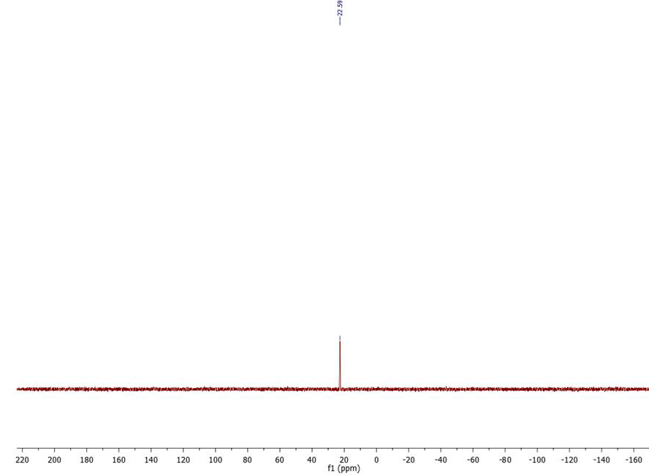
Fig. S 4. ³¹P NMR spectrum of product (2)

Mass spectrometry ESI/MS
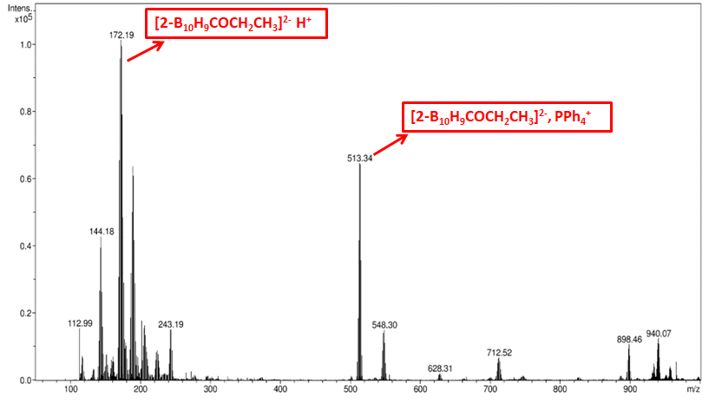
Fig. S 5. ESI/MS spectra of the product (2)

Product (PPh₄) (MgBr)[2-B₁₀H₉C(O)(CH₂)₄CH₃] (3)

¹H NMR Spectra
¹H NMR (δ ppm, DMSO-d6): 0.75 (3H, t, CH₃), 1.10 (2H, sextuplet, CH₂), 1.25 (4H, quintuplet, 2CH₂), 2.15 (2H, t, CH₂), 7.5-7.8 (20H, m, H of PPh₄⁺)
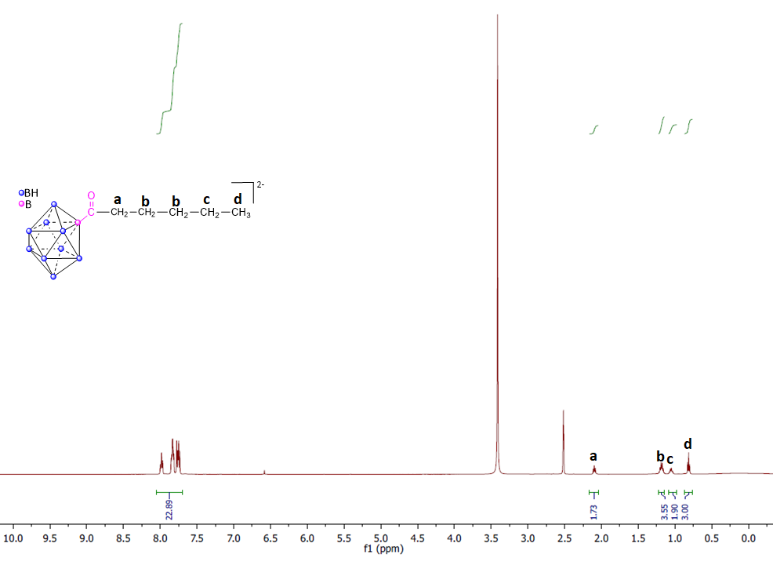
Fig. S 6. ¹H NMR spectrum of Product 2 in DMSO-d6

¹³C NMR Spectra
¹³C NMR (δ ppm, DMSO-d6): 166.35 (a), 135.52 (g), 134.88 (f), 130.45 (e), 118.73(d),32.10 (b), 24.18 (c), 22.72 (h), 14.32 (i).

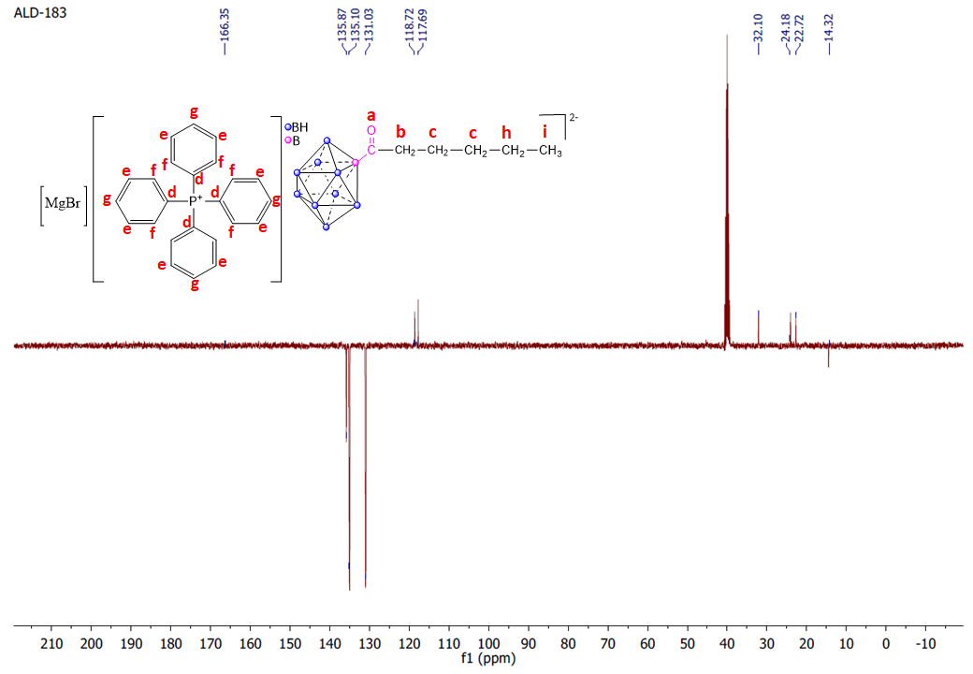
Fig. S 7. ¹³C NMR Spectrum of product (3). Attributed carbons (a to i) are annotated on the structure

³¹P NMR spectra
³¹P NMR (DMSO-d6): 22.13
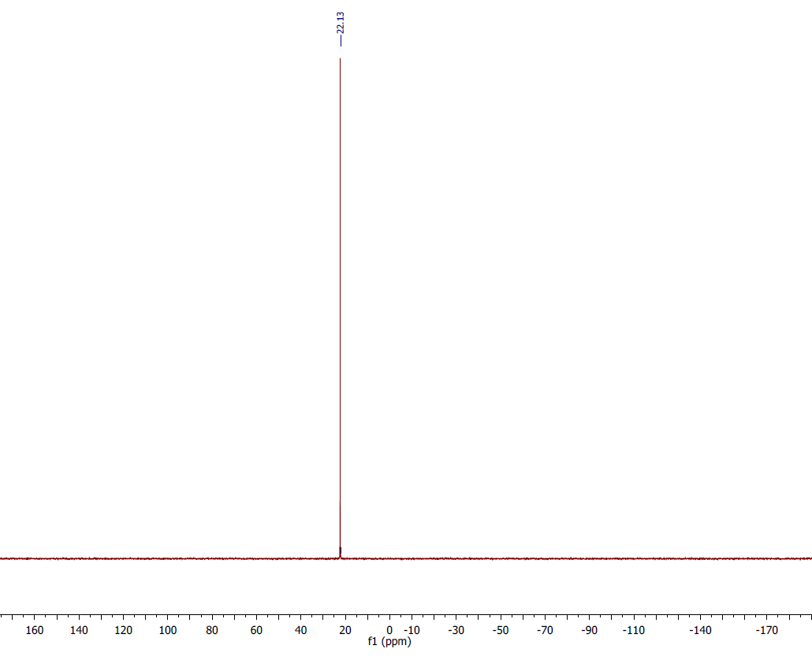
Fig. S 8. ³¹P spectrum of the product (3)

Mass spectrometry ESI/MS
Mass spectrometry m/z (3) = 216
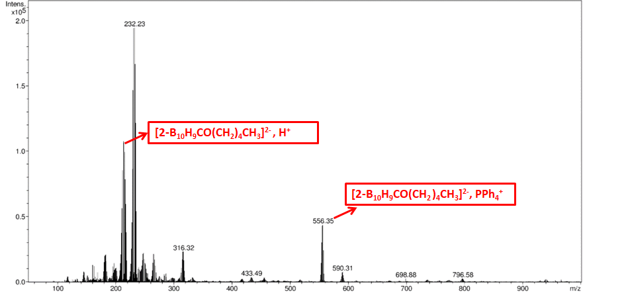
Fig. S 9. Mass spectrometry ESI/MS of the product (3)

Product (PPh₄) (MgCl)[2-B₁₀H₉C(O)C₃H₇] (4)

¹H NMR spectra
¹H NMR (δ ppm, DMSO-d6): 0.68 (6H, d, 2CH₃), 2.65 (1H, septuplet, CH), 7.51-8.04 (20H, m, H of PPh₄⁺)
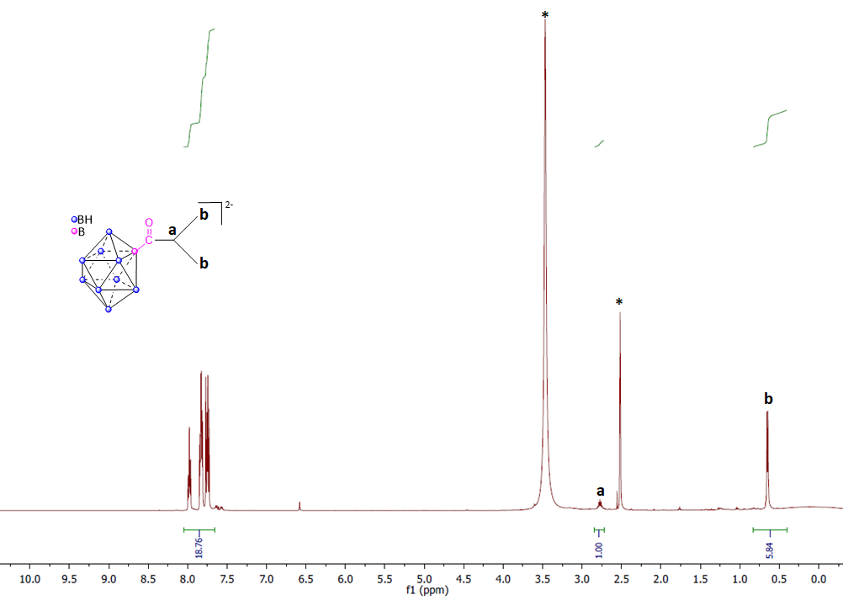
Fig. S 10. ¹H NMR spectrum of Product (4) in DMSO-d6

¹³C NMR spectra
¹³C NMR (δ ppm, DMSO-d6): 135.75 (g), 135.29 (f), 130.91 (e),118.71 (d), 19.59 (c).
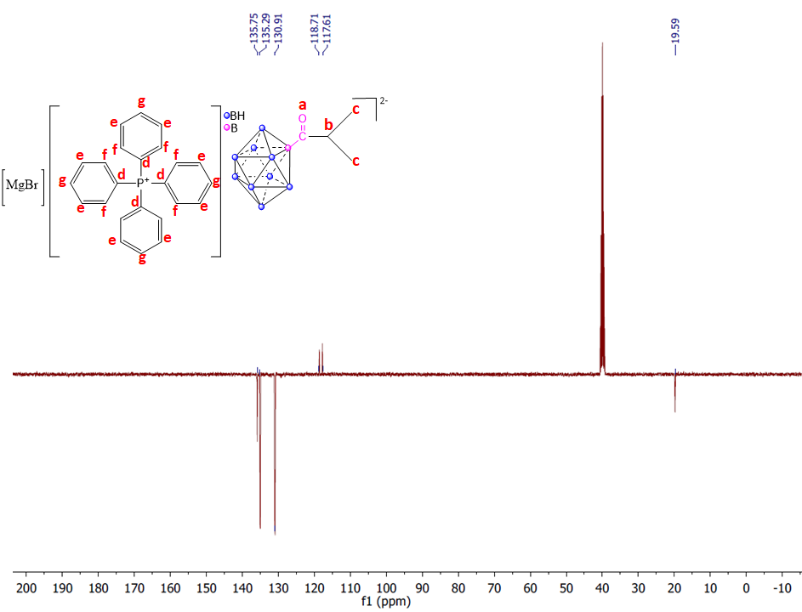
Fig. S 11. ¹³C NMR Spectrum of product (4). Attributed carbons (a to g) are annotated on the structure

³¹P NMR spectra
³¹P NMR (DMSO-d6): 22.59
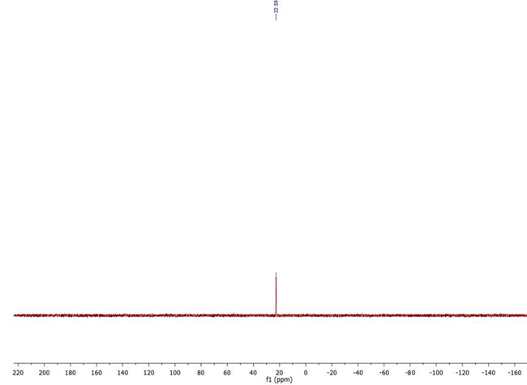
Fig. S 12. ³¹P NMR spectrum of the product (4)

Mass spectrometry ESI/MS
Mass spectrometry (ESI): m/z (4) = 188
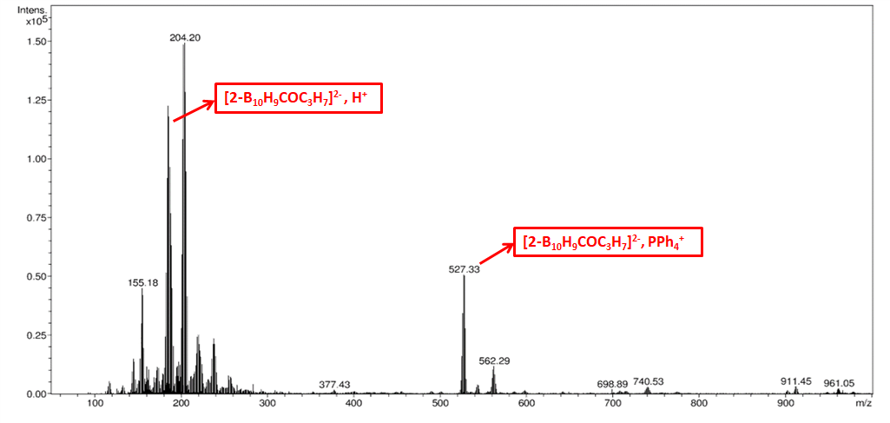
Fig. S 13. Mass spectrometry ESI/MS of the product (4)

Product (PPh₄) (MgCl)[2-B₁₀H₉C(O)CH₂CH=CH₂] (5)

¹³C NMR spectra
¹³C NMR (δ ppm, DMSO-d6): 135.87(g), 135.09 (h), 131.03(f),130.84 (e), 118.61 (d), 117.69 (c), 45.959 (b)
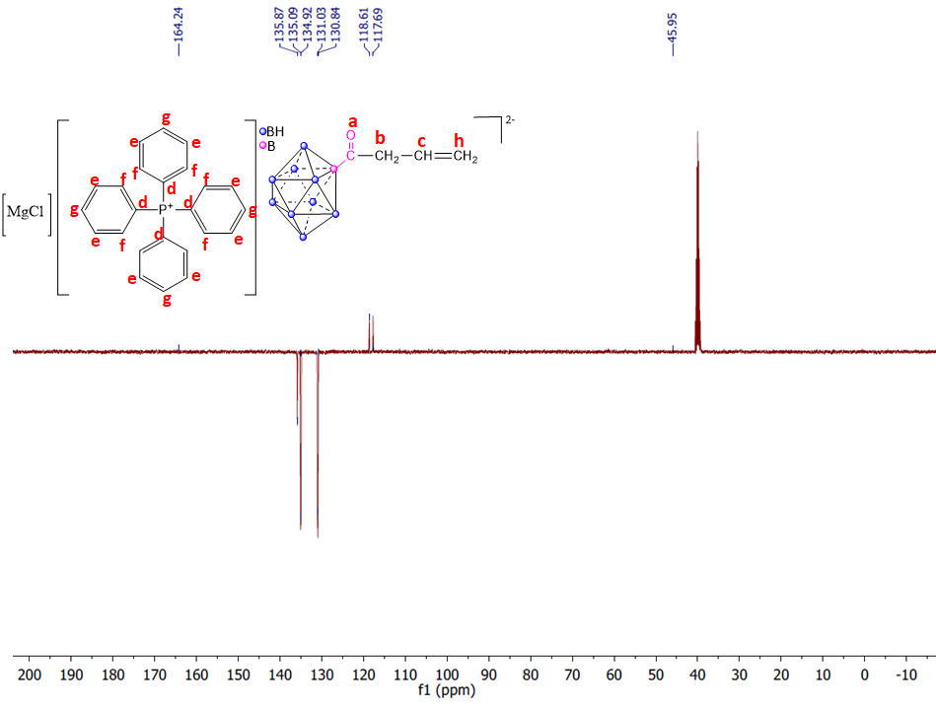
Fig. S 14. ¹³C NMR Spectrum of product (5). Attributed carbons (a to h) are annotated on the structure

³¹P NMR spectra
³¹P NMR (DMSO-d6): 21.64
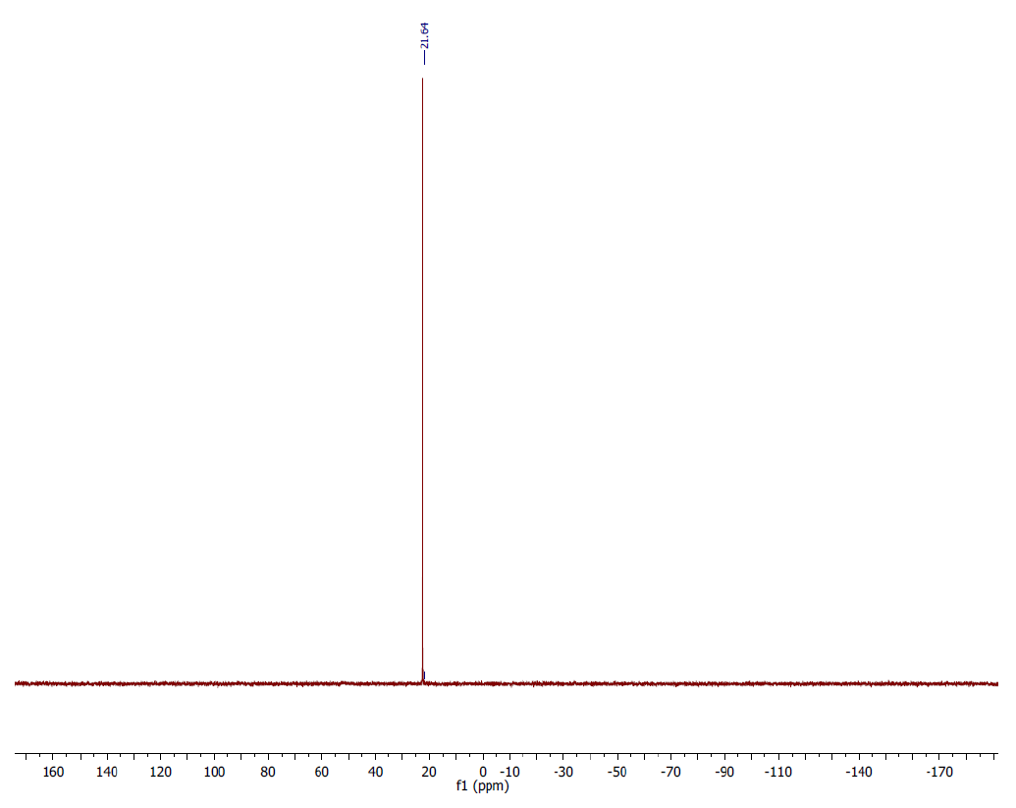
Fig. S 15. ³¹P NMR spectrum of product (5)

Mass spectrometry ESI/MS
Mass spectrometry (ESI): m/z (5)= 185
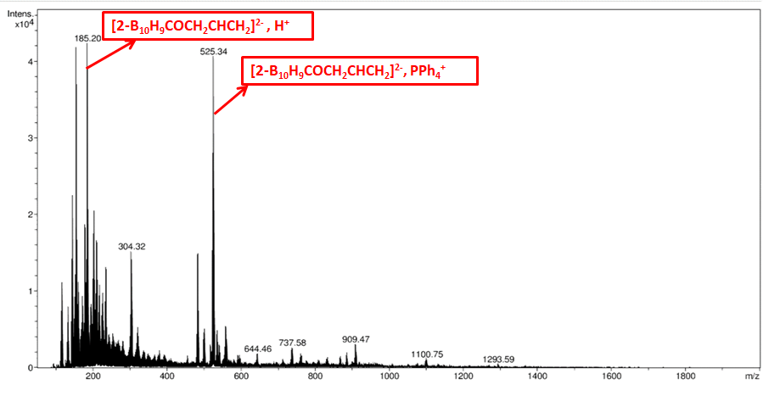
Fig. S 16. Mass spectrometry ESI/MS of the product (5)

Product (PPh₄) (MgBr)[2-B₁₀H₉C(O)CH=CH₂] (6)

¹³C NMR spectra
¹³C NMR (δ ppm, DMSO-d6): 175.56 (a), 135.95(b), 135.10(g),134.90(f), 130.91(c),118.72, 117.65(d)
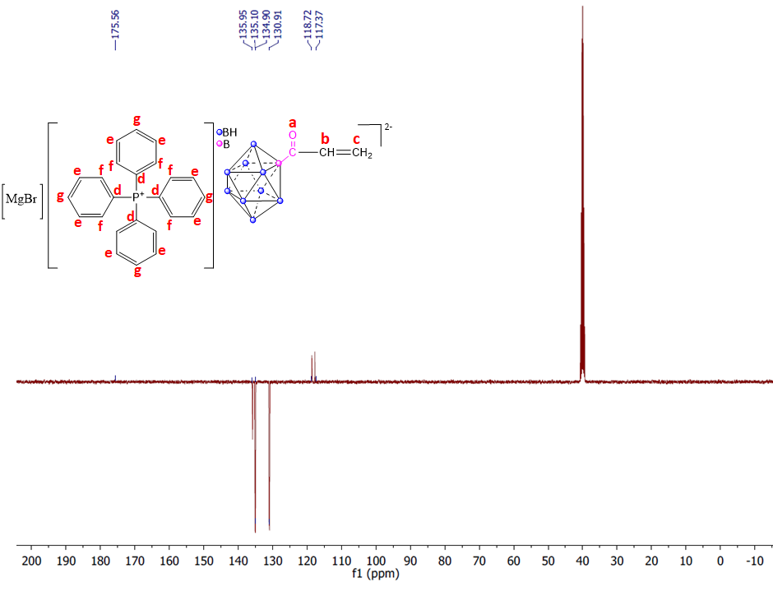
Fig. S 17. ¹³C NMR Spectrum of product (6). Attributed carbons (a to g) are annotated on the structure

³¹P NMR spectra
³¹P NMR (DMSO-d6): 22.14.
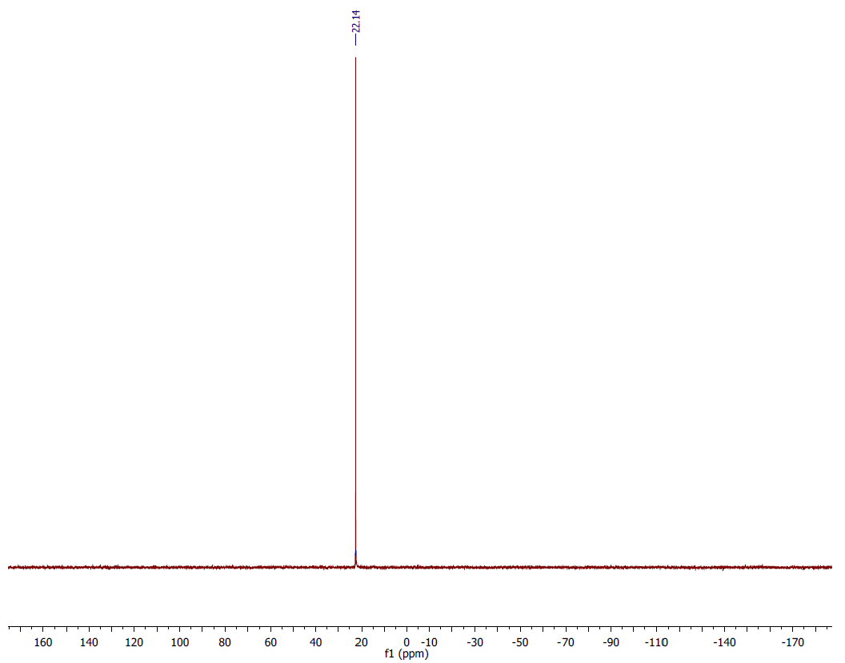
Fig. S 18. ³¹P NMR Spectrum of the product (6)

Mass spectrometry ESI/MS
Mass spectrometry (ESI): m/z (6) = 172.
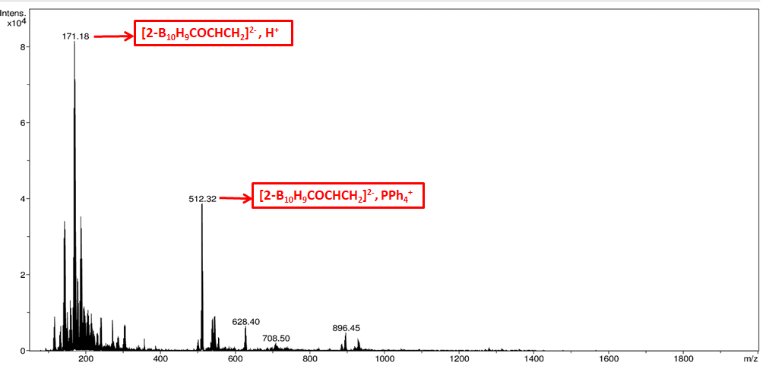
Fig. S 19. Mass spectrometry ESI/MS of the product (6)

Product (PPh₄) (MgBr)[2-B₁₀H₉C(O)C≡CCH₃] (7)

³¹P NMR spectra
³¹P NMR (DMSO-d6): 22.13.
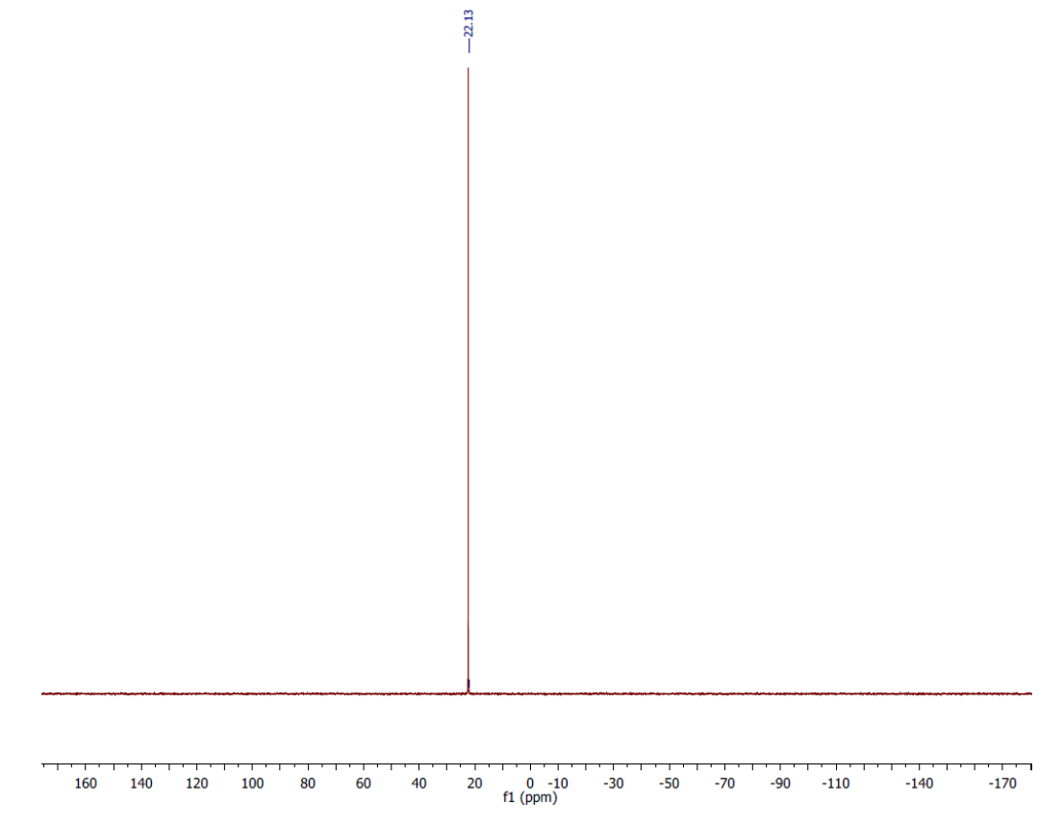
Fig. S 20. ³¹P NMR spectrum of the product (7)

