Supplementary material

Table S1. Weight, width, length, and peel thickness of Haruka, Kiyomi, and Yellowball.
 | Weight (g) | Width (cm) | Length (cm) | Peel thickness (cm)
Haruka | 331.49 ± 29.46 | 10.63 ± 0.38 | 10.09 ± 0.42 | 0.90 ± 0.09
Kiyomi | 250.69 ± 18.83 | 9.39 ± 0.39 | 8.92 ± 0.37 | 0.68 ± 0.12
Yellowball | 273.74 ± 15.47 | 9.76 ± 0.60 | 9.32 ± 0.37 | 0.44 ± 0.03

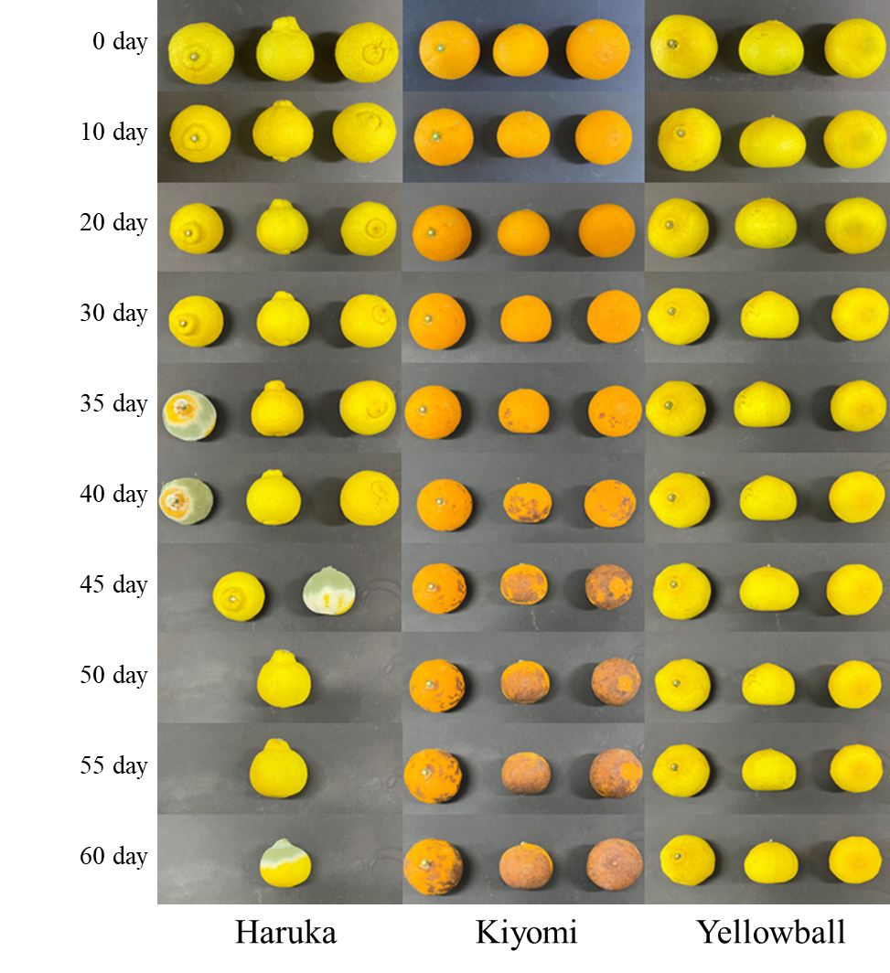
Figure S1. Appearance changes of Haruka, Kiyomi, and Yellowball during storage for 60 days at 25 °C.

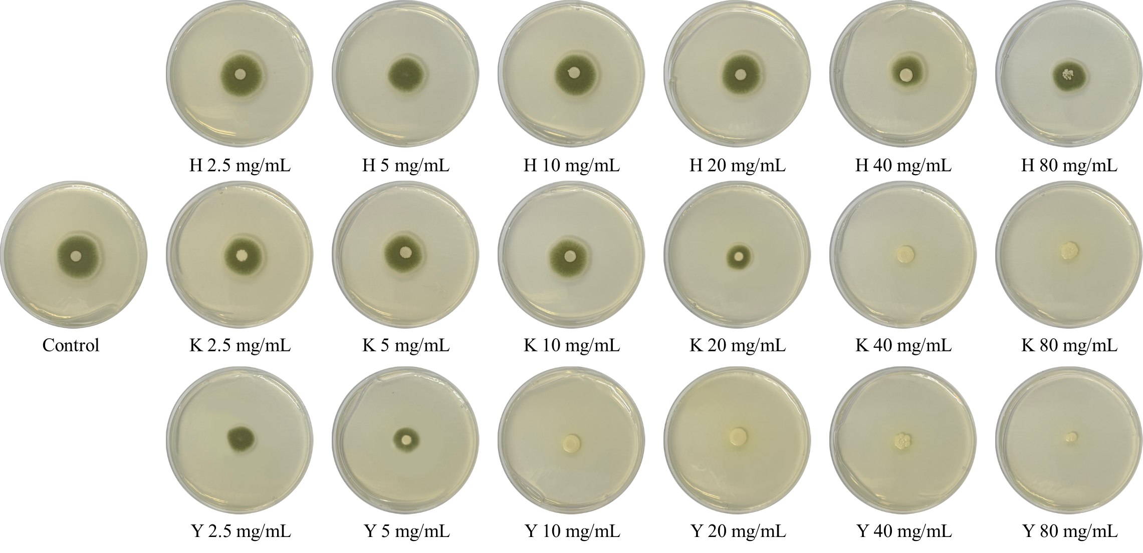
Figure S2. Growth inhibition test of peel extracts on citrus green mold (Penicillium digitatum) with different concentration (2.5‒80 mg/mL). H, haruka; K, Kiyomi; Y, Yellowball.

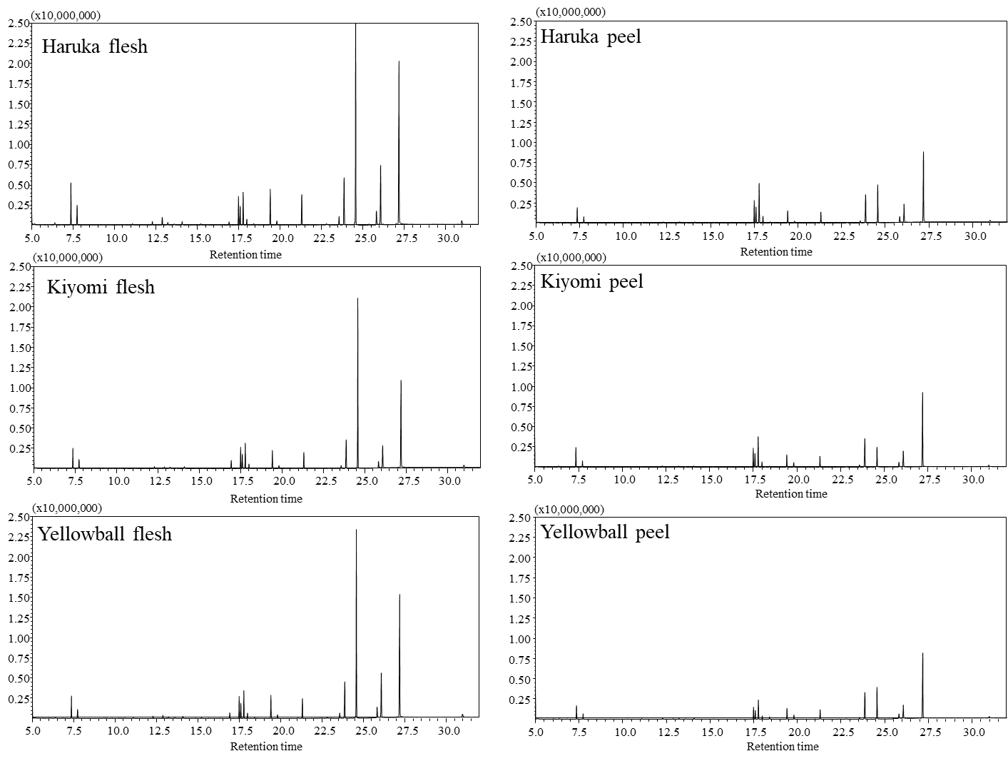
Figure S3. Representative chromatograms of citrus metabolites analyzed by GC-MS.

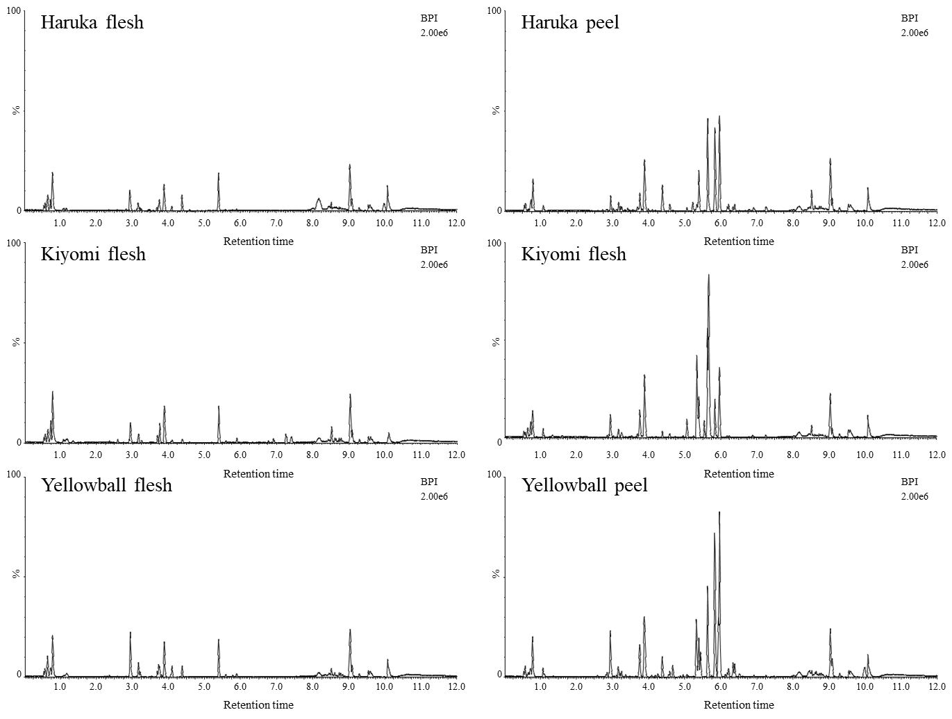
Figure S4. Representative chromatograms of citrus metabolites analyzed by UPLC-Q-TOF MS.

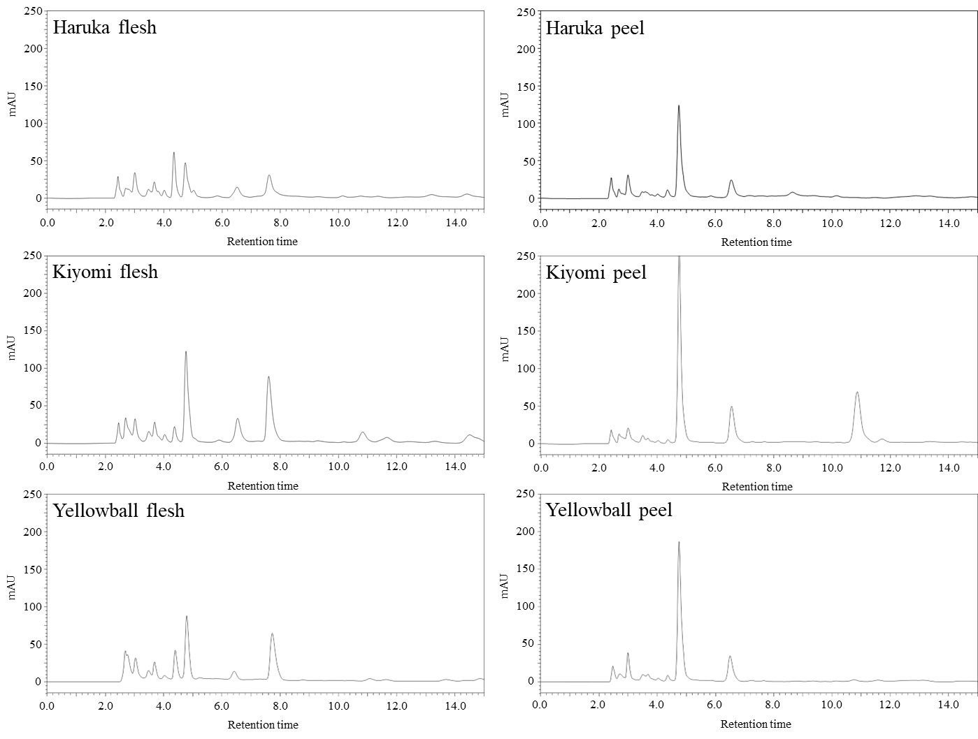
Figure S5. Representative chromatograms of organic acids analyzed by HPLC at 220 nm.

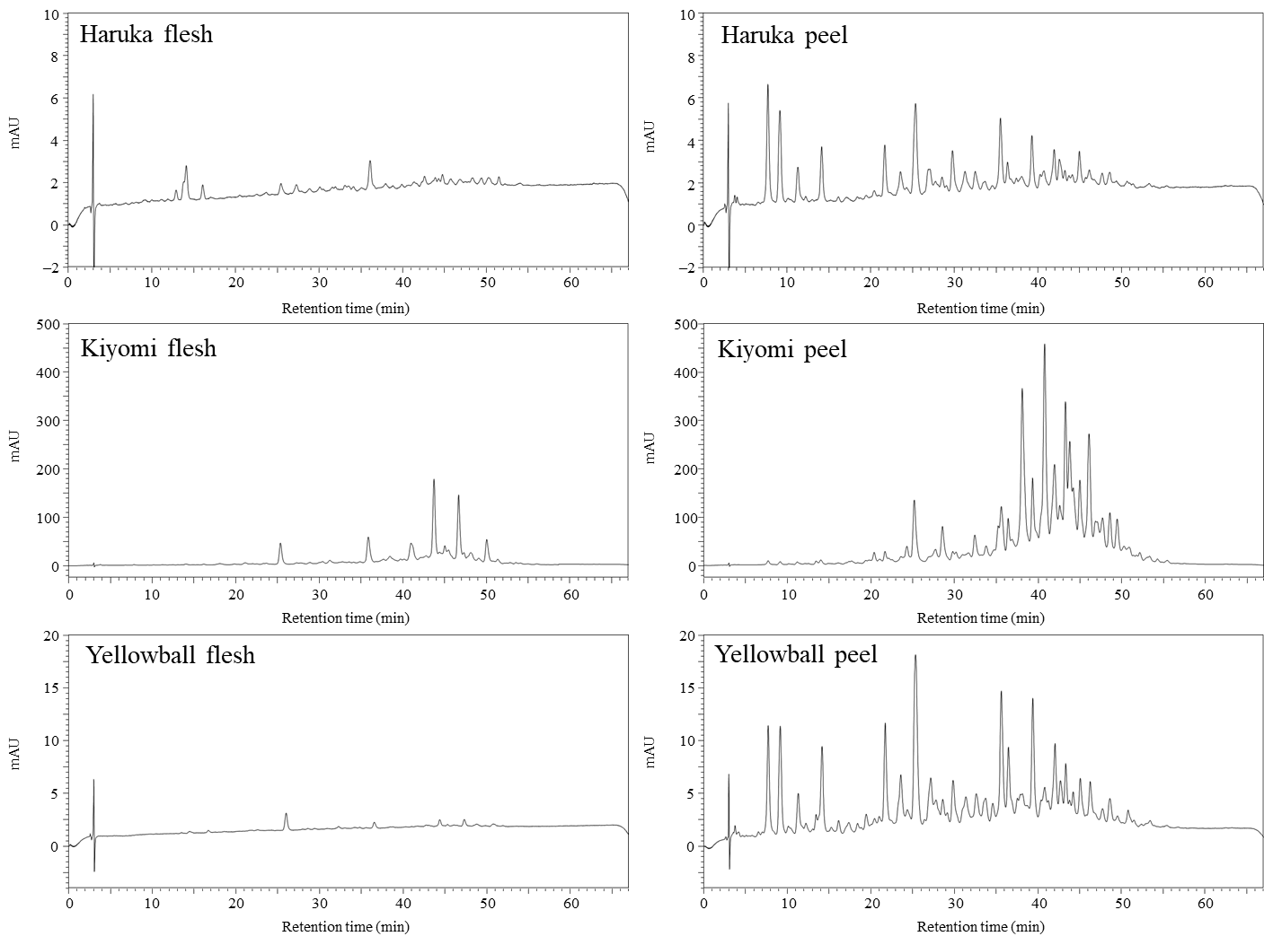
Figure S6. Representative chromatograms of carotenoids analyzed by HPLC at 450 nm.

Table S2. Identification of major metabolite by GC-MS.
RT | Compounds | RI | VIP | p-value
6.34 | glycine | 1051 | 1.21 | 2.45 × 10^{‒2}
10.22 | proline | 1293 | 0.94 | 1.54 × 10^{‒6}
13.48 | 4-aminobutanoic acid | 1525 | 1.32 | 1.10 × 10^{‒10}
15.21 | aspartic acid | 1663 | 1.04 | 1.29 × 10^{‒8}
17.34 | quinic acid | 1846 | 1.24 | 7.17 × 10^{‒20}
17.49 | fructose | 1860 | 1.16 | 3.90 × 10^{‒5}
17.77 | glucose | 1885 | 1.35 | 7.10 × 10^{‒7}
18.14 | methyl galactoside | 1920 | 1.06 | 2.17 × 10^{‒19}
19.41 | palmitic acid | 2022 | 0.81 | 2.32 × 10^{‒10}
19.80 | myo-inositol | 2042 | 1.25 | 8.03 × 10^{‒13}
21.30 | stearic acid | 2240 | 0.84 | 6.09 × 10^{‒12}
24.51 | oleic acid | 2615 | 1.31 | 1.09 × 10^{‒14}
24.57 | sucrose | 2622 | 1.21 | 8.29 × 10^{‒30}
RT, retention time; RI, retention indices; VIP, variable importance in the projection.
p-Values were analyzed by Duncan’s test.

Table S3. Identification of major metabolite by UPLC-Q-TOF MS.
RT | Compounds | Exact mass  (M+H) | MS fragment | VIP | p-value
0.64 | arginine | 175.1181 | 70, 158, 116 | 1.27 | 6.60 × 10^{‒28}
0.78 | stachydrine | 144.1010 | 116, 184, 70, 102, 58 | 1.15 | 6.02 × 10^{‒15}
2.59 | phenylalanine | 166.0847 | 120, 103 | 1.39 | 2.22 × 10^{‒14}
2.90 | tryptophan | 205.0959 | 188, 188, 144, 170 | 1.19 | 3.98 × 10^{‒22}
2.93 | feruloyl putrescine | 265.1533 | 177, 145 | 1.81 | 2.19 × 10^{‒23}
3.03 | luteolin-3'-7'-diglucoside | 611.1608 | 163, 593, 575, 325 | 0.90 | 1.41 × 10^{‒8}
3.16 | saponarin | 595.1664 | 577, 475 | 1.33 | 1.91 × 10^{‒4}
3.21 | apigenin-7-rutinoside-4’-glucoside | 741.2250 | 595, 433, 271, 377, 653 | 0.96 | 3.15 × 10^{‒4}
3.48 | apioside | 565.1550 | 433, 415, 313, 521 | 1.31 | 2.36 × 10^{‒2}
3.68 | zapoterin | 471.2016 | 425, 95 | 1.19 | 1.55 × 10^{‒6}
3.72 | apigenin-7-rutinoside | 579.1719 | 271, 433, 519 | 1.77 | 7.64 × 10^{‒15}
3.75 | narirutin | 581.1875 | 273, 419, 119 | 0.96 | 1.19 × 10^{‒15}
3.88 | hesperidin | 611.1973 | 303, 449, 177 | 0.93 | 4.86 × 10^{‒18}
4.09 | xylogranatin K | 515.2287 | 496, 409 | 1.50 | 5.87 × 10^{‒10}
4.37 | didymin | 595.2021 | 287, 433, 559 | 1.19 | 3.53 × 10^{‒12}
4.58 | cyclonatsudamine A | 728.3989 | 615, 587, 502, 474 | 0.95 | 2.81 × 10^{‒7}
4.67 | natsudaidain derivatives  (natsudaidain 3-(4-O-3-hydroxy-3-methylglutaroylglucoside)) | 725.2313 | 419 | 1.05 | 2.97 × 10^{‒13}
4.73 | monohydroxy tetramethoxyflavone | 359.1125 | 184 | 0.88 | 5.36 × 10^{‒8}
5.06 | isosinensetin | 373.1276 | 343, 358 | 1.08 | 4.13 × 10^{‒28}
5.33 | sinensetin | 373.1269 | 343, 358 | 1.09 | 4.13 × 10^{‒25}
5.63 | nobiletin | 403.1379 | 373, 355 | 0.94 | 1.04 × 10^{‒25}
5.66 | tetramethoxyflavone | 343.1163 | 313, 282, 299, 281 | 1.08 | 9.13 × 10^{‒23}
5.83 | heptamethoxyflavone | 433.1489 | 403, 385, 418 | 0.97 | 4.90 × 10^{‒34}
5.88 | monohydroxy tetramethoxyflavone | 359.1123 | 184, 326 | 1.03 | 6.07 × 10^{‒16}
5.89 | phytosphingosine | 318.3003 | 184, 282 | 1.12 | 5.03 × 10^{‒16}
5.93 | natsudaidain | 419.1335 | 184, 389, 371 | 1.17 | 5.29 × 10^{‒38}
5.96 | tangeretin | 373.1275 | 343, 358 | 0.92 | 1.17 × 10^{‒29}
6.17 | monohydroxy pentamethoxyflavone-1 | 389.1235 | 359 | 1.00 | 7.52 × 10^{‒9}
6.21 | heptamethoxyflavone | 403.1398 | 184, 373, 355 | 1.13 | 1.96 × 10^{‒22}
6.34 | monohydroxy pentamethoxyflavone-2 | 389.1237 | 359, 374, 356, 341 | 1.09 | 3.43 × 10^{‒29}
6.38 | 5-hydroxy-3,6,7,8,3',4'-hexamethoxyflavone | 419.1335 | 184, 389, 371 | 1.08 | 6.06 × 10^{‒26}
6.90 | LPE(C18:2) | 478.2943 | 155, 337, 98, 460 | 1.46 | 2.14 × 10^{‒10}
6.92 | LPC(C18:2) | 520.3410 | 337, 478, 104 | 1.16 | 1.39 × 10^{‒4}
7.24 | LPE(C16:0) | 454.2945 | 184, 104, 125 | 1.58 | 1.12 × 10^{‒18}
7.27 | LPC(C16:0) | 496.3406 | 184, 104, 125 | 1.49 | 2.20 × 10^{‒12}
7.39 | LPE(C18:1) | 480.3086 | 155, 337, 98, 460 | 1.40 | 4.30 × 10^{‒12}
7.41 | LPC(C18:1) | 522.3572 | 339, 341, 313, 104, 504 | 1.28 | 2.99 × 10^{‒9}
8.63 | pheophorbide A | 593.2772 | 184 | 0.89 | 2.61 × 10^{‒7}
9.98 | cholesteryl acetate | 429.3728 | 165, 205, 164, 219 | 1.23 | 6.61 × 10^{‒5}
RT, retention time; VIP, variable importance in the projection; LPE, lysophosphatidylethanolamine; LPC, lysophosphatidylcholine; p-Values were analyzed by Duncan’s test.
Table S4. Identification of major metabolite by HPLC.
 | RT | Compounds |  | λ_{max} (nm) | VIP | p-value
Organic acid | 3.1 | oxalic acid |  |  | 1.39 | 7.11 × 10^{‒7}
 | 3.5 | tartaric acid |  |  | 1.12 | 1.68 × 10^{‒21}
 | 4.4 | malic acid |  |  | 1.59 | 1.73 × 10^{‒37}
 | 4.8 | ascorbic acid |  |  | 1.04 | 2.64 × 10^{‒29}
 | 5.4 | lactic acid |  |  | 1.01 | 6.13 × 10^{‒5}
 | 5.7 | acetic acid |  |  | 1.45 | 1.68 × 10^{‒13}
 | 7.7 | maleic acid |  |  | 1.01 | 3.94 × 10^{‒25}
 | 7.8 | citric acid |  |  | 1.30 | 5.90 × 10^{‒39}
 | 8.8 | succinic acid |  |  | 1.35 | 1.22 × 10^{‒19}
Carotenoids | 9.1 | violaxanthin |  | 421, 448 | 0.77 | 2.05 × 10^{‒7}
 | 11.2 | neoxanthin |  | 436, 464 | 0.70 | 2.35 × 10^{‒7}
 | 13.4 | lutein |  | 400, 422 | 0.92 | 8.33 × 10^{‒8}
 | 14.1 | zeaxanthin |  | 422 | 0.84 | 7.98 × 10^{‒5}
 | 25.3 | β-cryptoxanthin |  | 451, 477 | 1.09 | 4.83 × 10^{‒8}
 | 35.6 | α-carotene |  | 446, 474 | 0.87 | 4.38 × 10^{‒5}
 | 38.1 | β-carotene |  | 436, 464 | 1.00 | 3.98 × 10^{‒14}
 | 39.3 | 9-cis-β-carotene |  | 439, 469 | 0.84 | 1.79 × 10^{‒4}
RT, retention time; VIP, variable importance in the projection.
p-Values were analyzed by Duncan’s test.

