Article
Adipose tissue denervation blunted the decrease in bone formation promoted by obesity in rats
Milene Subtil Ormanji¹, Maria Victória Lazarini Melo¹, Renata Meca¹, Michelle Louvaes Garcia², Ana Carolina Anauate¹, Juan José Augusto Moyano Muñoz¹, Lila Missae Oyama², Erika Emy Nishi², Cassia T. Bergamaschi², Aluizio Barbosa Carvalho¹, Ita Pfeferman Heilberg^{1*}
¹ Nephrology Division, Universidade Federal de São Paulo, 04023-062, São Paulo, Brazil milene.ormanji@gmail.com (M.S.O.); mavi.lazarini@hotmail.com (M.V.L.M.) rmeca28@gmail.com (R.M.); anauatte@gmail.com (A.C.A.); juanjomoy@gmail.com (J.J.A.M.M.); aluizio@uol.com.br (A.B.C.)
² Department of Physiology, Universidade Federal de São Paulo, 04023-062, São Paulo, Brazil michelle.louvaes@gmail.com (M.L.G.); lmoyama@unifesp.br (L.M.O.); enishi@unifesp.br (E.E.N.); bergamaschi.cassia@unifesp.br (C.T.B.)
* Correspondence: ita.heilberg@gmail.com (I.P.H.); Tel.: +55(11) 5576-4848 (ext 2465)
SUPPLEMENTARY FIGURES
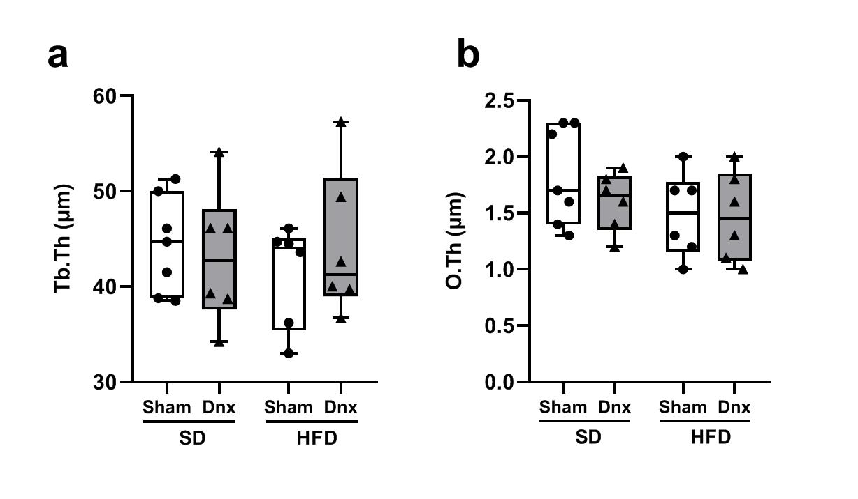
Figure S1. Static histomorphometric parameters in Sham or denervated (Dnx) groups under standard diet (SD) or high fat diet (HFD). (a) trabecular thickness – Tb.Th, (b) osteoid thickness – O.Th. Open bars (Sham groups) and closed bars (Dnx) represent median and interquartile range. Statistical analyses were performed by two-way ANOVA with Bonferroni post-hoc test. P<0.05 was considered statistically significant.
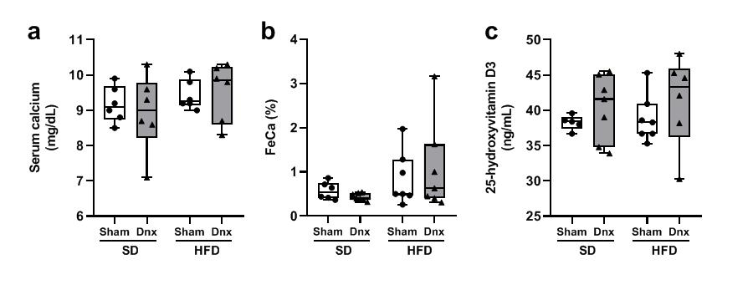
Figure S2. HFD did not alter calcium metabolism. Biochemical parameters evaluated at the end of protocol did not differ among groups: (a) serum calcium; (b) urinary fractional excretion of calcium – FeCa (%); (c) serum 25-hydroxyvitamin D₃. Bars represent median and interquartile range. Statistical analyses were performed by two-way ANOVA with Bonferroni post-hoc test. P<0.05 was considered statistically significant.
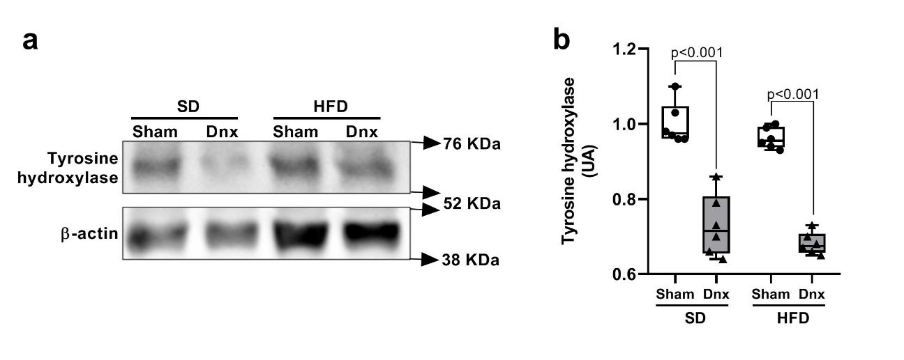
Figure S3. Denervation surgery confirmation. Denervation of retroperitoneal white adipose tissue (rWAT) was confirmed by western blot quantification of tyrosine hydroxylase protein, which was significantly lower in SD+Dnx and HFD+Dnx groups when compared to non-denervated groups (Sham SD and HFD). (a) representative western blots of relative protein levels and (b) relative quantification of tyrosine hydroxylase protein. Bars represent median and interquartile range. Statistical analyses were performed by two-way ANOVA with Bonferroni post-hoc test. P<0.05 was considered statistically significant.
SUPPLEMENTARY TABLES
Table S1. Composition of the diets used in the study.
Ingredients (g/kg of diet) | SD | HFD
Cornstarch | 720.7 | 248.7
Sucrose | - | 100.0
Casein | 140.0 | 200.0
Soybean oil | 40.0 | 40.0
Cellulose | 50.0 | 50.0
Lard | - | 312.0
AIN-93M Vitamin mixture | 10.0 | 10.0
AIN-93M Mineral mixture | 35.0 | 35.0
L-cystine | 1.8 | 1.8
Choline bitartrate | 2.5 | 2.5
Butyl hydroquinone | 0.008 | 0.008
SD: standard diet; HFD: high-fat diet
Table S2. List of antibodies used for Western Blot.
Protein/Epitope | Source and Catalog number | Host | Application | Dilution | Application specific details
Tyrosine hydroxylase | Cell Signaling, 2792S | rabbit | Western Blot | 1:1000 | 5% BSA, overnight, 4°C
Anti-rabbit IgG | Abcam, ab97051 | goat | Western Blot | 1:50000 | 5% BSA, 1hr RT
Table S3. Primer sequences used for qPCR.
Gene | Forward sequence | Reverse sequence
NPY | 5’ CAGATACTACTCCGCTCTGC 3’ | 5’ AAGGGTCTTCAAGCCTTGTT 3’
Gapdh | 5’ CAACTCCCTCAAGATTGTCAGCAA 3’ | 5’ GGCATGGACTGTGGTCATGA 3’

