A B
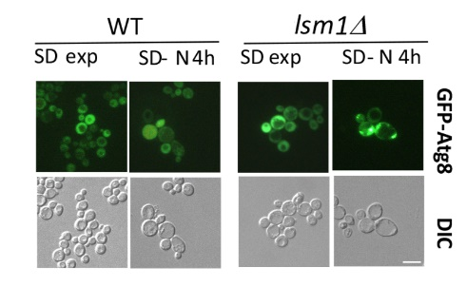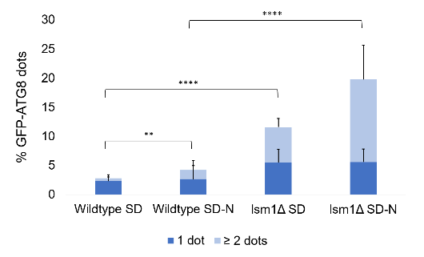
C D
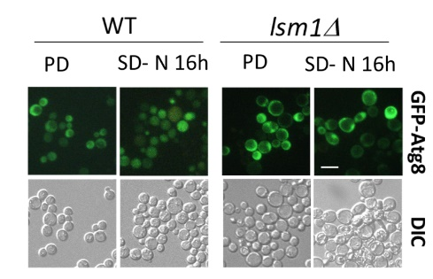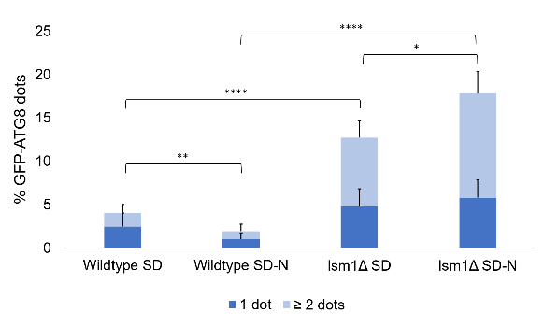
E F
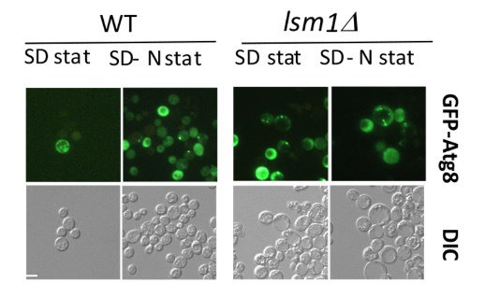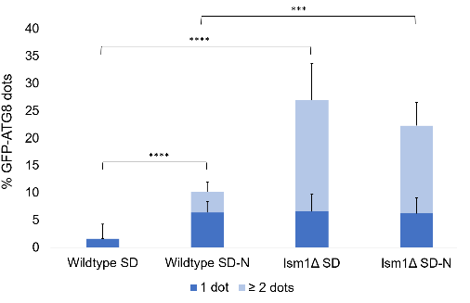

Figure S1. Lsm1Δ mutant shows defects in autophagy-related structures transport to the vacuole, as indicated by a higher percentage of GFP-ATG8 dots in the cytoplasm during nitrogen starvation and CLS. Wild type BMA38 and mutant lsm1Δ cells expressing the fusion protein GFP-ATG8 were observed at the fluorescence microscope during exponential phase in both SD and SD-N medium for 4h (A), during post diauxic phase (PD) and in SD-N for 16h (C) and after 3 days of growth in SD (SD stat) or SD-N (SD-N stat) (E). GFP-Atg8 dots per cell were quantified from three biological replicates (n ≥ 300 cells), and the mean of cells containing one or ≥2 dots was plotted in (B), (D) and (F). Error bars represent standard deviation. *p-value<0.05 **p-value<0.01 ***p-value<0.001 ****p-value<0.0001

