Supplemental Materials
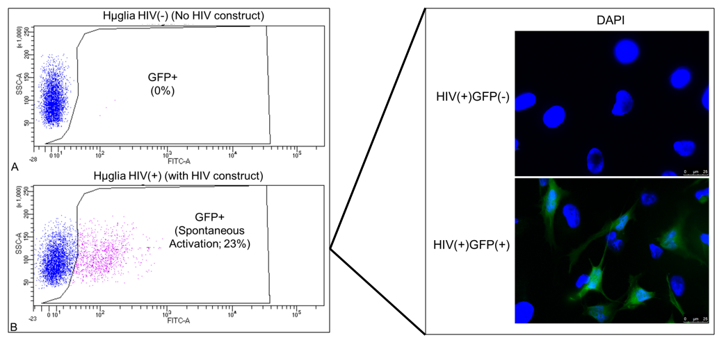

Supplemental Figure 1. FACS analysis of HIV+ hμglia cell populations. Scatter plot (top left panel) shows no GFP expression in uninfected hμglia; the bottom left panel shows HIV+ (infected) C20 hμglia sorted into GFP-negative (blue dots) and GFP+ (pink dots). X-axis shows mean fluorescence intensity of fluorescein isothiocyanate (FITC)-A signal within HIV+ hμglia; Y-axis shows signal gated according to side-scatter-area (SS-A). GFP+ and GFP-negative cell populations were sorted and separated for use in later experiments Green fluorescence in these populations is shown in the top right panel (HIV+ hμglia containing latent HIV provirus have blue nuclei stained with DAPI and are GFP-negative) and bottom right (activated HIV+/GFP+ hμglia with ongoing HIV transcription show green fluorescence).

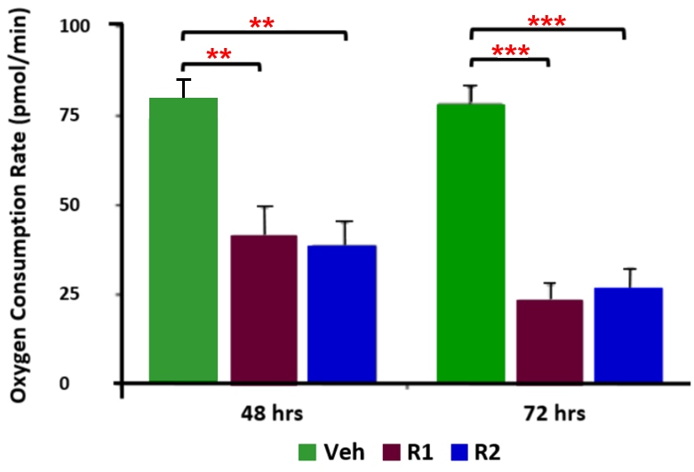

Supplemental Figure 2. Effects of antiretroviral Regimen1 (R1) and 2 (R2) on the basal oxygen consumption rate (OCR) in SH-SY5Y cells at 48 and 72 hours. Both R1 and R2 significantly reduce the basal OCR at 72 hours compared to vehicle-treated (Veh) controls. Results summarizing at least 3 separate experiments are shown. **p<0.01; ***p<0.001 (Mann-Whitney U test)

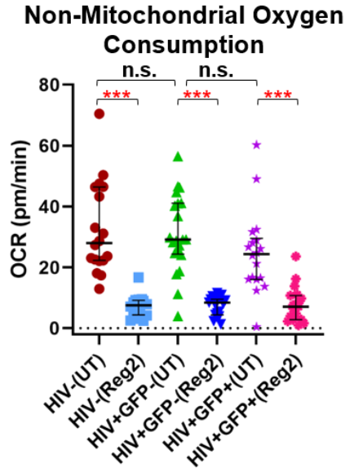

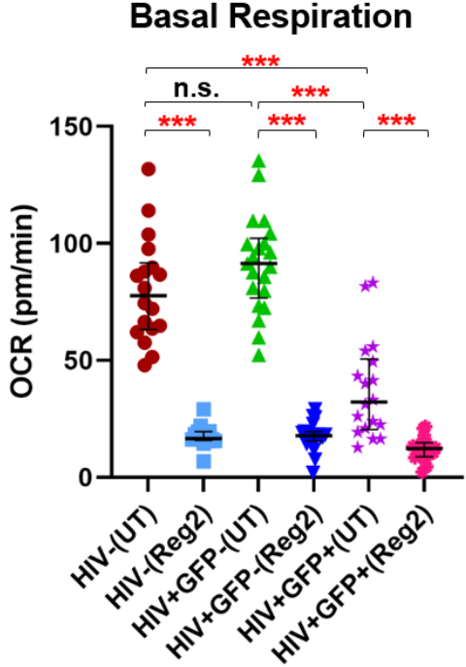
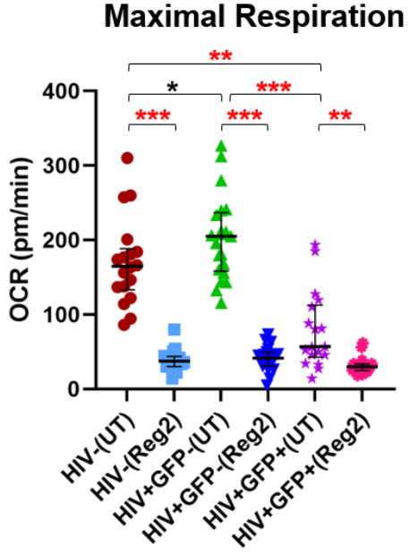

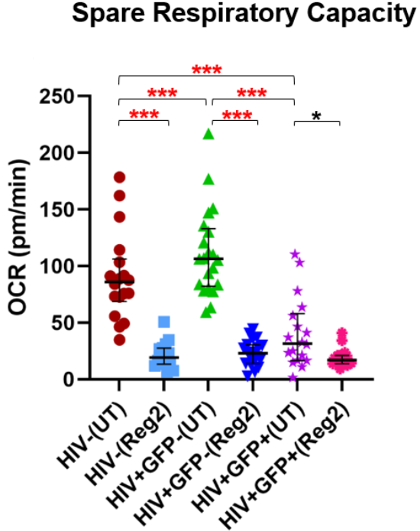
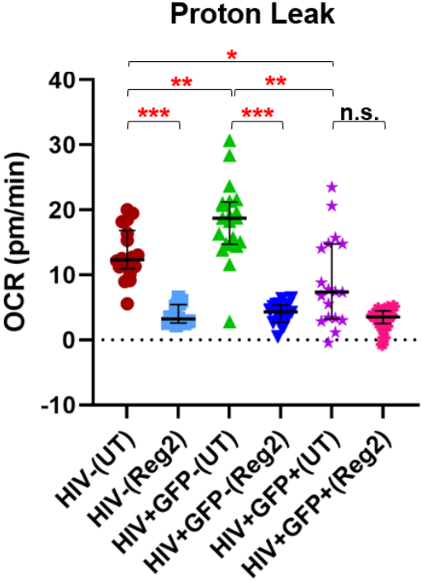
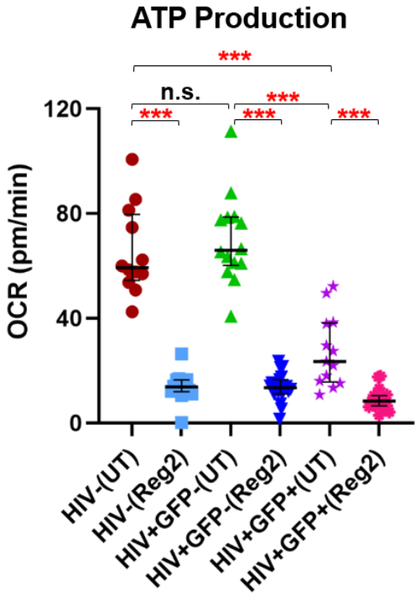

Supplemental Figure 3. Differences in mitochondrial energy expenditure across uninfected, latently infected HIV+, and activated HIV+ hμglia groups before and after 24 hours of treatment with antiretroviral drugs. All components of mitochondrial respiration are shown.
Abbreviations: OCR, oxygen consumption rate (pmol/min); UT, untreated (vehicle); Reg2, Regimen2
Statistical significance: n.s., p>0.10; *p-value=0.05-0.09; *p<0.05; **p<0.001; ***p<0.0001.
Basal OCR
 | N | Median (IQR)
HIV- UT | 12 | 71.6 (66.7, 91.8)
HIV- Reg2 | 16 | 16.6 (15.9, 19.4)
HIV-GFP- UT | 14 | 84.3 (77.5, 96.2)
HIV-GFP- Reg2 | 19 | 17.9 (15.6, 19.5)
HIV+GFP+ UT | 13 | 31.2 (19.4, 43.3)
HIV+GFP+ Reg2 | 19 | 12.3 (8.8, 14.8)

Maximal OCR
 | N | Median (IQR)
HIV- UT | 12 | 153.8 (133.8, 175.3)
HIV- Reg2 | 16 | 37.4 (30.3, 43.4)
HIV-GFP- UT | 14 | 184.6 (159.5, 215.9)
HIV-GFP- Reg2 | 19 | 41.6 (30.8, 49.4)
HIV+GFP+ UT | 13 | 52.5 (32.9, 80.2)
HIV+GFP+ Reg2 | 19 | 29.8 (24.7, 33.9)

Supplemental Table 1. Comparison of mitochondrial respiratory measurements in uninfected, latently infected-HIV+, activated HIV+ hμglia with and without antiretroviral Regimen2 (Reg2) exposure for 24 hours. Medians and interquartile ranges (IQR) of oxygen consumption rate (OCR) values in pmol/min (normalized to total cellular protein) are shown. p-values for comparisons between vehicle-treated (UT) controls and treated cells of each type are provided in Figures 2-4 of the main text and in Supplemental Figure 3. HIV-, uninfected; GFP-, latently infected-HIV+; GFP+, activated HIV+ cells.

ATP Production
 | N | Median (IQR)
HIV- UT | 12 | 59.2 (55.3, 77.9)
HIV- Reg2 | 16 | 13.8 (12, 16.3)
HIV-GFP- UT | 14 | 66 (60.9, 78.6)
HIV-GFP- Reg2 | 19 | 13.5 (11.1, 16.5)
HIV+GFP+ UT | 13 | 23.5 (16, 37.8)
HIV+GFP+ Reg2 | 19 | 8.3 (6.6, 10.5)

Proton Leak
 | N | Median (IQR)
HIV- UT | 12 | 11.9 (11.3, 14)
HIV- Reg2 | 16 | 3.2 (2.7, 5.3)
HIV-GFP- UT | 14 | 16.6 (15.4, 19)
HIV-GFP- Reg2 | 19 | 4.3 (2.7, 5.4)
HIV+GFP+ UT | 13 | 4.2 (2.9, 9.9)
HIV+GFP+ Reg2 | 19 | 3.5 (2.5, 4.5)

Non-Mitochondrial OCR
 | N | Median (IQR)
HIV- UT | 12 | 30.8 (22.5, 47.0)
HIV- Reg2 | 16 | 7.5 (4.6, 9.1)
HIV-GFP- UT | 14 | 36.0 (25.2, 38.4)
HIV-GFP- Reg2 | 19 | 8.4 (4.4, 9.5)
HIV+GFP+ UT | 13 | 26.7 (20.8, 32.4)
HIV+GFP+ Reg2 | 19 | 7.1 (2.8, 10.8)

Spare Respiratory Capacity
 | N | Median (IQR)
HIV- UT | 12 | 79.2 (67.0, 94.6)
HIV- Reg2 | 16 | 19.3 (13.6, 27.2)
HIV-GFP- UT | 14 | 100.8 (81.7, 120.6)
HIV-GFP- Reg2 | 19 | 23.0 (14.1, 30.5)
HIV+GFP+ UT | 13 | 25.0 (16.6, 36.9)
HIV+GFP+ Reg2 | 19 | 17.0 (13.9, 21.1)

Supplemental Figure 4. Mitochondrial bioenergetics measurements at 48 hours following Regimen2 exposure in uninfected hμglia. (a) MitoStress curve (blue=vehicle-treated controls (UT); red=drug-treated cells); (b) non-mitochondrial OCR; (c) basal respiration; (d) maximal respiration; (e) proton leak; (f) ATP production; (g) spare respiratory capacity. Median and interquartile ranges of OCR values obtained from at least six technical replicates and three separate experiments are shown. (p-values obtained by Mann-Whitney U test)

b
a

d e f g

c
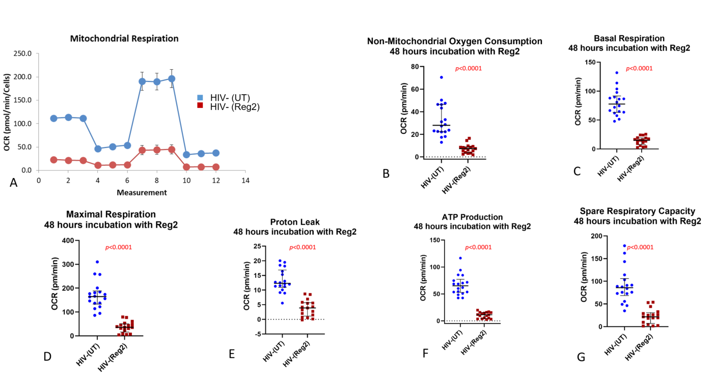
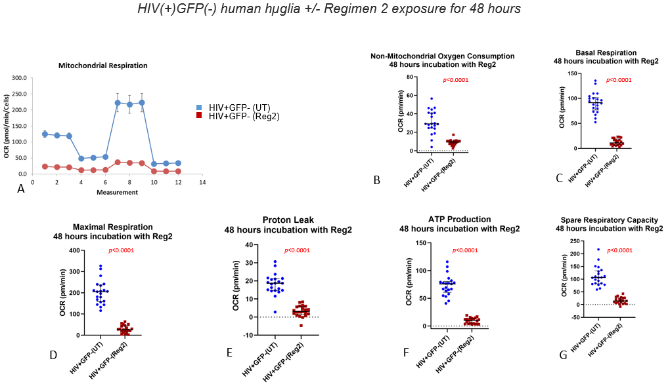

c

b
a

d
e
f
g

Supplemental Figure 5. Antiretroviral Regimen2 (Reg2) reduces multiple components of mitochondrial respiratory function in latently infected-HIV+ hµglia at 48 hours. (a) MitoStress curve (blue=vehicle-treated controls (UT); red=drug-treated cells); (b) non-mitochondrial OCR; (c) basal respiration; (d) maximal respiration; (e) proton leak; (F) ATP production; (g) Spare respiratory capacity. Median and interquartile ranges of OCR values obtained from at least three separate experiments, each with six technical replicates, are shown. (p-values obtained by Mann-Whitney U test)
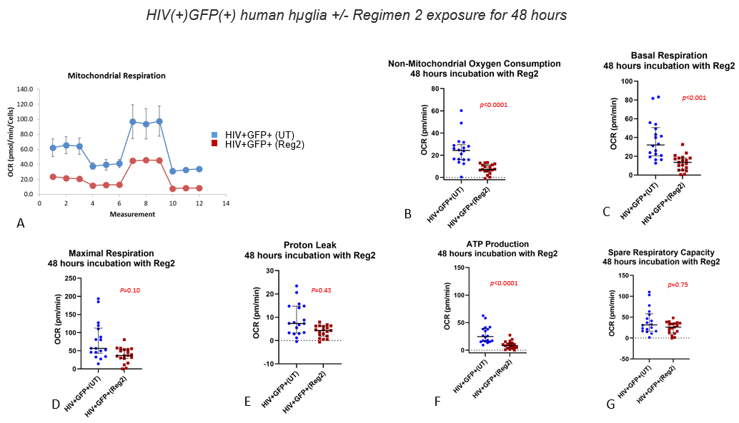

c

b
a

g
f
d
e
d

Supplemental Figure 6. Antiretroviral Regimen2 (Reg2) reduces several components of mitochondrial respiratory function in activated HIV+ hµglia at 48 hours. (a), MitoStress curve (blue=vehicle-treated controls (UT); red=drug-treated cells); (b), non-mitochondrial OCR; (c) basal respiration; (d), maximal respiration; (e) proton leak; (f) ATP production; (g) spare respiratory capacity. Median and interquartile ranges of OCR values are shown. (p-values obtained by Mann-Whitney U test)

c
b
a
f
d e
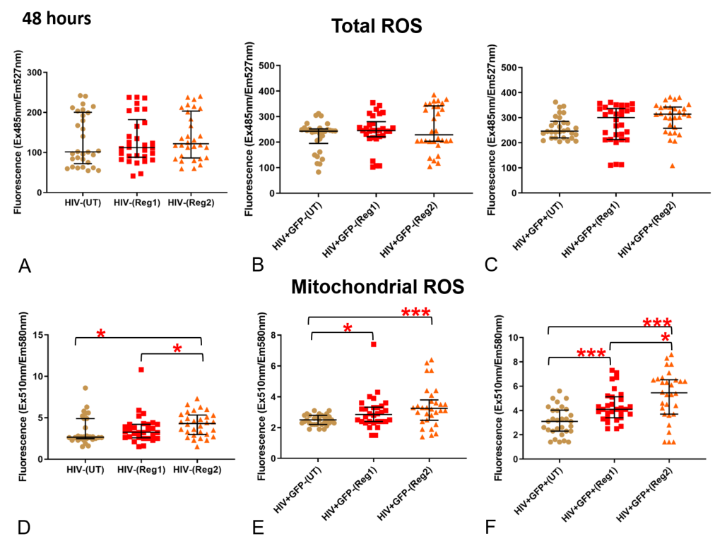
Supplemental Figure 7. Effects of Regimen1 (Reg1) and Regimen2 (Reg2) after 48 hours on (a-c) total cellular reactive oxygen species (ROS) production and (d-f) mitochondrial ROS production in: (a, d) uninfected, (b, e) latently infected HIV+, and (c, f) activated HIV+ hμglia. *p<0.05; **p<0.005; ***p<0.0001
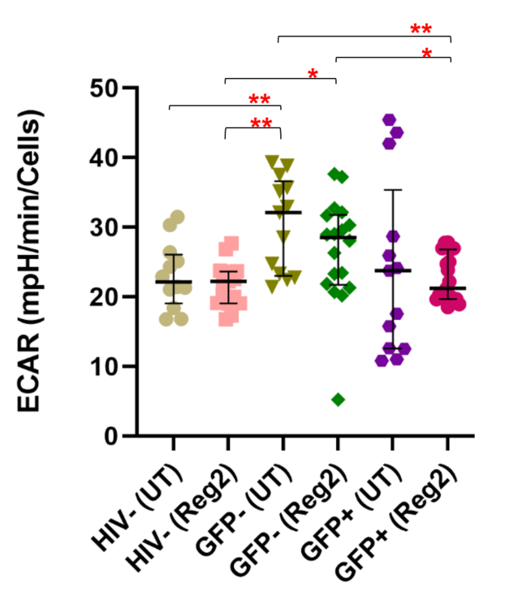
Supplemental Figure 8. Extracellular acidification (glycolytic) rate (ECAR) measurements in uninfected, latently infected-HIV+(GFP-), and activated HIV+(GFP+) hμglia after a 24-hour incubation with Regimen2 (Reg2). Comparisons are made to untreated (vehicle) controls (UT), and only statistically significant differences are shown. *p<0.05; **p<0.005 (Mann-Whitney U test)

(a) HIV-neg, UT: rho=0.224 (p=0.485)
(b) HIV+/GFP-, UT: rho=-0.117 (p=0.692)

(c) HIV+/GFP+, UT: rho=0.412 (p=0.162)

(d) HIV-neg, Reg2: rho=0.702 (p=0.002)

(f) HIV+/GFP+, Reg2: rho=0.488 (p=0.034)
(e) HIV+/GFP-, Reg2: rho=0.854 (p<0.0001)

Supplemental Figure 9. Correlations between basal OCR (plotted on the Y-axis) and ECAR measurements in uninfected (HIV-neg), latently infected HIV+ (HIV+/GFP-), and activated HIV+ (HIV+/GFP+) hμglia following Regimen2 exposure for 24 hours: (a-c) untreated cells; (d-f) Regimen2-treated cells after 24 hours. Spearman’s correlation p-values <0.05 are considered statistically significant (bolded).
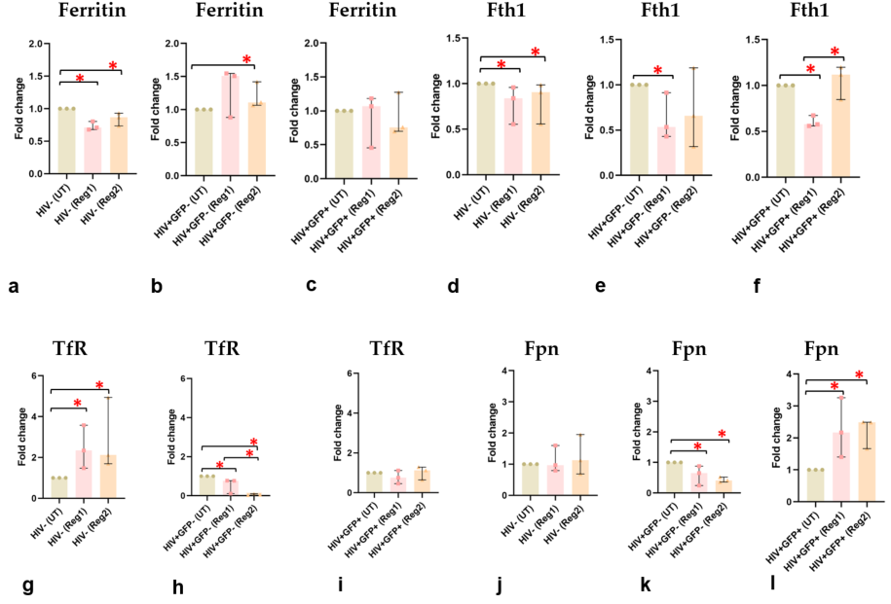

asdf

Supplemental Figure 10. Quantification of (a-c) total ferritin, (d-f) Fth1, (g-i) TfR, and (j-l) Fpn in uninfected, latently infected-HIV+ and activated HIV+ huglia at 48 hours after Regimen2 (Reg2) exposure. UT, untreated (vehicle-treated) controls; *p<0.05 (Mann-Whitney U test)

Cell type | Reg1 |  | Reg2 |  | Reg1 Iron phenotype | Reg2 Iron phenotype
 | 24 hrs | 48 hrs | 24 hrs | 48 hrs
HIV-negative  Ferritin | NC | DOWN* | NC | DOWN* | Iron import | Iron import
Fth1 | NC | DOWN* | NC | DOWN* | Iron import | Iron import
TfR | UP* | UP* | UP* | UP* | Iron import | Iron import
Fpn | NC | NC | UP* | NC | None | Iron export
Iron | UP* | N/A | UP* | N/A | Iron replete/excess | Iron replete/excess
Latent HIV+  Ferritin | UP* | NC | NC | DOWN* | Iron export | Iron import
Fth1 | NC | DOWN* | NC | NC | Iron import | None
TfR | NC | DOWN* | NC | DOWN* | Iron export | Iron export
Fpn | NC | DOWN* | NC | DOWN* | Iron import | Iron import
Iron | UP* | N/A | UP* | N/A | Iron replete/excess | Iron replete/excess
Activated HIV+  Ferritin | DOWN* | NC | DOWN* | NC | Iron import | Iron import
Fth1 | NC | DOWN* | NC | UP* | Iron import | Iron export
TfR | NC | NC | NC | NC | None | None
Fpn | NC | UP* | NC | UP* | Iron export | Iron export
Iron | UP* | N/A | DOWN* | N/A | Iron replete/excess | Reduced/Low iron
SH-SY5Y cells | BIC  24 hrs | Reg2  24 hrs |  |  | Comments
Ferritin | N/A | N/A |  |  | None
Fth1 | DOWN* | DOWN* |  |  | Iron import
TfR | UP* | N/A |  |  | Iron import
Iron | N/A | UP* |  |  | Iron replete/excess

Supplemental Table 2. Summary of changes in cellular iron phenotype of hμglia and SH-SY5Y cells after exposure to ARV Regimens 1 or 2, indicating altered iron homeostasis and dysregulated iron transport protein expression, due to both ARVs and HIV in hμglia, and ARVs in the neural cells. *Statistically significant with p-value<0.05; Reg1/2, Regimen 1/2; NC, no change; N/A, not assessed. TfR changes were used to anchor assessment of iron import vs. export.
Supplemental Figure 11. N-acetylcysteine (NAC), a cytosolic ROS scavenger, but not the mitochondrial ROS scavenger MitoTEMPO (MT) rescues the mitochondrial defect due to ARV Regimen2 (Reg2) in SH-SY5Y cells at 24 hours. **p=0.007




