Supplementary material

Biogeographic provinces shape the evolution of the treehopper helmet and the genetic variation of Membracis mexicana.

De la Mora-Curiel M. ¹ and D. Piñero²

Tables and figures included:

Table SM1 Landmark definition.
Table SM2 Variation of genetic markers.
Table SM3 Number and frequency of haplotypes.
Figure SM1 Landmark position.
Figure SM2 Centroid size of helmet by host plant.
Figure SM3 PCA colored by population.
Figure SM4 PCA colored by host plant.
Figure SM5 CVA using host plant as classifier variable.
Figure SM6 Mitochondrial COI gene haplotype network.
Figure SM7 Nuclear WG gene haplotype network.
Figure SM8 Nuclear 28S gene haplotype network.
Figure SM9 Nuclear H2A gene haplotype network.
Figure SM10 Nuclear H3 gene haplotype network.
Figure SM11 Geographic distribution and frequency of COI haplotypes.
Figure SM12 Geographic distribution and frequency of WG haplotypes.
Figure SM13 Geographic distribution and frequency of 28S haplotypes.
Figure SM14 Geographic distribution and frequency of H2A haplotypes.
Figure SM15 Geographic distribution and frequency of H3 haplotypes.
Figure SM16 Bayesian phylogeny using COI.
Figure SM17 Bayesian phylogeny using WG.
Figure SM18 Bayesian phylogeny using 28S gene segment.
Figure SM19 Bayesian phylogeny using H2A gene segment.
Figure SM20 Bayesian phylogeny using H3 gene segment.
Figure SM21 Skyline plot using mitochondrial (A) and nuclear markers (B).

Table SM1 Landmark definition of Membracis mexicana in Mexico.
ID | Landmark definition
1 | Eye spot lower right margin
2 | Eye spot lower left margin
3 | Helment base frontal top
4 | Anterior edge of the frontal spot
5 | Posterior edge of the frontal spot
6 | Anterior edge of the dorsal spot
7 | Posterior edge of the dorsal spot
8 | Anterior-dorsal edge of the caudal girdle
9 | Posterior-dorsal edge of the caudal girdle
10 | Anterior-dorsal edge of the ending spot
11 | Tip of the ending spot
12 | Anterior-ventral edge of the ending spot
13 | Posterior-ventral edge of the caudal girdle
14 | Anterior-ventral edge of the caudal girdle
15 | Base of the side spot
16 | Upper base of the wing
17 | Bottom base of the wing
18 | Right margin of the helmet at head
19 | Left margin of the helmet at head

Table SM2 Variation of genetic markers and neutrality tests, for the total number of insects, collected of M. mexicana in Mexico. * and ** are values statistically significant.
 | 28s | H3 | H2A | Wg | COI
Polymorphic Sites
Number of sequences: | 189 | 177 | 190 | 147 | 141
Number of sites: | 660 | 300 | 279 | 275 | 369
Segregating sites (S) | 110 | 19 | 29 | 24 | 72
Number of haplotypes, h: | 28 | 22 | 33 | 30 | 54
Haplotype (gene) diversity, Hd: | 0.797 | 0.625 | 0.425 | 0.874 | 0.881
Nucleotide diversity, Pi | 0.01071 | 0.00342 | 0.00375 | 0.03121 | 0.01807
Theta (per site) from S, Theta-W: | 0.02879 | 0.01112 | 0.01785 | 0.01568 | 0.03543
Fu and Li's Tests
Fu and Li's F* test statistic: | -6.41793 | -3.86732 | -4.04503 | 2.36933 | -2.85538
Statistical significance: | **, P < 0.02 | **, P < 0.02 | **, P < 0.02 | **, P < 0.02 | *, P < 0.05
Tajima's Test
Tajima's D: | -2.18358 | -1.97102 | -2.34419 | 2.81039 | -1.72698
Statistical significance: | **, P < 0.01 | *, P < 0.05 | **, P < 0.01 | **, P < 0.01 | 0.10 > P > 0.05

Table SM3 Number and frequency of haplotypes of each gene, the most frequent are highlighted with blue color.
28s | Frecuency | H2A | Frecuency | H3 | Frecuency | Wg | Frecuency | COI | Frecuency | COI | Frecuency
1 | 1 | 1 | 144 | 1 | 1 | 1 | 1 | 1 | 10 | 34 | 1
2 | 1 | 2 | 1 | 2 | 84 | 2 | 3 | 2 | 1 | 35 | 1
3 | 1 | 3 | 1 | 3 | 1 | 3 | 13 | 3 | 1 | 36 | 1
4 | 1 | 4 | 1 | 4 | 1 | 4 | 7 | 4 | 1 | 37 | 3
5 | 1 | 5 | 1 | 5 | 1 | 5 | 5 | 5 | 1 | 38 | 1
6 | 1 | 6 | 1 | 6 | 2 | 6 | 1 | 6 | 1 | 39 | 1
7 | 1 | 7 | 1 | 7 | 1 | 7 | 9 | 7 | 1 | 40 | 1
8 | 1 | 8 | 6 | 8 | 1 | 8 | 3 | 8 | 1 | 41 | 2
9 | 1 | 9 | 1 | 9 | 1 | 9 | 3 | 9 | 2 | 42 | 1
10 | 8 | 10 | 1 | 10 | 1 | 10 | 2 | 10 | 1 | 43 | 1
11 | 22 | 11 | 1 | 11 | 1 | 11 | 6 | 11 | 1 | 44 | 46
12 | 1 | 12 | 1 | 12 | 69 | 12 | 2 | 12 | 3 | 45 | 5
13 | 54 | 13 | 1 | 13 | 1 | 13 | 10 | 13 | 1 | 46 | 2
14 | 17 | 14 | 1 | 14 | 1 | 14 | 3 | 14 | 1 | 47 | 4
15 | 1 | 15 | 2 | 15 | 1 | 15 | 2 | 15 | 1 | 48 | 1
16 | 1 | 16 | 1 | 16 | 1 | 16 | 2 | 16 | 1 | 49 | 1
17 | 1 | 17 | 1 | 17 | 1 | 17 | 6 | 17 | 1 | 50 | 1
18 | 1 | 18 | 2 | 18 | 1 | 18 | 2 | 18 | 1 | 51 | 1
19 | 60 | 19 | 1 | 19 | 2 | 19 | 1 | 19 | 1 | 52 | 1
20 | 1 | 20 | 1 | 20 | 3 | 20 | 1 | 20 | 1 | 53 | 1
21 | 1 | 21 | 1 | 21 | 1 | 21 | 1 | 21 | 1 | 54 | 2
22 | 1 | 22 | 2 | 22 | 1 | 22 | 2 | 22 | 1
23 | 3 | 23 | 1 |  |  | 23 | 1 | 23 | 1
24 | 1 | 24 | 2 |  |  | 24 | 1 | 24 | 1
25 | 1 | 25 | 1 |  |  | 25 | 1 | 25 | 1
26 | 3 | 26 | 6 |  |  | 26 | 1 | 26 | 6
27 | 2 | 27 | 1 |  |  | 27 | 47 | 27 | 1
28 | 1 | 28 | 1 |  |  | 28 | 9 | 28 | 1
 |  | 29 | 1 |  |  | 29 | 1 | 29 | 10
 |  | 30 | 1 |  |  | 30 | 1 | 30 | 1
 |  | 31 | 1 |  |  |  |  | 31 | 5
 |  | 32 | 1 |  |  |  |  | 32 | 1
 |  | 33 | 1 |  |  |  |  | 33 | 1

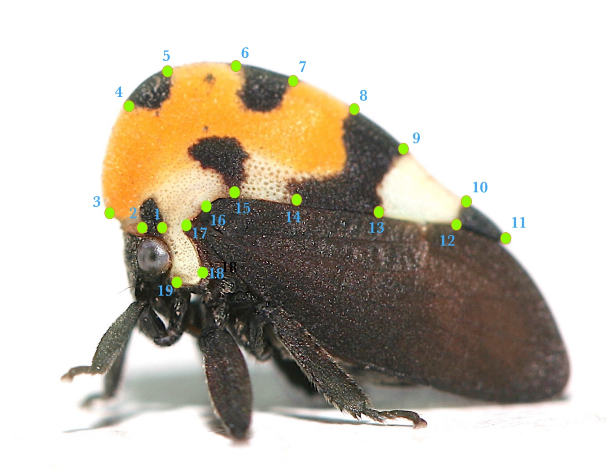
Figure SM1 Landmark position at the helmet of Membracis mexicana.

Figure SM2 Centroid size of the helmet of Membracis mexicana by host plant.
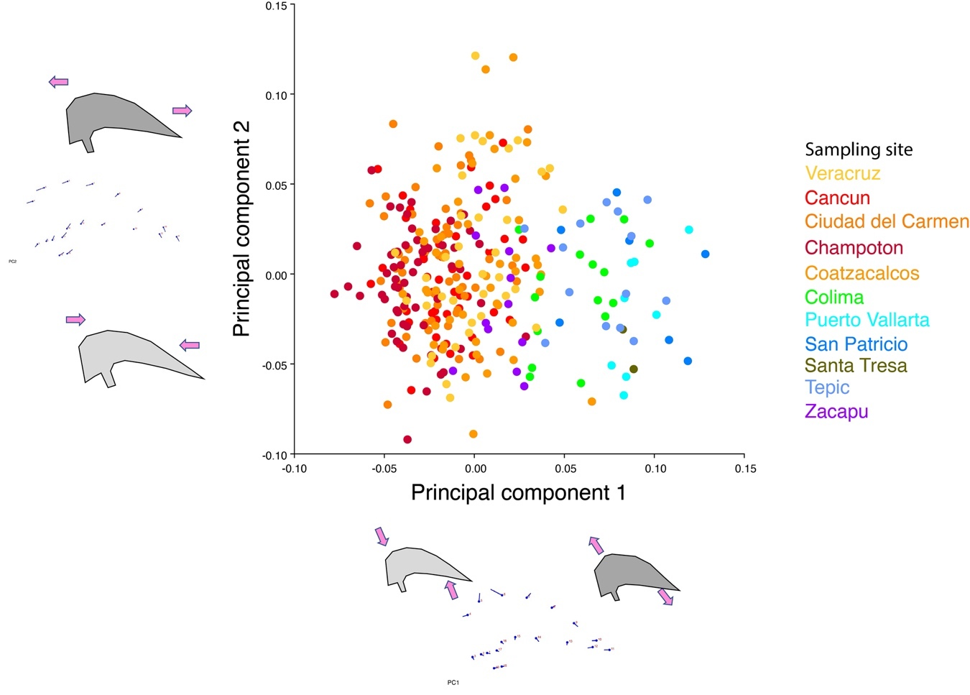
Figure SM3 PCA of Membracis mexicana colored by population.

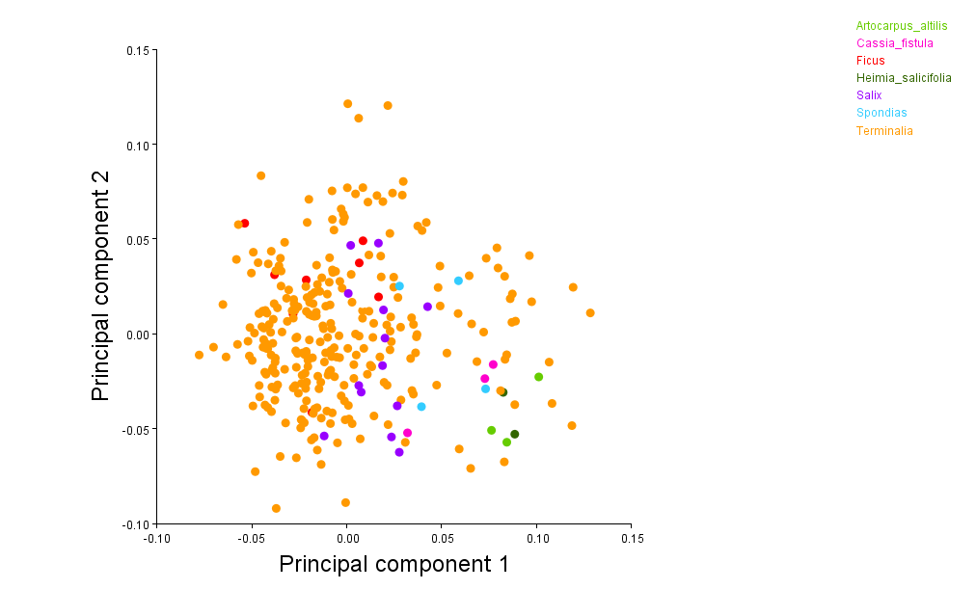
Figure SM4 PCA of Membracis mexicana colored by host plant.

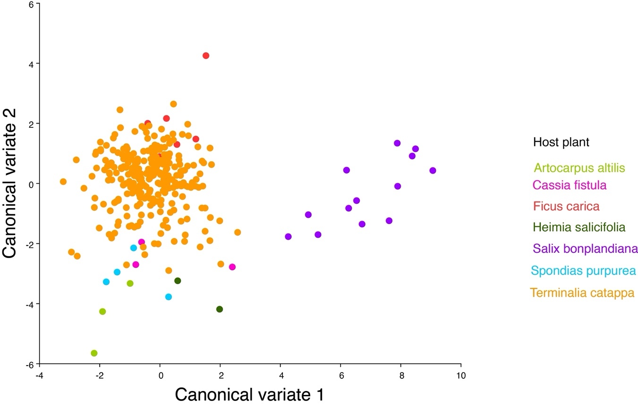
Figure SM5 CVA of Membracis mexicana using host plant as classifier variable
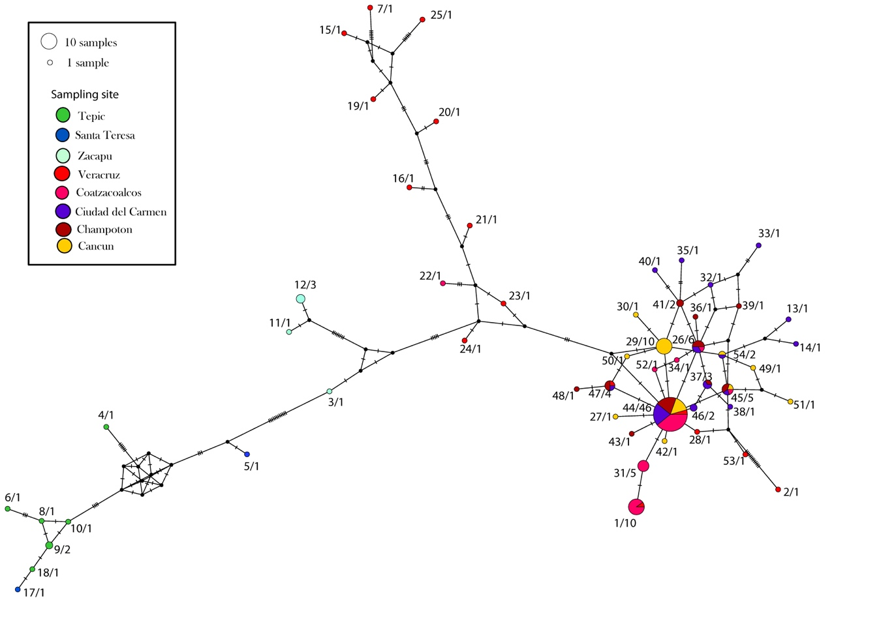
Figure SM6 Mitochondrial COI gene haplotype network of Membracis mexicana. The circle's size is the haplotype's frequency, which is colored by the population where it was sampled.
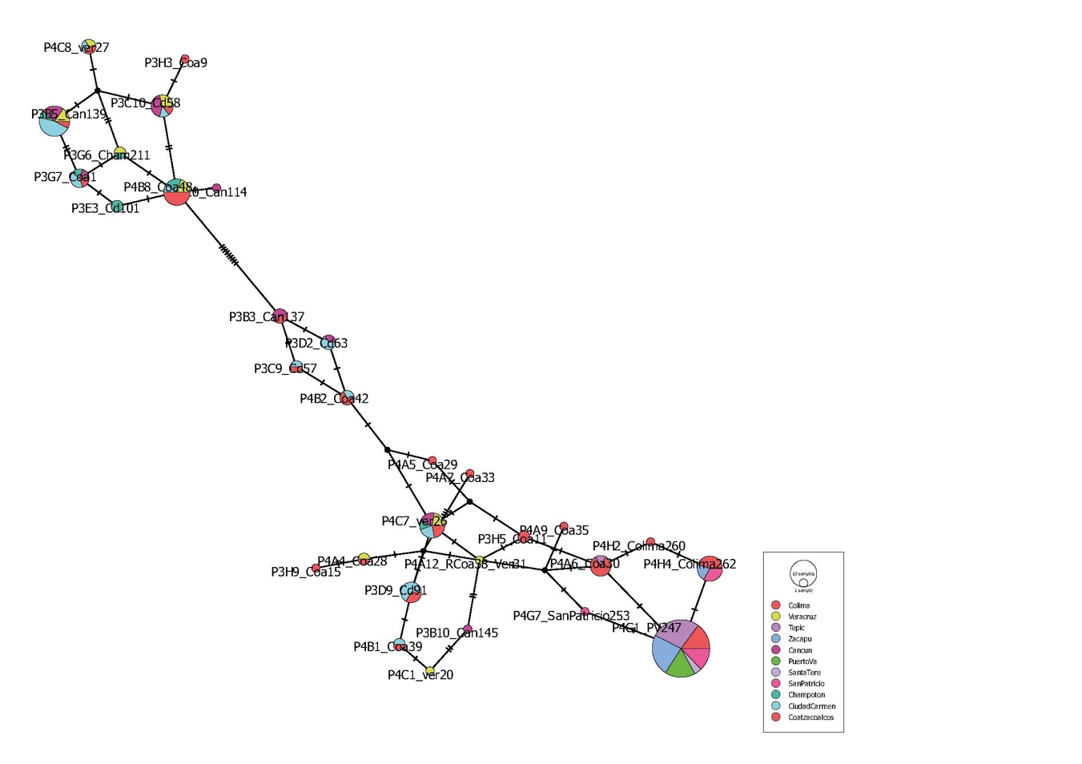
Figure SM7 Nuclear WG gene haplotype network of Membracis mexicana. The circle's size is the haplotype's frequency, which is colored by the population where it was sampled.

Figure SM8 Nuclear 28S gene haplotype network of Membracis mexicana. The circle's size is the haplotype's frequency, which is colored by the population where it was sampled.

Figure SM9 Nuclear H2A gene haplotype network of Membracis mexicana. The circle's size is the haplotype's frequency, which is colored by the population where it was sampled.

Figure SM10 Nuclear H3 gene haplotype network of Membracis mexicana. The circle's size is the haplotype's frequency, which is colored by the population where it was sampled.

Figure SM11 Geographic distribution and frequency of the haplotypes of COI gene of Membracis mexicana.

Figure SM12 Geographic distribution and frequency of the haplotypes of WG gene of Membracis mexicana.

Figure SM13 Geographic distribution and frequency of the haplotypes of 28S gene of Membracis mexicana.

Figure SM14 Geographic distribution and frequency of the haplotypes of H2A gene of Membracis mexicana.

Figure SM15 Geographic distribution and frequency of the haplotypes of H3 gene of Membracis mexicana.
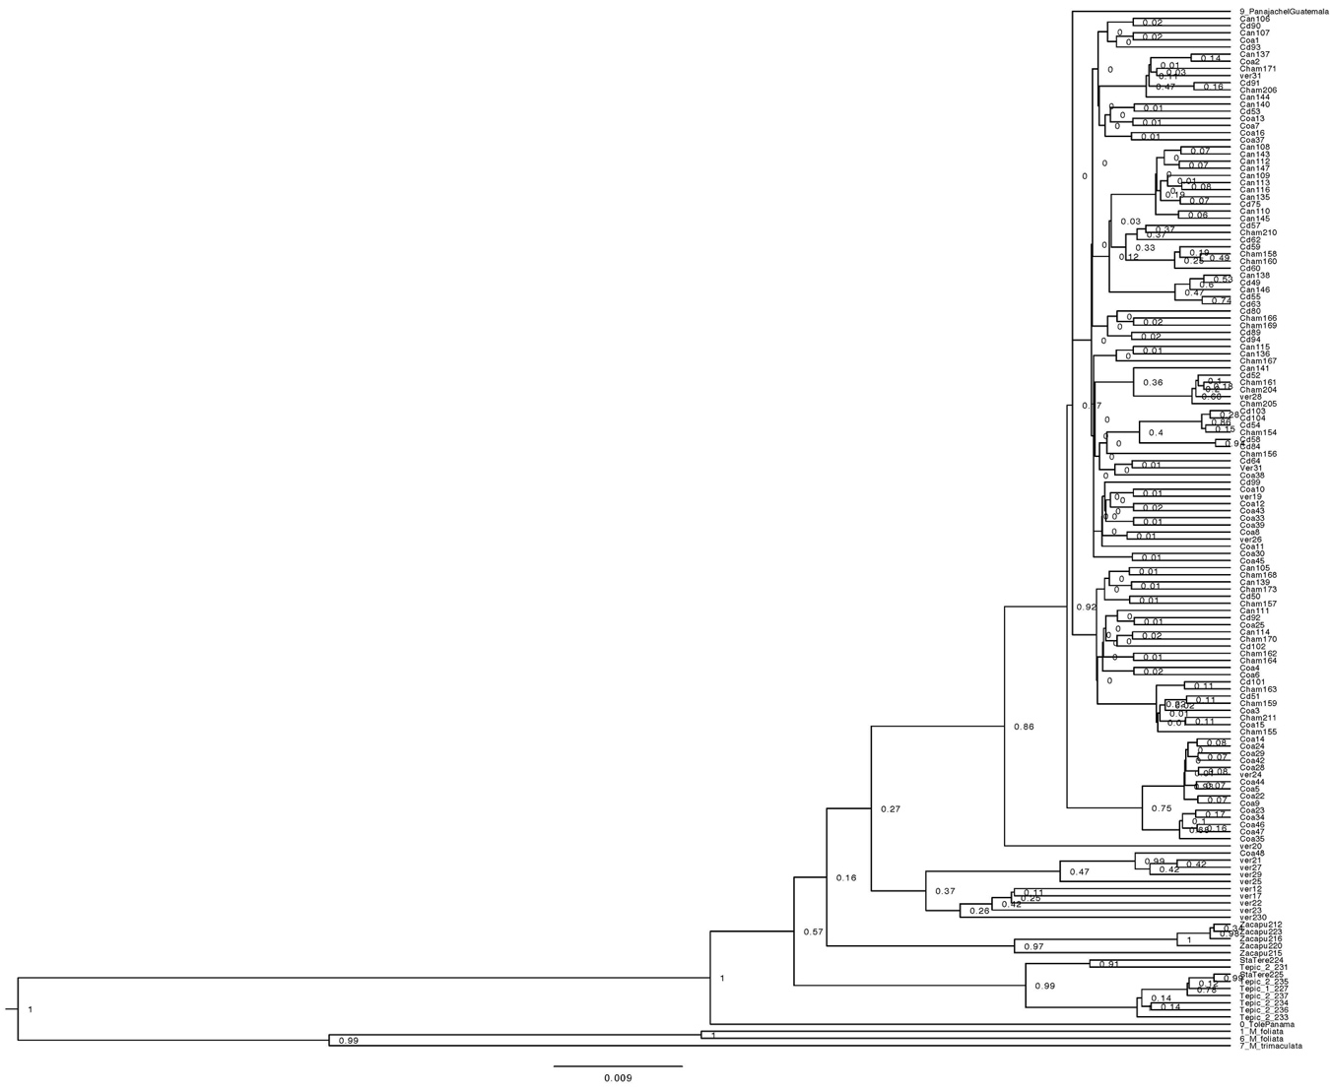
Figure SM16 Bayesian phylogeny of Membracis mexicana using COI gene segment.

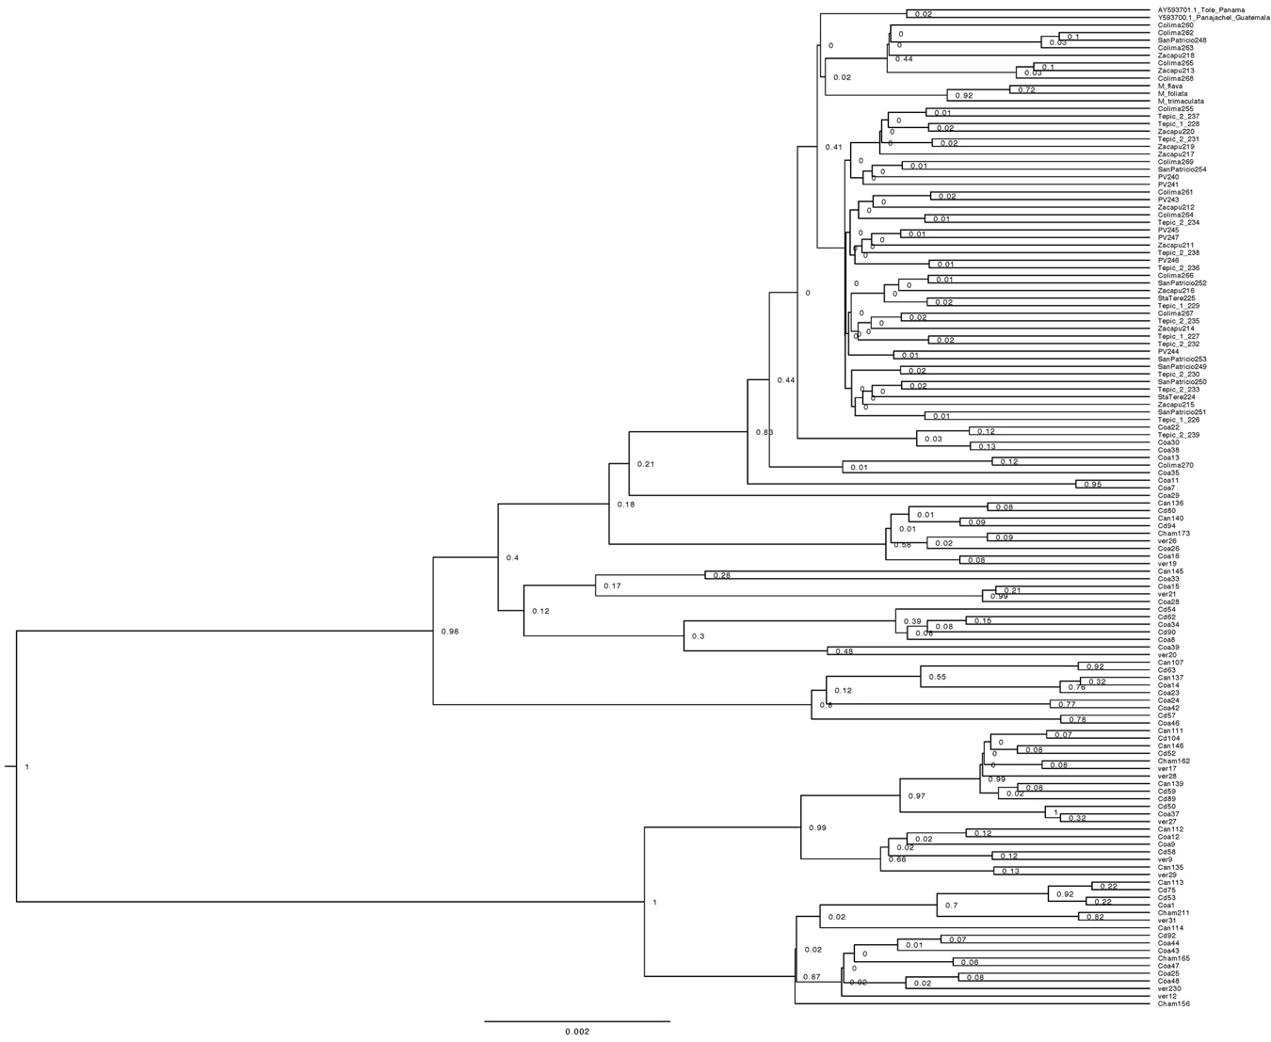
Figure SM17 Bayesian phylogeny of Membracis mexicana using WG gene segment.

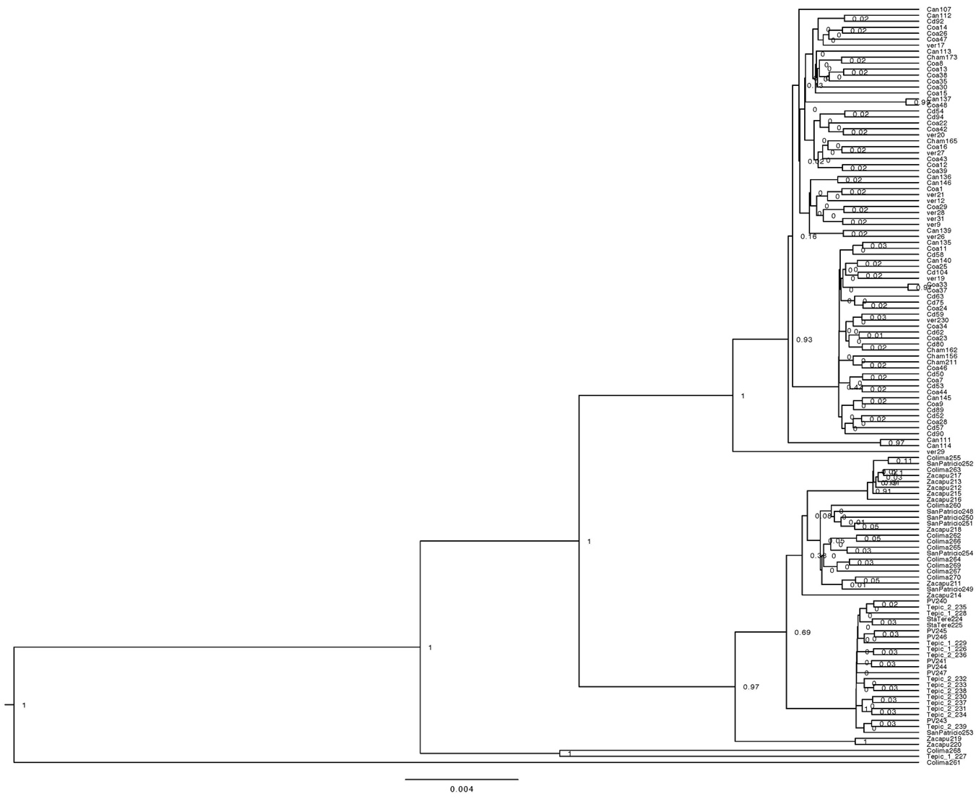
Figure SM18 Bayesian phylogeny of Membracis mexicana using 28S gene segment.

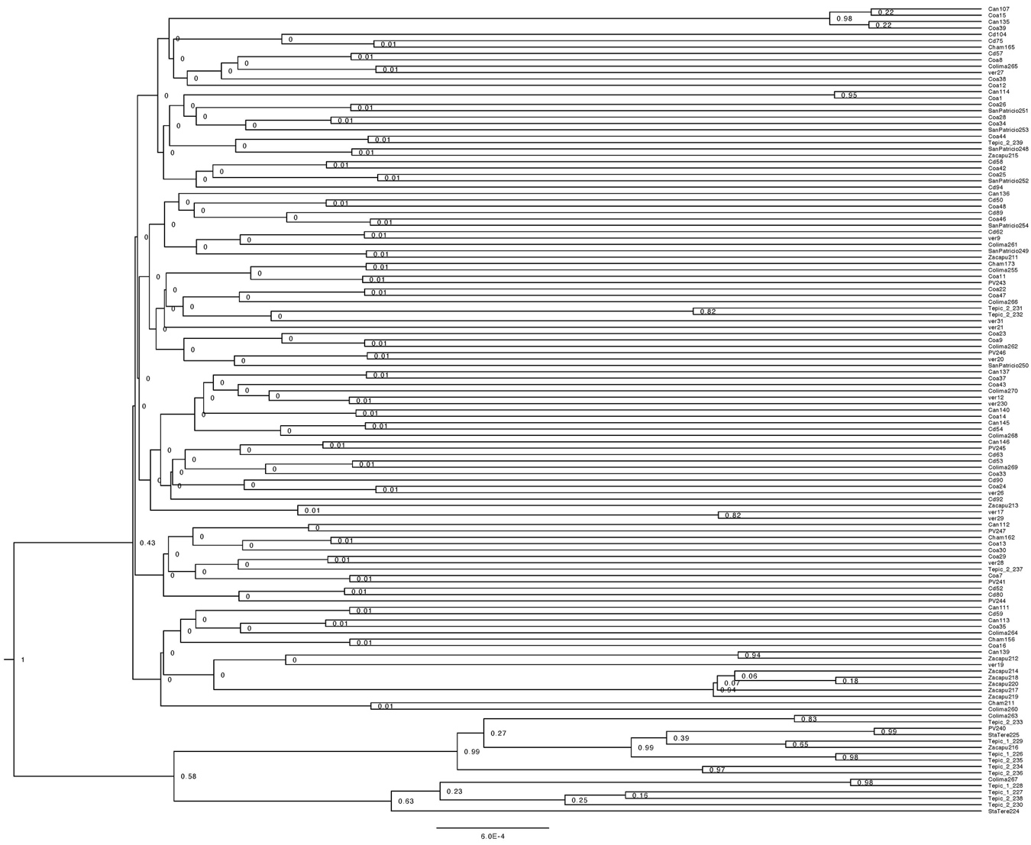
Figure SM19 Bayesian phylogeny of Membracis mexicana using H2A gene segment.

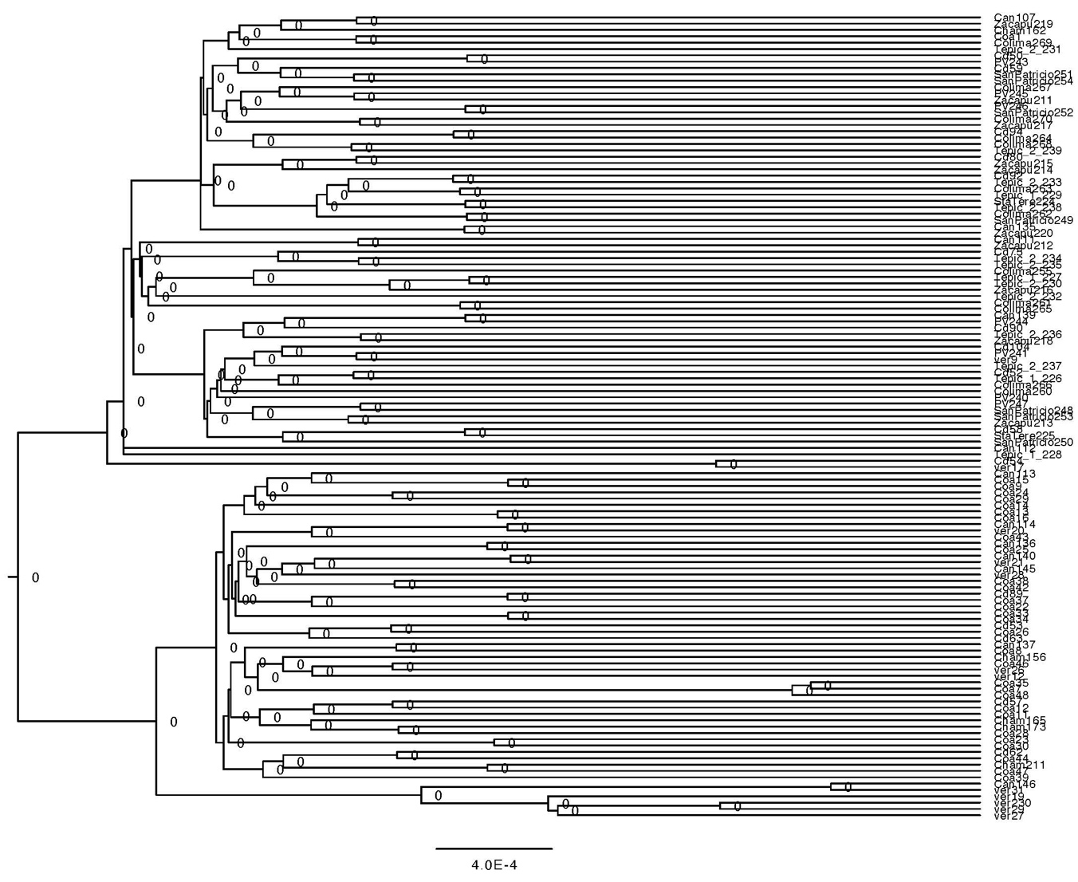
Figure SM20 Bayesian phylogeny of Membracis mexicana using H3 gene segment.

.
Figure SM21 Skyline plot using mitochondrial (A) and nuclear markers (B) of Membracis mexicana from Mexico.

