*Supplementary Material
Revealing the structure formation on polyglycerol citrate polymers – an environmentally friendly polyester as a coating material
Amanda S. Giroto^{a,b*}, Stella F. Valleª, Roger Borgesª, Tatiana S. Ribeiro^{c}, Luiz A. Colnagoª, Nicolai D. Jablonowski^{b*}, Caue Ribeiroª*, Luiz H. C. Mattosoª
ª Embrapa Instrumentation, XV de Novembro Street, 1452, 13560-970, São Carlos, SP, Brazil
^{b}Forschungszentrum Jülich GmbH, Institute of Bio- and Geosciences, IBG-2: Plant Sciences, 52425 Jülich, Germany
^{c}Department of Natural Science, Mathematics and Education, Federal University of São Carlos, Anhanguera, Km 174, Araras - SP 13604-900, SP, Brazil.

*Corresponding authors: a.soares.giroto@fz-juelich.de & asgiroto@gmail.com; n.d.jablonowski@fz-juelich.de; caue.ribeiro@embrapa.br.

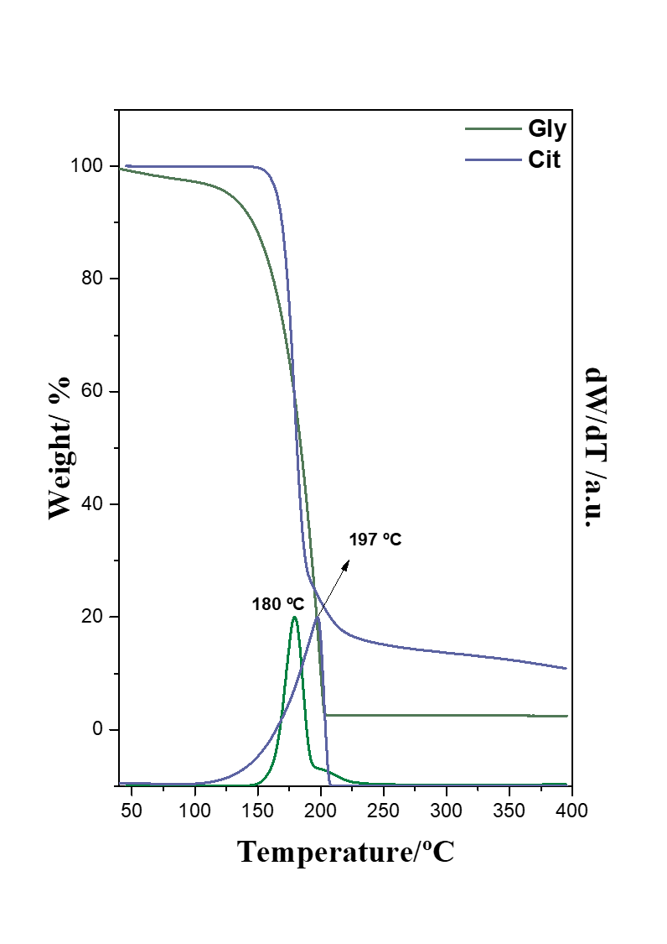
Figure S1. Thermogravimetric analyses of pristine Cit and Gly.

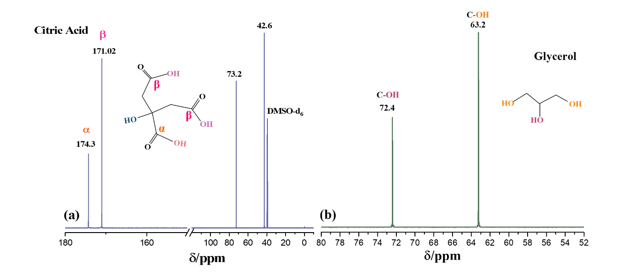
Figure S2. ¹³C NMR of pristine citric acid (a) and glycerol (b).

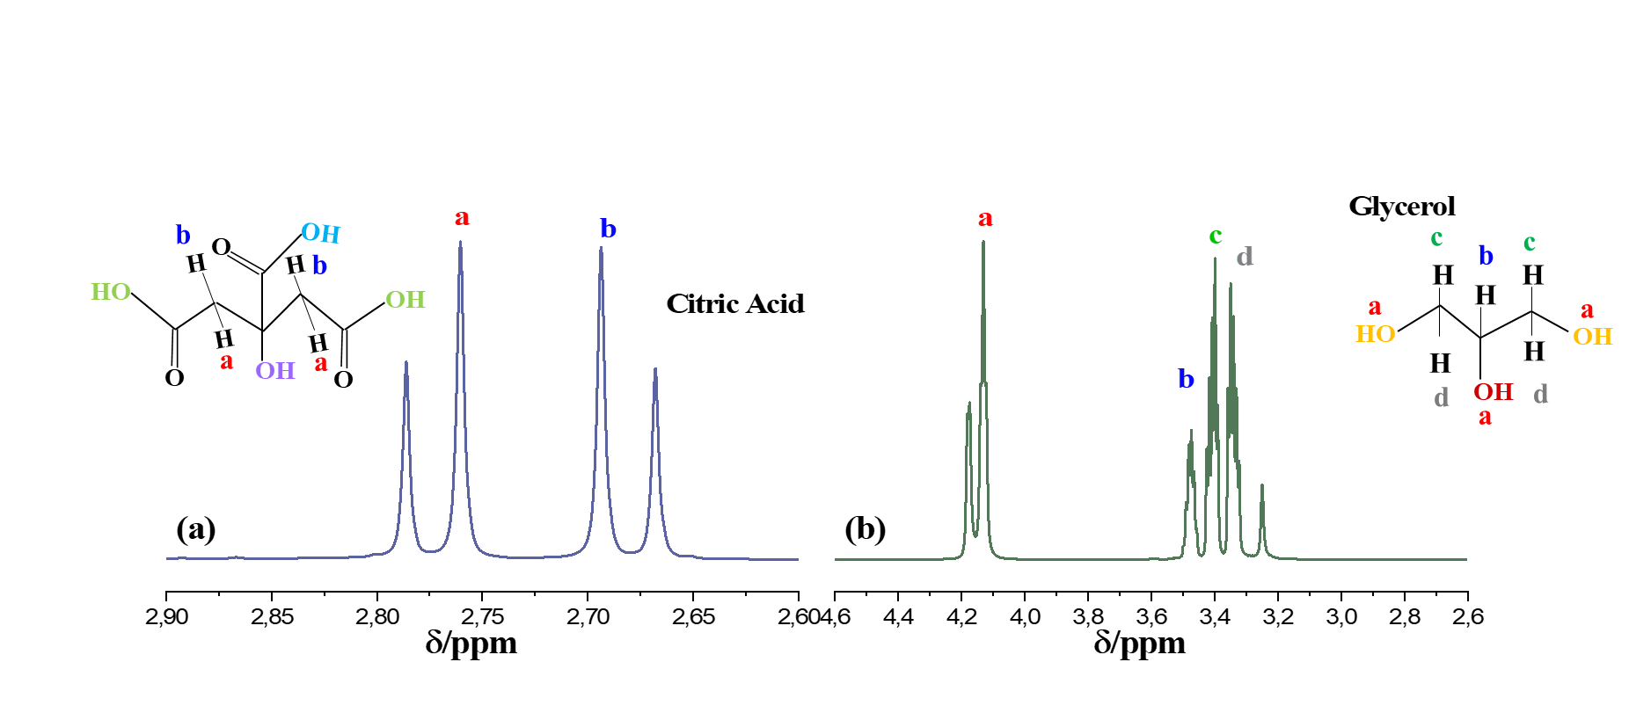
Figure S3. ¹H NMR of pristine citric acid (a) and glycerol (b).

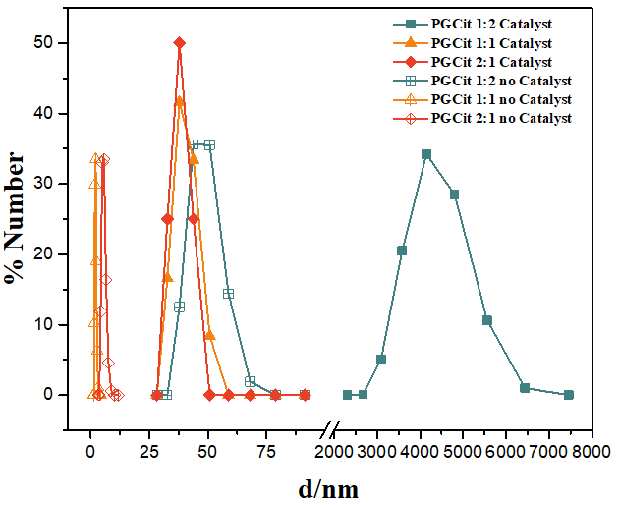
Figure S4. Hydrodynamic size distribution of PGCit in pH 7.

