Electronic Supporting Information
Graphitic Carbon Nitride Nanosheets Decorated Zinc-Cadmium Sulfide Type-II Heterojunctions for Photocatalytic Hydrogen Production
Ammar Bin Yousaf,¹† Muhammad Imran,²† Muhammad Farooq,^{3,}* Samaira Kausar,⁴ Samina Yasmeen,⁴ and Peter Kasak,^{1,}*

¹ Center for Advanced Materials, Qatar University, Doha 2713, Qatar
² Hefei National Laboratory for Physical Sciences at Microscale, University of Science and Technology of China, Hefei, Anhui 230026, PR China
³ Interdisciplinary Graduate School of Science and Technology,, Shinshu University, Ueda 386-8567, Japan
⁴ Department of Chemistry, National Science College, Satellite Town, Gujranwala 52250, Pakistan

† : These two authors contributed equally.
*Corresponding Authors E-mails: mufaroouk@gmail.com, 20hs109g@shinshu-u.ac.jp (Muhammad Farooq), peter.kasak@qu.edu.qa (Peter Kasak)

S1 Materials and Methods

S1.1. Chemicals
Melamine (C₃H₆N₆), sodium hydroxide (NaOH), zinc acetate [Zn(OAc)₂], cadmium acetate [Cd(OAc)₂], sodium sulfide nonahydrate [Na₂S·9H₂O], and sodium sulfite (Na₂SO₃) of analytical grade puritywere purchased from Sigma-Aldrich and used as received without further purification.

S1.2. Characterization
The structure and morphology of the as-synthesized samples were analyzed by transmission electron microscope (TEM, JEM-2100F, 200kV accelerating voltage). The crystal phase of the samples was measured by powder X-ray diffraction (XRD) measurements with a Philips X’Pert Pro Super diffractometer with Cu-Kα radiation (λ = 1.54178 Å) at an operating voltage of 40 kV and current of 200 mA. The elemental composition of the prepared catalyst was determined using X-ray photoelectron spectroscopy (XPS) analysis (PerkinElmer RBD). The UV−vis diffuse reflectance spectra (DRS) for band gap calculation and absorption behavior were recorded with a Shimadzu spectrophotometer (2501 PC model) in the 200 to 800 nm region. Photoelectrochemical tests were performed with a CHI-660B potentiostat (Chenhua Instrument Co., Shanghai, China) with a three-electrode setup (modified Ti foil as the working electrode, Ag/AgCl as the reference electrode, and Pt wire as the counter electrode) in 0.1 M Na₂SO₄ solution. The electrochemical impedance spectroscopy (EIS) was recorded with −0.6 V bias, and the frequency ranged from 1 Hz to 100 kHz with an alternating current signal amplitude of 5 mV.

Figure S1: Low resolution TEM image of g-C₃N₄‒ZnCdS catalyst.

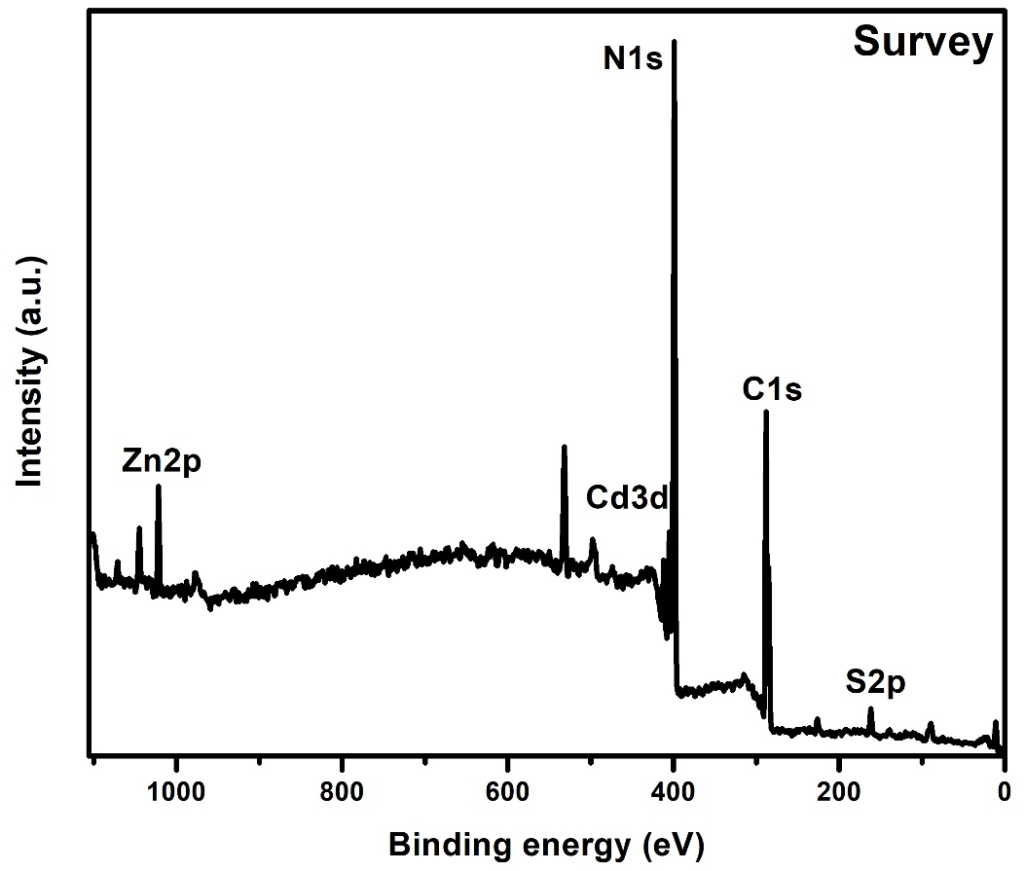
Figure S2: XPS full scan survey for g-C₃N₄‒ZnCdS catalyst.

