Article
Socio-demographic and health indicators of diet quality in pre-frail older adults in New Zealand
Esther Tay ¹, Daniel Barnett ², Maisie Rowland ³, Ngaire Kerse ¹, Richard Edlin ⁵, Debra L. Waters ^{6,7,8}, Martin Connolly ⁹, Avinesh Pillai ², Evelingi Leilua ¹, Ruth Teh ¹*

Supplementary Material
Materials and Methods

Figure S1 Summary of systems and changes implemented for cleaning Intake24 data.

Table S1. Multivariate regression against DQI-I score and subcomponents for Low Energy Reporter (LER) only.
Demographic and health variables | B | 95% Wald CI | p-value
DQI-I total score
(Intercept) | 58.567 | 52.248, 64.887 | <0.001
Live alone; (reference: with others) | 2.480 | -0.300, 5.260 | 0.080
Alcohol consumption (never; reference: regular) | -2.382 | -5.921, 1.156 | 0.187
(Occasional; reference: regular) | 0.680 | -2.404, 3.764 | 0.666
Vision (impaired; reference: non impaired) | -3.890 | -9.254, 1.474 | 0.155
Deprivation (low; reference: high) | 2.436 | -1.027, 5.898 | 0.168
(Medium; reference: high) | 2.125 | -1.208, 5.457 | 0.211
(Scale) | 68.016 | 54.281, 85.226
Variety score
(Intercept) | 7.743 | 3.259, 12.227 | <0.001
Live alone; (reference: with others) | 0.987 | -0.086, 2.059 | 0.071
Waist circumference, cm | 0.027 | -0.015, 0.069 | 0.207
GDS score (no depression; reference: depression) | 0.894 | -0.473, 2.261 | 0.200
(Scale) | 10.709 | 8.533, 13.438
Adequacy score
(Intercept) | 16.864 | 10.581, 23.147 | <0.001
Deprivation (low; reference: high) | 1.499 | -0.344, 3.341 | 0.111
(Medium; reference: high) | 2.489 | 0.689, 4.289 | 0.007
Waist circumference, cm | 0.083 | 0.025, 0.141 | 0.005
Alcohol consumption (never; reference: regular) | -0.920 | -2.854, 1.014 | 0.351
(Occasional; reference: regular) | 0.022 | -1.626, 1.669 | 0.979
(Scale) | 19.614 | 15.630, 24.615
Moderation score
(Intercept) | 20.251 | 16.143, 24.359 | <0.001
Sex (male; reference: female) | -1.777 | -3.135, -0.419 | 0.010
BMI, kg/m² | -0.177 | -0.303, -0.051 | 0.006
Live alone; (reference: with others) | 0.602 | -0.762, 1.966 | 0.387
(Scale) | 15.798 | 12.598, 19.810
Balance score
(Intercept) | 5.391 | 3.779, 7.004 | <0.001
Supplements (0; reference: 1+) | 0.514 | 0.028, 1.000 | 0.038
BMI, kg/m² | -0.031 | -0.078, 0.016 | 0.189
Sex (male; reference: female) | 0.401 | -0.087, 0.889 | 0.107
Education level (primary; reference: tertiary) | -0.989 | -2.500, 0.522 | 0.199
(Secondary; reference: tertiary) | -0.097 | -0.584, 0.391 | 0.698
(Scale) | 2.188 | 1.745, 2.744
Italicized p-values are significant at the 0.05 level.

Table S2. Multivariate regression against DQI-I score and subcomponents for plausible reporters only.
Demographic and health variables | B | 95% Wald CI | p-value
DQI-I total score
(Intercept) | 59.995 | 51.618, 68.372 | <0.001
Ethnic group (European; reference: non-European) | 3.034 | 0.016, 6.052 | 0.049
Waist circumference, cm | -.039 | -0.113, 0.035 | 0.299
Live alone; (reference: with others) | 0.807 | -0.936, 2.550 | 0.364
Deprivation (low; reference: high) | 1.443 | -0.695, 3.581 | 0.186
(Medium; reference: high) | 0.893 | -1.330, 3.116 | 0.431
(Scale) | 59.223 | 50.634, 69.267
Variety score
(Intercept) | 13.526 | 12.693, 14.360 | <0.001
Medications (1; reference: 2+) | 1.191 | -0.024, 2.406 | 0.055
Sex (male; reference: female) | 0.491 | -0.192, 1.173 | 0.159
Deprivation (low; reference: high) | 0.624 | -0.190, 1.437 | 0.133
(Medium; reference: high) | 0.751 | -0.094, 1.596 | 0.082
Alcohol consumption (never; reference: regular) | -0.682 | -1.557, 0.193 | 0.127
(Occasional; reference: regular) | -0.278 | -1.041, 0.486 | 0.476
(Scale) | 8.812 | 7.534, 10.306
Adequacy score
(Intercept) | 21.257 | 16.126, 26.387 | <0.001
Ethnic group (European; reference: non-European) | 2.088 | 0.724, 3.453 | 0.003
Smoking (non-smoker; reference: smoker) | 4.062 | 0.457, 7.666 | 0.027
Education level (primary; reference: tertiary) | -1.833 | -4.165, 0.499 | 0.123
(Secondary; reference: tertiary) | 0.079 | -0.750, 0.908 | 0.851
NEADL score | 0.161 | -0.026, 0.348 | 0.091
(Scale) | 13.025 | 11.136, 16.234
Moderation score
(Intercept) | 14.275 | 8.80, 19.744 | <0.001
Live alone; (reference: with others) | 0.927 | 0.031, 1.823 | 0.043
Age, (<80 years; reference: 80+ years) | -0.452 | -1.356, 0.452 | 0.327
MoCA score (not impaired; reference: impaired) | 0.778 | -0.244, 1.799 | 0.136
Waist circumference, cm | -0.048 | -0.084, -0.012 | 0.010
NEADL score | 0.047 | -0.156, 0.250 | 0.647
(Scale) | 14.938 | 12.771, 17.471
Balance score
(Intercept) | 4.652 | 4.259, 5.046 | <0.001
Alcohol consumption (never; reference: regular) | 0.674 | 0.256, 1.092 | 0.002
(Occasional; reference: regular) | 0.373 | 0.011, 0.734 | 0.043
MoCA score (not impaired; reference: impaired) | -0.590 | -0.966, -0.214 | 0.002
(Scale) | 2.040 | 1.744, 2.386
Italicized p-values are significant at the 0.05 level.

All participants
Variety  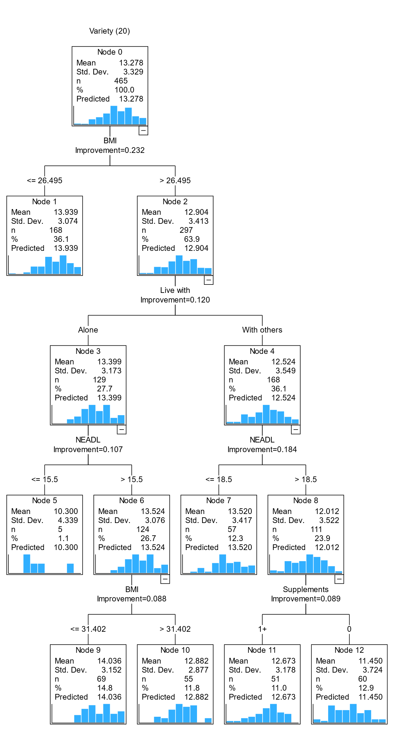 | Adequacy  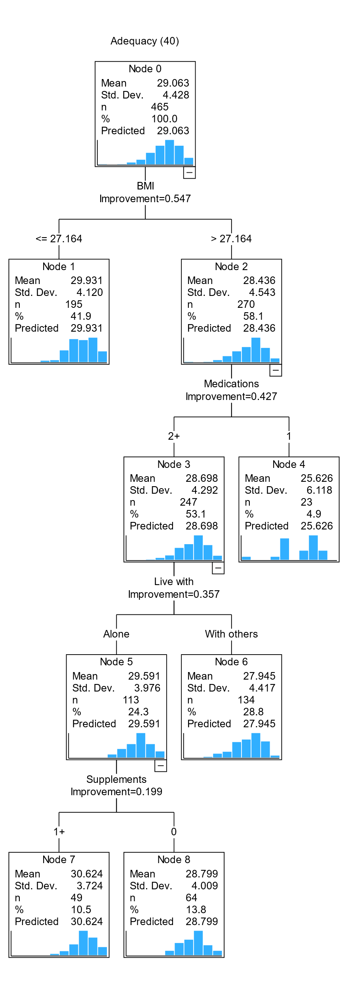 | Moderation  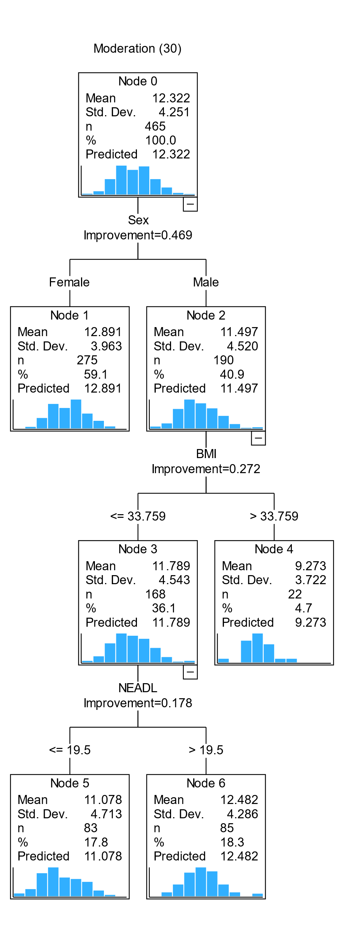 | Balance  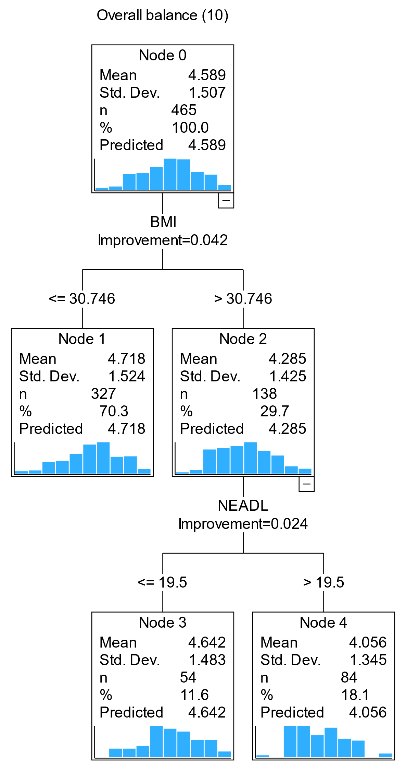
Figure S2. CART diagram of factors associated with DQI-I subcomponents in pre-frail older adults

Plausible reporters only
Total DQI-I  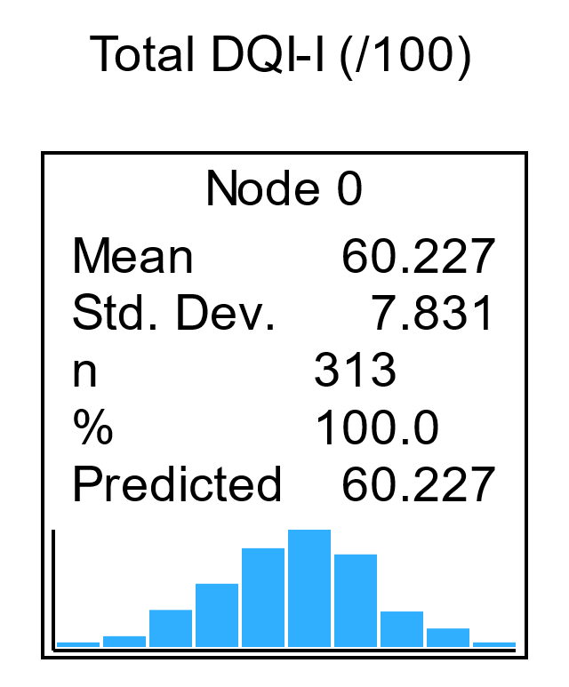 | Variety  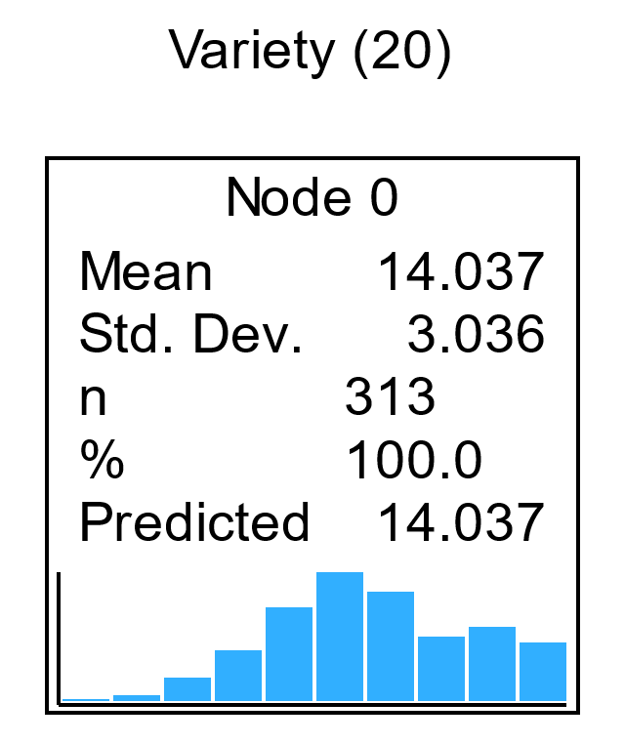 | Adequacy  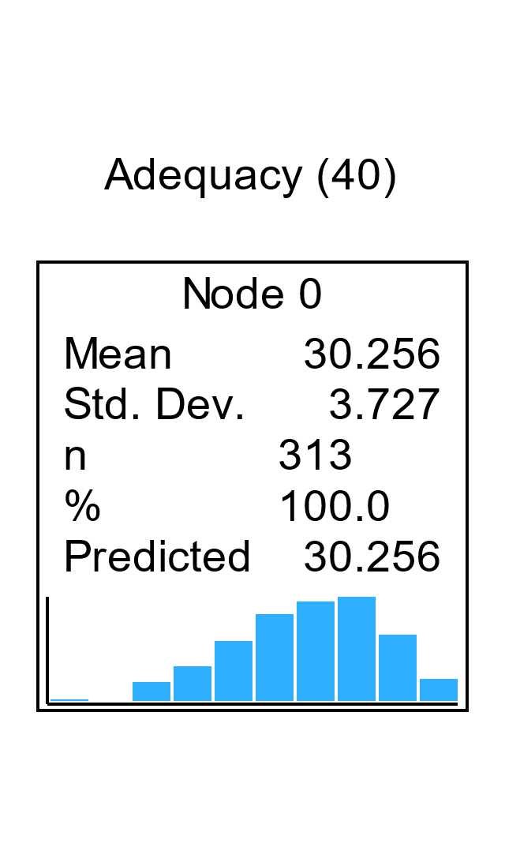 | Moderation  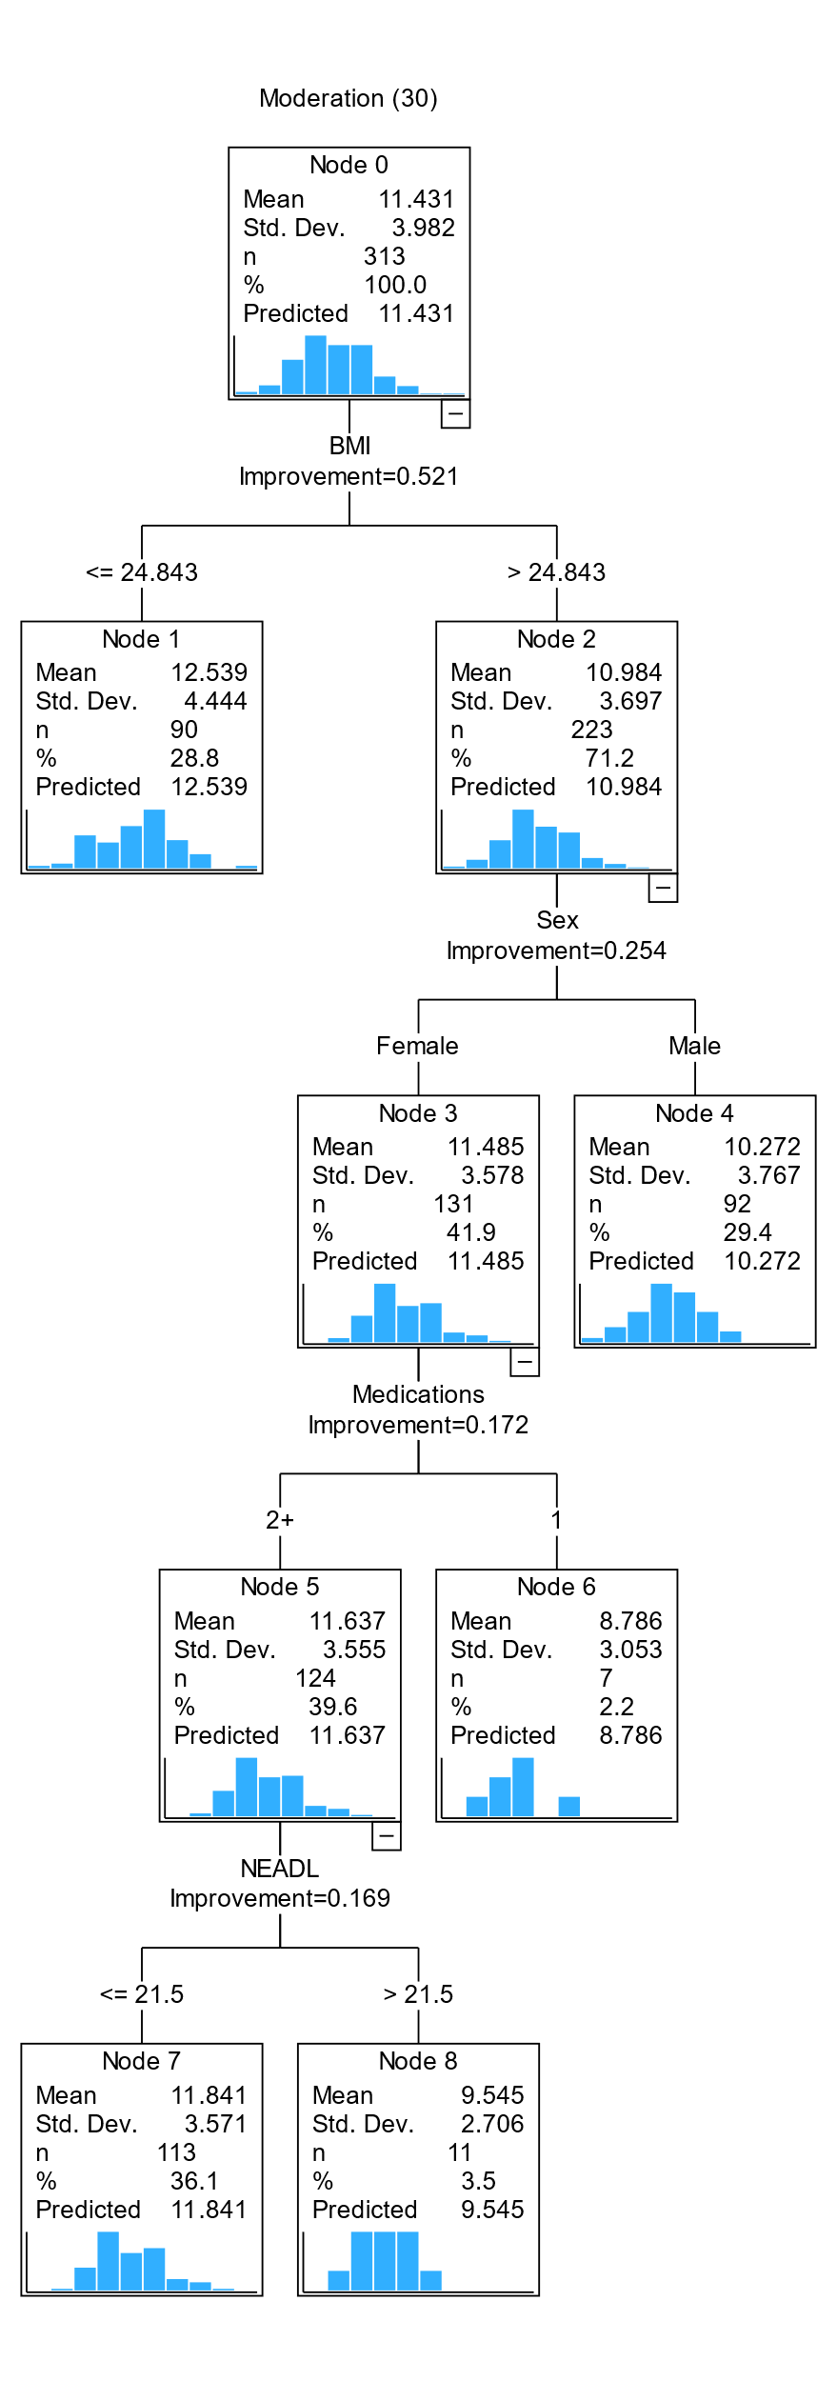 | Balance  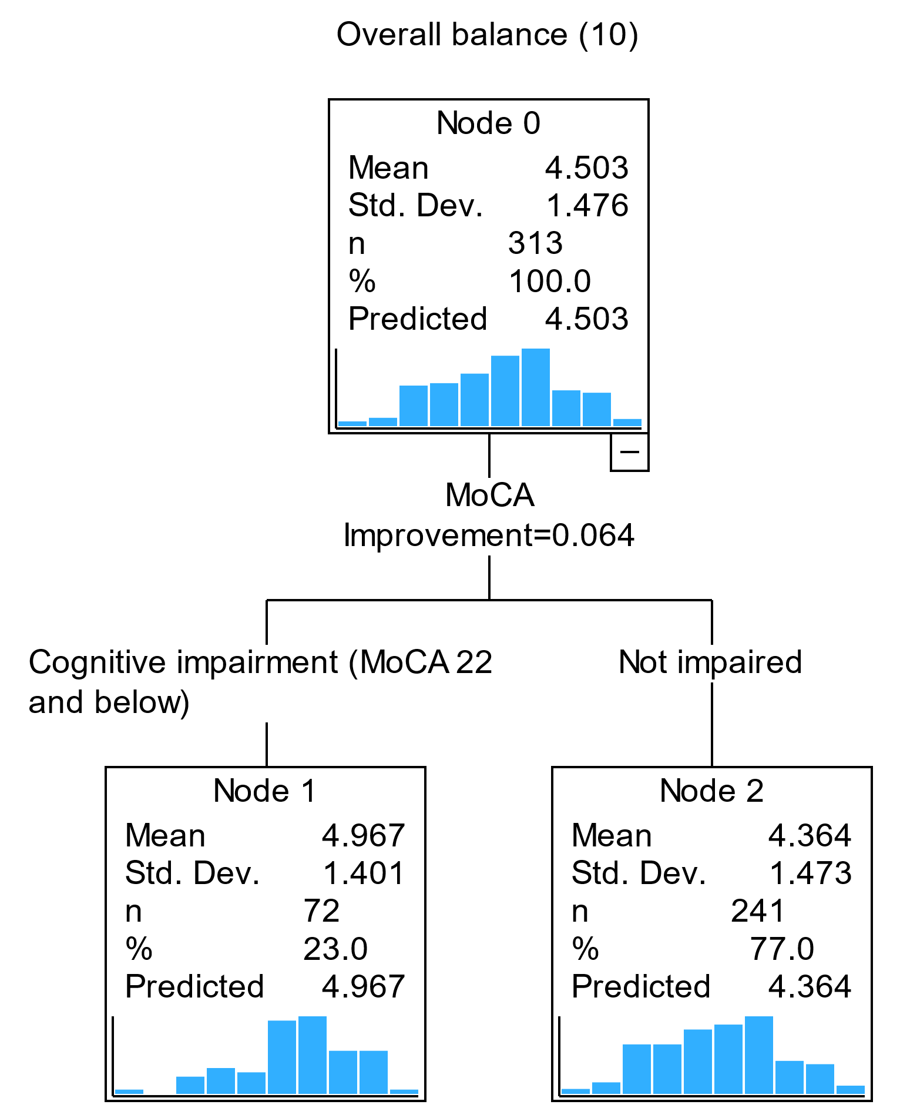
Figure S3. CART diagram of factors associated with DQI-I and subcomponents in pre-frail older adults for plausible reporter (PR) only.

Low Energy Reporters only
Total DQI-I  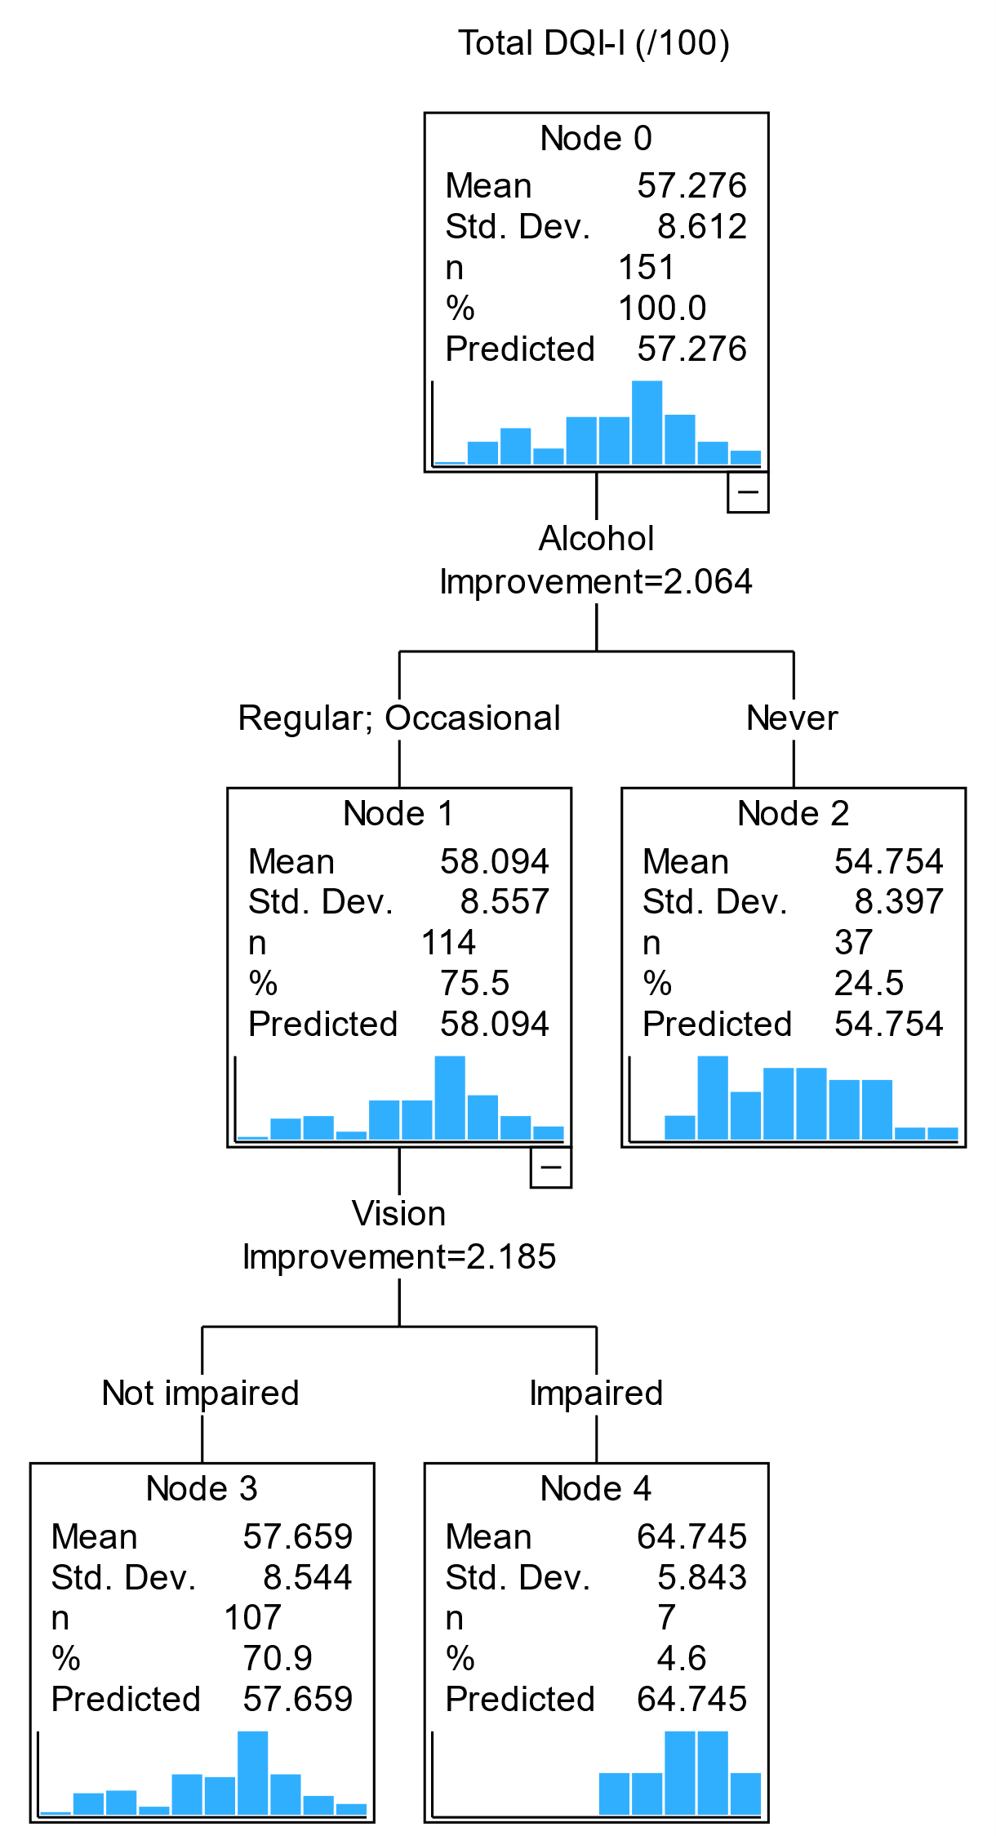 | Variety  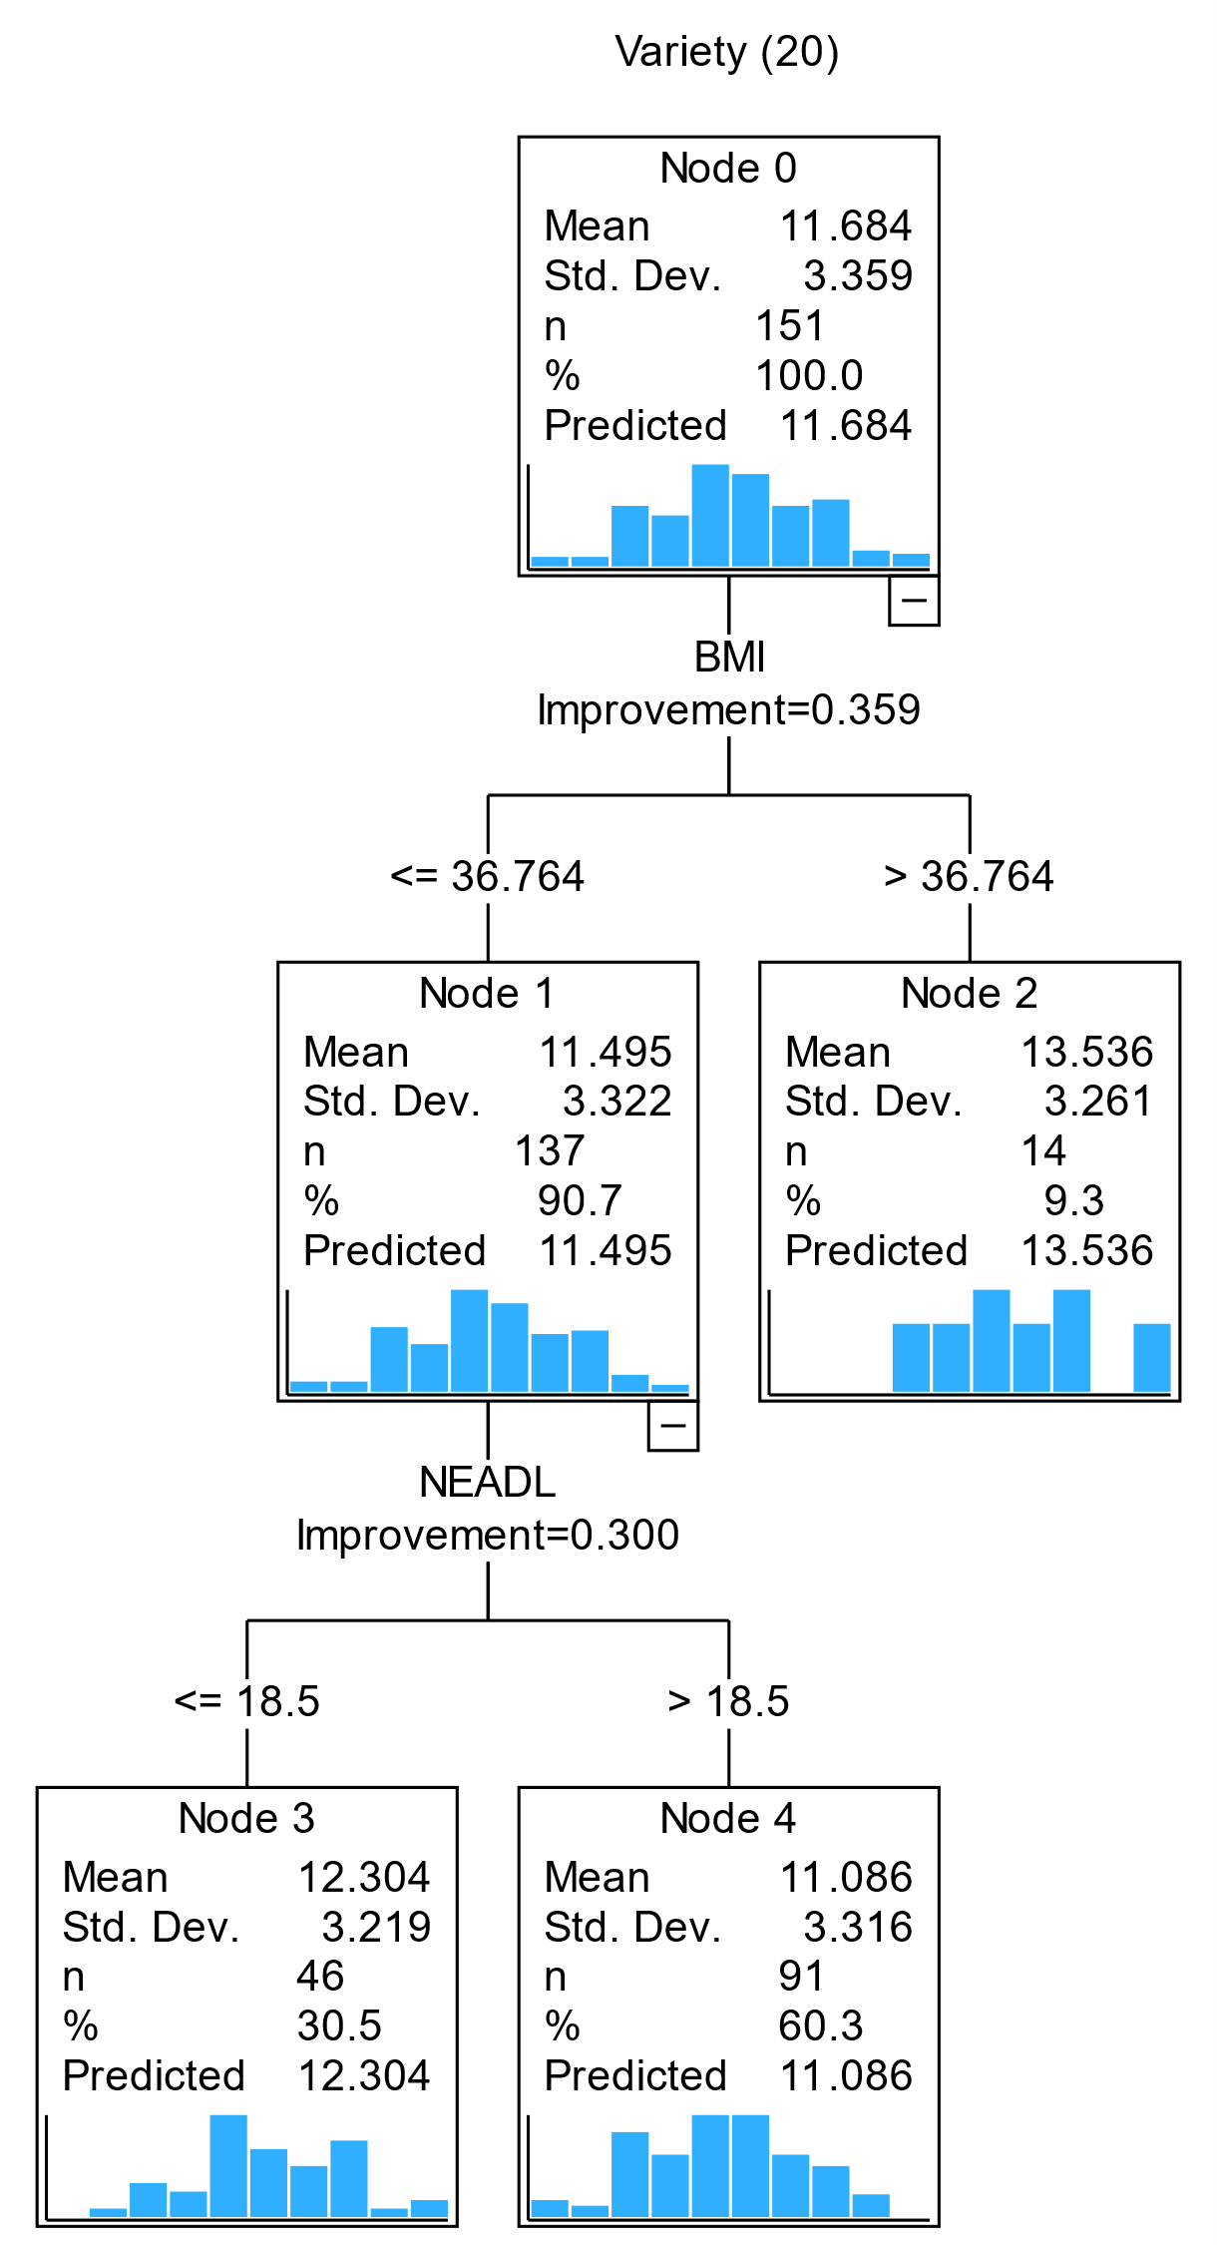 | Adequacy | Moderation  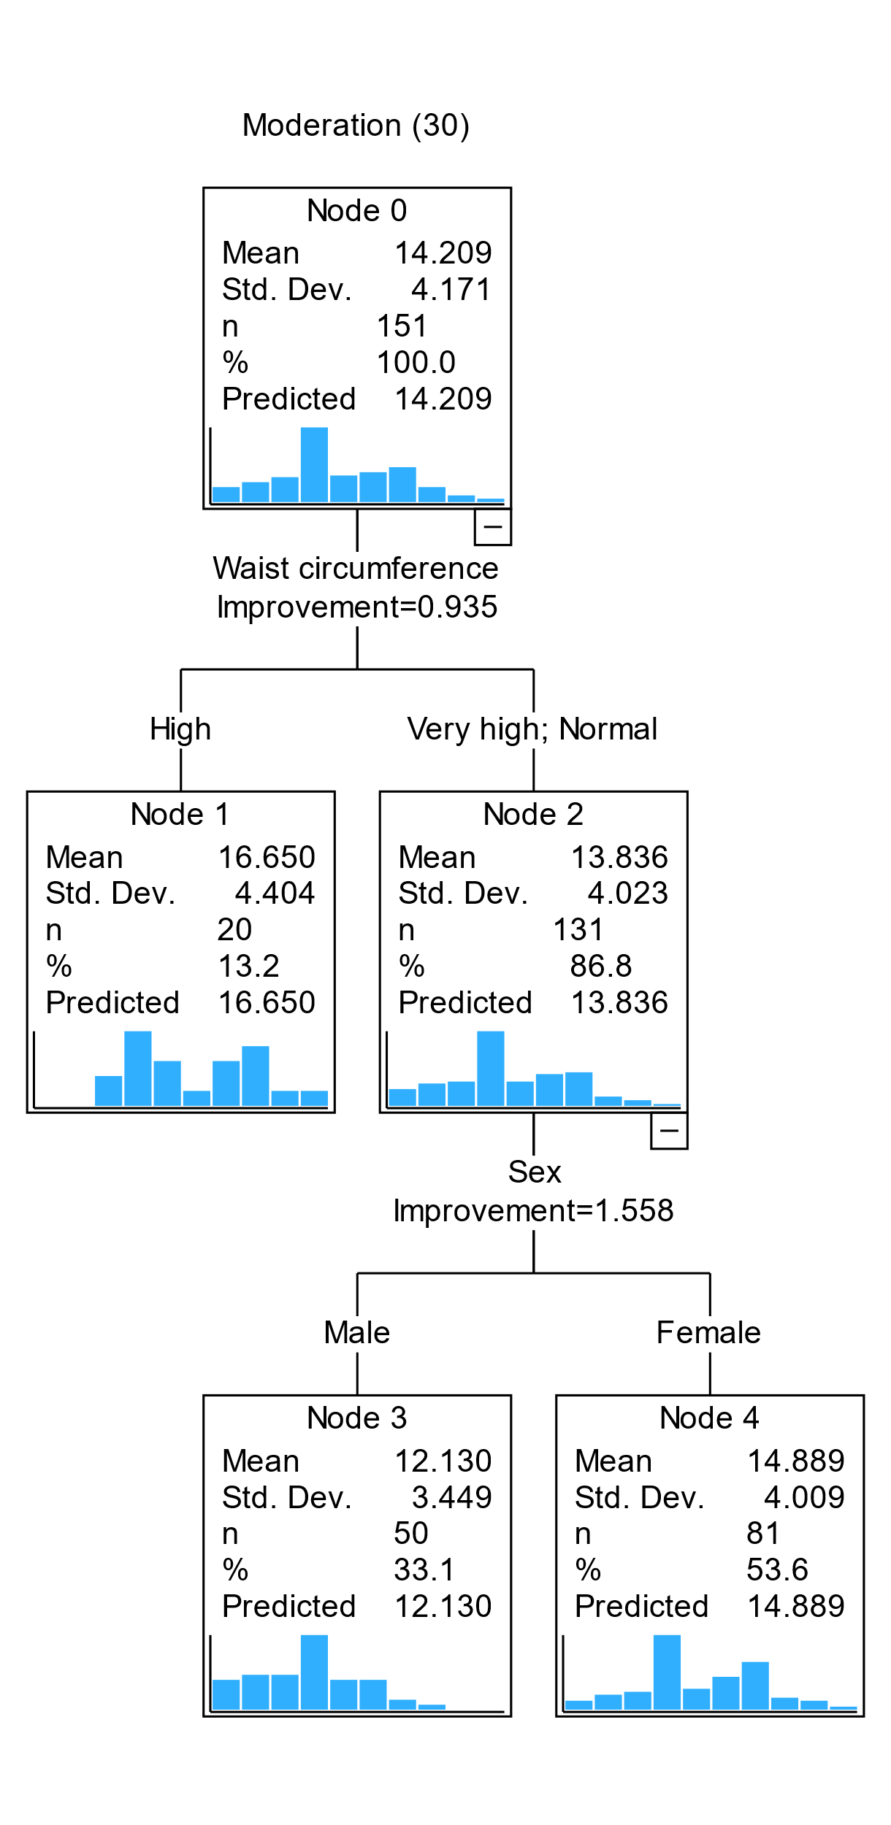 | Balance  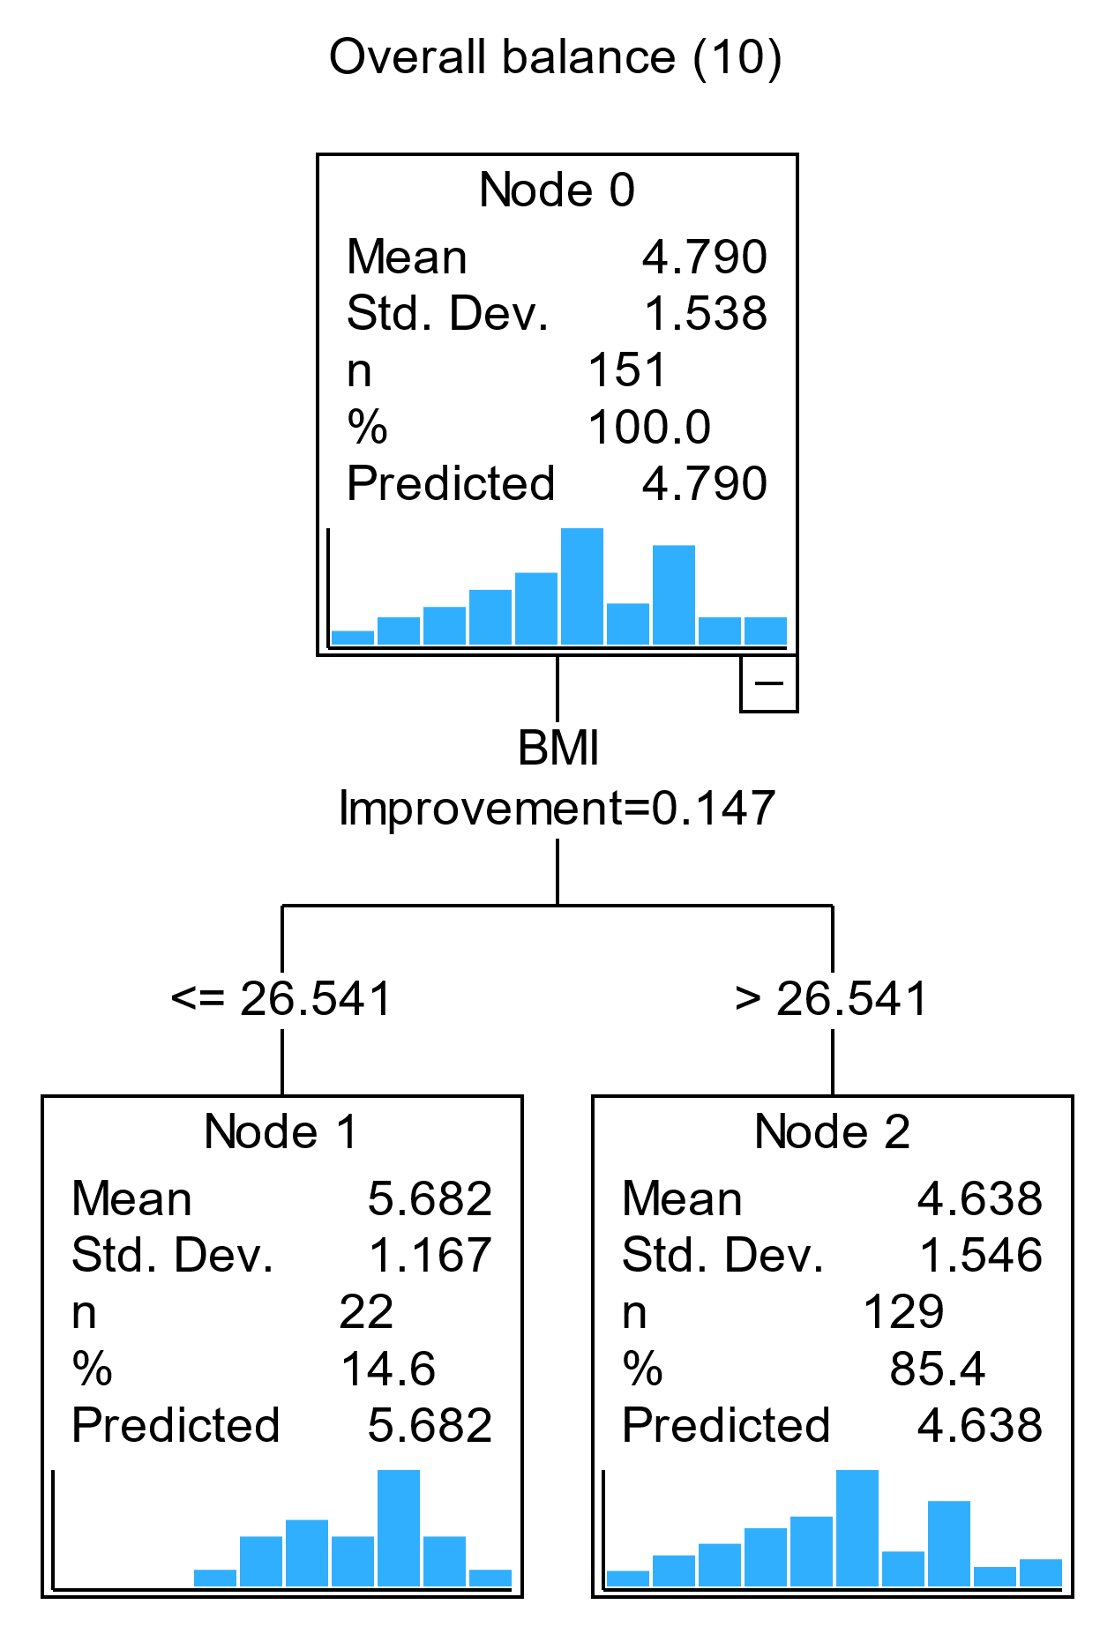
Figure S4. CART diagram of factors associated with DQI-I and subcomponents in pre-frail older adults for LER only.

