Supplementary Materials:

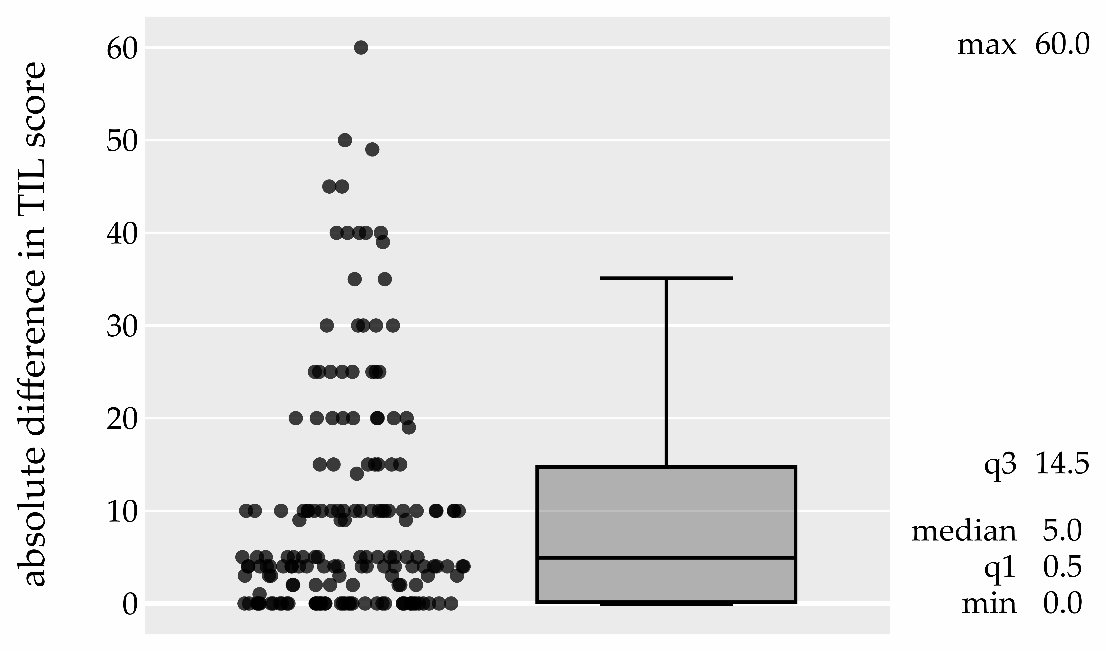

Figure S1: Absolute difference between TIL scores of two pathologists, boxplot.
Abbreviations: min: minimum; max: maximum; q3: 3rd quartile; q1: 1st quartile; TIL: tumour-infiltrating lymphocytes.

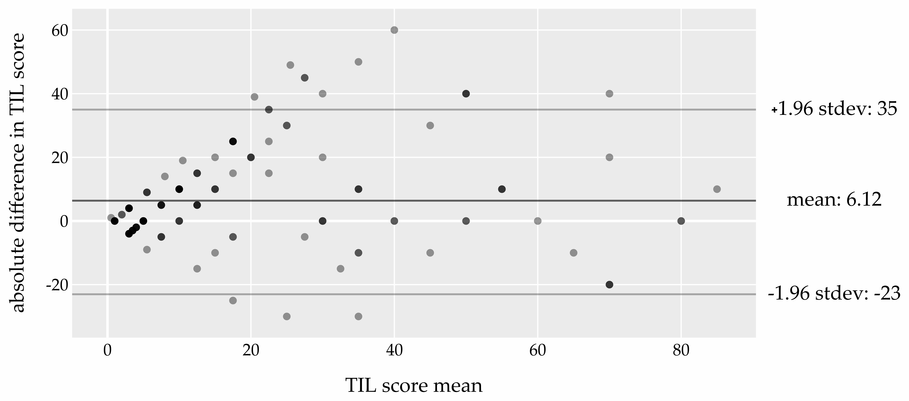
Figure S2: Bland-Altman plot for TIL measurements by two pathologists (solid line represents the mean difference, the dashed lines represent the 95% limits of agreement).
Abbreviations: TIL: tumour-infiltrating lymphocytes; stdev: standard deviation.
Figure S3: Distribution of tumour-infiltrating lymphocytes in breast cancer according to the four breast cancer subtypes, boxplots.
Abbreviations: min: minimum; max: maximum; q3: 3rd quartile; q1: 1st quartile; TIL: tumour-infiltrating lymphocytes; HER-2: human epidermal growth factor receptor 2.

Table S1: Association of TIL and its subtypes (CD8+ TILs, CXCL13+ TILs, PD-1+ TILs, FOXP3+ TILs) with other clinicopathological characteristics.

Clinicopathologic characteristics | total TILs median (IQR) | p* | adjusted p-  value † | total TILs  n(%) |  | p # | adjusted p-value † | CD8+ TILs  median (IQR) | p * | adjusted p-value † | CXCL13+ TILs  median (IQR) |  | p * | adjusted p-value † | PD-1+ TILs median (IQR) | p * | adjusted p-value † | FOXP3+ TILs  median (IQR) | p * | adjusted p-  value †
 |  |  |  | low (<60%) | high (≥60%)
Grade 3 | 12.5 (4.0-30.0) | <0.001 | 0.002 | 115 | 9 | 0.290 | 1.0 | 40.0 (30.0-50.0) | 0.077 | 1.0 | 1.0  (0.0-2.0) | 0.302 |  | 1.0 | 2.0  (0.0-7.0) | 0.001 | 0.015 | 5.0  (2.0-7.5) | <0.001 | 0.012
 |  |  |  | (93.0%) | (7.0%)
Grade 2 | 5.0 (3.0-7.5) |  |  | 45 | 1 |  |  | 30.0 (20.0-50.0) |  |  | 1.0  (1.0-1.0) |  |  |  | 0.0  (0.0-2.0) |  |  | 2.0  (1.0-5.0)
 |  |  |  | (98.0%) | (2.0%)
Ki-67 10-20% | 5.0  (3.0-10.0) | <0.001 | 0.002 | 45 | 1 | 0.224 | 1.0 | 40.0 (30.0-50.0) | 0.420 | 1.0 | 1.0  (0.5-2.0) | 0.800 |  | 1.0 | 0.0  (0.0-2.0) | 0.001 | 0.024 | 2.5  (1.0-5.0) | 0.021 | 0.487
 |  |  |  | (98.0%) | (2.0%)
Ki-67 20-40% | 10.0 (3.8-20.0) |  |  | 63 | 3 |  |  | 40.0 (30.0-50.0) |  |  | 1.0  (0.0-2.0) |  |  |  | 1.0  (0.0-5.0) |  |  | 4.0  (1.0-8.0)
 |  |  |  | (95.0%) | (5.0%)
Ki-67 >40% | 17.5 (5.5-35.0) |  |  | 52 | 6 |  |  | 40.0 (27.5-50.0) |  |  | 1.0  (1.0-2.0) |  |  |  | 3.0  (2.0-8.0) |  |  | 5.0  (2.0-7.0)
 |  |  |  | (90.0%) | (10.0%)
Lymph nodes positive | 10.0 (3.5-25.0) | 0.284 | 1.0 | 117 | 8 | 1.000 | 1.0 | 40.0 (30.0-50.0) | 0.259 | 1.0 | 1.0  (1.0-2.0) | 0.546 |  | 1.0 | 2.0  (0.0-5.0) | 0.740 | 1.0 | 5.0  (1.0-7.0) | 0.840 | 1.0
 |  |  |  | (94.0%) | (6.0%)
Lymph nodes negative | 6.5  (3.0-20.0) |  |  | 44 | 2 |  |  | 40.0 (20.0-50.0) |  |  | 1.0  (0.0-2.5) |  |  |  | 1.5  (0.0-6.0) |  |  | 3.0  (1.0-7.0)
 |  |  |  | (96.0%) | (4.0%)
Tumor ≤20 mm (MRI) | 30.0 (5.0-50.0) | 0.051 | 1.0 | 22 | 3 | 0.305 | 1.0 | 40.0 (25.0-50.0) | 0.887 | 1.0 | 1.0  (1.0-2.0) | 0.002 |  | 0.051 | 3.0  (0.0-8.0) | 0.609 | 1.0 | 5.0 (1.0-10.0) | 0.709 | 1.0
 |  |  |  | (88.0%) | (12.0%)
Tumor 20-50 mm (MRI) | 10.0 (3.0-22.5) |  |  | 106 | 7 |  |  | 40.0 (30.0-50.0) |  |  | 1.0  (0.0-2.0) |  |  |  | 2.0  (0.0-5.0) |  |  | 4.0  (1.5-7.0)
 |  |  |  | (94.0%) | (6.0%)
Tumor >50 mm (MRI) | 6.5  (4.0-11.2) |  |  | 18 | 0 |  |  | 40.0 (30.0-50.0) |  |  | 2.0  (2.0-5.0) |  |  |  | 1.0  (0.0-7.0) |  |  | 5.0  (3.0-7.0)
 |  |  |  | (100.0%) | (0.0%)
Luminal  B-like | 5.0  (3.0-17.5) | 0.004 | 0.085 | 86 | 5 | 0.173 | 1.0 | 40.0 (30.0-50.0) | 0.346 | 1.0 | 1.0  (1.0-2.0) | 0.499 |  | 1.0 | 1.0  (0.0-5.0) | 0.062 | 1.0 | 3.0  (1.0-6.5) | 0.027 | 0.598
 |  |  |  | (95.0%) | (5.0%)
HER2+  -luminal | 10.0 (5.0-21.5) |  |  | 32 | 0 |  |  | 45.0 (30.0-50.0) |  |  | 1.0  (1.0-1.0) |  |  |  | 1.0  (0.0-2.5) |  |  | 3.0  (1.0-5.0)
 |  |  |  | (100.0%) | (0.0%)
HER2+  -non-luminal | 22.5 (4.8-45.0) |  |  | 15 | 1 |  |  | 40.0 (30.0-60.0) |  |  | 2.0  (0.0-3.0) |  |  |  | 2.5  (0.0-8.5) |  |  | 6.0  (3.5-9.0)
 |  |  |  | (94.0%) | (6.0%)
Triple  negative | 16.2 (9.0-32.5) |  |  | 28 | 4 |  |  | 40.0 (30.0-40.0) |  |  | 1.0  (0.5-2.0) |  |  |  | 3.0  (2.0-8.0) |  |  | 6.0  (3.0-7.5)
 |  |  |  | (88.0%) | (12.0%)
*Mann-Whitney test (if 2 categories) or Kruskal-Wallis test (if 3 categories or more); # Fisher's exact test; † p-values were adjusted for all comparisons in this table.Statistically significant adjustet p-values are presented in bold.
Abbreviations: TIL: tumour-infiltrating lymphocytes; HER-2: human epidermal growth factor receptor 2; IQR: interquartile range; n: number

Table S2: Multivariable model of prognostic factors for pathological complete response (AUC= 0.807, loglikelihood ratio test p<0.001).
Characteristic | OR (95% CI) | p-value
CD8+ TILs (per 10%) | 1.31 (1.01-1.72) | 0.045
Age | 0.98 (0.95-1.02) | 0.351
Ki-67 (per 10%) | 1.44 (1.18-1.79) | <0.001
Negative lymph nodes | 2.34 (1.03-5.42) | 0.042
HER2+-luminal, HER2+-non-luminal, TN vs lumB | 4.93 (2.31-11.09) | <0.001
Statistically significant adjustet p-values are presented in bold.
TIL: tumour-infiltrating lymphocytes; TN: triple negative subtype; lumB: luminal B subtype; HER-2: human epidermal growth factor receptor 2; OR: odds ratio; CI: confidence interval; AUC: area under the curve

Table S3: Multivariable model of prognostic factors for pathological complete response (AUC= 0.796, loglikelihood ratio test p<0.001).
Characteristic | OR (95% CI) | p-value
CXCL13+ TILs (per 10%) | 1.01 (0.18-5.35) | 0.934
Age | 0.98 (0.95-1.01) | 0.235
Ki-67 (per 10%) | 1.39 (1.14-1.71) | 0.001
Negative lymph nodes | 1.93 (0.85-4.39) | 0.114
HER2+-luminal, HER2+-non-luminal, TN vs lumB | 4.79 (2.26-10.66) | <0.001
Statistically significant adjustet p-values are presented in bold.
TIL: tumour-infiltrating lymphocytes; TN: triple negative subtype; lumB: luminal B subtype; HER-2: human epidermal growth factor receptor 2; OR: odds ratio; CI: confidence interval; AUC: area under the curve

Table S4: Multivariable model of prognostic factors for pathological complete response (AUC= 0.801, loglikelihood ratio test p<0.001).
Characteristic | OR (95% CI) | p-value
PD-1+ TILs (per 10%) | 1.56 (0.87-2.83) | 0.131
Age | 0.98 (0.95-1.01) | 0.262
Ki-67 (per 10%) | 1.37 (1.12-1.69) | 0.002
Negative lymph nodes | 2.20 (0.97-5.08) | 0.059
HER2+-luminal, HER2+-non-luminal, TN vs lumB | 4.79 (2.26-10.67) | <0.001
Statistically significant adjustet p-values are presented in bold.
TIL: tumour-infiltrating lymphocytes; TN: triple negative subtype; lumB: luminal B subtype; HER-2: human epidermal growth factor receptor 2; OR: odds ratio; CI: confidence interval; AUC: area under the curve
Table S5: Multivariable model of prognostic factors for pathological complete response (AUC= 0.807, loglikelihood ratio test p<0.001).
Characteristic | OR (95% CI) | p-value
FOXP3+ TILs (per 10%) | 1.83 (0.73-4.61) | 0.193
Age | 0.98 (0.95-1.01) | 0.213
Ki-67 (per 10%) | 1.38 (1.13-1.70) | 0.001
Negative lymph nodes | 2.08 (0.92-4.72) | 0.076
HER2+-luminal, HER2+-non-luminal, TN vs lumB | 4.65 (2.21-10.27) | <0.001
Statistically significant adjustet p-values are presented in bold.
TIL: tumour-infiltrating lymphocytes; TN: triple negative subtype; lumB: luminal B subtype; HER-2: human epidermal growth factor receptor 2; OR: odds ratio; CI: confidence interval; AUC: area under the curve

