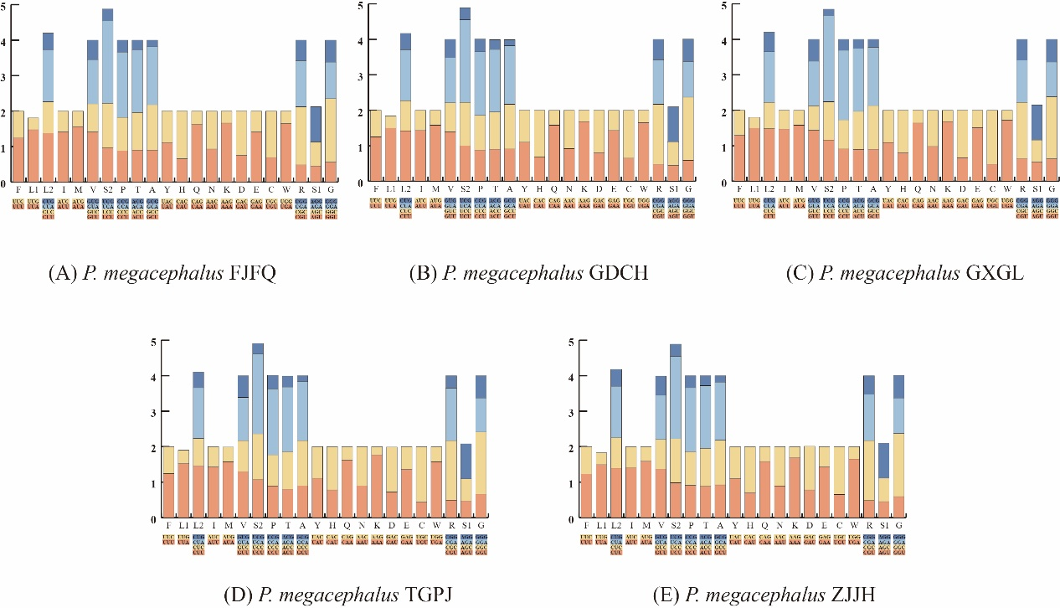
Figure S1. Relative synonymous codon usage (RSCU) in five P. megacephalus mitogenomes. .
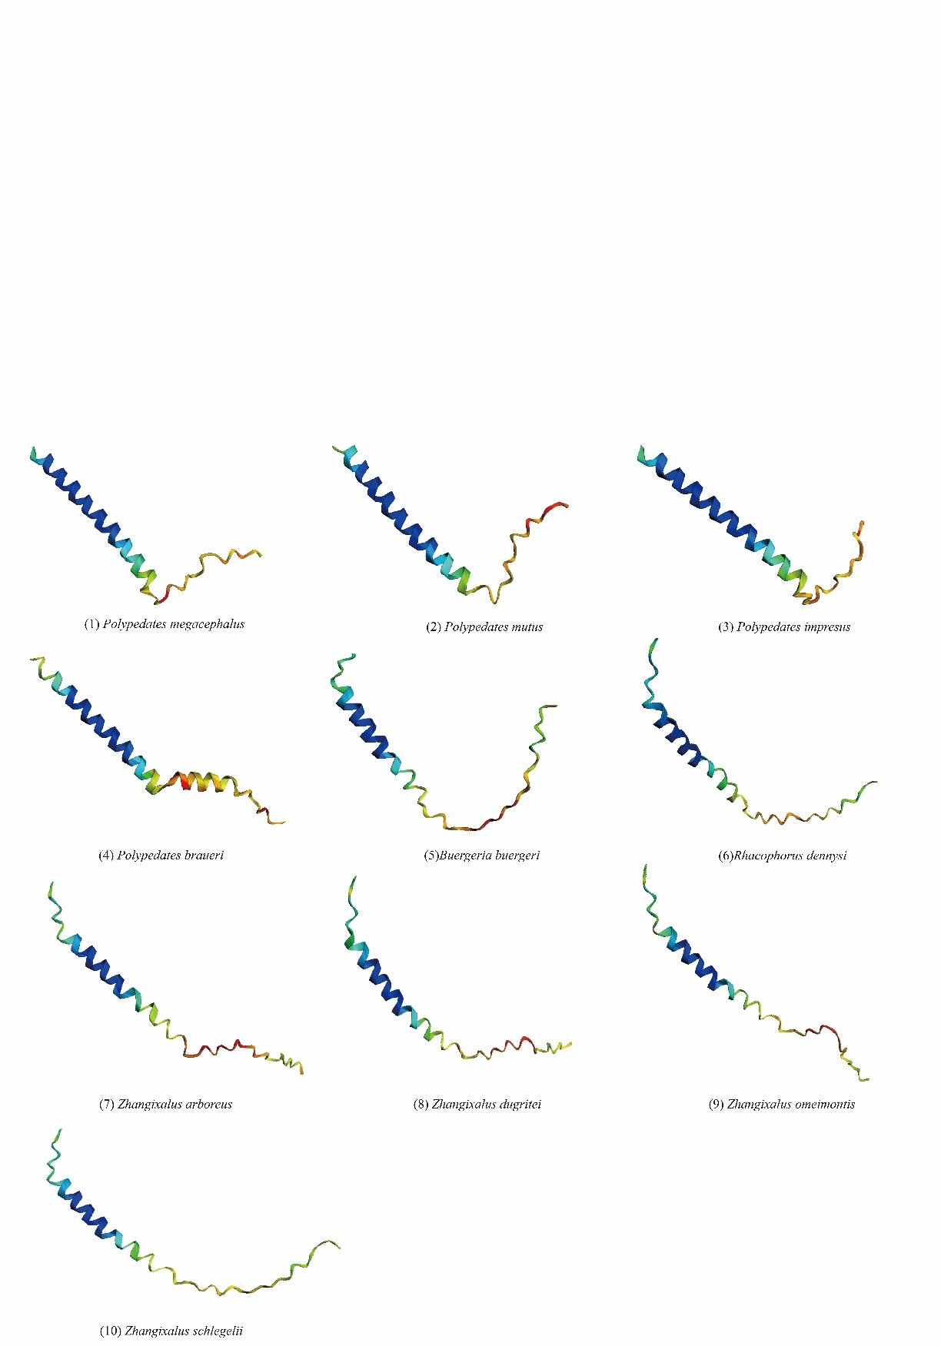
Figure S2. Three-dimensional(3D) structures of the ATP8 protein of all ten Rhacophoridae.
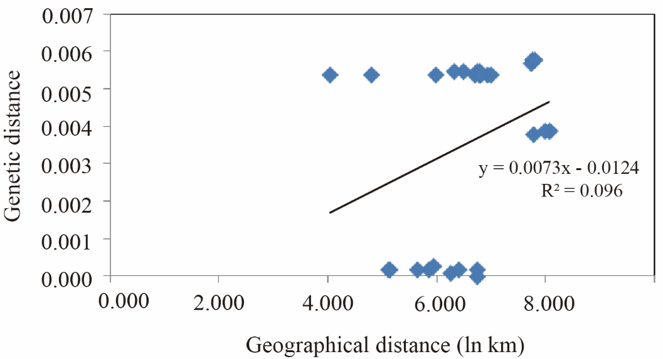
Figure S3. Scatter plots of genetic distance vs. geographical distance for pairwise population comparisons. The horizontal coordinate is Geographical distance (ln Km), and the vertical coordinate is Genetic distance.

Table S1. Collection data of samples of P. megacephalus.
Samples | Collecting locality | Latitude | Longitude
ZJJH | Wucheng, Jinhua, Zhejiang, China | 29.14 °N | 119.64 °E
ZJWZ | Chashan, Wenzhou, Zhejiang, China | 27.92 °N | 120.70 °E
GXGL | Xiangshan, Guilin, Guangxi, China | 25.21 °N | 110.25 °E
GDQY | Huadu, Guangzhou, Guangdong, China | 23.58 °N | 113.22 °E
GDCH | Conghua, Guangzhou, Guangdong, China | 23.65 °N | 113.78 °E
GDHD | Huidong, Huizhou, Guangdong,China | 22.985 °N | 114.71 °E
FJFQ | Fuqing, Fuzhou, Fujian, China | 25.71 °N | 119.25 °E
TGPJ | Phuket Island, Thailand | 7.84 °N | 98.37 °E

Table S2. The other PCR primer pairs, sequences, and used in this study.
PCR Fragments | Primer Names | Primer Sequence(5’ - 3’) | Length of Fragments
F5 | P1-219-J | AAAGCATAGTGCTGAAAACGC | ~600 bp
 | P1-818-N | TTGTCGATTATAGAACAGGCTCCTCT
F6 | P2-1162-J | TAGAAGAGGCAAGTCGTAAC | ~1,800 bp
 | P2-2951-N | GGTGGGTGAGGTAAAGTATT
F7 | P3-2611-J | GGCTTACGACCTCGATGTTGGATCA | ~1,400 bp
 | P3-4062-N | GGTATGGGCCCAARAGCTT
F8 | P4-3917-J | GAAAGATAAGGAYCTCCTTGATAG | ~1,400 bp
 | P4-5347-N | AAGTAGAATGAAGCTCGCTGG
F9 | P5-5169-J | AGCCCGAAGGCCTTCAAAGC | ~2,000 bp
 | P5-7236-N | ATAATAGGGGATGCGGCGTCTTG
F10 | P6-7069-J | CGAGAAAGGAAGGAGTTGAAC | ~2,500 bp
 | P6-9543-N | GGTCATGGGCTGGGGTTTACTAT
F11 | P7-7925-J | CGCGACGGCCTTTTAAGCT | ~2,000 bp
 | P7-10724-N | TGAGYCGAAATCAGGTGTCTT
F12 | P8-10278-J | TCAATTTACTGATGAGGTTT | ~2,300 bp
 | P8-12511-N | TTGCTAACTACTTATTACCGCGGTTC
F13 | P9-12425-J | AAAACATTAGGCTGTGGCTCTA | ~800 bp
 | P9-13284-N | AGCGATGTGTCTGCAGTGTAGTG
F14 | P10-13065-J | TAACCTAGACCTATAGTCCGAAAA | ~1,000 bp
 | P10-14136-N | TCTTCTACTGGTTGGCCTCCGAT

Table S3. List of species used in the phylogenetic analyses.
Family | Genus | Species | Genome length | GenBank No.
Rhacophoridae | Polypedates | Polypedates mutus | 20,056 bp | MN869009
 |  | Polypedates braueri | 19,904 bp | MK687567
 |  | Polypedates impresus | 19,720 bp | MN869008
 |  | Polypedates megacephalus FJFQ | 23,798 bp | OP936085
 |  | Polypedates megacephalus GDCH | 23,848 bp | OP936086
 |  | Polypedates megacephalus GXGL | 23,996 bp | OP965715
 |  | Polypedates megacephalus ZJJH | 24,103 bp | OP965717
 |  | Polypedates megacephalus TGPJ | 23,881 bp | OP965716
 |  | Polypedates megacephalus GDHD | 15,353 bp | OP965713
 |  | Polypedates megacephalus GDQY | 17,012 bp | OP965714
 |  | Polypedates megacephalus ZJWZ | 15,361 bp | OP965718
 |  | Polypedates megacephalus 20130003 | 19,952 bp | MH936677
 |  | Polypedates megacephalus | 16,473bp | AY458598
 | Zhangixalus | Zhangixalus dennysi | 18,052 bp | KM035412
 |  | Zhangixalus omeimontis | 19,604 bp | MN427892
 |  | Zhangixalus schlegelii | 21,359 bp | AB202078
 |  | Zhangixalus dugritei | 19,412 bp | MZ712011
 |  | Zhangixalus arboreus | 22,236 bp | LC565708
 | Buergeria | Buergeria buergeri | 19,959 bp | AB127977
Mantellidae | Mantella | Mantella madagascariensis | 22,874 bp | AB212225
 |  | Mantella baroni | 20,945 bp | MH141579

Table S4. The partition schemes and best-fitting models selected for the 11 protein-coding genes and 2 rRNA genes.
Subset | Nucleotide sequence alignments
 | Subset partitions | Best model
Partition 1 | ND3_codon1, ND4L_codon1, ND1_codon1, ATP6_condon1, ND4_codon1, ND2_codon1 | GTR+I+G
Partition 2 | ND4L_codon2, ND2_codon2, ND4_codon2, ND3_codon2, ATP6_codon2 | TVM+I+G
Partition 3 | ATP6_codon3, ND4L_codon3, COI_codon3, ND3_codon3, COII_codon3, COIII_codon3 | TRN+G
Partition 4 | Cytb_codon1, COII_codon1, COI_codon1, COIII_codon1 | SYM+G
Partition 5 | COI_codon2, ND1_codon2, Cytb_codon2, COII_codon2, COIII_codon2 | HKY+I+G
Partition 6 | Cytb_codon3, ND2_codon3, ND4_codon3, ND1_codon3 | TRN+I+G
Partition 7 | ND6_codon1, ND6_codon2 | HKY+G
Partition 8 | ND6_codon3 | TRN+G
Partition 9 | rrnS, rrnL | GTR+I+G

Table S5. Base compositions of five P. megacephalus mitogenomes.
Species name | A+T (%) |  |  |  | AT-skew |  |  |  |  |  | GC-skew
 | Mito | PCGs | rRNAs | Contral  region | Mito | PCGs-H | PCGs-L | rRNAs | Contral  region | Mito |  | PCGs-H | PCGs-L | rRNAs | Contral  region
GXGL | 61.9 | 59.9 | 59.5 | 68.5 | -0.009 | -0.056 | -0.353 | 0.146 | -0.018 | -0.252 |  | -0.293 | 0.464 | -0.102 | 0.247
GDCH | 61.2 | 59.4 | 59.3 | 67.7 | -0.005 | -0.050 | -0.414 | 0.144 | -0.021 | -0.263 |  | -0.299 | 0.525 | -0.099 | 0.279
ZJJH | 61.4 | 59.2 | 59.2 | 68.3 | -0.003 | -0.048 | -0.427 | 0.146 | -0.015 | -0.267 |  | -0.301 | 0.520 | -0.101 | 0.289
FJFQ | 61.1 | 59.2 | 59.0 | 67.8 | -0.002 | -0.048 | -0.414 | 0.147 | -0.015 | -0.264 |  | -0.300 | 0.525 | -0.105 | 0.276
TGPJ | 61.2 | 59.3 | 59.3 | 67.6 | -0.007 | -0.052 | -0.392 | 0.143 | -0.016 | -0.254 |  | -0.293 | 0.507 | -0.089 | 0.262

Table S6. Locations of features in the mtDNA of P. megacephalus from five regions.
Feature | Strand | Position | Length | Initiation | Stop | Anticodon | Intergenic
 |  |  | (bp) | codon | codon |  | nucleotide
tRNA^{Thr} | H | 1-71 | 71 |  |  | TGT
tRNA^{Leu(CUN)} | H | 72-143 | 72 |  |  | TAG | 5
tRNA^{Pro} | L | 149-217 | 69 |  |  | TGG | 1
tRNA^{Phe} | H | 219-288 | 70 |  |  | GAA | -2
12S rRNA | H | 287-1216 | 930
tRNA^{Val} | H | 1217-1285 | 69 |  |  | TAC
16S rRNA | H | 1286-2856 | 1571 |  |  |  | 2
tRNA^{Leu(UUR)} | H | 2859-2932 | 74 |  |  | TAA | 3
ND1 | H | 2936-3896. | 961 | ATG | T(AA)
tRNA^{Ile} | H | 3897-3967 | 71 |  |  | GAT | -1
tRNA^{Gln} | L | 3967-4037 | 71 |  |  | TTG | -1
tRNA^{Met} | H | 4037-4105 | 69 |  |  | CAT
ND2 | H | 4106-5143 | 1038 | ATT | TAG |  | -2
tRNA^{Trp} | H | 5142-5212 | 71 |  |  | TCA
tRNA^{Ala} | L | 5213-5282 | 70 |  |  | TGC | 1
tRNA^{Asn} | L | 5284-5356 | 73 |  |  | GTT | 2
OL | L | 5359-5384 | 26 |  |  |  | -1
tRNA^{Cys} | L | 5384-5448 | 65 |  |  | GCA
tRNA^{Tyr} | L | 5449-5515 | 67 |  |  | GTA | 4
COI | H | 5520-7073 | 1554 | ATA | AGG |  | -13
tRNA^{Ser(UCN)} | L | 7061-7131 | 71 |  |  | TGA | 1
tRNA^{Asp} | H | 7133-7201 | 69 |  |  | GTC
COII | H | 7202-7891 | 690 | ATA | TAA |  | 5
tRNA^{Lys} | H | 7897-7966 | 70 |  |  | TTT
NC | H | 7967-8679 | 713
ATP8 | H | 8680-8832 | 153 | ATG | TAG |  | -4
ATP6 | H | 8829-9507 | 679 | ATA | T(AA)
COIII | H | 9508-10291 | 784 | ATG | T(AA)
tRNA^{Gly} | H | 10292-10359 | 68 |  |  | TCC
ND3 | H | 10360-10699 | 340 | ATG | T(AA)
tRNA^{Arg} | H | 10700-10768 | 69 |  |  | TCG
ND4L | H | 10769-11053 | 285 | ATG | TAA |  | -7
ND4 | H | 11047-12409 | 1363 | GTG | T(AA)
tRNA^{His} | H | 12410-12478 | 69 |  |  | GTG
tRNA^{Ser(AGY)} | H | 12479-12546 | 68 |  |  | GCT | 2
ND6 | L | 12549-13040 | 492 | ATG | AGG
tRNA^{Glu} | L | 13041-13109 | 69 |  |  | TTC | 4
Cytb | H | 13114-14269 | 1156 | ATG | T(AA)
CR1 | H | 14270-15920 | 1651
ND5 | H | 15921-17699 | 1779 | ATG | TAA
CR2 | H | 17700-19384 | 1685
ND5 | H | 19385-21163 | 1779 | ATG | TAA
CR3 | H | 21164-24103 | 2940
“H”means gene encoded by the H-strand, “L” means gene encoded by the L-strand. Intergenic nucleotide represent noncoding base between genes, a negative number(-) denotes a gene overlapping.

Table S6. 2 Location of features in the mtDNA of P.megacephalus FJBT.
Feature | Strand | Position | Length | Initiation | Stop | Anticodon | Intergenic
 |  |  | (bp) | codon | codon |  | nucleotide
tRNA^{Thr} | H | 1-71 | 71 |  |  | TGT | 0
tRNA^{Leu(CUN)} | H | 72-143 | 72 |  |  | TAG | 5
tRNA^{Pro} | L | 149-216 | 69 |  |  | TGG | 1
tRNA^{Phe} | H | 219-288 | 70 |  |  | GAA | -2
12S rRNA | H | 287-1216 | 930 |  |  |  | 0
tRNA^{Val} | H | 1217-1285 | 69 |  |  | TAC | 0
16S rRNA | H | 1286-2864 | 1579 |  |  |  | 2
tRNA^{Leu(UUR)} | H | 2867-2940 | 74 |  |  | TAA | 3
ND1 | H | 2944-3904 | 961 | ATG | T(AA) |  | 0
tRNA^{Ile} | H | 3905-3975 | 71 |  |  | GAT | -1
tRNA^{Gln} | L | 3975-4045 | 71 |  |  | TTG | -1
tRNA^{Met} | H | 4045-4113 | 69 |  |  | CAT | 0
ND2 | H | 4114-5151 | 1038 | ATT | TAG |  | -2
tRNA^{Trp} | H | 5150-5220 | 71 |  |  | TCA | 0
tRNA^{Ala} | L | 5221-5290 | 70 |  |  | TGC | 1
tRNA^{Asn} | L | 5292-5364 | 73 |  |  | GTT | 2
OL | L | 5367-5392 | 26 |  |  |  | -1
tRNA^{Cys} | L | 5392-5456 | 65 |  |  | GCA | 0
tRNA^{Tyr} | L | 5457-5523 | 67 |  |  | GTA | 4
COI | H | 5528-7081 | 1554 | ATA | AGG |  | -13
tRNA^{Ser(UCN)} | L | 7069-7139 | 71 |  |  | TGA | 1
tRNA^{Asp} | H | 7141-7209 | 69 |  |  | GTC | 0
COII | H | 7210-7899 | 690 | ATA | TAA |  | 5
tRNA^{Lys} | H | 7905-7974 | 70 |  |  | TTT | 0
NC | H | 7975-8687 | 713 |  |  |  | 0
ATP8 | H | 8688-6640 | 153 | ATA | TAG |  | -4
ATP6 | H | 8837-9515 | 679 | ATA | T(AA) |  | 0
COIII | H | 9516-10299 | 784 | ATG | T(AA) |  | 0
tRNA^{Gly} | H | 10300-10367 | 68 |  |  | TCC | 0
ND3 | H | 10368-10707 | 340 | ATG | T(AA) |  | 0
tRNA^{Arg} | H | 10708-10776 | 69 |  |  | TCG | 0
ND4L | H | 10777-11061 | 285 | ATG | TAA |  | -7
ND4 | H | 11055-12417 | 1363 | GTG | T(AA) |  | 0
tRNA^{His} | H | 12418-12486 | 69 |  |  | GTG | 0
tRNA^{Ser(AGY)} | H | 12487-12554 | 68 |  |  | GCT | 2
ND6 | L | 12557-13048 | 492 | ATG | AGG |  | 0
tRNA^{Glu} | L | 13049-13117 | 69 |  |  | TTC | 4
Cytb | H | 13122-14277 | 1156 | ATG | T(AA)
CR1 | H | 14278-15929 | 1652
ND5 | H | 15930-17708 | 1779 | ATG | TAA
CR2 | H | 17709-19280 | 1572
ND5 | H | 19281-21059 | 1779 | ATG | TAA
CR3 | H | 21060-23798 | 2739
Notes.“H”means gene encoded by the H-strand, “L” means gene encoded by the L-strand. Intergenic nucleotide represent noncoding base between genes, a negative number(-) denotes a gene overlapping.

Table S6. 3 Location of features in the mtDNA of P.megacephalus GDCH.
Feature | Strand | Position | Length | Initiation | Stop | Anticodon | Intergenic
 |  |  | (bp) | codon | codon |  | nucleotide
tRNA^{Thr} | H | 1-71 | 71 |  |  | TGT
tRNA^{Leu(CUN)} | H | 72-142 | 71 |  |  | TAG | 5
tRNA^{Pro} | L | 148-216 | 69 |  |  | TGG | 1
tRNA^{Phe} | H | 218-287 | 70 |  |  | GAA | -2
12S rRNA | H | 286-1216 | 930
tRNA^{Val} | H | 1216-1285 | 70 |  |  | TAC | 2
16S rRNA | H | 1288-2858 | 1571
tRNA^{Leu(UUR)} | H | 2859-2932 | 74 |  |  | TAA | 3
ND1 | H | 2936-3896. | 961 | ATG | T(AA)
tRNA^{Ile} | H | 3897-3967 | 71 |  |  | GAT | -1
tRNA^{Gln} | L | 3967-4037 | 71 |  |  | TTG | -1
tRNA^{Met} | H | 4037-4105 | 69 |  |  | CAT
ND2 | H | 4106-5143 | 1038 | ATT | TAG |  | -2
tRNA^{Trp} | H | 5142-5212 | 71 |  |  | TCA
tRNA^{Ala} | L | 5213-5282 | 70 |  |  | TGC | 1
tRNA^{Asn} | L | 5284-5356 | 73 |  |  | GTT | 2
OL | L | 5359-5384 | 26 |  |  |  | -1
tRNA^{Cys} | L | 5384-5448 | 65 |  |  | GCA
tRNA^{Tyr} | L | 5449-5515 | 67 |  |  | GTA | 4
COI | H | 5520-7073 | 1554 | ATA | AGG |  | -13
tRNA^{Ser(UCN)} | L | 7061-7131 | 71 |  |  | TGA | 1
tRNA^{Asp} | H | 7133-7201 | 69 |  |  | GTC
COII | H | 7202-7891 | 690 | ATA | TAA |  | 5
tRNA^{Lys} | H | 7897-7966 | 70 |  |  | TTT
NC | H | 7967-8679 | 713
ATP8 | H | 8680-8832 | 153 | ATG | TAG |  | -4
ATP6 | H | 8829-9507 | 679 | ATA | T(AA)
COIII | H | 9508-10291 | 784 | ATG | T(AA)
tRNA^{Gly} | H | 10292-10359 | 68 |  |  | TCC
ND3 | H | 10360-10699 | 340 | ATG | T(AA)
tRNA^{Arg} | H | 10700-10768 | 69 |  |  | TCG
ND4L | H | 10769-11053 | 285 | ATG | TAA |  | -7
ND4 | H | 11047-12409 | 1363 | GTG | T(AA)
tRNA^{His} | H | 12410-12478 | 69 |  |  | GTG
tRNA^{Ser(AGY)} | H | 12479-12546 | 68 |  |  | GCT | 2
ND6 | L | 12549-13040 | 492 | ATG | AGG
tRNA^{Glu} | L | 13041-13109 | 69 |  |  | TTC | 4
Cytb | H | 13114-14269 | 1156 | ATG | T(AA)
CR1 | H | 14270-15918 | 1649
ND5 | H | 15919-17697 | 1779 | ATG | TAA
CR2 | H | 17698-19304 | 1607
ND5 | H | 19305-21083 | 1779 | ATG | TAA
CR3 | H | 21084-23848 | 2765
Notes.“H”means gene encoded by the H-strand, “L” means gene encoded by the L-strand. Intergenic nucleotide represent noncoding base between genes, a negative number(-) denotes a gene overlapping.

Table S6. 4 Location of features in the mtDNA of P.megacephalus TGPJ.
Feature | Strand | Position | Length | Initiation | Stop | Anticodon | Intergenic
 |  |  | (bp) | codon | codon |  | nucleotide
tRNA^{Thr} | H | 1-71 | 71 |  |  | TGT | 0
tRNA^{Leu(CUN)} | H | 72-143 | 72 |  |  | TAG | 5
tRNA^{Pro} | L | 149-217 | 69 |  |  | TGG | 1
tRNA^{Phe} | H | 219-288 | 70 |  |  | GAA | -2
12S rRNA | H | 287-1216 | 930 |  |  |  | 0
tRNA^{Val} | H | 1217-1285 | 69 |  |  | TAC | 0
16S rRNA | H | 1286-2856 | 1571 |  |  |  | 2
tRNA^{Leu(UUR)} | H | 2859-2932 | 74 |  |  | TAA | 3
ND1 | H | 2936-3896 | 961 | ATG | T(AA) |  | 0
tRNA^{Ile} | H | 3897-3967 | 71 |  |  | GAT | -1
tRNA^{Gln} | L | 3967-4037 | 71 |  |  | TTG | -1
tRNA^{Met} | H | 4037-4105 | 69 |  |  | CAT | 0
ND2 | H | 4106-5143 | 1038 | ATT | TAG |  | -2
tRNA^{Trp} | H | 5142-5212 | 71 |  |  | TCA | 0
tRNA^{Ala} | L | 5213-5282 | 70 |  |  | TGC | 1
tRNA^{Asn} | L | 5284-5356 | 73 |  |  | GTT | 2
OL | L | 5359-5384 | 26 |  |  |  | -1
tRNA^{Cys} | L | 5384-5448 | 65 |  |  | GCA | 0
tRNA^{Tyr} | L | 5449-5515 | 67 |  |  | GTA | 4
COI | H | 5520-7073 | 1554 | ATA | AGG |  | -13
tRNA^{Ser(UCN)} | L | 7061-7131 | 71 |  |  | TGA | 1
tRNA^{Asp} | H | 7133-7201 | 69 |  |  | GTC | 0
COII | H | 7202-7891 | 690 | ATA | TAA |  | 5
tRNA^{Lys} | H | 7897-7966 | 70 |  |  | TTT | 0
NC | H | 7967-8679 | 713 |  |  |  | 0
ATP8 | H | 8680-8832 | 153 | ATG | TAG |  | -4
ATP6 | H | 8829-9507 | 679 | ATA | T(AA) |  | 0
COIII | H | 9508-10291 | 784 | ATG | T(AA) |  | 0
tRNA^{Gly} | H | 10292-10359 | 68 |  |  | TCC | 0
ND3 | H | 10360-10699 | 340 | ATG | T(AA) |  | 0
tRNA^{Arg} | H | 10700-10768 | 69 |  |  | TCG | 0
ND4L | H | 10769-11053 | 285 | ATG | TAA |  | -7
ND4 | H | 11047-12409 | 1363 | GTG | T(AA) |  | 0
tRNA^{His} | H | 12410-12478 | 69 |  |  | GTG | 0
tRNA^{Ser(AGY)} | H | 12479-12546 | 68 |  |  | GCT | 2
ND6 | L | 12549-13040 | 492 | ATG | AGG |  | 0
tRNA^{Glu} | L | 13041-13109 | 69 |  |  | TTC | 4
Cytb | H | 13114-14269 | 1156 | ATG | T(AA) |  | 0
CR1 | H | 14270-15908 | 1639 |  |  |  | 0
ND5 | H | 15909-17693 | 1785 | ATG | TAA |  | 0
CR2 | H | 17694-19266 | 1573 |  |  |  | 0
ND5 | H | 19267-21051 | 1785 | ATG | TAA |  | 0
CR3 | H | 21052-23881 | 2830
Notes. “H”means gene encoded by the H-strand, “L” means gene encoded by the L-strand. Intergenic nucleotide represent noncoding base between genes, a negative number(-) denotes a gene overlapping.

Table S6. 5 Location of features in the mtDNA of P.megacephalus GXGL.
Feature | Strand | Position | Length | Initiation | Stop | Anticodon | Intergenic
 |  |  | (bp) | codon | codon |  | nucleotide
tRNA^{Thr} | H | 1-71 | 71 |  |  | TGT
tRNA^{Leu(CUN)} | H | 72-143 | 72 |  |  | TAG | 5
tRNA^{Pro} | L | 149-217 | 69 |  |  | TGG | 1
tRNA^{Phe} | H | 219-288 | 70 |  |  | GAA | -2
12S rRNA | H | 287-1216 | 930
tRNA^{Val} | H | 1217-1285 | 69 |  |  | TAC
16S rRNA | H | 1286-2860 | 1575 |  |  |  | 2
tRNA^{Leu(UUR)} | H | 2863-2936 | 74 |  |  | TAA | 3
ND1 | H | 2940-3900 | 961 | ATG | T(AA)
tRNA^{Ile} | H | 3901-3971 | 71 |  |  | GAT | -1
tRNA^{Gln} | L | 3971-4041 | 71 |  |  | TTG | -1
tRNA^{Met} | H | 4041-4109 | 69 |  |  | CAT
ND2 | H | 4110-5147 | 1038 | ATT | TAG |  | -2
tRNA^{Trp} | H | 5146-5216 | 71 |  |  | TCA
tRNA^{Ala} | L | 5217-5286 | 70 |  |  | TGC | 1
tRNA^{Asn} | L | 5288-5360 | 73 |  |  | GTT | 2
OL | L | 5363-5388 | 26 |  |  |  | -1
tRNA^{Cys} | L | 5388-5452 | 65 |  |  | GCA
tRNA^{Tyr} | L | 5453-5519 | 67 |  |  | GTA | 4
COI | H | 5524-7077 | 1554 | ATA | AGG |  | -13
tRNA^{Ser(UCN)} | L | 7065-7135 | 71 |  |  | TGA | 1
tRNA^{Asp} | H | 7137-7205 | 69 |  |  | GTC
COII | H | 7206-7895 | 690 | ATA | TAA |  | 5
tRNA^{Lys} | H | 7901-7970 | 70 |  |  | TTT
NC | H | 7971-8678 | 708
ATP8 | H | 8679-8831 | 153 | ATG | TAG |  | -4
ATP6 | H | 8828-9506 | 679 | ATA | T(AA)
COIII | H | 9507-10290 | 784 | ATG | T(AA)
tRNA^{Gly} | H | 10291-10358 | 68 |  |  | TCC
ND3 | H | 10359-10698 | 340 | ATG | T(AA)
tRNA^{Arg} | H | 10699-10767 | 69 |  |  | TCG
ND4L | H | 10768-11052 | 285 | ATG | TAA |  | -7
ND4 | H | 11046-12408 | 1363 | GTG | T(AA)
tRNA^{His} | H | 12409-12477 | 69 |  |  | GTG
tRNA^{Ser(AGY)} | H | 12478-12545 | 68 |  |  | GCT | 2
ND6 | L | 12548-13039 | 492 | ATG | AGG
tRNA^{Glu} | L | 13040-13108 | 69 |  |  | TTC | 4
Cytb | H | 13113-14268 | 1156 | ATG | T(AA)
CR1 | H | 14269-15999 | 1731
ND5 | H | 16000-17778 | 1779 | ATG | TAA
CR2 | H | 17779-19471 | 1693
ND5 | H | 19472-21250 | 1779 | ATG | TAA
CR3 | H | 21251-23996 | 2746
Notes. “H”means gene encoded by the H-strand, “L” means gene encoded by the L-strand. Intergenic nucleotide represent noncoding base between genes, a negative number(-) denotes a gene overlapping.

Table S7. Features of P. megacephalus control regions.
species | Length of CR1 | copy number of 38 bp tandem repeat in CR1 | Length of CR2 | copy number of 38 bp tandem repeat in CR2 | Length of CR3 | copy number of 38 bp tandem repeat in CR3 | copy number of 100 bp tandem repeats in CR3 | Length of similar regions/similarity
GDCH | 1649 | 8.6 | 1607 | 7.5 | 2765 | 7.5 | 11.6 | 99%  (99.32%)
FJFQ | 1652 | 8.6 | 1572 | 6.5 | 2739 | 9.5 | 10.6 | 99%  (98.92%)
GXGL | 1731 | 9.6 | 1693 | 8.5 | 2746 | 9.5 | 10.7 | 99%  (99.76%)
ZJJH | 1651 | 8.6 | 1685 | 9.5 | 2940 | 9.5 | 12.6 | 99%  (99.45%)
TGPJ | 1639 | 7.6 | 1573 | 6.5 | 2830 | 6.5 | 12.6 | 99%  (98.98%)

Table S8. Pairwise genetic distance (below diagonal) and natural logarithm of geographical distance (km) (above diagonal) between geographical populations of P. megacephalus based on the mitogenomes. The specific collection locations of the two published sequences (MH936677 and AY458598) retrieved from the NCBI database are unknown, and geographical distances to other samples were not calculated.
Samples | ZJJH | ZJWZ | GXGL | GDQY | GDCH | GDHD | FJFQ | TGPJ | MH936677 | AY458598
ZJJH |  | 5.140 | 6.934 | 6.788 | 6.737 | 6.735 | 5.945 | 8.084 | - | -
ZJWZ | 0.002 |  | 6.988 | 6.792 | 6.734 | 6.701 | 5.649 | 8.081 | - | -
GXGL | 0.054 | 0.054 |  | 5.861 | 5.984 | 6.247 | 6.810 | 7.740 | - | -
GDQY | 0.055 | 0.054 | 0.002 |  | 4.040 | 5.113 | 6.483 | 7.764 | - | -
GDCH | 0.002 | 0.000 | 0.054 | 0.054 |  | 4.794 | 6.396 | 7.783 | - | -
GDHD | 0.055 | 0.054 | 0.001 | 0.002 | 0.054 |  | 6.311 | 7.792 | - | -
FJFQ | 0.003 | 0.002 | 0.054 | 0.055 | 0.002 | 0.055 |  | 7.996 | - | -
TGPJ | 0.039 | 0.039 | 0.057 | 0.058 | 0.038 | 0.058 | 0.039 |  | - | -
MH936677 | 0.003 | 0.002 | 0.054 | 0.055 | 0.002 | 0.055 | 0.002 | 0.039 |  | -
AY458598 | 0.055 | 0.055 | 0.001 | 0.003 | 0.055 | 0.002 | 0.055 | 0.058 | 0.056

