Supplementary Materials
Role of curing agents in the adaptive response of the bioprotective Latilactobacillus curvatus CRL 705 from a physiologic and proteomic perspective
Lucrecia C. Terán¹, Alejandra Orihuel¹, Emilse Bentencourt¹, E, Raúl Raya¹ and Silvina Fadda^{1,}*
¹ Centro de Referencia para Lactobacilos, Consejo Nacional de Investigaciones Científicas y Técnicas (CERELA CONICET, CCT Tucumán), Chacabuco 145, T4000ILC Tucumán, Argentina; lucreteran@gmail.com (L.C.T.), aorihuel@mpdtucuman.gob.ar (A.O.), ebentencourt@cerela.org.ar (E.B.), rraya@cerela.org.ar (R.R.)
* Correspondence: sfadda@cerela.org.ar (S.F.)

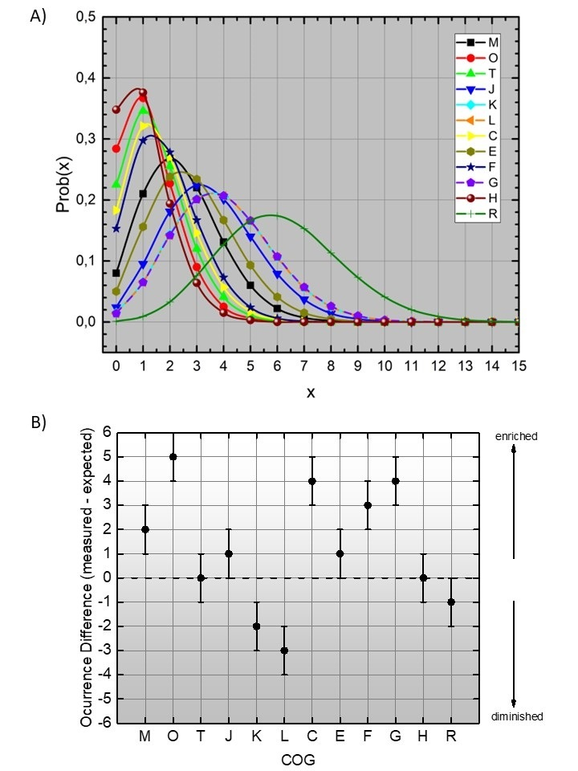
Figure 1. A) Hypergeometric distribution for the probabilities (Prob) of finding a certain COG functional category a certain number of times “x” of the differentially expressed proteins of L. curvatus CRL 705 while growing in CDM with and without additives at 25 °C. The highest value of the y axis (Prob) for each of the curves represents the higher probability of the times of occurrence of proteins from a certain COG. B) Differences between measured and expected occurrence for the proteins of each COG category, where 0 represents no differences in occurrence and separates potentially enriched categories (positive values) from the potentially impoverished categories (negative values).

Table S2. Differentially expressed proteins by L. curvatus CRL 705 during growth in CDM with (CDM^{+CA}) and without (CDM⁻) the presence of curing additives (CA) at 25°C
Biological process | COGª | Spot Nº^{b} | UniProt entry | Name of the protein and abbreviation | MASCOT  Score^{c} | # matching peptides^{d} | MM/pl^{f} | Fold change^{g} | Detailed 2DE gel showing differentially expressed  spot in:  CDM^{+CA} | CDM⁻
TRANSLATION AND MODIFICATION OF PROTEINS | O | LT04 | A0A3R5V4Y6 | Trigger factor  Tig  WP_004271115.1 | 218 | 7 | 47903/  4.43 | -1.5 | 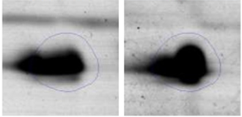
 | O | LT08 | A0A385ACP8 | ATP-dependent Clp protease ATP-binding subunit  DT351_03000  WP_004265761.1 | 136 | 4 | 81331/  5.06 | -3.0 | 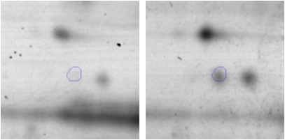
 | J | LT12 | A0A385ACG4 | Glutamyl-tRNA(Gln) amidotransferase subunit A  GatA  WP_004270872.1 | 408 | 12 | 51771/  4.90 | -1.2 | 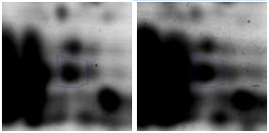
 | J | LT16 | A0A1B2A539 | 50S ribosomal protein L10  RplJ  WP_064777478.1 | 350 | 8 | 17832/  4.97 | -1.3 | 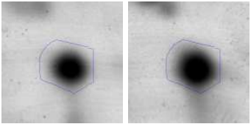
 | J | LT25 | A0A1X7QIK5 | Elongation factor Tu  TufA  WP_004271118.1 | 112 | 2 | 43183/  4.70 | -1.2 | 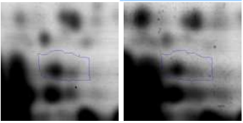
 | J | LT40 | A0A1B2A552 | 50S ribosomal protein L7/L12  RplL  WP_004270851.1 | 413 | 4 | 12639/ 4.43 | -1.5 | 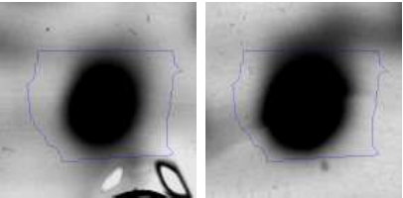
 | O | LT42 | A0A0B2XPV1 | Molecular chaperone  GroEL  WP_004265033.1 | 324 | 6 | 57243/  4.67 | -1.4 | 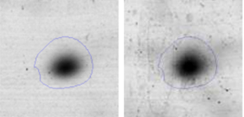
 | G | LT09 | A0A0B2XPK6 | 2,3-diphosphoglycerate-dependent phosphoglycerate mutase  GpmA  WP_039098080.1 | 111 | 2 | 258382/  5.13 | -1.5 | 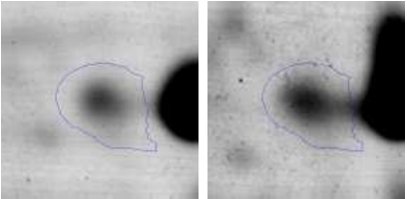
CARBOHYDRATES METABOLISM AND ENERGY PRODUCTION | G | LT10 | UPI000230F3DE | sn-glycerol-3-phosphate ABC transporter ATP-binding protein  UgpC  WP_004266075.1 | 161 | 3 | 40966/  5.36 | +2.3 | 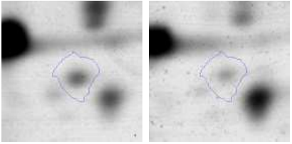
 | G | LT26 | UPI000230F588 | PTS mannose transporter subunit IIAB  ManX  WP_004270728.1 | 279 | 7 | 35347/  5.34 | -1.3 | 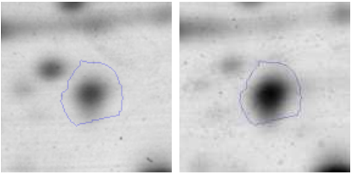
 | G | LT27 | A0A0B2XK70 | (ATP dependent)  6-phosphofructokinase  PfkA  KHO12221.1 | 234 | 6 | 33664/  5.26 | -1.5 | 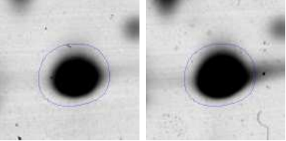
 | G | LT30 | A0A1B2A4B2 | 2,3-diphosphoglycerate-dependent phosphoglycerate mutase  GpmA  WP_004271006.1 | 345 | 8 | 25868/  5.04 | -1.5 | 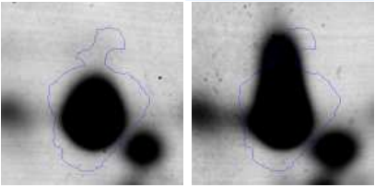
 | G | LT31 | A0A1B2A408 | Histidine phosphatase  LCU_08255  WP_004266073.1 | 300 | 9 | 24829/  6.08 | -1.8 | 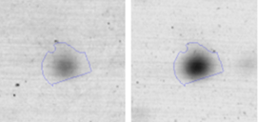
 | C | LT32 | A0A1B2A5E8 | L-lactate dehydrogenase  Ldh  WP_004270763.1 | 298 | 7 | 33664/  5.26 | -1.4 | 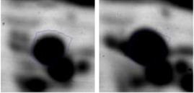
 | G  T | LT36 | UPI000230EFAA | Pyruvate kinase  Pyk  WP_004270411.1 | 271 | 8 | 62980/ 5.27 | -1.4 | 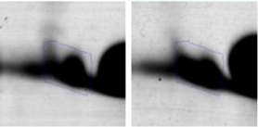
 | C | LT41 | A0A385ADR5 | L-lactate oxidase  DT351_03565  WP_004265223.1 | 220 | 1 | 39721/  5.36 | +1.7 | 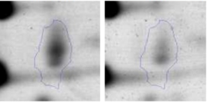
 | C | LT43 | UPI000B5E1B86 | Dihydrolipoyl dehydrogenase  LpdA  ASN60289.1 | 103 | 1 | 49610  49330/  5.07 | -1.4 | 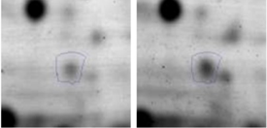
METABOLISM AND TRANSPORT OF AMINOACIDS AND NUCLEOTIDES | F | LT02 | A0A4U0E4L1 | Dihydroorotase  FCF11_02690  WP_004270425.1 | 226 | 8 | 46224/  5.45 | -2.8 | 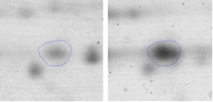
 | F | LT07 | A0A4U0E0K0 | CTP sintetase  FCF11_05720  WP_004270634.1 | 314 | 7 | 58991/  5.44 | -2.7 | 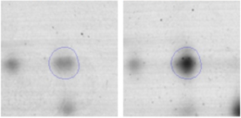
 | E | LT11 | UPI000230F388 | Type I glutamate--ammonia ligase  GlnA  WP_004265314.1 | 382 | 9 | 50544/  5.40 | -2.3 | 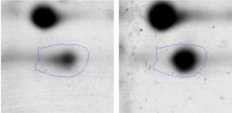
 | E  H | LT19 | UPI0006F0BB97 | Pyruvate oxidase  Pox  KRK92661.1 | 240 | 9 | 61527/ 5.06 | +1.6 | 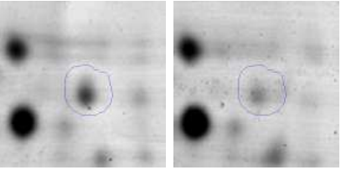
 | F  R | LT28 | A0A1B2A4E0 | IMP dehydrogenase  GuaB  WP_004265151.1 | 355 | 9 | 52368/  5.37 | -1.5 | 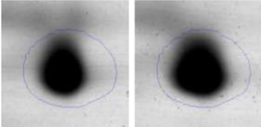
 | E | LT35 | UPI000230EFAA | ABC transporter family protein  OppF  WP_004265559.1 | 363 | 9 | 36057/  6.09 | -1.8 | 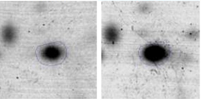
 | F | LT37 | A0A1X7QJJ2 | UMP kinase  PyrH  WP_076800600.1 | 245 | 5 | 25824/  5.04 | -1.5 | 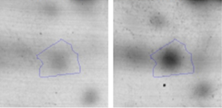
CELL WALL BIOSYNTHESIS | M | LT14 | WP_056967123.1 | bifunctional UDP-N-acetylglucosamine diphosphorylase/glucosamine-1-phosphate N-acetyltransferase, partial  GlmU | 240 | 7 | 43975/  5.73 | -1.4 | 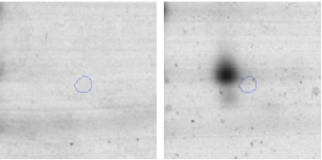
 | M | LT22 | UPI000B5EB748 | D-alanine--D-alanine ligase  Ddl  ASN59162.1  WP_004271284.1 | 281 | 6 | 38239/ 4.48 | -1.5 | 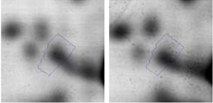
 | M | LT23 | UPI000230D57D | UTP--glucose-1-phosphate uridylyltransferase  GalU  WP_004271214.1 | 188 | 7 | 33693/ 5.52 | -1.7 | 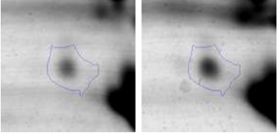
 | M | LT39 | UPI000975D304 | dTDP-4-dehydrorhamnose 3,5-epimerase  RfbC  WP_076638998.1 | 431 | 9 | 21646/  5.35 | -1.4 | 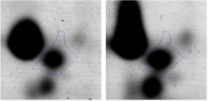
RNA RELATED | R | LT13 | A0A221RYJ7 | GTPase Era  Era  WP_004270810.1 | 165 | 5 | 34532/ 6.04 | -1.7 | 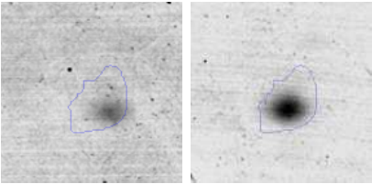
 | R | LT18 | A0A1B2A7I2 | Ribonuclease J  Rnj  WP_065825720.1 | 239 | 8 | 63559/  5.70 | -1.6 | 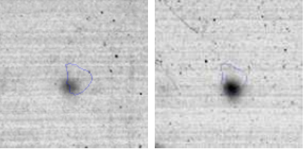
 | R | LT38 | UPI000230F4ED | Phenylalanine-tRNA ligase/  DUF4479 domain-containing protein  PheRS  WP_004270340.1 | 145 | 1 | 22224/ 4.34 | -1.3 | 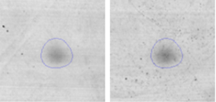
DNA REPLICATION AND REPAIR | L | LT05 | A0A0B2XPH3 | Single-stranded DNA-binding protein  Ssb  WP_004265848.1 | 367 | 6 | 18621/ 4.92 | -1.4 | 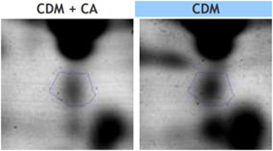
 | L | LT20 | UPI000230F194 | putative endonuclease 4  Nfo  EHE85189.1 | 107 | 6 | 32046/  5.28 | -1.5 | 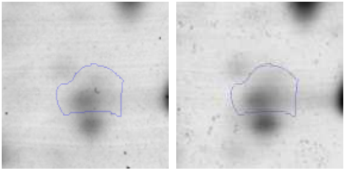
REDOX PROCESSES | O | LT06 | A0A1B2A4R3 | NAD(P)/FAD-dependentOxidoreductase  BCY75_02680  WP_004270517.1 | 173 | 3 | 36259  36281/  5.21 | -1.4 | 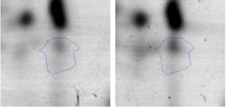
 | O  C | LT15 | A0A0B2XKA6 | Thioredoxin  TrxA  WP_004265032.1 | 140 | 9 | 11555/  4.57 | -1.6 | 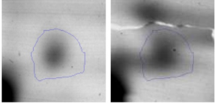
REDOX PROCESSES | O | LT21 | A0A385AFF0 | Thioredoxin-disulfide reductase  TrxB  WP_004265965.1 | 118 | 3 | 32787/  4.73 | -1.3 | 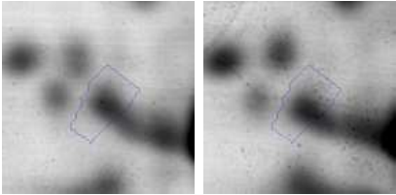
 | C  R | LT29 | A0A0B2XMI6 | NADP-dependent oxidoreductase  OA78_1420  WP_035185948.1 | 421 | 9 | 33766/ 5.13 | -1.3 | 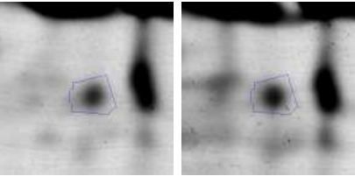
REGULATION | K | LT03 | A0A0B2XPU8 | Cold Shock protein  CspC  WP_004270163.1 | 178 | 3 | 7346/ 4.48 | -1.4 | 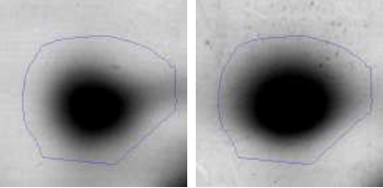
 | K | LT17 | A0A0B2XP73 | MarR family transcriptional regulator  OhrR  WP_039098448.1 | 173 | 6 | 17636/ 5.97 | -2.0 | 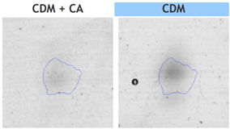
ª: Functional category according to COG database where each letter represents the different COG functional categories: O: molecular chaperones and related functions; J: translation, including ribosome structure and biogenesis; G: carbohydrate metabolism and transport; C: energy production and conversion; T: signal transduction mechanisms; K: transcription; E: amino acid transport and metabolism; F: nucleotide transport and metabolism; H: Coenzyme transport and metabolism; M: cell wall structure and biogenesis and outer membrane; L: Replication, recombination and repair; K: Transcription; R: general functional prediction only.
^{b}: Spot designations correspond to those of the gels shown in Figure 3

