Table S1. Year of birth and department of HCWS who did not complete the self-declaration.
 | Born since 1979 | Born before 1979 | p
Department  Infectious diseases  Emergency medicine  Virology  Proctological surgery | 2 (22.2%)  69 (59.5%)  0 (0%)  2 (50%) | 7 (77.8%)  47 (40.5%)  5 (100%)  2 (50%) | 0.012
Infectious diseases  Not infectious diseases | 2 (22.2%)  71 (56.8%) | 7 (77.8%)  54 (43.2%) | 0.044
Emergency medicine  Not emergency medicine | 69 (59.5%)  4 (22.2%) | 47 (40.5%)  14 (77.8%) | 0.003
Virology  Not virology | 0 (0%)  73 (56.6%) | 5 (100%)  56 (43.4%) | 0.013
Proctological surgery  Not Proctological surgery | 2 (50%)  71 (54.6%) | 2 (50%)  59 (45.4%) | 0.855
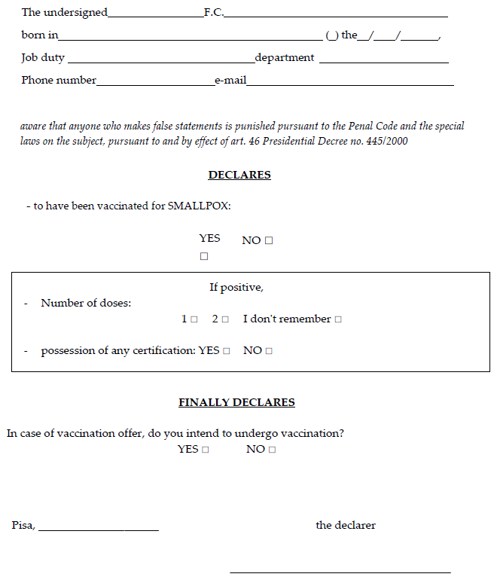
Figure S1. Self-declaration.

