Figure S1. miRNAs predication for CYP24A1 and CYP27B1 using Target scan and miRTarBase

CYP24A1
miRTarBase
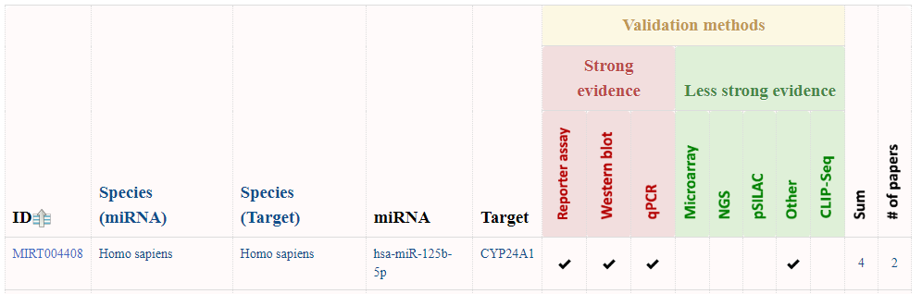
Target scan
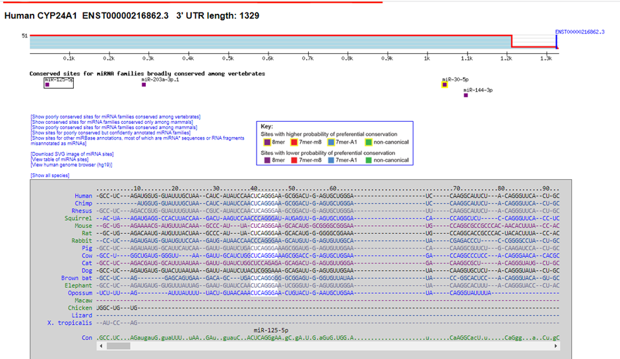
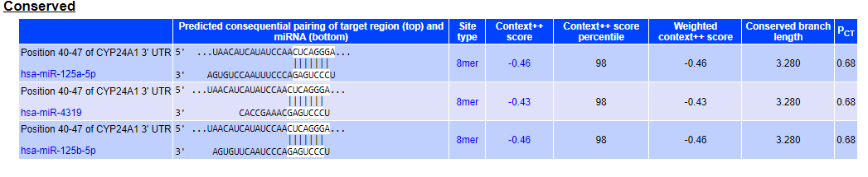

CYP27B1
