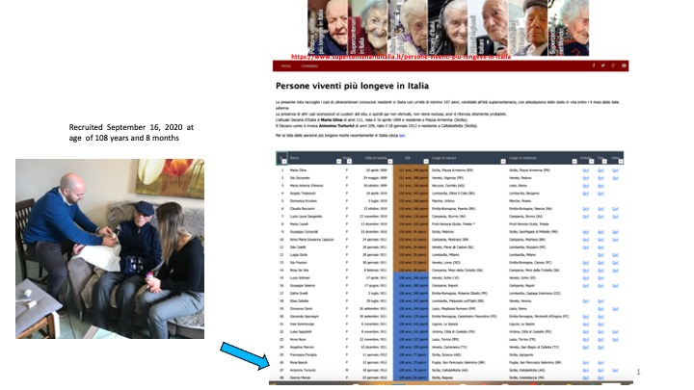

Supplementary Figure 1. Recruitment and age validation of Mr. Antonino Turturici. The website https://www.supercentenariditalia.it/persone-viventi-piu-longeve-in-italia, curated by Dr. De Lucchi, includes the names of known supercentenarians residing in Italy who are at least 107 years old, with proof of their current status. All cases are validated through in-person or remote verification of the individual's identity card

